UNITED STATES

SECURITIES AND EXCHANGE COMMISSION
Washington, D.C. 20549

FORM 10-Q

(Mark One)

x

QUARTERLY REPORT PURSUANT TO SECTION 13 OR 15(d) OF THE SECURITIES EXCHANGE ACT OF 1934

For the quarterly period ended November 24, 2018

or

- TRANSITION REPORT PURSUANT TO SECTION 13 OR 15(d) OF THE SECURITIES EXCHANGE ACT OF 1934

For the transition period from _________________ to _________________

Commission File Number: 001-06403


WINNEBAGO INDUSTRIES, INC.

(Exact name of registrant as specified in its charter)

Iowa |  | 42-0802678
(State or other jurisdiction of incorporation or organization) |  | (I.R.S. Employer Identification No.)
P. O. Box 152, Forest City, Iowa |  | 50436
(Address of principal executive offices) |  | (Zip Code)

(641) 585-3535

(Registrant's telephone number, including area code)

Indicate by check mark whether the registrant (1) has filed all reports required to be filed by Section 13 or 15(d) of the Securities Exchange Act of 1934 during the preceding 12 months (or for such shorter period that the registrant was required to file such reports), and (2) has been subject to such filing requirements for the past 90 days. Yes x No o

Indicate by check mark whether the registrant has submitted electronically every Interactive Data File required to be submitted pursuant to Rule 405 of Regulation S-T (§ 232.405 of this chapter) during the preceding 12 months (or for such shorter period that the registrant was required to submit such files). Yes x No o

Indicate by check mark whether the registrant is a large accelerated filer, an accelerated filer, a non-accelerated filer, a smaller reporting company or an emerging growth company. See the definitions of "large accelerated filer," "accelerated filer," "smaller reporting company" and "emerging growth company" in Rule 12b-2 of the Exchange Act.

Large accelerated filer x | Accelerated filer o | Non-accelerated filer o
Smaller reporting company o | Emerging growth company o

If an emerging growth company, indicate by check mark if the registrant has elected not to use the extended transition period for complying with any new or revised financial accounting standards provided pursuant to Section 13(a) of the Exchange Act. o

Indicate by check mark whether the registrant is a shell company (as defined in Rule 12b-2 of the Exchange Act). Yes o No x The number of shares of common stock, par value $0.50 per share, outstanding on December 14, 2018 was 32,025,628.

Winnebago Industries, Inc.

Table of Contents

PART I. |  | FINANCIAL INFORMATION. |  |  |  |  |  |  |  |  |  |  |  | 3
Item 1. |  | Condensed Consolidated Financial Statements. |  |  |  |  |  |  |  |  |  |  |  | 3
 |  |  |  | Condensed Consolidated Statements of Income and Comprehensive Income |  |  |  |  |  |  |  |  |  | 3
 |  |  |  | Condensed Consolidated Balance Sheets |  |  |  |  |  |  |  |  |  |  |  | 4
 |  |  |  | Condensed Consolidated Statements of Cash Flows |  |  |  |  |  |  |  |  |  |  |  | 5
 |  |  |  | Condensed Consolidated Statements of Changes in Stockholders' Equity |  |  |  |  |  |  |  |  |  |  |  | 6
 |  |  |  | Notes to Condensed Consolidated Financial Statements |  |  |  |  |  |  |  |  |  |  |  | 7
Item 2. |  | Management's Discussion and Analysis of Financial Condition and Results of Operations. |  |  |  |  |  |  |  |  |  |  |  | 19
Item 3. |  | Quantitative and Qualitative Disclosures About Market Risk. |  |  |  |  |  |  |  |  |  |  |  | 26
Item 4. |  | Controls and Procedures. |  |  |  |  |  |  |  |  |  |  |  | 27

PART II. |  |  |  | OTHER INFORMATION.
Item 1. |  |  |  | Legal Proceedings. |  |  |  |  |  | 28
Item 1A. |  |  |  | Risk Factors. |  |  |  |  |  | 28
Item 2. |  |  |  | Unregistered Sales of Equity Securities and Use of Proceeds. |  |  |  |  |  | 28
Item 6. |  |  |  | Exhibits. |  |  |  |  |  | 29
SIGNATURES |  |  |  |  |  |  |  |  |  | 30
 |  |  |  |  |  |  |  |  |  | 2

Table of Contents
PART I. FINANCIAL INFORMATION.
Item 1. Condensed Consolidated Financial Statements
Winnebago Industries, Inc.
Condensed Consolidated Statements of Income and Comprehensive Income
(Unaudited)
 |  |  |  | Three Months Ended
 |  |  |  | November 24, |  |  | November 25,
(in thousands, except per share data) |  |  |  | 2018 |  |  | 2017
Net revenues |  | $ |  | 493,648 |  | $ | 450,021
Cost of goods sold |  |  |  | 422,652 |  |  | 387,190
Gross profit |  |  |  | 70,996 |  |  | 62,831
Selling, general, and administrative expenses |  |  |  | 35,712 |  |  | 29,600
Amortization of intangible assets |  |  |  | 2,659 |  |  | 2,055
Total operating expenses |  |  |  | 38,371 |  |  | 31,655
Operating income |  |  |  | 32,625 |  |  | 31,176
Interest expense |  |  |  | 4,501 |  |  | 4,781
Non-operating income |  |  |  | (763) |  |  | (123)
Income before income taxes |  |  |  | 28,887 |  |  | 26,518
Provision for income taxes |  |  |  | 6,726 |  |  | 8,560
Net income |  | $ |  | 22,161 |  | $ | 17,958
Income per common share:
Basic |  | $ |  | 0.70 |  | $ | 0.57
Diluted |  | $ |  | 0.70 |  | $ | 0.57
Weighted average common shares outstanding:
Basic |  |  |  | 31,567 |  |  | 31,614
Diluted |  |  |  | 31,814 |  |  | 31,772
Net income |  | $ |  | 22,161 |  | $ | 17,958
Other comprehensive income (loss):
Amortization of net actuarial loss (net of tax of $3 and $4) |  |  |  | 8 |  |  | 6
Change in fair value of interest rate swap (net of tax of $7 and $387) |  |  |  | (22) |  |  | 634
Total other comprehensive income (loss) |  |  |  | (14) |  |  | 640
Comprehensive income |  | $ |  | 22,147 |  | $ | 18,598
See Notes to Condensed Consolidated Financial Statements.
 |  | 3

Table of Contents
Winnebago Industries, Inc.
Condensed Consolidated Balance Sheets
(Unaudited)
 |  |  |  | November 24, |  |  | August 25,
(in thousands, except per share data) |  |  |  | 2018 |  |  | 2018
Assets
Current assets:
Cash and cash equivalents |  | $ |  | 702 |  | $ | 2,342
Receivables, less allowance for doubtful accounts ($179 and $197, respectively) |  |  |  | 140,837 |  |  | 164,585
Inventories |  |  |  | 191,461 |  |  | 195,128
Prepaid expenses and other assets |  |  |  | 10,256 |  |  | 9,883
Total current assets |  |  |  | 343,256 |  |  | 371,938
Property, plant, and equipment, net |  |  |  | 110,212 |  |  | 101,193
Other assets:
Goodwill |  |  |  | 275,072 |  |  | 274,370
Other intangible assets, net |  |  |  | 263,058 |  |  | 265,717
Investment in life insurance |  |  |  | 26,651 |  |  | 28,297
Other assets |  |  |  | 11,724 |  |  | 10,290
Total assets |  | $ |  | 1,029,973 |  | $ | 1,051,805
Liabilities and Stockholders' Equity
Current liabilities:
Accounts payable |  | $ |  | 79,687 |  | $ | 81,039
Income taxes payable |  |  |  | 13,212 |  |  | 15,655
Accrued expenses:
Accrued compensation |  |  |  | 21,977 |  |  | 29,350
Product warranties |  |  |  | 41,303 |  |  | 40,498
Self-insurance |  |  |  | 13,381 |  |  | 12,262
Promotional |  |  |  | 14,868 |  |  | 11,017
Accrued interest |  |  |  | 3,026 |  |  | 3,095
Other |  |  |  | 11,736 |  |  | 11,269
Total current liabilities |  |  |  | 199,190 |  |  | 204,185
Non-current liabilities:
Long-term debt |  |  |  | 253,262 |  |  | 291,441
Deferred income taxes |  |  |  | 4,834 |  |  | 4,457
Unrecognized tax benefits |  |  |  | 1,745 |  |  | 1,745
Deferred compensation benefits, net of current portion |  |  |  | 14,214 |  |  | 15,282
Other |  |  |  | 250 |  |  | 250
Total non-current liabilities |  |  |  | 274,305 |  |  | 313,175
Contingent liabilities and commitments (Note 12)
Stockholders' equity:
Preferred stock, par value $0.01: Authorized-10,000 shares; Issued-none |  |  |  | — |  |  | —
Common stock, par value $0.50: Authorized-60,000 shares; Issued-51,776 shares |  |  |  | 25,888 |  |  | 25,888
Additional paid-in capital |  |  |  | 88,288 |  |  | 86,223
Retained earnings |  |  |  | 787,794 |  |  | 768,816
Accumulated other comprehensive income |  |  |  | 878 |  |  | 892
Treasury stock, at cost: 20,178 and 20,243 shares, respectively |  |  |  | (346,370) |  |  | (347,374)
Total stockholders' equity |  |  |  | 556,478 |  |  | 534,445
Total liabilities and stockholders' equity |  | $ |  | 1,029,973 |  | $ | 1,051,805
See Notes to Condensed Consolidated Financial Statements.
 |  | 4

Table of Contents
Winnebago Industries, Inc.
Condensed Consolidated Statements of Cash Flows
(Unaudited)
 |  |  |  | Three Months Ended
 |  |  |  | November 24, |  |  | November 25,
(in thousands) |  |  |  | 2018 |  |  | 2017
Operating activities:
Net income |  | $ |  | 22,161 |  | $ | 17,958
Adjustments to reconcile net income to net cash provided by operating activities:
Depreciation |  |  |  | 3,169 |  |  | 2,130
Amortization of intangibles assets |  |  |  | 2,659 |  |  | 2,055
Amortization of debt issuance costs |  |  |  | 394 |  |  | 437
Last in, first-out expense |  |  |  | 597 |  |  | 299
Stock-based compensation |  |  |  | 2,472 |  |  | 823
Deferred income taxes |  |  |  | 382 |  |  | 1,665
Other, net |  |  |  | (570) |  |  | 97
Change in assets and liabilities:
Receivables |  |  |  | 23,748 |  |  | 7,675
Inventories |  |  |  | 3,070 |  |  | (9,821)
Prepaid expenses and other assets |  |  |  | 68 |  |  | (936)
Accounts payable |  |  |  | (799) |  |  | (2,443)
Income taxes and unrecognized tax benefits |  |  |  | (2,443) |  |  | 6,447
Accrued expenses and other liabilities |  |  |  | (737) |  |  | 3,072
Net cash provided by operating activities |  |  |  | 54,171 |  |  | 29,458
Investing activities:
Purchases of property and equipment |  |  |  | (12,771) |  |  | (5,357)
Acquisition of business, net of cash acquired |  |  |  | (702) |  |  | —
Proceeds from the sale of property |  |  |  | — |  |  | 92
Other, net |  |  |  | 311 |  |  | (57)
Net cash used in investing activities |  |  |  | (13,162) |  |  | (5,322)
Financing activities:
Borrowings on credit agreement |  |  |  | 133,711 |  |  | —
Repayments of credit agreement |  |  |  | (172,229) |  |  | (4,250)
Payments of cash dividends |  |  |  | (3,183) |  |  | —
Payments for repurchases of common stock |  |  |  | (948) |  |  | (1,363)
Net cash used in financing activities |  |  |  | (42,649) |  |  | (5,613)
Net (decrease) increase in cash and cash equivalents |  |  |  | (1,640) |  |  | 18,523
Cash and cash equivalents at beginning of year |  |  |  | 2,342 |  |  | 35,945
Cash and cash equivalents at end of year |  | $ |  | 702 |  | $ | 54,468
Supplement cash flow disclosure:
Income taxes paid, net |  | $ |  | 8,778 |  | $ | 322
Interest paid |  | $ |  | 3,736 |  | $ | 4,548
Non-cash transactions:
Capital expenditures in accounts payable |  | $ |  | 145 |  | $ | 379
Accrued dividends |  | $ |  | — |  | $ | 3,187
See Notes to Condensed Consolidated Financial Statements.
 |  | 5

Table of Contents

Winnebago Industries, Inc.

Condensed Consolidated Statements of Changes in Stockholders' Equity

(Unaudited)

 | Common Shares |  |  |  |  |  |  |  | Accumulated Other | Treasury Stock
(in thousands, |  |  |  | Additional paid-in |  |  | Retained | Comprehensive Income |  |  |  |  |  | Total stockholders'
except per share data) | Number |  | Amount |  | capital |  | earnings |  | (Loss) | Number |  | Amount |  | equity
Balance, August 26, 2017 | 51,776 | $ | 25,888 | $ | 80,401 | $ | 679,138 | $ | (1,023) | (20,183) | $ | (342,730) | $ | 441,674
Stock-based compensation, net of forfeitures | — |  | — |  | 804 |  | — |  | — | 1 |  | 19 |  | 823
Issuance of restricted stock | — |  | — |  | (1,165) |  | — |  | — | 74 |  | 1,251 |  | 86
Repurchase of common stock | — |  | — |  | — |  | — |  | — | (32) |  | (1,363) |  | (1,363)
Common stock dividends; $0.10 per share | — |  | — |  | — |  | (3,187) |  | — | — |  | — |  | (3,187)
Actuarial loss, net of $4 tax | — |  | — |  | — |  | — |  | 6 | — |  | — |  | 6
Change in fair value of interest rate swap, net of $387
tax | — |  | — |  | — |  | — |  | 634 | — |  | — |  | 634
Net income | — |  | — |  | — |  | 17,958 |  | — | — |  | — |  | 17,958
Balance, November 25, 2017 | 51,776 | $ | 25,888 | $ | 80,040 | $ | 693,909 | $ | (383) | (20,140) | $ | (342,823) | $ | 456,631
Balance, August 25, 2018 | 51,776 | $ | 25,888 | $ | 86,223 | $ | 768,816 | $ | 892 | (20,243) | $ | (347,374) | $ | 534,445
Stock-based compensation, net of forfeitures | — |  | — |  | 2,448 |  | — |  | — | 2 |  | 41 |  | 2,489
Issuance of restricted stock | — |  | — |  | (383) |  | — |  | — | 111 |  | 1,911 |  | 1,528
Repurchase of common stock | — |  | — |  | — |  | — |  | — | (48) |  | (948) |  | (948)
Common stock dividends; $0.10 per share | — |  | — |  | — |  | (3,183) |  | — | — |  | — |  | (3,183)
Actuarial loss, net of $3 tax | — |  | — |  | — |  | — |  | 8 | — |  | — |  | 8
Change in fair value of interest rate swap, net of $7
tax | — |  | — |  | — |  | — |  | (22) | — |  | — |  | (22)
Net income | — |  | — |  | — |  | 22,161 |  | — | — |  | — |  | 22,161
Balance, November 24, 2018 | 51,776 | $ | 25,888 | $ | 88,288 | $ | 787,794 | $ | 878 | (20,178) | $ | (346,370) | $ | 556,478

See Notes to Condensed Consolidated Financial Statements.

6

Table of Contents

Winnebago Industries, Inc.

Notes to Condensed Consolidated Financial Statements

(Unaudited)

Note 1: Basis of Presentation

Unless the context otherwise requires, the use of the terms "Winnebago Industries," "WGO," "we," "us," and "our" in these Notes to Condensed Consolidated Financial Statements refers to Winnebago Industries, Inc. and its wholly-owned subsidiaries.

In the opinion of management, the accompanying Condensed Consolidated Financial Statements contain all adjustments necessary for a fair presentation as prescribed by accounting principles generally accepted in the United States (“GAAP”). All adjustments were comprised of normal recurring adjustments, except as noted in these Notes to Condensed Consolidated Financial Statements.

The interim Condensed Consolidated Financial Statements included in this Quarterly Report on Form 10-Q should be read in conjunction with the audited Consolidated Financial Statements included in our Annual Report on Form 10-K for the fiscal year ended August 25, 2018.

Fiscal Period

We follow a 52-/53-week fiscal year, ending the last Saturday in August. Fiscal 2019 is a 53-week year, while Fiscal 2018 was a 52-week year. The extra (53rd) week in Fiscal 2019 will be recognized in our fourth quarter.

Subsequent Events

In preparing the accompanying unaudited Condensed Consolidated Financial Statements, we evaluated subsequent events for potential recognition and disclosure through the date of this filing.

There were no material subsequent events, except for those listed below.

2019 Omnibus Incentive Plan

On December 11, 2018, our shareholders approved the Winnebago Industries, Inc. 2019 Omnibus Incentive Plan as detailed in our Proxy Statement for the 2018 Annual Meeting of Shareholders.

Dividend

On December 12, 2018, our Board of Directors approved a quarterly cash dividend of $0.11 per share payable on January 23, 2019 to common stockholders of record at the close of business on January 9, 2019.

New Accounting Pronouncements

In February 2016, the Financial Accounting Standards Board ("FASB") issued Accounting Standard Update (“ASU”) 2016-02, Leases (Topic 842), which requires an entity to recognize both assets and liabilities arising from financing and operating leases, along with additional qualitative and quantitative disclosures. This ASU and the related amendments must be adopted on a modified retrospective basis to either each prior reporting period presented or as of the beginning of the period of adoption. Based on the effective dates, we expect to adopt the new guidance in the first quarter of Fiscal 2020. We are currently evaluating the impact of the adoption on our consolidated financial statements.

In August 2017, the FASB issued ASU 2017-12, Derivatives and Hedging (Topic 815), which improves the financial reporting of hedging relationships to better portray the economic results of an entity's risk management activities in its financial statements. ASU 2017-12 is effective for annual reporting periods beginning after December 15, 2018 (our Fiscal 2020), including interim periods within those annual reporting periods. Early adoption is permitted. We are currently evaluating the impact of adopting this ASU on our consolidated financial statements.

Recently Adopted Accounting Pronouncements

In the first quarter of Fiscal 2019, we adopted ASU 2014-09, Revenue from Contracts with Customers (Topic 606), which establishes a comprehensive five-step model for the recognition of revenue from contracts with customers. This model is based on the core principle that revenue should be recognized to depict the transfer of promised goods or services to customers in an amount that reflects the consideration to which the entity expects to be entitled in exchange for those goods or services. We elected the modified retrospective method of adoption, which we applied to contracts not completed as of the initial date of adoption. Application of the transition requirements had no material impact on operations or beginning retained earnings. While changes to certain control processes and procedures were updated for this adoption, the changes did not have a material impact to our internal control financial reporting framework.

7

Table of Contents

Also in the first quarter of Fiscal 2019, we retrospectively adopted ASU 2016-15, Classification of Certain Cash Receipts and Cash Payments (Topic 230), which provides guidance for eight specific cash flow issues with the objective of reducing the existing diversity in practice. The adoption of this standard did not materially impact our statements of cash flows, and no cash flow reclassifications were required for the prior period.

Note 2: Business Segments

In the fourth quarter of Fiscal 2018, we revised our segment presentation. We have five operating segments: 1) Winnebago motorhomes, 2) Winnebago towables, 3) Grand Design towables, 4) Winnebago specialty vehicles, and 5) Chris-Craft marine. We evaluate performance based on each operating segment's Adjusted EBITDA, as defined below, which excludes certain corporate administration expenses and non-operating income and expense.

Our two reportable segments include: 1) Motorhome (comprised of products that include a motorized chassis as well as other related manufactured products and services) and 2) Towable (comprised of products which are not motorized and are generally towed by another vehicle as well as other related manufactured products and services), which is an aggregation of the Winnebago towables and Grand Design towables operating segments.

The Corporate / All Other category includes the Winnebago specialty vehicles and Chris-Craft marine operating segments as well as expenses related to certain corporate administration expenses for the oversight of the enterprise. These expenses include items such as corporate leadership and administration costs. Previously, these expenses were allocated to each operating segment.

Identifiable assets of the reportable segments exclude general corporate assets, which principally consist of cash and cash equivalents and certain deferred tax balances. The general corporate assets are included in the Corporate / All Other category.

Prior period segment information has been reclassified to conform to the current reportable segment presentation. The reclassifications included removing the corporate administration expenses from both the Motorhome and Towable reportable segments and removing Winnebago specialty vehicles from the Motorhome reportable segment, as we began to dedicate leadership and focus on these operations separately from our Winnebago motorhomes operations.

Our chief operating decision maker ("CODM") is our Chief Executive Officer. Our CODM relies on internal management reporting that analyzes consolidated results to the net earnings level and operating segment's Adjusted EBITDA. Our CODM has ultimate responsibility for enterprise decisions. Our CODM determines, in particular, resource allocation for, and monitors the performance of, the consolidated enterprise, the Motorhome segment, and the Towable segment. The Motorhome segment management and Towable segment management have responsibility for operating decisions, allocating resources, and assessing performance within their respective segments. The accounting policies of both reportable segments are the same and are described in Note 1, Summary of Significant Accounting Policies, of the Notes to Consolidated Financial Statements included in our Annual Report on Form 10-K for the fiscal year ended August 25, 2018.

We evaluate the performance of our reportable segments based on Adjusted EBITDA. EBITDA is defined as net income before interest expense, provision for income taxes, and depreciation and amortization expense. Adjusted EBITDA is defined as net income before interest expense, provision for income taxes, depreciation and amortization expense, and other adjustments made in order to present comparable results from period to period. Examples of items excluded from Adjusted EBITDA include acquisition-related costs and non-operating income.

8

Table of Contents
The following table shows information by reportable segment:
 |  |  |  | Three Months Ended
 |  |  |  | November 24, |  |  | November 25,
(in thousands) |  |  |  | 2018 |  |  | 2017
Net Revenues
Motorhome |  | $ |  | 181,328 |  | $ | 188,197
Towable |  |  |  | 292,833 |  |  | 259,665
Corporate / All Other |  |  |  | 19,487 |  |  | 2,159
Consolidated |  | $ |  | 493,648 |  | $ | 450,021
Adjusted EBITDA
Motorhome |  | $ |  | 11,976 |  | $ | 4,900
Towable |  |  |  | 30,828 |  |  | 33,392
Corporate / All Other |  |  |  | (4,351) |  |  | (2,881)
Consolidated |  | $ |  | 38,453 |  | $ | 35,411
Capital Expenditures
Motorhome |  | $ |  | 3,192 |  | $ | 3,107
Towable |  |  |  | 8,877 |  |  | 2,250
Corporate / All Other |  |  |  | 702 |  |  | —
Consolidated |  |  | $ | 12,771 |  | $ | 5,357
 |  |  |  | November 24, |  |  | August 25,
(in thousands) |  |  |  | 2018 |  |  | 2018
Total Assets
Motorhome |  | $ |  | 303,984 |  | $ | 322,048
Towable |  |  |  | 624,445 |  |  | 626,588
Corporate / All Other |  |  |  | 101,544 |  |  | 103,169
Consolidated |  | $ |  | 1,029,973 |  | $ | 1,051,805
Reconciliation of net income to consolidated Adjusted EBITDA:
 |  |  |  | Three Months Ended
(in thousands) |  |  |  | November 24, 2018 |  |  | November 25, 2017
Net income |  | $ |  | 22,161 |  | $ | 17,958
Interest expense |  |  |  | 4,501 |  |  | 4,781
Provision for income taxes |  |  |  | 6,726 |  |  | 8,560
Depreciation |  |  |  | 3,169 |  |  | 2,130
Amortization of intangible assets |  |  |  | 2,659 |  |  | 2,055
EBITDA |  |  |  | 39,216 |  |  | 35,484
Acquisition-related costs |  |  |  | — |  |  | 50
Non-operating income |  |  |  | (763) |  |  | (123)
Adjusted EBITDA |  | $ |  | 38,453 |  | $ | 35,411
 |  | 9

Table of Contents
Note 3: Revenue
The following table disaggregates revenue by reportable segment and product category:
 |  |  | Three Months Ended
 |  |  | November 24, |  |  | November 25,
(in thousands) |  |  | 2018 |  |  | 2017
Net Revenues
Motorhome:
Class A |  | $ | 48,678 |  | $ | 74,205
Class B |  |  | 68,720 |  |  | 29,120
Class C |  |  | 56,142 |  |  | 76,775
Other⁽¹⁾ |  |  | 7,788 |  |  | 8,097
Total Motorhome |  |  | 181,328 |  |  | 188,197
Towable:
Fifth Wheel |  |  | 162,749 |  |  | 144,114
Travel Trailer |  |  | 125,626 |  |  | 112,725
Other⁽¹⁾ |  |  | 4,458 |  |  | 2,826
Total Towable |  |  | 292,833 |  |  | 259,665
Corporate / All Other:
Other⁽²⁾ |  |  | 19,487 |  |  | 2,159
Total Corporate / All Other |  |  | 19,487 |  |  | 2,159
Consolidated |  | $ | 493,648 |  | $ | 450,021

- Relates to parts and accessories and services.

- Relates to marine and specialty vehicle units, parts and accessories, and services.

We generate all of our operating revenue from contracts with customers. Our primary source of revenue is generated through the sale of manufactured motorized units, non-motorized towable units, and marine units to our independent dealer network (our customer). We also generate income through the sale of certain parts and services, acting as the principal in these arrangements. We apply the new revenue standard requirements to a portfolio of contracts (or performance obligations) with similar characteristics for transactions where it is expected that the effects on the financial statements of applying the revenue recognition guidance to the portfolio would not differ materially from applying this guidance to the individual contracts (or performance obligations) within that portfolio. Revenue is recognized when control of the promised goods or services is transferred to our customers, in an amount that reflects the transaction price consideration that we expect to receive in exchange for those goods or services. Control refers to the ability of the customer to direct the use of, and obtain substantially all of, the remaining benefits from the goods or services. Our transaction price consideration is fixed, unless otherwise disclosed below as variable consideration. We made an accounting policy election so that our revenue excludes sales and usage-based taxes collected.

Unit revenue

Unit revenue is recognized at a point-in-time when control passes, which generally occurs when the unit is shipped or picked-up from our manufacturing facilities to the customer, which is consistent with our past practice. Our payment terms are typically at the point of shipment, and do not include a significant financing component. The amount of consideration received and recorded to revenue varies with changes in marketing incentives and offers to our customers. These marketing incentives and offers to our customers are considered variable consideration. We adjust the estimate of revenue at the earlier of when the most likely amount of consideration we expect to receive changes or when the consideration becomes fixed.

Our contracts include some incidental items that are immaterial in the context of the contract. We have made an accounting policy election to not assess whether promised goods or services are performance obligations if they are immaterial in the context of the contract with the customer. We have made an accounting policy to account for any shipping and handling costs that occur after the transfer of control as a fulfillment cost that is accrued when control is transferred. Warranty obligations associated with the sale of a unit are assurance-type warranties that are a guarantee of the unit’s intended functionality and, therefore, do not represent a distinct performance obligation within the context of the contract. Contract costs incurred related to the sale of manufactured units are expensed at the point-in-time when the related revenue is recognized.

We do not have material contract assets or liabilities. We establish allowances for uncollectible receivables based on historical collection trends and write-off history.

10

Table of Contents

Concentration of Risk

None of our dealer organizations accounted for more than 10% of our net revenue for the first quarter of Fiscal 2019 or the first quarter of 2018.

Note 4: Derivatives, Investments, and Fair Value Measurements

Assets and Liabilities that are Measured at Fair Value on a Recurring Basis

We account for fair value measurements in accordance with Accounting Standards Codification ("ASC") 820, Fair Value Measurements and Disclosures, which defines fair value, establishes a framework for measurement, and expands disclosure about fair value measurement. The fair value hierarchy requires the use of observable market data when available. In instances in which the inputs used to measure fair value fall into different levels of the fair value hierarchy, the fair value measurement has been determined based on the lowest level input that is significant to the fair value measurement in its entirety. Our assessment of the significance of a particular item to the fair value measurement in its entirety requires judgment, including the consideration of inputs specific to the asset or liability.

Fair value is defined as the price that would be received to sell an asset or paid to transfer a liability (an exit price) in the principal or most advantageous market for the asset or liability in an orderly transaction between market participants on the measurement date. The fair value hierarchy contains three levels as follows:

Level 1 - Unadjusted quoted prices that are available in active markets for the identical assets or liabilities at the measurement date.

Level 2 - Other observable inputs available at the measurement date, other than quoted prices included in Level 1, either directly or indirectly, including:

- Quoted prices for similar assets or liabilities in active markets;

- Quoted prices for identical or similar assets in nonactive markets;

- Inputs other than quoted prices that are observable for the asset or liability; and

- Inputs that are derived principally from or corroborated by other observable market data.

Level 3 - Unobservable inputs that cannot be corroborated by observable market data and reflect the use of significant management judgment. These values are generally determined using pricing models for which the assumptions utilize management’s estimates of market participant assumptions.

The following tables set forth by level within the fair value hierarchy our financial assets and liabilities that were accounted for at fair value on a recurring basis at November 24, 2018 and August 25, 2018 according to the valuation techniques we used to determine their fair values:

 |  | Fair Value at |  |  |  |  |  | Fair Value Hierarchy
 |  | November 24,
(in thousands) |  | 2018 |  |  | Level 1 |  |  | Level 2 |  |  | Level 3
Assets that fund deferred compensation:
Domestic equity funds | $ | 996 |  | $ | 928 |  | $ | 68 |  | $ | —
International equity funds |  | 141 |  |  | 100 |  |  | 41 |  |  | —
Fixed income funds |  | 215 |  |  | 61 |  |  | 154 |  |  | —
Interest rate swap contract |  | 1,930 |  |  | — |  |  | 1,930 |  |  | —
Total assets at fair value | $ | 3,282 |  | $ | 1,089 |  | $ | 2,193 |  | $ | —

 |  | Fair Value at |  |  |  |  |  | Fair Value Hierarchy
 |  | August 25,
(in thousands) |  | 2018 |  |  | Level 1 |  |  | Level 2 |  |  | Level 3
Assets that fund deferred compensation:
Domestic equity funds | $ | 1,143 |  | $ | 1,114 |  | $ | 29 |  | $ | —
International equity funds |  | 139 |  |  | 120 |  |  | 19 |  |  | —
Fixed income funds |  | 223 |  |  | 132 |  |  | 91 |  |  | —
Interest rate swap contract |  | 1,959 |  |  | — |  |  | 1,959 |  |  | —
Total assets at fair value | $ | 3,464 |  | $ | 1,366 |  | $ | 2,098 |  | $ | —
 |  | 11

Table of Contents

The following methods and assumptions were used to estimate the fair value of each class of financial instrument:

Assets that fund deferred compensation

Our assets that fund deferred compensation are marketable equity securities measured at fair value using quoted market prices and primarily consist of equity-based mutual funds. These securities are primarily classified as Level 1 as they are traded in an active market for which closing stock prices are readily available. These securities fund the Executive Share Option Plan and the Executive Deferred Compensation Plan. Refer to Note 10, Employee and Retiree Benefits, of the Notes to Consolidated Financial Statements included in our Annual Report on Form 10-K for the fiscal year ended August 25, 2018 for additional information regarding these plans.

The proportion of the assets that will fund options which expire within a year are included in Prepaid expenses and other assets in the accompanying Condensed Consolidated Balance Sheets.

The remaining assets are classified as non-current and are included in Other assets.

Interest Rate Swap Contract

Under the terms of our Credit Agreement, as defined in Note 9, Long-Term Debt, we were previously required to hedge a portion of the floating interest rate exposure. In accordance with this requirement, on January 23, 2017, we entered into an interest rate swap contract, which effectively fixed our interest rate on our $300.0 million term loan agreement ("Term Loan") for a notional amount that reduces each December during the swap contract. As of November 24, 2018, we had $170.0 million of our Term Loan fixed at an interest rate of 5.32%. As of August 25, 2018, we had $170.0 million of our Term Loan fixed at an interest rate of 5.32%. The swap contract expires on December 8, 2020.

The fair value of the interest rate swap is classified as Level 2 as it is corroborated based on observable market data. The asset is included in Other assets on the Condensed Consolidated Balance Sheets. The change in value was predominately recorded to Accumulated other comprehensive income on the Condensed Consolidated Balance Sheets since the interest rate swap has been designated for hedge accounting.

Assets and Liabilities that are measured at Fair Value on a Nonrecurring Basis

Our non-financial assets, which include goodwill, intangible assets, and property, plant and equipment, are not required to be measured at fair value on a recurring basis. However, if certain triggering events occur, or if an annual impairment test is required, we must evaluate the non-financial asset for impairment. If an impairment has occurred, the asset is required to be recorded at the estimated fair value. No impairments were recorded for non-financial assets in the first quarter of Fiscal 2019 or the first quarter of 2018.

Fair Value of Financial Instruments

Our financial instruments, other than those presented in the disclosures above, include cash, receivables, accounts payable, other payables, and long-term debt. The fair values of cash, receivables, accounts payable, and other payables approximated carrying values because of the short-term nature of these instruments. If these instruments were measured at fair value in the financial statements, they would be classified as Level 1 in the fair value hierarchy. See Note 9, Long-Term Debt, for information about the fair value of our long-term debt.

12

Table of Contents
Note 5: Inventories
Inventories consist of the following:
 |  |  |  |  |  |  | November 24, |  |  | August 25,
(in thousands) |  |  |  |  |  |  | 2018 |  |  | 2018
Finished goods |  |  |  |  | $ |  | 44,602 |  | $ | 26,513
Work-in-process |  |  |  |  |  |  | 75,072 |  |  | 68,339
Raw materials |  |  |  |  |  |  | 111,147 |  |  | 139,039
Total |  |  |  |  |  |  | 230,821 |  |  | 233,891
Less last-in, first-out ("LIFO") reserve |  |  |  |  |  |  | 39,360 |  |  | 38,763
Inventories |  |  |  |  | $ |  | 191,461 |  | $ | 195,128
Inventory valuation methods consist of the following:
 |  |  |  |  |  |  | November 24, |  |  | August 25,
(in thousands) |  |  |  |  |  |  | 2018 |  |  | 2018
LIFO basis |  |  |  |  | $ |  | 178,377 |  | $ | 176,215
First-in, first-out basis |  |  |  |  |  |  | 52,444 |  |  | 57,676
Total |  |  |  |  | $ |  | 230,821 |  | $ | 233,891
The above value of inventories, before reduction for the LIFO reserve, approximates replacement cost at the respective dates.
Note 6: Property, Plant, and Equipment
Property, plant, and equipment is stated at cost, net of accumulated depreciation and consists of the following:
 |  |  |  |  |  |  | November 24, |  |  | August 25,
(in thousands) |  |  |  |  |  |  | 2018 |  |  | 2018
Land |  |  |  |  | $ |  | 6,747 |  | $ | 6,747
Buildings and building improvements |  |  |  |  |  |  | 102,478 |  |  | 94,622
Machinery and equipment |  |  |  |  |  |  | 107,839 |  |  | 105,663
Software |  |  |  |  |  |  | 24,920 |  |  | 23,388
Transportation |  |  |  |  |  |  | 8,845 |  |  | 8,837
Property, plant, and equipment, gross |  |  |  |  |  |  | 250,829 |  |  | 239,257
Less accumulated depreciation |  |  |  |  |  |  | 140,617 |  |  | 138,064
Property, plant, and equipment, net |  |  |  |  | $ |  | 110,212 |  | $ | 101,193
Depreciation expense was $3.2 million and $2.1 million during the first quarters of Fiscal 2019 and 2018, respectively.
Note 7: Goodwill and Intangible Assets
The changes in the carrying amount of goodwill by segment were as follows for the first quarters of Fiscal 2019 and 2018:
(in thousands) |  |  | Towable |  |  |  | Corporate / All Other |  |  | Total
Balance, August 26, 2017 |  | $ | 242,728 |  | $ |  | — |  | $ | 242,728
Grand Design purchase price adjustment⁽¹⁾ |  |  | 1,956 |  |  |  | — |  |  | 1,956
Balance, November 25, 2017 |  | $ | 244,684 |  | $ |  | — |  | $ | 244,684
Balance, August 25, 2018 |  | $ | 244,684 |  | $ |  | 29,686 |  | $ | 274,370
Chris-Craft purchase price adjustment⁽²⁾ |  |  | — |  |  |  | 702 |  |  | 702
Balance, November 24, 2018 |  | $ | 244,684 |  | $ |  | 30,388 |  | $ | 275,072

- Refer to Note 2, Business Combinations, of the Notes to Consolidated Financial Statements included in our Annual Report on Form 10-K for the fiscal year ended August 25, 2018 for additional information.

13

Table of Contents

- Purchase price adjustment made for working capital. For additional information related to the acquisition of Chris-Craft USA, Inc., refer to Note 2, Business Combinations, of the Notes to Consolidated Financial Statements included in our Annual Report on Form 10-K for the fiscal year ended August 25, 2018.

Other intangible assets, net of accumulated amortization, consist of the following:

 |  |  |  | November 24, 2018 |  |  |  |  |  | August 25, 2018
 | Weighted
 | Average Life- |  |  |  |  |  | Accumulated |  |  |  |  |  | Accumulated
(in thousands) | Years |  | Cost |  |  |  | Amortization |  |  | Cost |  |  | Amortization
Trade names | Indefinite |  | $ | 177,250 |  |  |  |  | $ | 177,250
Dealer networks | 12.2 |  |  | 95,581 | $ |  | 14,288 |  |  | 95,581 | $ |  | 12,328
Backlog | 0.5 |  |  | 19,527 |  |  | 19,527 |  |  | 19,527 |  |  | 19,135
Non-compete agreements | 4.1 |  |  | 5,347 |  |  | 2,330 |  |  | 5,347 |  |  | 2,084
Leasehold interest-favorable | 8.1 |  |  | 2,000 |  |  | 502 |  |  | 2,000 |  |  | 441
Other intangible assets, gross |  |  |  | 299,705 |  |  | 36,647 |  |  | 299,705 |  |  | 33,988
Less accumulated amortization |  |  |  | 36,647 |  |  |  |  |  | 33,988
Other intangible assets, net |  |  | $ | 263,058 |  |  |  |  | $ | 265,717
The weighted average remaining amortization period for intangible assets as of November 24, 2018 was approximately 11 years.
Remaining estimated aggregate annual amortization expense by fiscal year is as follows:
(in thousands) |  |  |  |  |  |  |  |  |  |  |  |  | Amount
Fiscal 2019 |  |  |  |  |  |  |  |  |  |  | $ |  | 6,828
Fiscal 2020 |  |  |  |  |  |  |  |  |  |  |  |  | 9,032
Fiscal 2021 |  |  |  |  |  |  |  |  |  |  |  |  | 9,032
Fiscal 2022 |  |  |  |  |  |  |  |  |  |  |  |  | 8,405
Fiscal 2023 |  |  |  |  |  |  |  |  |  |  |  |  | 8,197
Thereafter |  |  |  |  |  |  |  |  |  |  |  |  | 44,314
Total amortization expense remaining |  |  |  |  |  |  |  |  |  |  | $ |  | 85,808

Note 8: Warranty

We provide certain service and warranty on our products. From time to time, we also voluntarily incur costs for certain warranty-type expenses occurring after the normal warranty period to help protect the reputation of our products and the goodwill of our customers. Estimated costs related to product warranty are accrued at the time of sale and are based upon historical warranty and service claims experience. Adjustments are made to accruals as claim data and cost experience becomes available.

In addition to the costs associated with the contractual warranty coverage provided on our products, we also occasionally incur costs as a result of additional service actions not covered by our warranties, including product recalls and customer satisfaction actions. Although we estimate and reserve for the cost of these service actions, there can be no assurance that expense levels will remain at current levels or such reserves will continue to be adequate.

Changes in our product warranty liability are as follows:
 |  |  | Three Months Ended
 |  |  | November 24, |  |  | November 25,
(in thousands) |  |  | 2018 |  |  | 2017
Balance at beginning of period | $ |  | 40,498 |  | $ | 30,805
Provision |  |  | 10,757 |  |  | 9,953
Claims paid |  |  | (9,952) |  |  | (8,258)
Balance at end of period | $ |  | 41,303 |  | $ | 32,500
 | 14

Table of Contents

Note 9: Long-Term Debt

On November 8, 2016, we entered into a $125.0 million credit facility ("ABL") and a $300.0 million Term Loan with JPMorgan Chase Bank, N.A. ("Credit Agreement"). On December 8, 2017, we amended our Credit Agreement, which decreased the interest rate spread on the Term Loan and the ABL. As of September 21, 2018, the amount that may be borrowed under the ABL was increased to $165.0 million.

The Credit Agreement contains certain financial covenants. As of November 24, 2018, we are in compliance with all financial covenants of the Credit Agreement.

The components of long-term debt are as follows:
 |  | November 24, |  |  | August 25,
(in thousands) |  | 2018 |  |  | 2018
ABL | $ | 14 |  | $ | 38,532
Term Loan |  | 260,000 |  |  | 260,000
Long-term debt, excluding debt issuance costs |  | 260,014 |  |  | 298,532
Debt issuance cost, net |  | (6,752) |  |  | (7,091)
Long-term debt | $ | 253,262 |  | $ | 291,441

The fair value of long-term debt, excluding debt issuance costs, approximated the carrying values as of November 24, 2018 and August 25, 2018 as interest is at variable market rates.

Aggregate contractual maturities of debt in future fiscal years are as follows:
(in thousands) |  |  |  |  | Amount
Fiscal 2019 |  |  |  | $ | —
Fiscal 2020 |  |  |  |  | 10,250
Fiscal 2021 |  |  |  |  | 15,000
Fiscal 2022 |  |  |  |  | 15,000
Fiscal 2023 |  |  |  |  | 219,750
Total Term Loan |  |  |  | $ | 260,000
Note 10: Employee and Retiree Benefits
Deferred compensation liabilities are as follows:
 |  | November 24, |  |  | August 25,
(in thousands) |  | 2018 |  |  | 2018
Non-qualified deferred compensation | $ | 14,187 |  | $ | 14,831
Supplemental executive retirement plan |  | 2,324 |  |  | 2,309
Executive share option plan |  | 736 |  |  | 935
Executive deferred compensation plan |  | 548 |  |  | 421
Officer stock-based compensation |  | — |  |  | 1,528
Deferred compensation benefits |  | 17,795 |  |  | 20,024
Less current portion⁽¹⁾ |  | 3,581 |  |  | 4,742
Deferred compensation benefits, net of current portion | $ | 14,214 |  | $ | 15,282

(1) Included in Accrued compensation on the Condensed Consolidated Balance Sheets.

Note 11: Stock-Based Compensation

We have a 2014 Omnibus Equity, Performance Award, and Incentive Compensation Plan (as amended, the "Plan") in place as approved by shareholders, which allows us to grant or issue non-qualified stock options, incentive stock options, share awards, and other equity compensation to key employees and to non-employee directors.

Beginning with our annual grant of restricted stock units in October 2018, we attach dividend equivalents to our restricted stock units equal to dividends payable on the same number of shares of WGO common stock during the applicable period. Dividend

15

Table of Contents

equivalents, settled in cash, accrue on restricted stock unit awards during the vesting period. No dividend equivalents are paid on any restricted stock units that are forfeited prior to the vesting date.

Stock-based compensation expense was $2.5 million and $0.8 million during the first quarters of Fiscal 2019 and 2018, respectively. Compensation expense is recognized over the requisite service period of the award.

Note 12: Contingent Liabilities and Commitments

Repurchase Commitments

Generally, manufacturers in our industries enter into repurchase agreements with lending institutions which have provided wholesale floorplan financing to dealers. Most dealers are financed on a "floorplan" basis under which a bank or finance company lends the dealer all, or substantially all, of the purchase price, collateralized by a security interest in the units purchased.

Our repurchase agreements generally provide that, in the event of default by the dealer on the agreement to pay the lending institution, we will repurchase the financed merchandise. The terms of these agreements, which generally can last up to 24 months, provide that our liability will be the lesser of remaining principal owed by the dealer to the lending institution, or dealer invoice less periodic reductions based on the time since the date of the original invoice. Our liability cannot exceed 100% of the dealer invoice. In certain instances, we also repurchase inventory from our dealers due to state law or regulatory requirements that govern voluntary or involuntary relationship terminations. Although laws vary from state to state, some states have laws in place that require manufacturers of recreational vehicles or boats to repurchase current inventory if a dealership exits the business. Our total contingent liability on all repurchase agreements was approximately $933.4 million and $879.0 million at November 24, 2018 and August 25, 2018.

Repurchased sales are not recorded as a revenue transaction, but the net difference between the original repurchase price and the resale price are recorded against the loss reserve, which is a deduction from gross revenue. Our loss reserve for repurchase commitments contains uncertainties because the calculation requires management to make assumptions and apply judgment regarding a number of factors. Our risk of loss related to these repurchase commitments is significantly reduced by the potential resale value of any products that are subject to repurchase and is spread over numerous dealers and lenders. The aggregate contingent liability related to our repurchase agreements represents all financed dealer inventory at the period reporting date subject to a repurchase agreement, net of the greater of periodic reductions per the agreement or dealer principal payments. Based on these repurchase agreements and our historical loss experience, we establish an associated loss reserve which is included in Accrued expenses: Other on the Condensed Consolidated Balance Sheets. Our accrued losses on repurchases were $0.9 million and $0.9 million at November 24, 2018 and August 25, 2018, respectively. Repurchase risk is affected by the credit worthiness of our dealer network, and we do not believe there is a reasonable likelihood that there will be a material change in the estimates or assumptions used to establish the loss reserve for repurchase commitments.

There was no material activity related to repurchase agreements during the three months ended November 24, 2018 and November 25, 2017.

Litigation

We are involved in various legal proceedings which are ordinary and routine litigation incidental to our business, some of which are covered in whole or in part by insurance. While we believe the ultimate disposition of litigation will not have material adverse effect on our financial position, results of operations or liquidity, there exists the possibility that such litigation may have an impact on our results for a particular reporting period in which litigation effects become probable and reasonably estimable. Though we do not believe there is a reasonable likelihood that there will be a material change related to these matters, litigation is subject to inherent uncertainties and management’s view of these matters may change in the future.

Note 13: Income Taxes

We account for income taxes under ASC 740, Income Taxes. The objectives of accounting for income taxes are to recognize the amount of taxes payable or refundable for the current year and deferred tax liabilities and assets for the future tax consequences of events that have been recognized in our financial statements or tax returns.

Our effective tax rate decreased to 23.3% for the three months ended November 24, 2018 from 32.3% for the three months ended November 25, 2017 due primarily to the enactment of the 2017 Tax Cuts and Jobs Act ("Tax Act") on December 22, 2017. The rate reduction was primarily due to the Tax Act decrease in the Federal rate offset by the repeal of the domestic production activities deduction and by a reduced benefit from stock-based compensation activity in the current quarter.

ASU 2018-05, Income Taxes (Topic 740): Amendments to SEC Paragraphs Pursuant to SEC Staff Accounting Bulletin No. 118, provided guidance for companies that allows for a measurement period of up to one year after the enactment date of the Tax Act to finalize the recording of the related tax impacts under ASC 740, Income Taxes. In accordance with this guidance, a company must reflect the income tax effect of those aspects of the Tax Act for which the accounting under ASC 740 is complete. To the extent that

16

Table of Contents

a company's accounting for certain income tax effects of the Tax Act is incomplete, but it is able to determine a reasonable estimate, the company must record a provisional estimate in the financial statements.

In accordance with ASC 740, we recorded non-cash provisional estimates to income tax expense in Fiscal 2018 as a result of revaluing all deferred tax assets and liabilities at the newly enacted Federal corporate income tax rate. We have not made any measurement period adjustments related to these items during the first three months of Fiscal 2019 and are materially complete in analyzing and recording all aspects of the enactment of the Tax Act.

We file a U.S. Federal tax return as well as returns in various international and state jurisdictions. Although certain years are no longer subject to examination by the Internal Revenue Service ("IRS") and various state taxing authorities, net operating loss carryforwards generated in those years may still be adjusted upon examination by the IRS or state taxing authorities. As of November 24, 2018, our Federal returns from Fiscal 2015 to present continue to be subject to review by the IRS. With limited exception, our state returns from Fiscal 2014 to present continue to be subject to review by the state taxing jurisdictions. Several years may lapse before an uncertain tax position is audited and finally resolved, and it is difficult to predict the outcome of such audits.

It is our policy to recognize interest and penalties accrued relative to unrecognized tax benefits in income tax expense. Total reserves for uncertain tax positions were not material.

Note 14: Income Per Share
The following table reflects the calculation of basic and diluted income per share:
 |  | Three Months Ended
 |  | November 24, |  |  | November 25,
(in thousands, except per share data) |  | 2018 |  |  | 2017
Numerator
Net income | $ | 22,161 |  | $ | 17,958
Denominator
Weighted average common shares outstanding |  | 31,567 |  |  | 31,614
Dilutive impact of stock compensation awards |  | 247 |  |  | 158
Weighted average common shares outstanding, assuming dilution |  | 31,814 |  |  | 31,772
Anti-dilutive securities excluded from Weighted average common shares outstanding, assuming dilution |  | 90 |  |  | 73
Basic income per common share | $ | 0.70 |  | $ | 0.57
Diluted income per common share | $ | 0.70 |  | $ | 0.57

Anti-dilutive securities were not included in the computation of diluted income per common share because they are considered anti-dilutive under the treasury stock method.

Note 15: Accumulated Other Comprehensive Income (Loss)

Changes in Accumulated Other Comprehensive Income ("AOCI") by component, net of tax, were:

 |  |  |  |  |  |  |  | Three Months Ended
 |  |  |  | November 24, 2018 |  |  |  |  |  |  |  |  | November 25, 2017
 |  | Defined Benefit |  |  |  |  |  |  |  |  | Defined Benefit
(in thousands) |  | Pension Items |  | Interest Rate Swap |  |  |  | Total |  |  | Pension Items |  | Interest Rate Swap |  |  |  | Total
Balance at beginning of period | $ | (591) |  | $ | 1,483 |  | $ | 892 |  | $ | (509) |  | $ | (514) |  | $ | (1,023)
Other comprehensive income before reclassifications |  | — |  |  | (22) |  |  | (22) |  |  | — |  |  | 634 |  |  | 634
Amounts reclassified from AOCI |  | 8 |  |  | — |  |  | 8 |  |  | 6 |  |  | — |  |  | 6
Net current-period OCI |  | 8 |  |  | (22) |  |  | (14) |  |  | 6 |  |  | 634 |  |  | 640
Balance at end of period | $ | (583) |  | $ | 1,461 |  | $ | 878 |  | $ | (503) |  | $ | 120 |  | $ | (383)
 |  |  |  |  | 17

Table of Contents
Reclassifications out of AOCI in net periodic benefit costs, net of tax, were:
 |  |  | Three Months Ended
 |  | Location on Consolidated Statements | November 24, |  |  | November 25,
(in thousands) |  | of Income and Comprehensive Income | 2018 |  |  | 2017
Amortization of net actuarial loss |  | SG&A | $ | 8 |  | $ | 6
 |  | 18

Table of Contents

Item 2. Management's Discussion and Analysis of Financial Condition and Results of Operations.

Unless the context otherwise requires, the use of the terms "Winnebago Industries," "we," "us," and "our" refers to Winnebago Industries, Inc. and its wholly-owned subsidiaries.

Management’s Discussion and Analysis of Financial Condition and Results of Operations (“MD&A”) is intended to provide a reader of our financial statements with a narrative from the perspective of our management on our financial condition, results of operations, liquidity, and certain other factors that may affect our future results. Unless otherwise noted, transactions and other factors significantly impacting our financial condition, results of operations, and liquidity are discussed in order of magnitude.

Our MD&A should be read in conjunction with our Annual Report on Form 10-K for the fiscal year ended August 25, 2018, (including the information presented therein under Risk Factors), as well as our reports on Forms 10-Q and 8-K and other publicly available information. All amounts herein are unaudited.

Overview

Winnebago Industries, Inc. is one of the leading U.S. manufacturers with a diversified portfolio of recreation vehicles ("RV"s) and marine products used primarily in leisure travel and outdoor recreation activities. We produce our motorhome units in manufacturing facilities in Iowa and Oregon; our towable units in Indiana; and our marine units in Florida. We distribute our RV and marine products primarily through independent dealers throughout the U.S. and Canada, who then retail the products to the end consumer. We also distribute our marine products internationally through independent dealers, who then retail the products to the end consumer.

Non-GAAP Reconciliation

This MD&A includes financial information prepared in accordance with accounting principles generally accepted in the U.S. ("GAAP"), as well as certain adjusted or non-GAAP financial measures such as EBITDA and Adjusted EBITDA. EBITDA is defined as net income before interest expense, provision for income taxes, and depreciation and amortization expense. Adjusted EBITDA is defined as net income before interest expense, provision for income taxes, depreciation and amortization expense, and other adjustments made in order to present comparable results from period to period. These non-GAAP financial measures, which are not calculated or presented in accordance with GAAP, have been provided as information supplemental and in addition to the financial measures presented in accordance with GAAP. Such non-GAAP financial measures should not be considered superior to, as a substitute for, or as an alternative to, and should be considered in conjunction with, the GAAP financial measures presented herein. The non-GAAP financial measures presented may differ from similar measures used by other companies.

Refer to the Consolidated Performance Summary within Results of Operations - First Three Months of Fiscal 2019 Compared to the First Three Months of Fiscal 2018 for a detailed reconciliation of items that impacted EBITDA and Adjusted EBITDA. We have included this non-GAAP performance measure as a comparable measure to illustrate the effect of non-recurring transactions occurring during the reported periods and improve comparability of our results from period to period. We believe Adjusted EBITDA provides meaningful supplemental information about our operating performance because this measure excludes amounts that we do not consider part of our core operating results when assessing our performance. Examples of items excluded from Adjusted EBITDA include acquisition-related costs and non-operating income.

Management uses these non-GAAP financial measures (a) to evaluate our historical and prospective financial performance and trends as well as our performance relative to competitors and peers; (b) to measure operational profitability on a consistent basis; (c) in presentations to the members of our board of directors to enable our board of directors to have the same measurement basis of operating performance as is used by management in its assessments of performance and in forecasting and budgeting for our company; (d) to evaluate potential acquisitions; and (e) to ensure compliance with covenants and restricted activities under the terms of our Credit Agreement. We believe these non-GAAP financial measures are frequently used by securities analysts, investors, and other interested parties to evaluate companies in our industry.

Reportable Segments

In the fourth quarter of Fiscal 2018, we revised our segment presentation. We have five operating segments: 1) Winnebago motorhomes, 2) Winnebago towables, 3) Grand Design towables, 4) Winnebago specialty vehicles, and 5) Chris-Craft marine. We evaluate performance based on each operating segment's Adjusted EBITDA, as defined above, which excludes certain corporate administration expenses and non-operating income and expense.

Our two reportable segments include: 1) Motorhome (comprised of products that include a motorized chassis as well as other related manufactured products and services) and 2) Towable (comprised of products which are not motorized and are generally towed by another vehicle as well as other related manufactured products and services), which is an aggregation of the Winnebago towables and Grand Design towables operating segments.

19

Table of Contents

The Corporate / All Other category includes the Winnebago specialty vehicles and Chris-Craft marine operating segments as well as expenses related to certain corporate administration expenses for the oversight of the enterprise. These expenses include items such as corporate leadership and administration costs. Previously, these expenses were allocated to each operating segment.

Prior year segment information has been reclassified to conform to the current reportable segment presentation. The reclassifications included removing the corporate administration expenses from both the Motorhome and Towable reportable segments and removing Winnebago specialty vehicles from the Motorhome reportable segment, as we began to dedicate leadership and focus on these operations separately from our Winnebago motorhomes operations.

Industry Trends

Key reported statistics for the North American RV industry are as follows:

- Wholesale unit shipments: RV product delivered to the dealers, which is reported monthly by the Recreation Vehicle Industry Association ("RVIA")

- Retail unit registrations: consumer purchases of RVs from dealers, which is reported by Stat Surveys

We track RV Industry conditions using these key statistics to monitor trends and evaluate and understand our performance relative to the overall industry. The rolling twelve months shipment and retail information for 2018 and 2017, as noted below, illustrates that the RV industry continues to grow at the wholesale and retail level. We believe retail demand is the key driver to continued growth in the industry.

 |  |  |  |  |  |  | US and Canada Industry
 |  |  | Wholesale Unit Shipments per RVIA |  |  |  |  |  |  | Retail Unit Registrations per Stat Surveys
 |  |  | Rolling 12 Months through October |  |  |  |  |  |  |  | Rolling 12 Months through October
 | 2018 |  | 2017 |  | Unit Change |  | % Change |  | 2018 |  | 2017 |  | Unit Change |  | % Change
Motorhome⁽¹⁾ | 59,947 |  | 61,421 |  | (1,474) |  | (2.4)% |  | 57,829 | 56,758 |  |  | 1,071 |  | 1.9%
Towable⁽²⁾ | 428,489 |  | 420,857 |  | 7,632 |  | 1.8 % |  | 414,898 |  | 390,912 |  | 23,986 |  | 6.1%
Combined | 488,436 |  | 482,278 |  | 6,158 |  | 1.3 % |  | 472,727 | 447,670 |  |  | 25,057 |  | 5.6%

- Motorhome: Class A, B and C products.
- Towable: Fifth wheel and travel trailer products.

The most recent RVIA wholesale shipment forecasts for calendar year 2019, as noted in the table below, indicate that industry shipments are most likely expected to decline in 2019. The RV sales outlook is based on anticipated increases in inflation and interest rates and rising costs of production, partially offset by strong job and wage growth.

 |  |  | Calendar Year
 | 2019 |  | 2018
Wholesale Unit Shipment Forecast per RVIA⁽¹⁾ | Forecast |  | Actual |  | Unit Change |  | % Change
Aggressive | 466,000 |  | 479,000 |  | (13,000) |  | (2.7)%
Most likely | 453,200 |  | 479,000 |  | (25,800) |  | (5.4)%
Conservative | 439,800 |  | 479,000 |  | (39,200) |  | (8.2)%

(1) Prepared by Dr. Richard Curtin of the University of Michigan Consumer Survey Research Center for RVIA and reported in the Roadsigns RV Winter 2018 Industry Forecast Issue.

Market Share

Our retail unit market share, as reported by Stat Surveys based on state records, is illustrated below. Note that this data is subject to adjustment and is continuously updated.

 | Rolling 12 Months through October |  |  |  |  |  | Calendar Year
US and Canada | 2018 |  | 2017⁽¹⁾ |  | 2017⁽¹⁾ |  | 2016 |  | 2015
Motorhome A, B, C | 15.6% |  | 16.3% |  | 16.2% |  | 18.0% |  | 20.5%
Travel trailer and fifth wheels | 7.7% |  | 6.0% |  | 6.1% |  | 1.7% |  | 0.9%
(1) Includes retail unit market share for Grand Design since its acquisition on November 8, 2016.
 | 20

Table of Contents

Facility Expansion

During Fiscal 2017, our Board of Directors approved two large facility expansion projects to increase production capacity in the fast growing Towable segment. The Grand Design expansion project consisted of two new production facilities, which were completed in Fiscal 2018. The facility expansion in the Winnebago towables division is expected to be completed in the first half of Fiscal 2019.

Enterprise Resource Planning System

In the second quarter of Fiscal 2015, our Board of Directors approved the strategic initiative of implementing an enterprise resource planning ("ERP") system to replace our legacy business applications. The new ERP platform will provide better support for our changing business needs and plans for future growth. Our initial cost estimates have grown for additional needs of the business, such as the opportunity to integrate the ERP system with additional manufacturing systems. The project includes software, external implementation assistance, and increased internal staffing directly related to this initiative. We anticipate that approximately 40% of the cost will be expensed in the period incurred and 60% will be capitalized and depreciated over its useful life.

The following table illustrates the cumulative project costs:

 |  | Three Months Ended |  |  |  |  |  | Fiscal Year
 |  | November 24, |  |  |  |  |  |  |  |  |  |  |  |  |  |  | Cumulative
(in thousands) |  | 2018 |  |  | 2018 |  |  | 2017 |  |  | 2016 |  |  | 2015 |  |  | Investment
Capitalized | $ | 1,533 |  | $ | 5,941 |  | $ | 1,881 |  | $ | 7,798 |  | $ | 3,291 |  | $ | 20,444 |  |  | 58.8%
Expensed |  | 1,151 |  |  | 2,107 |  |  | 2,601 |  |  | 5,930 |  |  | 2,528 |  |  | 14,317 |  |  | 41.2%
Total | $ | 2,684 |  | $ | 8,048 |  | $ | 4,482 |  | $ | 13,728 |  | $ | 5,819 |  | $ | 34,761 |  |  | 100.0%

Results of Operations - First Three Months of Fiscal 2019 Compared to the First Three Months of Fiscal 2018

Consolidated Performance Summary

The following is an analysis of changes in key items included in the consolidated statements of income and comprehensive income for the three months ended November 24, 2018 compared to the three months ended November 25, 2017:

 |  |  |  |  |  |  | Three Months Ended
(in thousands, except percent and per share |  | November 24, |  |  |  |  | November 25,
data) |  | 2018 |  | % of Revenues⁽¹⁾ |  |  | 2017 |  | % of Revenues⁽¹⁾ |  | $ | Change |  | % Change
Net revenues | $ | 493,648 |  | 100.0 % |  | $ | 450,021 |  | 100.0 % |  | $ | 43,627 |  | 9.7 %
Cost of goods sold |  | 422,652 |  | 85.6 % |  |  | 387,190 |  | 86.0 % |  |  | 35,462 |  | 9.2 %
Gross profit |  | 70,996 |  | 14.4 % |  |  | 62,831 |  | 14.0 % |  |  | 8,165 |  | 13.0 %
Selling, general, and administrative expenses |  | 35,712 |  | 7.2 % |  |  | 29,600 |  | 6.6 % |  |  | 6,112 |  | 20.6 %
Amortization of intangible assets |  | 2,659 |  | 0.5 % |  |  | 2,055 |  | 0.5 % |  |  | 604 |  | 29.4 %
Total operating expenses |  | 38,371 |  | 7.8 % |  |  | 31,655 |  | 7.0 % |  |  | 6,716 |  | 21.2 %
Operating income |  | 32,625 |  | 6.6 % |  |  | 31,176 |  | 6.9 % |  |  | 1,449 |  | 4.6 %
Interest expense |  | 4,501 |  | 0.9 % |  |  | 4,781 |  | 1.1 % |  |  | (280) |  | (5.9)%
Non-operating income |  | (763) |  | (0.2)% |  |  | (123) |  | — % |  |  | 640 |  | (520.3)%
Income before income taxes |  | 28,887 |  | 5.9 % |  |  | 26,518 |  | 5.9 % |  |  | 2,369 |  | 8.9 %
Provision for income taxes |  | 6,726 |  | 1.4 % |  |  | 8,560 |  | 1.9 % |  |  | (1,834) |  | (21.4)%
Net income | $ | 22,161 |  | 4.5 % |  | $ | 17,958 |  | 4.0 % |  | $ | 4,203 |  | 23.4 %
Diluted income per share | $ | 0.70 |  |  |  | $ | 0.57 |  |  |  | $ | 0.13 |  | 22.8 %
Diluted average shares outstanding |  | 31,814 |  |  |  |  | 31,772 |  |  |  |  | 42 |  | 0.1 %

(1) Percentages may not add due to rounding differences.

Consolidated net revenues increased in the first three months of Fiscal 2019 compared to the first three months of Fiscal 2018 primarily due to an increase in our Towable segment unit volume, average selling price ("ASP") increases, and the acquisition of Chris-Craft in the fourth quarter of Fiscal 2018. This was partially offset by a decrease in unit volume in our Motorhome segment.

21

Table of Contents

Gross profit as a percentage of revenue increased in the first three months of Fiscal 2019 compared to the first three months of Fiscal 2018 due to a decrease in our Motorized manufacturing costs as a percentage of revenue due to higher costs in the prior year related to the ramp-up of our West Coast production facility and new product start-up. This was partially offset by margin pressure from inflationary cost pressures across all segments, but most notably in the Towable segment.

Operating expenses increased in the first three months of Fiscal 2019 compared to the first three months of Fiscal 2018 due to increased investments in our business as well as an increase in professional fees.

Interest expense decreased in the first three months of Fiscal 2019 compared to the first three months of Fiscal 2018 due to our Credit Agreement amendment during the second quarter of Fiscal 2018. This amendment resulted in a decrease to the interest rate spread by 1.0% on the Term Loan and 0.25% on the ABL.

Non-operating income increased in the first three months of Fiscal 2019 compared to the first three months of Fiscal 2018 due to net proceeds received for company-owned life insurance policies.

The effective tax rate decreased to 23.3% for the first three months of Fiscal 2019 compared to 32.3% for the first three months of Fiscal 2018 due primarily to the enactment of the 2017 Tax Cuts and Jobs Act ("Tax Act") on December 22, 2017. The rate reduction was primarily due to the decrease in the Federal rate provided by the Tax Act offset by the repeal of the domestic production activities deduction and by a reduced benefit from stock-based compensation activity in the first three months of Fiscal 2019.

Net income and diluted income per share increased in the first three months of Fiscal 2019 compared to the first three months of Fiscal 2018 primarily due to revenue growth, an increased gross profit rate and the lower effective income tax rate, offset slightly by an increase in operating expenses.

Non-GAAP Reconciliation

The following table reconciles net income to consolidated EBITDA and Adjusted EBITDA for the first three months ended November 24, 2018 and November 25, 2017:

 |  |  | Three Months Ended
 |  |  | November 24, |  |  | November 25,
(in thousands) |  |  | 2018 |  |  | 2017
Net income | $ |  | 22,161 |  | $ | 17,958
Interest expense |  |  | 4,501 |  |  | 4,781
Provision for income taxes |  |  | 6,726 |  |  | 8,560
Depreciation |  |  | 3,169 |  |  | 2,130
Amortization of intangible assets |  |  | 2,659 |  |  | 2,055
EBITDA |  |  | 39,216 |  |  | 35,484
Acquisition-related costs |  |  | — |  |  | 50
Non-operating income |  |  | (763) |  |  | (123)
Adjusted EBITDA | $ |  | 38,453 |  | $ | 35,411
 | 22

Table of Contents

Reportable Segment Performance Summary

Motorhome

The following is an analysis of key changes in our Motorhome segment for the first three months ended November 24, 2018 compared to the first three months ended November 25, 2017 and as of November 24, 2018 compared to November 25, 2017:

 |  |  |  |  |  |  | Three Months Ended
 |  | November 24, |  |  |  |  | November 25,
(in thousands, except ASP) |  | 2018 |  | % of Revenues |  |  | 2017 |  | % of Revenues |  |  | $ Change |  | % Change
Net revenues | $ | 181,328 |  |  |  | $ | 188,197 |  |  |  | $ | (6,869) |  | (3.6)%
Adjusted EBITDA |  | 11,976 | 6.6% |  |  |  | 4,900 | 2.6% |  |  |  | 7,076 |  | 144.4 %
ASP |  | 98,690 |  |  |  |  | 91,246 |  |  |  |  | 7,444 |  | 8.2 %
 |  |  |  |  |  |  | Three Months Ended
 |  | November 24, |  |  |  |  | November 25,
Unit deliveries |  | 2018 |  | Product Mix⁽¹⁾ |  |  | 2017 |  | Product Mix⁽¹⁾ |  |  | Unit Change |  | % Change
Class A |  | 422 | 23.2% |  |  |  | 723 | 35.8% |  |  |  | (301) |  | (41.6)%
Class B |  | 719 | 39.5% |  |  |  | 370 | 18.3% |  |  |  | 349 |  | 94.3 %
Class C |  | 678 |  | 37.3% |  |  | 926 |  | 45.9% |  |  | (248) |  | (26.8)%
Total motorhomes |  | 1,819 | 100.0% |  |  |  | 2,019 | 100.0% |  |  |  | (200) |  | (9.9)%
 |  | November 24, |  |  |  |  | November 25,
($ in thousands) |  | 2018 |  |  |  |  | 2017 |  |  |  |  | Change |  | % Change
Backlog⁽²⁾
Units |  | 1,961 |  |  |  |  | 2,632 |  |  |  |  | (671) |  | (25.5)%
Dollars | $ | 191,632 |  |  |  | $ | 250,757 |  |  |  | $ | (59,125) |  | (23.6)%
Dealer Inventory
Units |  | 4,458 |  |  |  |  | 4,226 |  |  |  |  | 232 |  | 5.5 %

- Percentages may not add due to rounding differences.
- We include in our backlog all accepted orders from dealers to generally be shipped within the next six months. Orders in backlog can be cancelled or postponed at the option of the dealer at any time without penalty and, therefore, backlog may not necessarily be an accurate measure of future sales.

Net revenues decreased in the first three months of Fiscal 2019 compared to the first three months of Fiscal 2018 due to a decrease in the number of units sold, partially offset by increased pricing.

Unit deliveries decreased in the first three months of Fiscal 2019 compared to the first three months of Fiscal 2018 driven by our Class A and Class C products, partially offset by our Class B products. Additionally, we have seen a decrease in the backlog volumes in the first quarter of Fiscal 2019 as compared to the first quarter of Fiscal 2018 due to less demand for our Class A and C products, offset partially by our Class B products. Dealer inventory increased slightly due to the strong shipment of our Class B products.

Adjusted EBITDA increased in the first three months of Fiscal 2019 compared to the first three months of Fiscal 2018 due to pricing increases in the second half of Fiscal 2018 and a reduction in our manufacturing costs as a percentage of revenue due to higher costs in the prior year related to the ramp-up of our West Coast production facility and new product start-ups.

23

Table of Contents

Towable

The following is an analysis of key changes in our Towable segment for the first three months ended November 24, 2018 compared to the first three months ended November 25, 2017 and as of

November 24, 2018 compared to November 25, 2017:

 |  |  |  |  |  |  | Three Months Ended
 |  | November 24, |  |  |  |  | November 25,
(in thousands, except ASP) |  | 2018 |  | % of Revenues |  |  | 2017 |  | % of Revenues |  |  | $ Change |  | % Change
Net revenues | $ | 292,833 |  |  |  | $ | 259,665 |  |  |  | $ | 33,168 |  | 12.8 %
Adjusted EBITDA |  | 30,828 | 10.5% |  |  |  | 33,392 | 12.9% |  |  |  | (2,564) |  | (7.7)%
ASP |  | 32,117 |  |  |  |  | 30,557 |  |  |  |  | 1,560 |  | 5.1 %
 |  |  |  |  |  |  | Three Months Ended
 |  | November 24, |  |  |  |  | November 25,
Unit deliveries |  | 2018 |  | Product Mix⁽¹⁾ |  |  | 2017 |  | Product Mix⁽¹⁾ |  |  | Unit Change |  | % Change
Travel trailer |  | 5,836 | 62.2% |  |  |  | 5,349 | 61.7% |  |  |  | 487 |  | 9.1 %
Fifth wheel |  | 3,549 |  | 37.8% |  |  | 3,327 |  | 38.3% |  |  | 222 |  | 6.7 %
Total towables |  | 9,385 | 100.0% |  |  |  | 8,676 | 100.0% |  |  |  | 709 |  | 8.2 %
 |  | November 24, |  |  |  |  | November 25,
($ in thousands) |  | 2018 |  |  |  |  | 2017 |  |  |  |  | Change |  | % Change
Backlog⁽²⁾
Units |  | 9,199 |  |  |  |  | 9,955 |  |  |  |  | (756) |  | (7.6)%
Dollars | $ | 327,724 |  |  |  | $ | 341,065 |  |  |  | $ | (13,341) |  | (3.9)%
Dealer Inventory
Units |  | 16,662 |  |  |  |  | 12,050 |  |  |  |  | 4,612 |  | 38.3 %

- Percentages may not add due to rounding differences.
- We include in our backlog all accepted orders from dealers to generally be shipped within the next six months. Orders in backlog can be cancelled or postponed at the option of the dealer at any time without penalty and, therefore, backlog may not necessarily be an accurate measure of future sales.

Net revenues increased in the first three months of Fiscal 2019 compared to the first three months of Fiscal 2018 due to strong organic growth.

Unit deliveries increased in the first three months of Fiscal 2019 compared to the first three months of Fiscal 2018 primarily due to volume growth in excess of recent industry trends. Our Towable market share increased from 6.0% to 7.7% when comparing shipments during the twelve-month trailing periods ended September 2017 and September 2018. Towable ASP increased slightly due to price increases during the second half of Fiscal 2018.

Adjusted EBITDA decreased in the first three months of Fiscal 2019 compared to the first three months of Fiscal 2018 primarily due to increased material costs and higher dealer program costs partially offset by organic volume growth. Shipments grew faster than the industry as a result of greater penetration of our new products and further expansion of our distribution base.

24

Table of Contents

Analysis of Financial Condition, Liquidity, and Resources

Cash Flows

The following table summarizes our cash flows from total operations for the first three months ended November 24, 2018 and November 25, 2017:

 |  | Three Months Ended
 |  | November 24, |  |  | November 25,
(in thousands) |  | 2018 |  |  | 2017
Total cash provided by (used in):
Operating activities | $ | 54,171 |  | $ | 29,458
Investing activities |  | (13,162) |  |  | (5,322)
Financing activities |  | (42,649) |  |  | (5,613)
Net (decrease) increase in cash and cash equivalents | $ | (1,640) |  | $ | 18,523

Operating Activities

Cash provided by operating activities increased for the first three months ended November 24, 2018 due to an increase in net income and improvements in net working capital.

Investing Activities

Cash used in investing activities for the first three months ended November 24, 2018 consisted primarily of capital expenditures related to the capacity expansions taking place in our Towable segment. Cash used in investing activities for the first three months ended November 25, 2017 consisted primarily of capital expenditures.

Financing Activities

Cash used in financing activities for the first three months ended November 24, 2018 consisted of payments on the Credit Agreement, dividends payments, and share repurchases; these were partially offset by cash proceeds on the Credit Agreement. Cash used in financing activities for the first three months ended November 25, 2017 consisted of payments on the Credit Agreement and share repurchases.

Debt and Capital

As of September 21, 2018, we have a debt agreement that consists of a $300.0 million term loan agreement ("Term Loan") and a $165.0 million asset-based revolving credit facility ("ABL") (collectively, the "Credit Agreement") with JPMorgan Chase Bank, N.A. Refer to Note 9, Long-Term Debt, of the Notes to Consolidated Financial Statements, included in Item 8, Financial Statements and Supplementary Data, of our Annual Report on Form 10-K for the fiscal year ended August 25, 2018 for additional details. As of November 24, 2018, there were no material borrowings against the ABL.

We filed a Registration Statement on Form S-3, which was declared effective by the Securities and Exchange Commission on April 25, 2016. Subject to market conditions, this registration provides for the ability to offer and sell up to $35.0 million of our common stock in one or more offerings pursuant to the Registration Statement. The Registration Statement will be available for use for three years from its effective date. We currently have no plans to offer and sell the common stock registered under this Registration Statement; however, it does provide another potential source of liquidity to raise capital if we need it, in addition to the alternatives already in place.

Other Financial Measures

Working capital at November 24, 2018 and August 25, 2018 was $144.1 million and $167.8 million, respectively. We currently expect cash on hand, funds generated from operations, and the borrowing available under our Credit Agreement to be sufficient to cover both short-term and long-term operating requirements.

Share Repurchases and Dividends

We repurchase our common stock and pay dividends pursuant to programs approved by our Board of Directors. Our long-term capital allocation strategy is to first fund operations and investments in growth, maintain a debt leverage ratio within our targeted zone, maintain reasonable liquidity, and then return excess cash over time to shareholders through dividends and share repurchases.

25

Table of Contents

On December 19, 2007, our Board of Directors authorized the repurchase of outstanding shares of our common stock, depending on market conditions, for an aggregate consideration of up to $60.0 million. On October 18, 2017, our Board of Directors authorized a share repurchase program in the amount of $70.0 million. There is no time restriction on either authorization. We continually evaluate if share repurchases reflect a prudent use of our capital and, subject to compliance with our Credit Agreement, we may purchase shares in the future. At November 24, 2018, we have $65.7 million remaining on our board repurchase authorization.

Contractual Obligations and Commercial Commitments

There has been no material change in our contractual obligations other than in the ordinary course of business since the end of Fiscal 2018. See our Annual Report on Form 10-K for the fiscal year ended August 25, 2018, for additional information regarding our contractual obligations and commercial commitments.

Significant Accounting Policies and Estimates

We describe our significant accounting policies in Note 1: Summary of Significant Accounting Policies, of the Notes to Consolidated Financial Statements included in our Annual Report on Form 10-K for the fiscal year ended August 25, 2018. We discuss our critical accounting estimates in Item 7, Management's Discussion and Analysis of Financial Condition and Results of Operations, in our Annual Report on Form 10-K for the fiscal year ended August 25, 2018.

There have been no significant changes in our significant accounting policies or critical accounting estimates since the end of Fiscal 2018.

New Accounting Pronouncements

For a description of new applicable accounting pronouncements, see Note 1, Basis of Presentation, of the Notes to Condensed Consolidated Financial Statements, included in this Quarterly Report on Form 10-Q.

Safe Harbor Statement Under the Private Securities Litigation Reform Act

Section 27A of the Securities Act of 1933, as amended (“Securities Act”), and Section 21E of the Securities Exchange Act of 1934, as amended (“Exchange Act”), provide a “safe harbor” for forward-looking statements to encourage companies to provide prospective information about their companies. With the exception of historical information, the matters discussed in this Quarterly Report on Form 10-Q are forward-looking statements and may be identified by the use of words such as "anticipate," "assume," "believe," "estimate," "expect," "guidance," "intend," "outlook," "plan," "project," and other words and terms of similar meaning. Such statements reflect our current views and estimates with respect to future market conditions, company performance and financial results, operational investments, business prospects, new strategies, the competitive environment, and other events. These statements are subject to certain risks and uncertainties that could cause actual results to differ materially from the potential results discussed in such forward-looking statements. Readers should review Item 1A, Risk Factors, of our Annual Report on Form 10-K for the fiscal year ended August 25, 2018, for a description of important factors that could cause our actual results to differ materially from those contemplated by the forward-looking statements made in this Quarterly Report on Form 10-Q. Among the factors that could cause actual results and outcomes to differ materially from those contained in such forward-looking statements are the following: competition and new product introductions by competitors, our ability to attract and retain qualified personnel, business or production disruptions, sales order cancellations, risk related to compliance with debt covenants and leverage ratios, stock price volatility, availability of labor, a slowdown in the economy, low consumer confidence, the effect of global tensions, increases in interest rates, availability of credit, risk related to cyclicality and seasonality, slower than anticipated sales of new or existing products, integration of operations relating to merger and acquisition activities generally, inadequate liquidity or capital resources, inventory and distribution channel management, our ability to innovate, our reliance on large dealer organizations, significant increase in repurchase obligations, availability and price of fuel, availability of chassis and other key component parts, increased material and component costs, exposure to warranty claims, ability to protect our intellectual property, exposure to product liability claims, dependence on information systems and web applications, any unexpected expenses related to ERP, risk related to data security, governmental regulation, including for climate change, and risk related to anti-takeover provisions applicable to us and other factors. We caution that the foregoing list of important factors is not complete. Any forward-looking statements speak only as of the date they are made, and we assume no obligation to update any forward-looking statement that we may make.

Item 3. Quantitative and Qualitative Disclosures About Market Risk.

There have been no material changes in our primary risk exposures or management of market risks from those previously disclosed in Part II, Item 7A, Quantitative and Qualitative Disclosures About Market Risk, of our Annual Report on Form 10-K for the fiscal year ended August 25, 2018.

26

Table of Contents

Item 4. Controls and Procedures.

Evaluation of Disclosure Controls and Procedures

We maintain "disclosure controls and procedures", as such term is defined under Securities Exchange Act of 1934, as amended ("Exchange Act") Rule 13a-15(e), that are designed to ensure that information required to be disclosed in our reports filed or submitted under the Exchange Act is recorded, processed, summarized, and reported within the time periods specified in the Securities and Exchange Commission rules and forms, and that such information is accumulated and communicated to our management, including our Chief Executive Officer and Chief Financial Officer, as appropriate, to allow timely decisions regarding required disclosures. Management necessarily applied its judgment in assessing the costs and benefits of such controls and procedures and believes that such controls and procedures are effective at the reasonable assurance level.

Our management, under the supervision and with the participation of our Chief Executive Officer and Chief Financial Officer, has evaluated the effectiveness of the design and operation of our disclosure controls and procedures, required by Exchange Act Rule 13a-15(b), as of the end of the period covered by this report (the "Evaluation Date"). Based on this evaluation, the Chief Executive Officer and Chief Financial Officer have concluded that our disclosure controls and procedures were effective as of the Evaluation Date.

Changes in Internal Control Over Financial Reporting

We are implementing an ERP system, which is expected to improve the efficiency of certain financial and related transaction processes. The implementation of an ERP system will likely affect the processes that constitute our internal control over financial reporting and will require testing for effectiveness. As we have completed implementation of certain phases of the ERP, internal controls over financial reporting have been tested for effectiveness with respect to the scope of the phase completed. We concluded, as part of our evaluation described in the above paragraphs, that the implementation of ERP in these circumstances has not materially affected our internal control over financial reporting. The implementation is continuing in a phased approach and will continue to be evaluated for effect on our internal control over financial reporting.

There were no changes in our internal control over financial reporting that occurred during the first quarter of Fiscal 2019 that have materially affected, or are reasonably likely to materially affect, our internal control over financial reporting.

27

Table of Contents

PART II. OTHER INFORMATION.

Item 1. Legal Proceedings.

For a description of our legal proceedings, see Note 12, Contingent Liabilities and Commitments, of the Notes to Condensed Consolidated Financial Statements, included in this Quarterly Report on Form 10-Q.

Item 1A. Risk Factors.

There have been no material changes from the risk factors previously disclosed in Part I, Item 1A, Risk Factors, of our Annual Report on Form 10-K for the fiscal year ended August 25, 2018.

Item 2. Unregistered Sales of Equity Securities and Use of Proceeds.

(c) Stock Repurchases

Purchases of our common stock during each fiscal month of the first quarter of Fiscal 2019 were:

 |  |  |  |  |  |  | Approximate Dollar Value of Shares That
 | Total Number of Shares | Average Price Paid |  | Number of Shares Purchased as Part of |  |  | May Yet Be Purchased Under the Plans or
Period | Purchased⁽¹⁾ |  | per Share | Publicly Announced Plans or Programs⁽¹⁾ |  |  | Programs⁽²⁾
08/26/18 - 09/29/18 | — | $ | — | — |  | $ | 65,989,000
09/30/18 - 10/27/18 | 37,136 | $ | 31.11 | — |  | $ | 65,989,000
10/28/18 - 11/24/18 | 11,326 | $ | 27.81 | 10,900 |  | $ | 65,685,000
Total | 48,462 | $ | 30.33 | 10,900 |  | $ | 65,685,000

- Shares not purchased as part of a publicly announced program were repurchased from employees who vested in Company shares and elected to pay their payroll tax via the value of shares delivered as opposed to cash.
- Pursuant to a combined $130.0 million share repurchase program authorized by our Board of Directors. On December 19, 2007, $60.0 million was approved, and on October 18, 2017, $70.0 million was approved. There is no time restriction on either authorization.

Our Credit Agreement, as defined in Note 9, Long-Term Debt, of the Notes to Condensed Consolidated Financial Statements, included in Item 1, Condensed Consolidated Financial Statements, of this Quarterly Report on Form 10-Q, contains restrictions that may limit our ability to make distributions or payments with respect to purchases of our common stock without consent of the lenders, except for limited purchases of our common stock from employees, in the event of a significant reduction in our EBITDA or in the event of a significant borrowing on our asset-based revolving credit agreement.

28

Table of Contents
Item 6. Exhibits.
 |  |  | 3a. |  |  |  |  | Articles of Incorporation of the Registrant previously filed as Exhibit 3a with the Registrant’s Annual Report on Form 10-K for the fiscal year ended August 25, 2018
 |  |  |  |  |  |  |  | (Commission File Number 001-06403) and incorporated by reference herein.
 |  |  | 3b. |  |  |  |  | Amended By-Laws of the Registrant previously filed as Exhibit 3.1 with the Registrant's Current Report on Form 8-K dated March 16, 2016 (Commission File
 |  |  |  |  |  |  |  | Number 001-06403) and incorporated by reference herein.
 | 10a. |  |  |  |  |  |  | Amendment 4 to Credit Agreement dated as of September 21, 2018 by and among Winnebago Industries, Inc., Winnebago of Indiana, LLC, Grand Design RV, LLC,
 |  |  |  |  |  |  |  | the other Loan Parties hereto, the financial institutions party hereto as Lenders, and JPMorgan Chase Bank, N.A. as Administrative Agent.
 | 10b. |  |  |  |  |  |  | Form of Non-Qualified Stock Option Agreement under Winnebago Industries, Inc. 2014 Omnibus Equity, Performance Award, and Incentive Compensation Plan
 |  |  |  |  |  |  |  | (fiscal 2019 awards)
 | 10c. |  |  |  |  |  |  | Form of Restricted Stock Unit Award Agreement (Executives) under Winnebago Industries, Inc. 2014 Omnibus Equity, Performance Award, and Incentive
 |  |  |  |  |  |  |  | Compensation Plan (fiscal 2019 awards).
 | 10d. |  |  |  |  |  |  | Form of Performance Stock Unit Agreement under Winnebago Industries, Inc. 2014 Omnibus Equity, Performance Award, and Incentive Compensation Plan (fiscal
 |  |  |  |  |  |  |  | 2019 awards).
 | 10e. |  |  |  |  |  |  | Form of Restricted Stock Unit Award Agreement (Non-Employee Director) under Winnebago Industries, Inc. 2014 Omnibus Equity, Performance Award, and
 |  |  |  |  |  |  |  | Incentive Compensation Plan (fiscal 2019 awards).
 |  | 10f. |  |  |  |  |  | Form of Change in Control Agreement.
 | 31.1 |  |  |  |  |  |  | Certification by the Chief Executive Officer pursuant to Section 302 of the Sarbanes-Oxley Act of 2002.
 | 31.2 |  |  |  |  |  |  | Certification by the Chief Financial Officer pursuant to Section 302 of the Sarbanes-Oxley Act of 2002.
 | 32.1 |  |  |  |  |  |  | Certification by the Chief Executive Officer pursuant to Section 1350, as adopted pursuant to Section 906 of the Sarbanes-Oxley Act of 2002.
 | 32.2 |  |  |  |  |  |  | Certification by the Chief Financial Officer pursuant to Section 1350, as adopted pursuant to Section 906 of the Sarbanes-Oxley Act of 2002.
101.INS* |  |  |  |  |  |  |  | XBRL Instance Document
101.SCH* |  |  |  |  |  |  |  | XBRL Taxonomy Extension Schema Document
101.CAL* |  |  |  |  |  |  |  | XBRL Taxonomy Extension Calculation Linkbase Document
101.DEF* |  |  |  |  |  |  |  | XBRL Taxonomy Extension Definitions Linkbase Document
101.LAB* |  |  |  |  |  |  |  | XBRL Taxonomy Extension Label Linkbase Document
101.PRE* |  |  |  |  |  |  |  | XBRL Taxonomy Extension Presentation Linkbase Document

*Attached as Exhibit 101 to this report are the following financial statements from our Quarterly Report on Form 10-Q for the quarter ended November 24, 2018 formatted in XBRL: (i) the Unaudited Condensed Consolidated Statements of Income and Comprehensive Income, (ii) the Unaudited Condensed Consolidated Balance Sheets, (iii) the Unaudited Condensed Consolidated Statements of Cash Flows, (iv) the Unaudited Condensed Consolidated Statements of Changes in Stockholders' Equity, and (v) related Notes to Condensed Consolidated Financial Statements. Such exhibits are deemed furnished and not filed pursuant to Rule 406T of Regulation S-T.

29

Table of Contents

SIGNATURES

Pursuant to the requirements of the Securities Exchange Act of 1934, the Registrant has duly caused this report to be signed on its behalf by the undersigned, thereunto duly authorized.

 |  | WINNEBAGO INDUSTRIES, INC.
Date: | December 20, 2018 | By |  | /s/ Michael J. Happe
 |  |  |  | Michael J. Happe
 |  |  |  | Chief Executive Officer, President
 |  |  |  | (Principal Executive Officer)
Date: | December 20, 2018 | By |  | /s/ Bryan L. Hughes
 |  |  |  | Bryan L. Hughes
 |  |  |  | Vice President, Chief Financial Officer
 |  |  |  | (Principal Financial and Accounting Officer)
 |  |  | 30

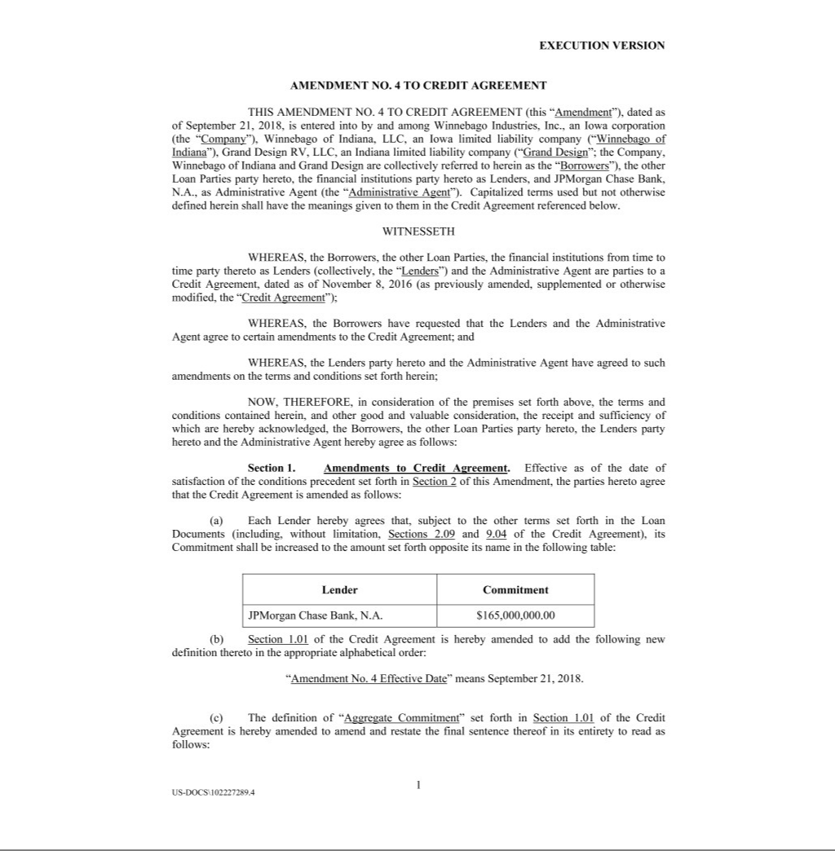

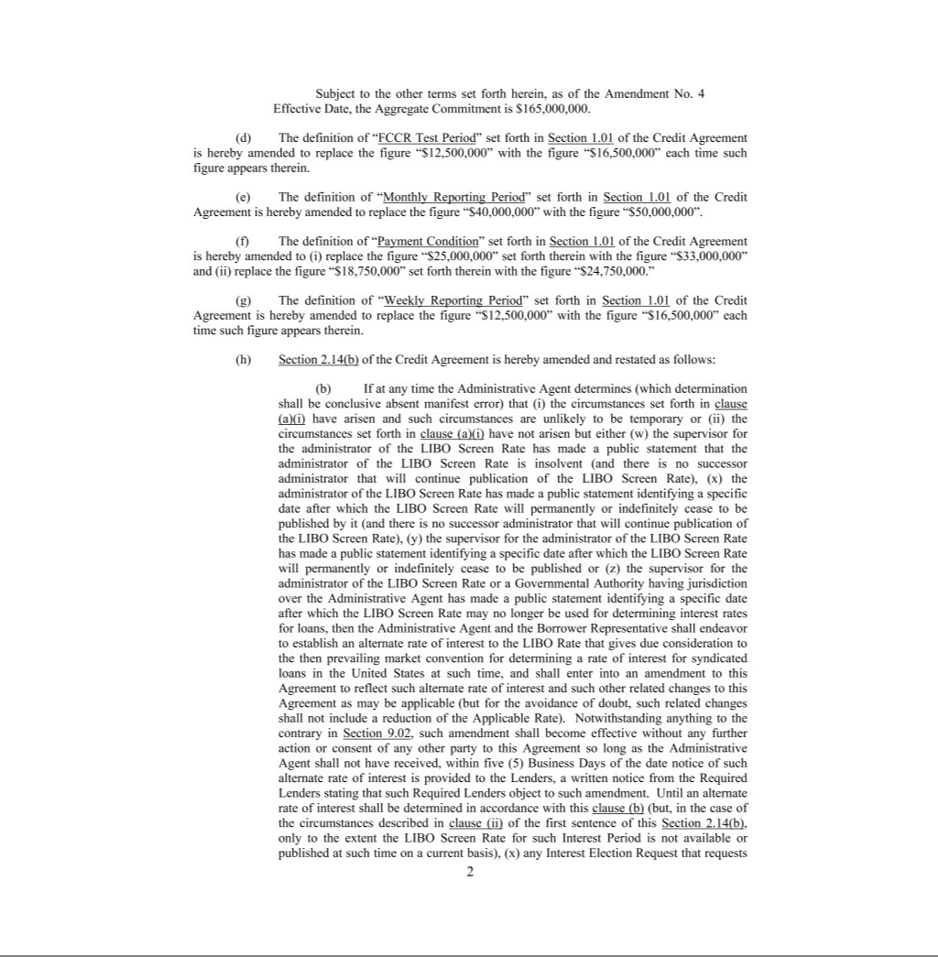

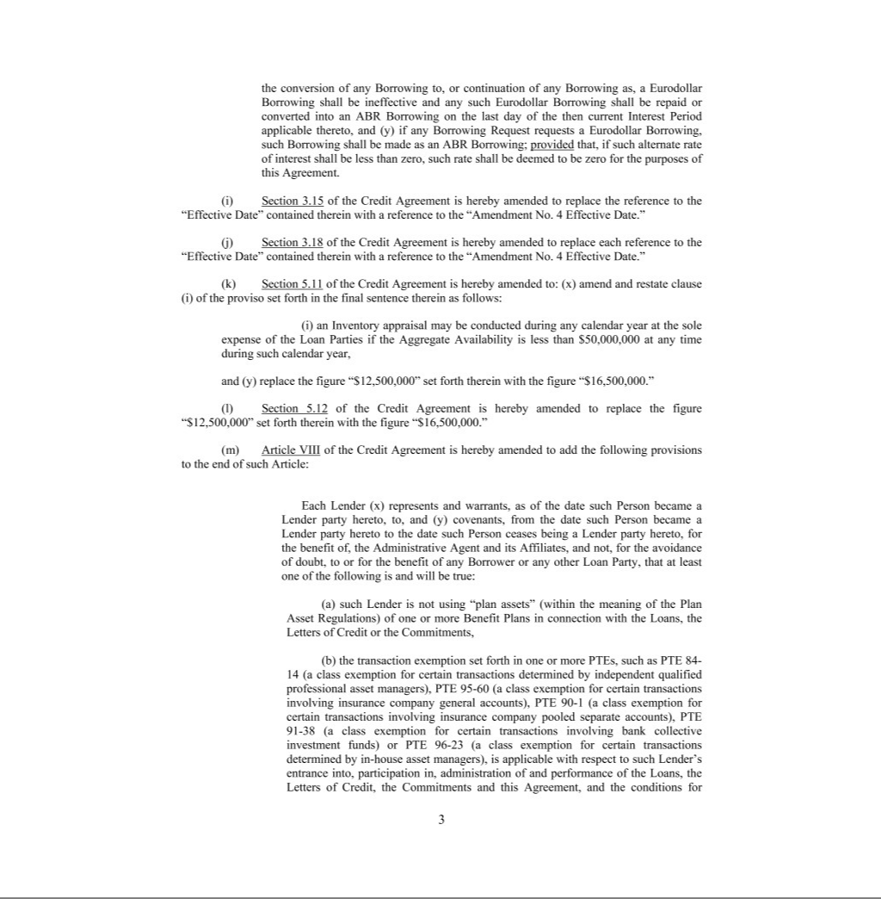

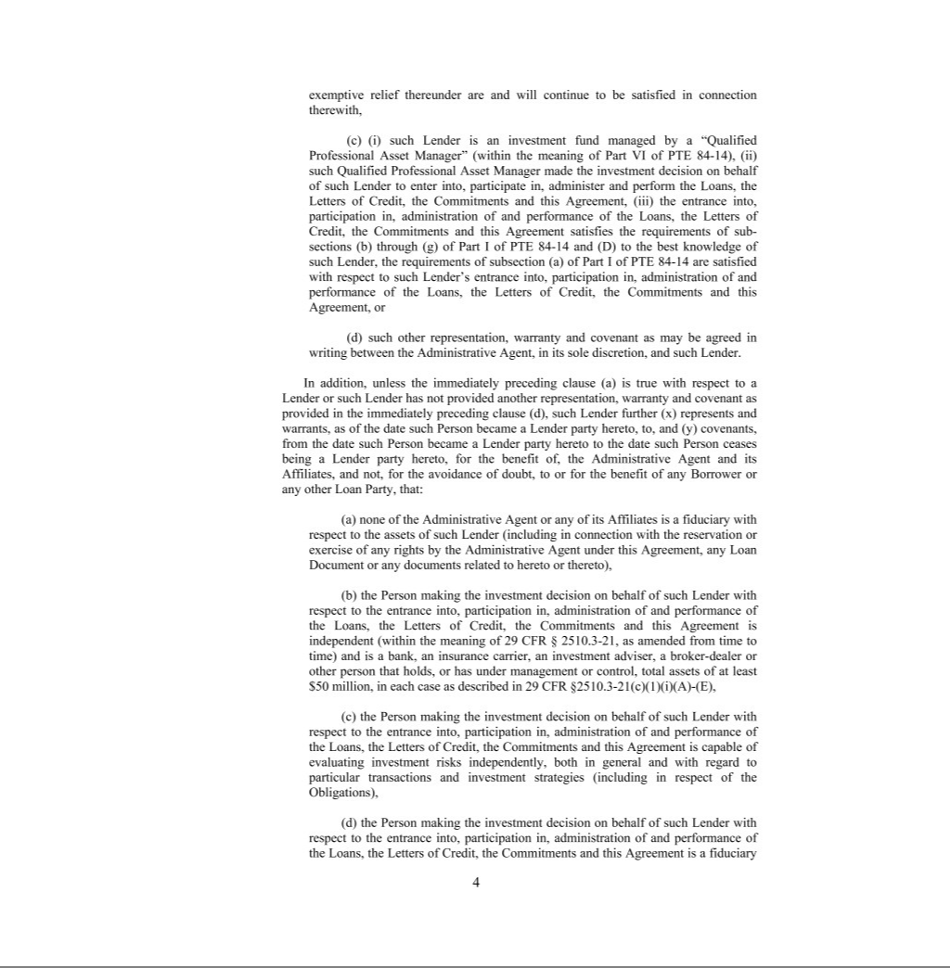

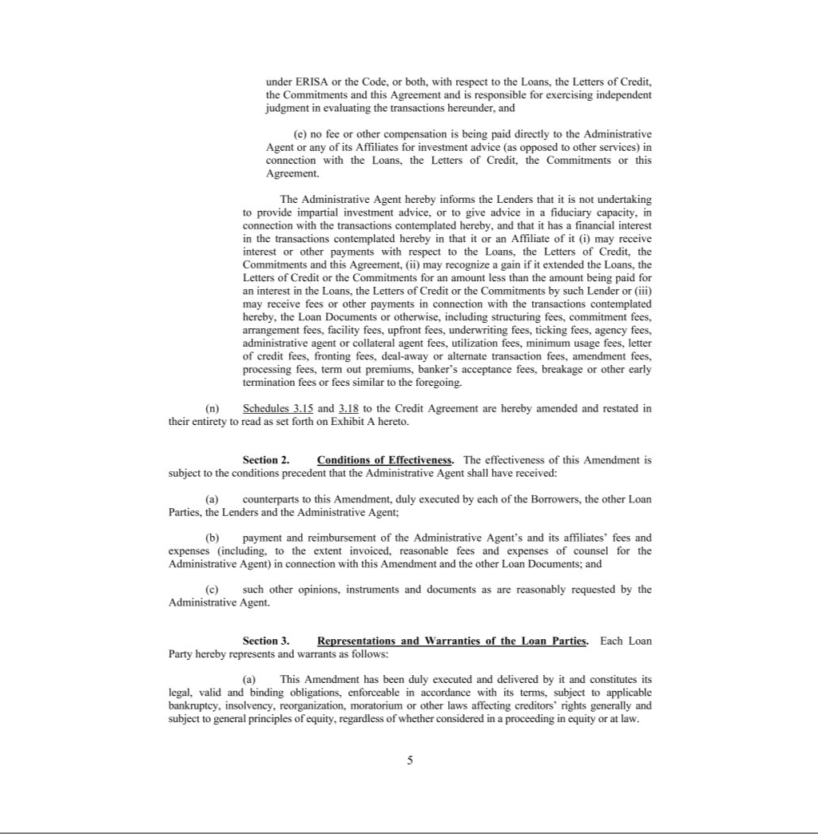

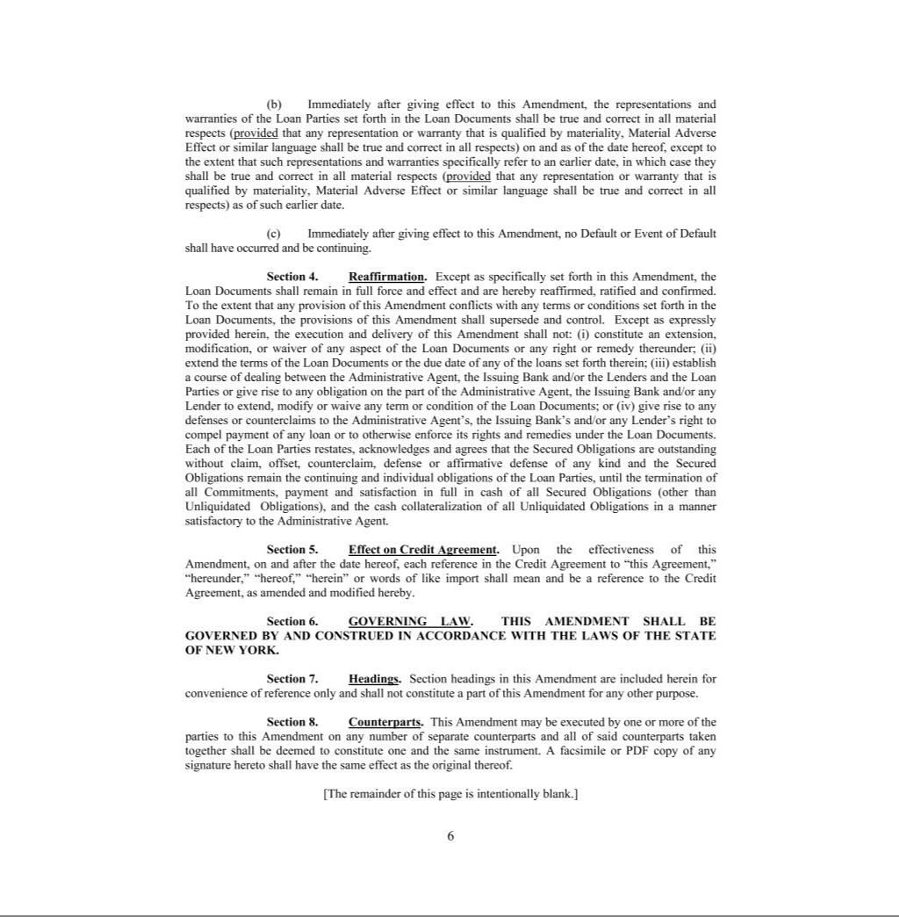

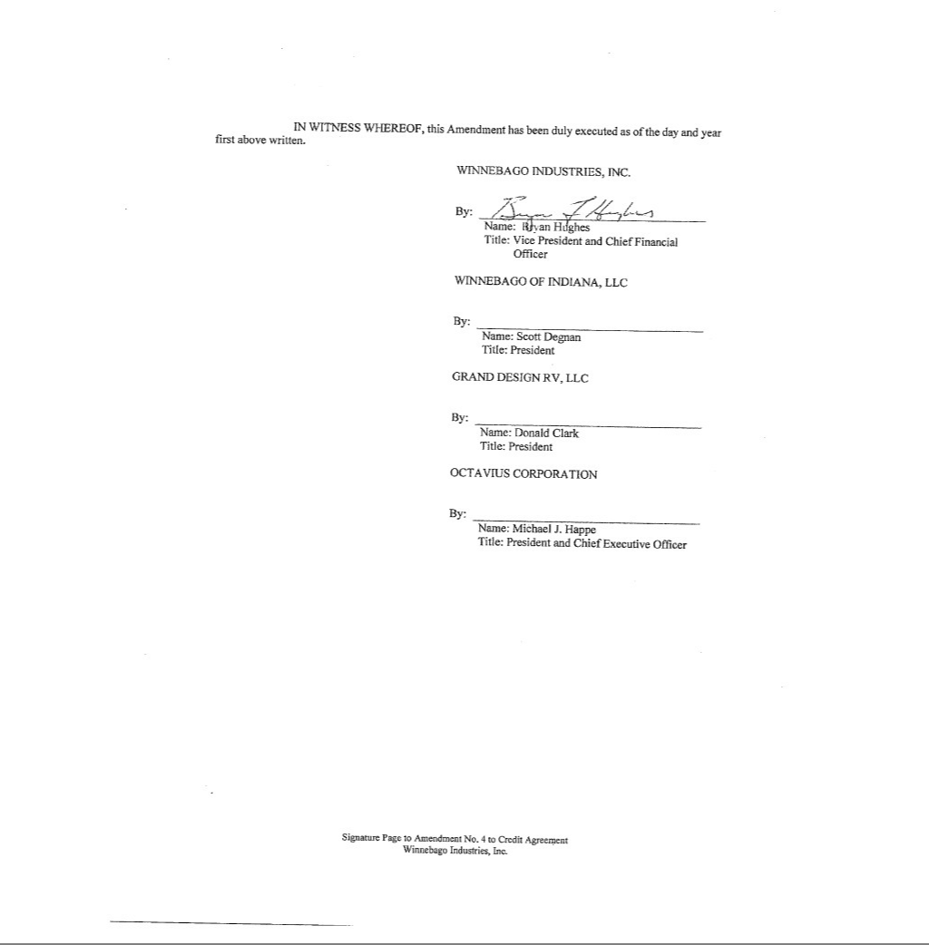

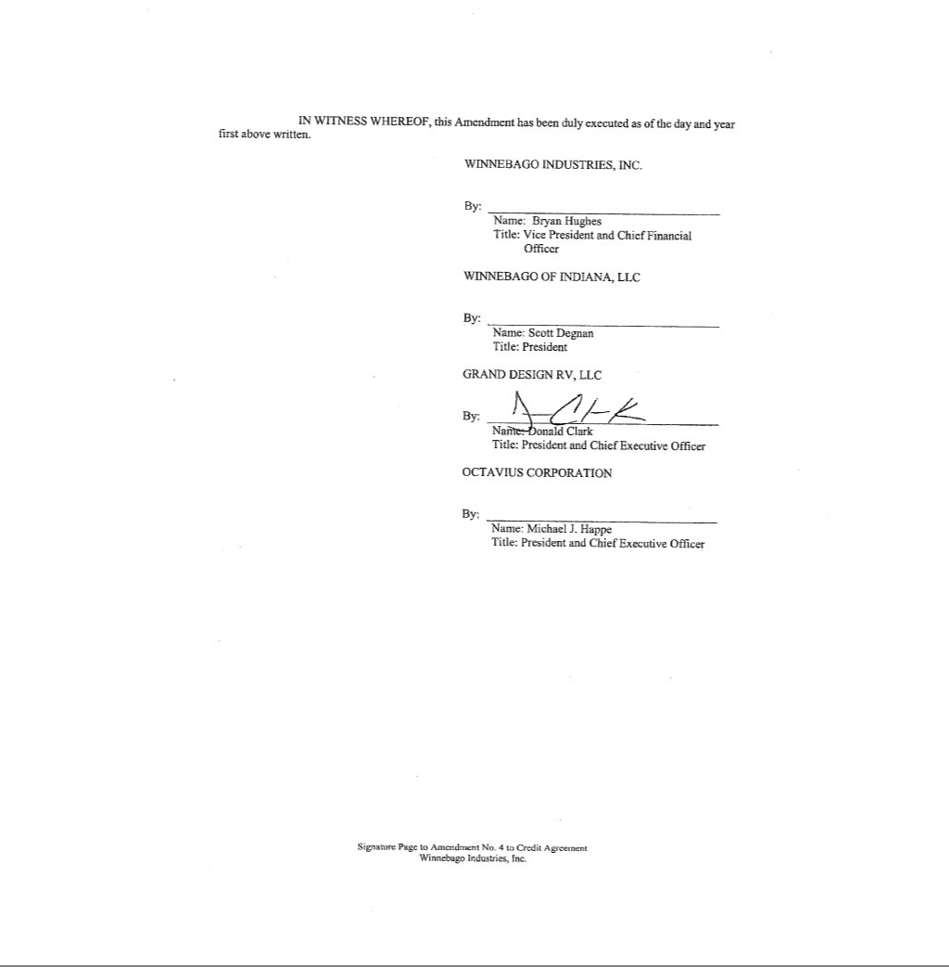

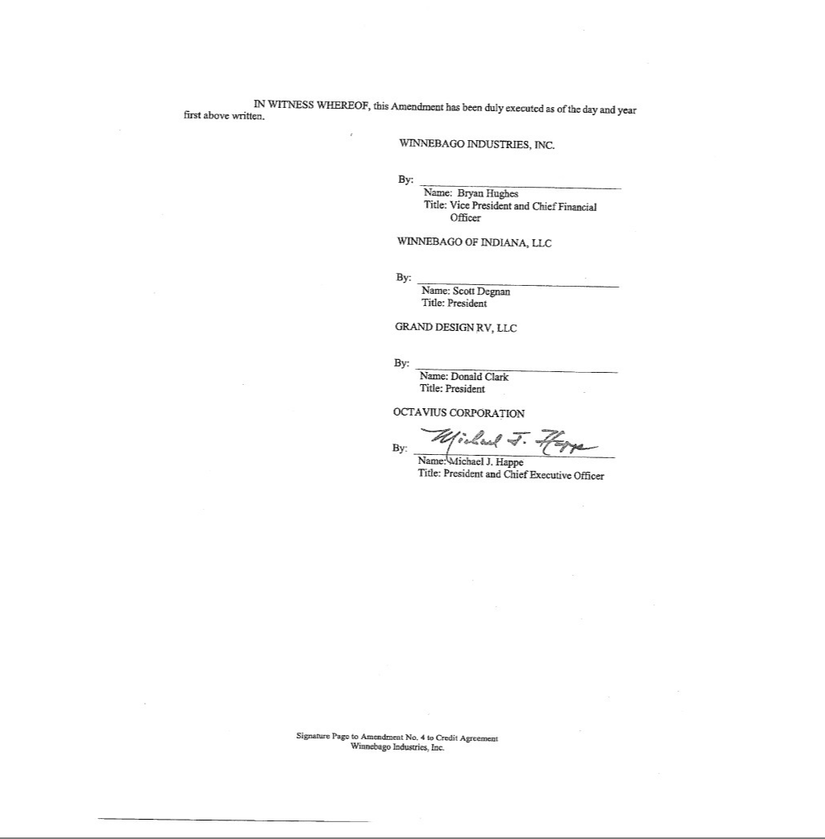

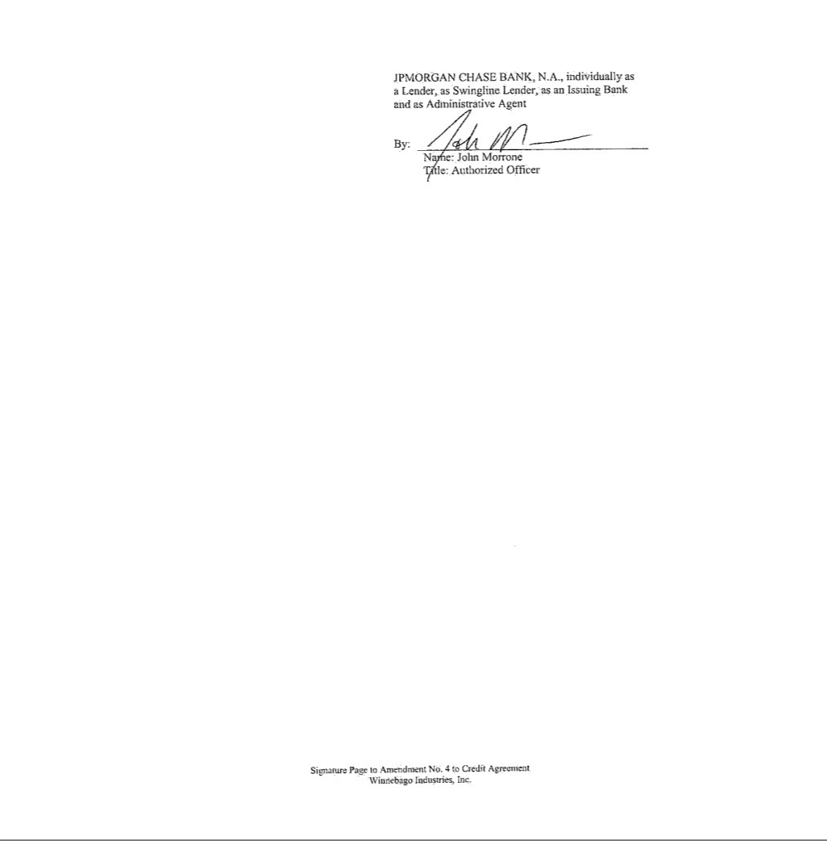



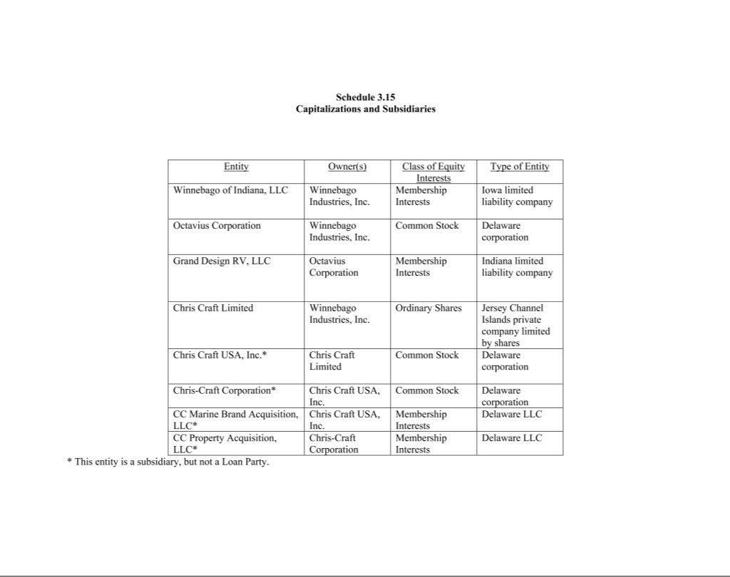

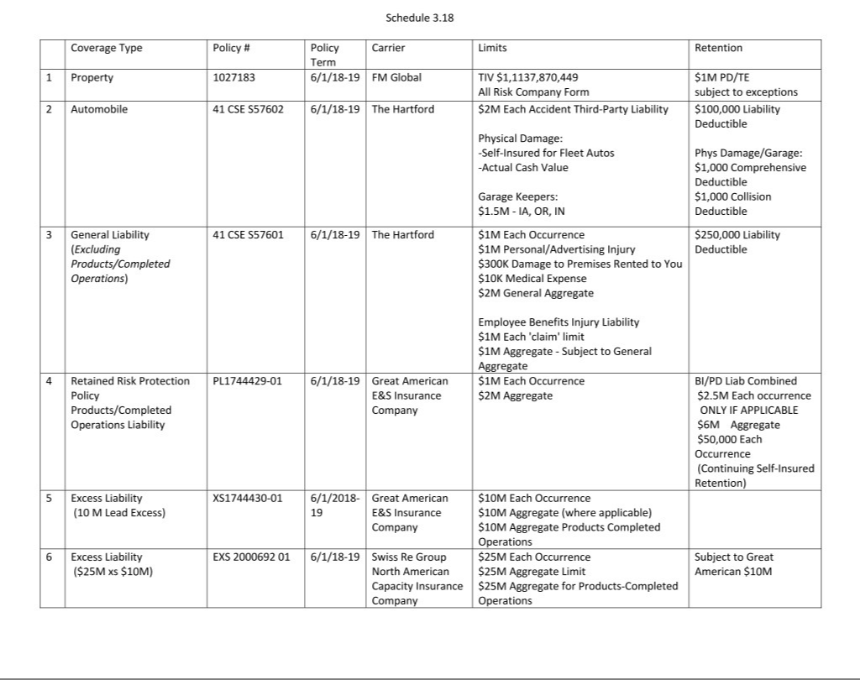

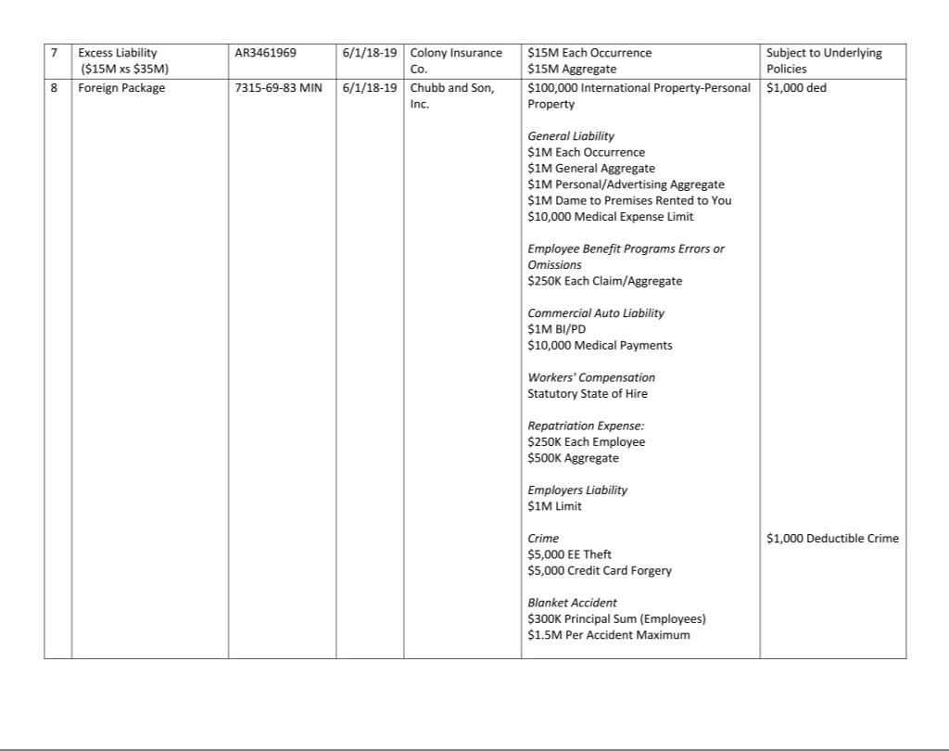

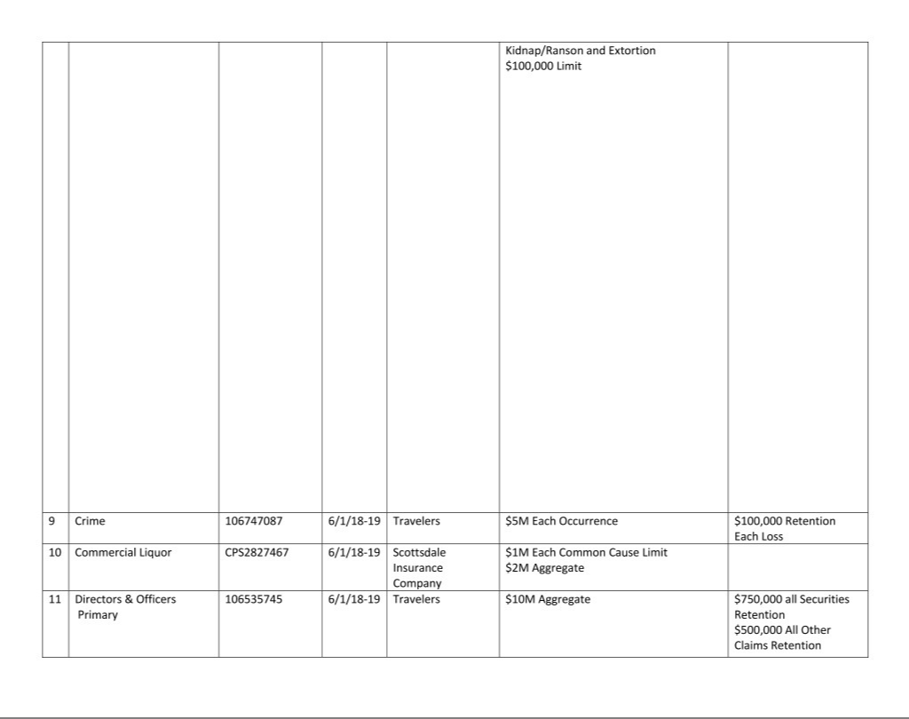

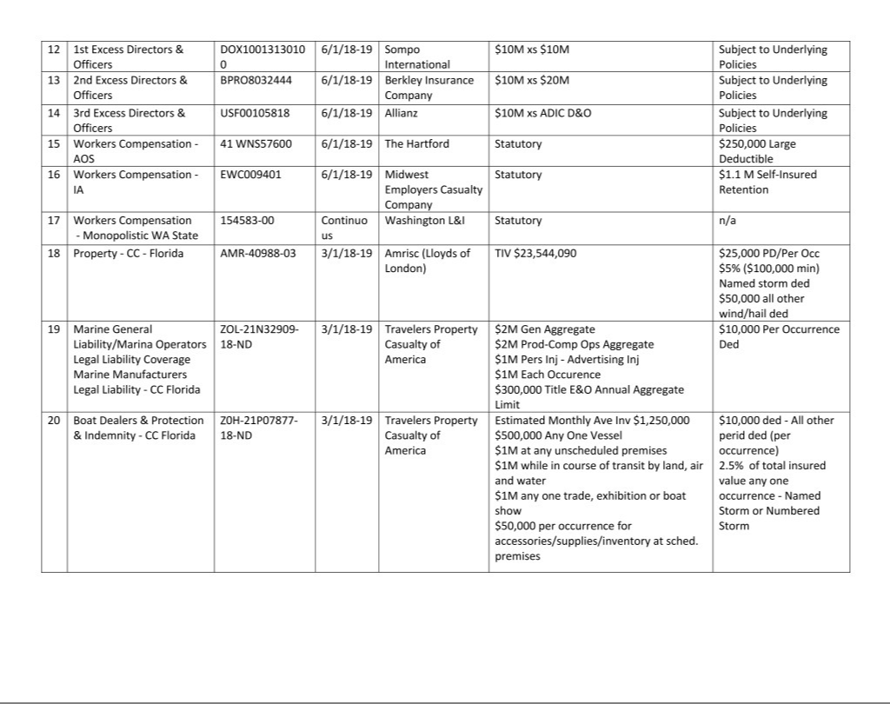

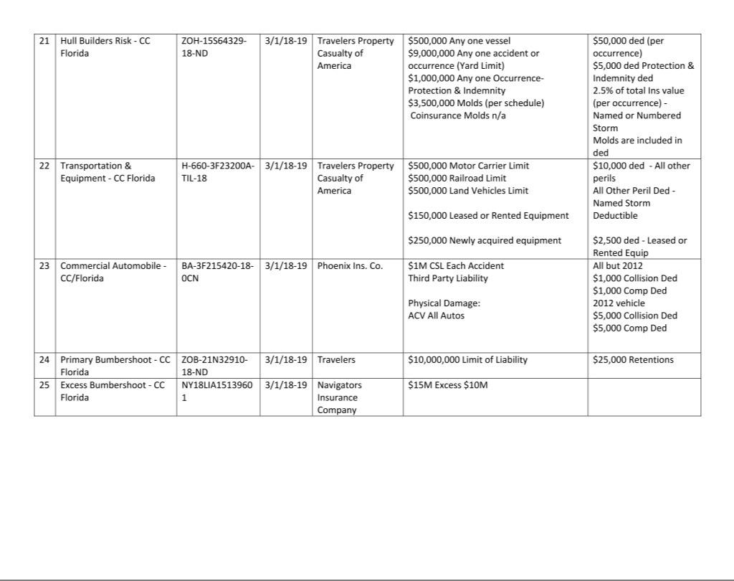

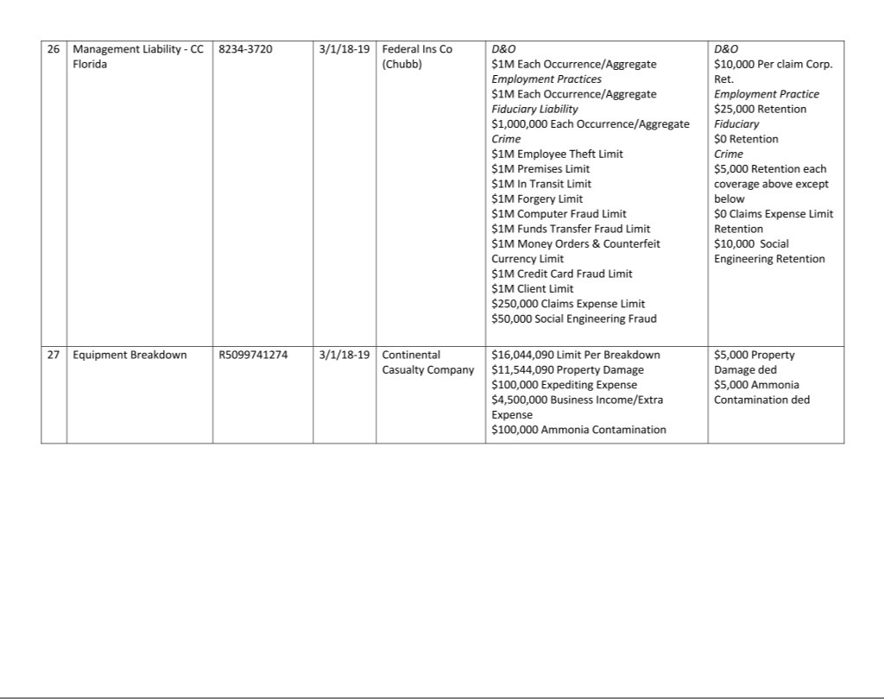

Exhibit 10b.

WINNEBAGO INDUSTRIES, INC.

2014 OMNIBUS EQUITY, PERFORMANCE AWARD, AND

INCENTIVE COMPENSATION PLAN

Non-Qualified Stock Option Agreement

Winnebago Industries, Inc. (the “Company”), pursuant to its 2014 Omnibus Equity, Performance Award, and Incentive Compensation Plan (the “Plan”), hereby grants a stock option award (the “Option”) to you, the Participant named below (the “Participant”). The terms and conditions of this Option Award are set forth in this Agreement (the “Agreement”), consisting of this cover page, the Option Terms and Conditions on the following pages, and in the Plan document, a copy of which has been provided to you. Any capitalized term that is used but not defined in this Agreement shall have the meaning assigned to it in the Plan as it currently exists or as it is amended in the future.


Name of Participant:_______________________

 | No. of Shares Covered: _______ |  |  |  | Grant Date: October 15, 2018
 | Exercise Price Per Share:$ ______ |  |  |  | Expiration Date: October 15, 2028
 | Vesting and Exercise Schedule:
 |  |  | Dates
 |  | October 15, 2019
 |  | October 15, 2020
 |  | October 15, 2021

By signing below or otherwise evidencing your acceptance of this Agreement in a manner approved by the Company, you agree to all of the terms and conditions contained in this Agreement and in the Plan document. You acknowledge that you have received and reviewed these documents and that they set forth the entire agreement between you and the Company regarding your right to purchase shares of the Company’s common stock pursuant to this Option.

PARTICIPANT: WINNEBAGO INDUSTRIES, INC.

By:

Title:

Exhibit 10b-1

WINNEBAGO INDUSTRIES, INC.

2014 OMNIBUS EQUITY, PERFORMANCE AWARD, AND

INCENTIVE COMPENSATION PLAN

Non-Qualified Stock Option Agreement

Terms and Conditions

- DEFINITIONS. For purposes of this Agreement, the definitions of terms contained in the Plan hereby are incorporated by reference, except to the extent that any such term is specifically defined in this Agreement.

“Cause” means, unless otherwise defined in a then-effective written agreement (including an Agreement) between a Participant and the Company or any Affiliate, a Participant’s

- material failure to perform satisfactorily the duties reasonably required of the Participant by the Company (other than by reason of Disability); (ii) material violation of any law, rule, regulation, court order or regulatory directive (other than traffic violations, misdemeanors or other minor offenses); (iii) material breach of the Company's business conduct or ethics code or of any fiduciary duty or nondisclosure, non-solicitation, non-competition or similar obligation owed to the Company or any Affiliate; (iv) engaging in any act or practice that involves personal dishonesty on the part of the Participant or demonstrates a willful and continuing disregard for the best interests of the Company and its Affiliates; or (v) engaging in dishonorable or disruptive behavior, practices or acts which would be reasonably expected to harm or bring disrepute to the Company or any of its Affiliates, their business or any of their customers, employees or vendors.

“Change in Control” means one of the following:

- An Exchange Act Person becomes the beneficial owner (within the meaning of Rule 13d-3 under the Exchange Act) of securities of the Company representing 30% or more of the combined voting power of the Company’s then outstanding Voting Securities, except that the following will not constitute a Change in Control:

  - any acquisition of securities of the Company by an Exchange Act Person from the Company for the purpose of providing financing to the Company;

  - any formation of a Group consisting solely of beneficial owners of the Company's Voting Securities as of the effective date of the Plan; or

  - any repurchase or other acquisition by the Company of its Voting Securities that causes any Exchange Act Person to become the beneficial owner of 30% or more of the Company’s Voting Securities.

If, however, an Exchange Act Person or Group referenced in clause (A), (B) or (C) above acquires beneficial ownership of additional Company Voting Securities after initially becoming the beneficial owner of 30% or more of the combined voting power of the Company’s Voting Securities by one of the means described in those clauses, then a Change in Control will be deemed to have occurred.

- Individuals who are Continuing Directors cease for any reason to constitute a majority of the members of the Board.

- A Corporate Transaction is consummated, unless, immediately following such Corporate Transaction, all or substantially all of the individuals and entities who were the beneficial owners of the Company's Voting Securities immediately prior to such Corporate Transaction beneficially own, directly or indirectly, more than 50% of the combined voting power of the then outstanding Voting Securities of the surviving or acquiring entity resulting from such Corporate Transaction (including beneficial ownership through any parent of such entity) in substantially the same proportions as their ownership, immediately prior to such Corporate Transaction, of the Company's Voting Securities.

“Continuing Director” means an individual (i) who is, as of the effective date of the Plan, a director of the Company, or (ii) who becomes a director of the Company after the effective date hereof and whose initial election, or nomination for election by the Company’s stockholders, was approved by at least a majority of the then Continuing Directors but excluding, for purposes of this clause (ii), an individual whose initial assumption of office occurs as the result of an actual or threatened proxy contest involving the solicitation of proxies or consents by a person or Group other than the Board, or by reason of an agreement intended to avoid or settle an actual or threatened proxy contest.

“Corporate Transaction” means (i) a sale or other disposition of all or substantially all of the assets of the Company, or (ii) a merger, consolidation, share exchange or similar transaction involving the Company, regardless of whether the Company is the surviving entity.

“Exchange Act Person” means any natural person, entity or Group other than (i) the Company or any Affiliate; (ii) any employee benefit plan (or related trust) sponsored or maintained by the Company or any Affiliate; (iii) an underwriter temporarily

Exhibit 10b-2

holding securities in connection with a registered public offering of such securities; or (iv) an entity whose voting securities are beneficially owned by the beneficial owners of the Company’s voting securities in substantially the same proportions as their beneficial ownership of the Company’s voting securities.

“Good Reason” shall have the meaning set forth in the Participant’s change in control agreement, if applicable.

“Group” means two or more persons who act, or agree to act together, as a partnership, limited partnership, syndicate or other group for the purpose of acquiring, holding, voting or disposing of securities of the Company.

“Service” means provision of services to the Company or any Affiliate in any Service Provider capacity. The Participant’s Service shall be deemed to have terminated either upon an actual cessation of providing services to the Company or any Affiliate or upon the entity to which the Participant provides services ceasing to be an Affiliate. Service shall not be deemed terminated in the case of (i) any approved leave of absence; (ii) the Participant’s transfer among the Company and any Affiliates in any Service Provider capacity; or (iii) any change in the Participant’s status so long as the Participant remains in the service of the Company or any Affiliate in any Service Provider capacity.

“Service Provider” means an Employee, a non-employee director, or any natural person who is a consultant or advisor, or is employed by a consultant or advisor retained by the Company or any Affiliate, and who provides services (other than in connection with (i) a capital-raising transaction or (ii) promoting or maintaining a market in Company securities) to the Company or any Affiliate.

“Voting Securities” of an entity means the outstanding equity securities (or comparable equity interests) entitled to vote generally in the election of directors of such entity.

- Vesting and Exercisability of Option.

  - Scheduled Vesting. This Option will vest and become exercisable as to the number of Shares and on the dates specified in the Vesting and Exercise Schedule on the cover page to this Agreement, so long as the Participant’s Service to the Company does not end. The Vesting and Exercise Schedule is cumulative, meaning that to the extent the Option has not already been exercised and has not expired or been terminated or cancelled, the Participant or the person otherwise entitled to exercise the Option as provided in this Agreement may at any time purchase all or any portion of the Shares subject to the vested portion of the Option. This Option shall not be exercisable under any circumstances after the expiration of ten (10) years from the date this option is granted.

  - Accelerated Vesting. Vesting and exercisability of this Option will be accelerated during the term of the Option under the circumstances described in Section 11 of the Plan. If the Participant’s Service terminates prior to the final scheduled vesting date specified in the Vesting and Exercise Schedule on the cover page to this Agreement due to the Participant’s death or Disability, then any unvested portion of the Option subject to this Agreement shall vest as of such termination date.

- Intentionally Omitted.

- Expiration. This vested and exercisable portions of this Option will expire and will no longer be exercisable at 5:00 p.m. Central Time on the earliest of:

  - The ten (10) year anniversary of the date this option is granted;

  - Upon the Participant’s termination of employment for Cause;

  - Upon the one year anniversary of the date of the Participant’s termination of Service due to death or Disability;

  - Upon the three month anniversary of the date of the Participant’s termination of Service due to any reason other than Cause, death or Disability; or

  - The date (if any) fixed for termination or cancellation of this Option pursuant to Section 11 of the Plan.

- METHOD OF EXERCISING THE OPTION.

  - Minimum Shares. This Option may be exercised in whole or in part, but not for less than 100 shares at any one time, unless fewer than 100 Shares are then purchasable under the Option and the Option is then being exercised as to all such Shares.

  - Written Notice. This Option may be exercised only by Participant or Participant’s legal representative as provided for in the Plan. This Option may be exercised by giving written notice to the Company, addressed to the attention of the Secretary of the Company. Such notice shall be in such form as may be approved by the Company and shall state, among other things, the number of shares of Common Stock to be purchased, and must be signed or otherwise authenticated by the Participant or Participant’s legal representative entitled to exercise the Option and, if being exercised by any person other than Participant, be accompanied by proof, satisfactory to counsel for the Company, of the right of such person to exercise the Option. After the Participant has obtained approval from the Secretary of the Company to exercise some or all of the Option, he or she is required to deliver an

Exhibit 10b-3

electronic notice of exercise to the third-party stock plan administrator retained by the Company (which electronic notice will be in such form as may be approved by the Company, including (but not limited to) the following information: the number of shares of Common Stock to be purchased, the person(s) in whose name the stock certificate for the Shares is to be registered together with other identifying information relating to such holder, and the manner in which the exercise price will be paid). The electronic notice must be authenticated by the person exercising this Option.

- Payment of Exercise Price. The Exercise Price plus any applicable withholding or other compensation taxes, commissions and fees payable upon exercise of all or any portion of the Shares subject to this Option shall be payable to the Company in full through one or a combination of the following methods:

  - “Cash Transfer” from the Participant’s stock brokerage account at least 2 days prior to event, the Participant shall submit payment of the aggregate amount of the Exercise Price as well as all applicable withholding or other compensation taxes, commissions and fees to his or her brokerage account to cover costs; and/or
  - “Share Withholding” whereby the Participant authorizes the Company to retain, from the total number of Shares as to which the Option is being exercised, that number of Shares having a Fair Market Value on the date of exercise equal to the aggregate exercise price and the amount of any compensation taxes, commissions and fees
due relating to such exercise.

In the event the Participant does not elect a payment method, the “Share Withholding” method shall apply automatically.

  - Withholding Taxes. The Participant may not exercise this Option in whole or in part unless the Participant makes arrangements acceptable to the Company for payment of any federal, state, local or foreign withholding taxes that may be due as a result of the exercise of this Option. Withholding taxes shall be payable by the Participant in accordance with the election(s) he or she makes pursuant to Section 5(c) above. Delivery of Shares upon exercise of this Option is subject to the satisfaction of applicable withholding tax obligations.

  - Transfer of Shares. As promptly as practicable after receipt of such written notice, required representations, and payment, the Company shall cause to be issued and delivered to the Participant or Participant’s legal representative, electronic transfer of such shares so purchased, registered in the name as specified in the written notice and endorsed with any appropriate restrictive legends in the Participant’s stock plan account.

- TRANSFERABILITY OF OPTION. This Option may not be sold, transferred, pledged, assigned or otherwise alienated or hypothecated, other than by will or by the laws of descent and distribution. In the event of the death of Participant, the Company shall deliver this Option and/or amounts payable to the executor or administrator of Participant’s estate or, if no executor or administrator has been appointed to the knowledge of the Company, the Company, it its sole discretion, may deliver this Option and/or amounts payable to the spouse or to any one or more dependents or relatives of Participant, or if no spouse, dependent may designate. This Option shall not be subject to any levy, attachment execution or similar process. In the event of any transfer or levy of process upon the rights or interests hereby conferred, the Company may terminate this Option by written notice to Participant and it shall thereupon become null and void. This Agreement shall be binding upon the beneficiaries and legal representative of Participant.

- ADDITIONAL RESTRICTIONS ON EXERCISE. This Option may not be exercised if the issuance of shares upon such exercise would constitute a violation of any applicable federal or state securities or other law or regulation, including, without limitation, the Internal Revenue Code of 1986, as amended, or regulations promulgated thereunder, or Section 16(b) of the Securities Exchange Act of 1934, as amended. As a condition to the exercise of this Option, the Company may require the person exercising this Option to make any representation or warranty to the Company as may be required by applicable law or regulation or other restriction or agreement binding upon or otherwise affecting the Shares of the Company.

- CHANGE OF CONTROL. Pursuant to the terms of the Plan, the provisions of Section 11 of the Plan are hereby superseded for purposes of this Agreement by the provisions set forth on Appendix A attached hereto.

- NOTICE. Every notice or other communication relating to this Agreement shall be in writing and shall be mailed to or delivered (including electronically) to the party for whom it is intended at such address as may from time to time be designated by it in a notice mailed or delivered to the other party as herein provided. Unless and until some other address is so designated, all notices or communications by the Participant to the Company shall be mailed or delivered to the Company, to the attention of its Vice President, General Counsel and Secretary, at its office at 13200 Pioneer Trail, Eden Prairie, MN 55347, slbogart@winnebagoind.com, and all notices or communications by the Company to the Participant may be given to the Participant personally or may be mailed or, if the Participant is still a Service Provider, emailed to the Participant at the address indicated in the Company's records as the Participant’s most recent mailing or email address.

- Additional Provisions.

  - No Right to Continued Service. This Agreement does not give the Participant a right to continued Service with the Company or any Affiliate, and the Company or any such Affiliate may terminate the Participant’s Service at any time and otherwise deal with the Participant without regard to the effect it may have upon the Participant under this Agreement.

Exhibit 10b-4

- Governing Plan Document. This Agreement and the Award are subject to all the provisions of the Plan, and to all interpretations, rules and regulations which may, from time to time, be adopted and promulgated by the Committee pursuant to the Plan. If there is any conflict between the provisions of this Agreement and the Plan, the provisions of the Plan will govern.

- Governing Law. This Agreement, the parties’ performance hereunder, and the relationship between them shall be governed by, construed, and enforced in accordance with the laws of the State of Iowa, without giving effect to the choice of law principles thereof.

- Severability. The provisions of this Agreement shall be severable and if any provision of this Agreement is found by any court to be unenforceable, in whole or in part, the remainder of this Agreement shall nevertheless be enforceable and binding on the parties. The Participant also agrees that any trier of fact may modify any invalid, overbroad or unenforceable provision of this Agreement so that such provision, as modified, is valid and enforceable under applicable law.

- Binding Effect. This Agreement will be binding in all respects on the Participant’s heirs, representatives, successors and assigns, and on the successors and assigns of the

Company.

- Electronic Delivery and Acceptance. The Company may deliver any documents related to this Option by electronic means and request the Participant’s acceptance of this Agreement by electronic means. The Participant hereby consents to receive all applicable documentation by electronic delivery and to participate in the Plan through an on-line (and/or voice activated) system established and maintained by the Company or the Company’s third-party stock plan administrator.

By signing the cover page of this Agreement or otherwise accepting this Agreement in a manner approved by the Company, you agree to all the terms and conditions described above and in the Plan document.

Exhibit 10b-5

APPENDIX A

- Corporate Transactions; Change in Control. The following provisions shall apply to outstanding Awards in the event of a Change in Control that involves a Corporate Transaction.

(a)(1) Continuation, Assumption or Replacement of Awards. In the event of a Corporate Transaction, then the surviving or successor entity (or its parent) may continue, assume or replace Awards outstanding as of the date of the Corporate Transaction (with such adjustments as may be required or permitted by Section 17), and such Awards or replacements therefor shall remain outstanding and be governed by their respective terms, subject to Section 11(a)(4) below. A surviving or successor entity may elect to continue, assume or replace only some Awards or portions of Awards. For purposes of this Section 11(a)(1), an Award shall be considered assumed or replaced if, in connection with the Corporate Transaction and in a manner consistent with Code Section 409A (and Code Section 424 if the Award is an ISO), either (i) the contractual obligations represented by the Award are expressly assumed by the surviving or successor entity (or its Parent) with appropriate adjustments to the number and type of securities subject to the Award and the exercise price thereof that preserves the intrinsic value of the Award existing at the time of the Corporate Transaction, or (ii) the Participant has received a comparable equity-based award that preserves the intrinsic value of the Award existing at the time of the Corporate Transaction and contains terms and conditions that are substantially similar to those of the Award. To the extent vesting of any Award continued, assumed or replaced under this Section 11(a)(1) is subject to satisfaction of specified performance goals, those goals shall be deemed to be achieved as of the date of the Corporate Transaction at the target level of performance, or, in the discretion of the Committee, at the actual level of performance (if determinable), and such Awards shall continue to be subject to any continuing service requirements.

  - Acceleration. If and to the extent that outstanding Awards under the Plan are not continued, assumed or replaced in connection with a Corporate Transaction, then (i) all outstanding Option and SAR Awards shall become fully vested and exercisable for such period of time prior to the effective time of the Corporate Transaction as is deemed fair and equitable by the Committee, and shall terminate at the effective time of the Corporate Transaction, (ii) all outstanding Stock Awards shall fully vest immediately prior to the effective time of the Corporate Transaction, and (iii) to the extent vesting of any Award is subject to satisfaction of specified performance goals, such Award shall be deemed “fully vested” for purposes of this Section 11(a)(2) at the greater of target level of performance or actual level of performance (if determinable) and the vested portion of the Award at that level of performance is proportionate to the portion of the performance period that has elapsed as of the effective time of the Corporate Transaction. The Committee shall provide written notice of the period of accelerated exercisability of Option and SAR Awards to all affected Participants. The exercise of any Option or SAR Award whose exercisability is accelerated as provided in this Section 11(a)(2) shall be conditioned upon the consummation of the Corporate Transaction and shall be effective only immediately before such consummation.

  - Payment for Awards. If and to the extent that outstanding Awards under the Plan are not continued, assumed or replaced in connection with a Corporate Transaction, then the Committee may provide that some or all of such outstanding Awards shall be canceled at or immediately prior to the effective time of the Corporate Transaction in exchange for payments to the holders as provided in this Section 11(a)(3). The Committee will not be required to treat all Awards similarly for purposes of this Section 11(a)(3). The payment for any Award canceled shall be in an amount equal to the difference, if any, between (i) the fair market value (as determined in good faith by the Committee) of the consideration that would otherwise be received in the Corporate Transaction for the number of Shares subject to the Award, and (ii) the aggregate exercise price (if any) for the Shares subject to such Award. If the amount determined pursuant to the preceding sentence is not a positive number with respect to any Award, such Award may be canceled pursuant to this Section 11(a)(3) without payment of any kind to the affected Participant. With respect to an Award whose vesting is subject to the satisfaction of specified performance goals, the number of Shares subject to such an Award for purposes of this Section 11(a)(3) shall be the number of Shares as to which the Award would have been deemed “fully vested” for purposes of Section 11(a)(2). Payment of any amount under this Section 11(a)(3) shall be made in such form, on such terms and subject to such conditions as the Committee determines in its discretion, which may or may not be the same as the form, terms and conditions applicable to payments to the Company’s stockholders in connection with the Corporate Transaction, and may, in the Committee’s discretion, include subjecting such payments to vesting conditions comparable to those of the Award canceled, subjecting such payments to escrow or holdback terms comparable to those imposed upon the Company’s stockholders under the Corporate Transaction, or calculating and paying the present value of payments that would otherwise be subject to escrow or holdback terms.

  - Termination After a Corporate Transaction. If and to the extent that Awards are continued, assumed or replaced under the circumstances described in Section 11(a)(1), and if within twenty-four (24) months after the Corporate Transaction a Participant experiences an involuntary termination of Service for reasons other than Cause, or terminates his or her Service for Good Reason, then (i) outstanding Option and SAR Awards issued to the Participant that are not yet fully exercisable shall immediately become exercisable in full and shall remain exercisable for one year following the Participant’s termination of employment, and (ii) any Stock Awards that are not yet fully vested shall immediately vest in full.

- Other Change in Control. In the event of a Change in Control that does not involve a Corporate Transaction, if within twenty-four (24) months after the Change in Control a Participant experiences an involuntary termination of Service for reasons other than Cause, or terminates his or her Service for Good Reason, then (i) outstanding Option and SAR Awards issued to the Participant that are not yet fully exercisable shall immediately become fully vested and exercisable and shall remain exercisable for one year following the Participant’s termination of employment, (ii) any Stock Awards that are not yet fully vested shall immediately

Exhibit 10b-6

vest in full, and (iii) to the extent vesting of any Award is subject to satisfaction of specified performance goals, such Award shall be deemed “fully vested” for purposes of this Section 11(b) at the greater of target level of performance or actual level of performance (if determinable) and the vested portion of the Award at that level of performance is proportionate to the portion of the performance period that has occurred up to the date of such Participant’s termination of Service.

- Dissolution or Liquidation. Unless otherwise provided in an applicable Agreement, in the event of a proposed dissolution or liquidation of the Company, the Committee will notify each Participant as soon as practicable prior to the effective date of such proposed transaction. An Award will terminate immediately prior to the consummation of such proposed action.

Exhibit 10b-7

Exhibit 10c.

WINNEBAGO INDUSTRIES, INC.

2014 OMNIBUS EQUITY, PERFORMANCE AWARD, AND

INCENTIVE COMPENSATION PLAN

Restricted Stock Unit Award Agreement (Executives)

Winnebago Industries, Inc. (the “Company”), pursuant to its 2014 Omnibus Equity, Performance Award, and Incentive Compensation Plan (the “Plan”), hereby grants an award of Restricted Stock Units to you, the Participant named below. The terms and conditions of this Award are set forth in this Restricted Stock Unit Award Agreement (the “Agreement”), consisting of this cover page and the Terms and Conditions on the following pages, and in the Plan document, a copy of which has been provided to you. Any capitalized term that is used but not defined in this Agreement shall have the meaning assigned to it in the Plan as it currently exists or as it is amended in the future.


Name of Participant:_______________________

Number of Restricted Stock Units: _______ |  |  |  | Grant Date:October 15, 2018
Vesting Schedule:
 | Scheduled Vesting Dates |  |  |  | Number of Restricted Stock Units that Vest
 |  | October 15, 2019
 |  | October 15, 2020
 |  | October 15, 2021

By signing below or otherwise evidencing your acceptance of this Agreement in a manner approved by the Company, you agree to all of the terms and conditions contained in this Agreement and in the Plan document. You acknowledge that you have received and reviewed these documents.

PARTICIPANT: WINNEBAGO INDUSTRIES, INC.

By:

Title:

Exhibit 10c-1

WINNEBAGO INDUSTRIES, INC.

2014 OMNIBUS EQUITY, PERFORMANCE AWARD AND

INCENTIVE COMPENSATION PLAN

Restricted Stock Unit Award Agreement (Executives)

Terms and Conditions

- Defined Terms. For purposes of this Agreement, the definitions of terms contained in the Plan hereby are incorporated by reference, except to the extent that any such term is specifically defined in this Agreement.

“Cause” means, unless otherwise defined in a then-effective written agreement (including an Agreement) between a Participant and the Company or any Affiliate, a Participant’s

- material failure to perform satisfactorily the duties reasonably required of the Participant by the Company (other than by reason of Disability); (ii) material violation of any law, rule, regulation, court order or regulatory directive (other than traffic violations, misdemeanors or other minor offenses); (iii) material breach of the Company's business conduct or ethics code or of any fiduciary duty or nondisclosure, non-solicitation, non-competition or similar obligation owed to the Company or any Affiliate; (iv) engaging in any act or practice that involves personal dishonesty on the part of the Participant or demonstrates a willful and continuing disregard for the best interests of the Company and its Affiliates; or (v) engaging in dishonorable or disruptive behavior, practices or acts which would be reasonably expected to harm or bring disrepute to the Company or any of its Affiliates, their business or any of their customers, employees or vendors.

“Change in Control” means one of the following:

- An Exchange Act Person becomes the beneficial owner (within the meaning of Rule 13d-3 under the Exchange Act) of securities of the Company representing 30% or more of the combined voting power of the Company’s then outstanding Voting Securities, except that the following will not constitute a Change in Control:

  - any acquisition of securities of the Company by an Exchange Act Person from the Company for the purpose of providing financing to the Company;

  - any formation of a Group consisting solely of beneficial owners of the Company's Voting Securities as of the effective date of the Plan; or

  - any repurchase or other acquisition by the Company of its Voting Securities that causes any Exchange Act Person to become the beneficial owner of 30% or more of the Company’s Voting Securities.

If, however, an Exchange Act Person or Group referenced in clause (A), (B) or (C) above acquires beneficial ownership of additional Company Voting Securities after initially becoming the beneficial owner of 30% or more of the combined voting power of the Company’s Voting Securities by one of the means described in those clauses, then a Change in Control will be deemed to have occurred.

- Individuals who are Continuing Directors cease for any reason to constitute a majority of the members of the Board.

- A Corporate Transaction is consummated, unless, immediately following such Corporate Transaction, all or substantially all of the individuals and entities who were the beneficial owners of the Company's Voting Securities immediately prior to such Corporate Transaction beneficially own, directly or indirectly, more than 50% of the combined voting power of the then outstanding Voting Securities of the surviving or acquiring entity resulting from such Corporate Transaction (including beneficial ownership through any parent of such entity) in substantially the same proportions as their ownership, immediately prior to such Corporate Transaction, of the Company's Voting Securities.

“Continuing Director” means an individual (i) who is, as of the effective date of the Plan, a director of the Company, or (ii) who becomes a director of the Company after the effective date hereof and whose initial election, or nomination for election by the Company’s stockholders, was approved by at least a majority of the then Continuing Directors but excluding, for purposes of this clause (ii), an individual whose initial assumption of office occurs as the result of an actual or threatened proxy contest involving the solicitation of proxies or consents by a person or Group other than the Board, or by reason of an agreement intended to avoid or settle an actual or threatened proxy contest.

“Corporate Transaction” means (i) a sale or other disposition of all or substantially all of the assets of the Company, or (ii) a merger, consolidation, share exchange or similar transaction involving the Company, regardless of whether the Company is the surviving entity.

“Exchange Act Person” means any natural person, entity or Group other than (i) the Company or any Affiliate; (ii) any employee benefit plan (or related trust) sponsored or maintained by the Company or any Affiliate; (iii) an underwriter temporarily holding securities in connection with a registered public offering of such securities; or (iv) an entity whose Voting Securities are

Exhibit 10c-2

beneficially owned by the beneficial owners of the Company’s Voting Securities in substantially the same proportions as their beneficial ownership of the Company’s Voting Securities.

“Good Reason” shall have the meaning set forth in your change in control agreement, if applicable.

“Group” means two or more persons who act, or agree to act together, as a partnership, limited partnership, syndicate or other group for the purpose of acquiring, holding, voting or disposing of securities of the Company.

“Service” means your provision of services to the Company or any Affiliate in any Service Provider capacity. Your Service shall be deemed to have terminated either upon an actual cessation of providing services to the Company or any Affiliate or upon the entity to which you provide services ceasing to be an Affiliate. Service shall not be deemed terminated in the case of (i) any approved leave of absence; (ii) your transfer among the Company and any Affiliates in any Service Provider capacity; or (iii) any change in your status so long as you remain in the service of the Company or any Affiliate in any Service Provider capacity.

“Service Provider” means an Employee, a non-employee director, or any natural person who is a consultant or advisor, or is employed by a consultant or advisor retained by the Company or any Affiliate, and who provides services (other than in connection with (i) a capital-raising transaction or (ii) promoting or maintaining a market in Company securities) to the Company or any Affiliate.

“Voting Securities” of an entity means the outstanding equity securities (or comparable equity interests) entitled to vote generally in the election of directors of such entity.

- Grant of Restricted Stock Units. The Company hereby confirms the grant to you, as of the Grant Date and subject to the terms and conditions in this Agreement and the Plan, of the number of Restricted Stock Units specified on the cover page of this Agreement (the “Units”). Each Unit represents the right to receive one share of the Company’s Common Stock (each, a “Share”). Prior to their settlement or forfeiture in accordance with the terms of this Agreement, the Units granted to you will be credited to an account in your name maintained by the Company. This account shall be unfunded and maintained for book-keeping purposes only, with the Units simply representing an unfunded and unsecured contingent obligation of the Company.

- Restrictions Applicable to Units. Neither this Award nor the Units subject to this Award may be sold, assigned, transferred, exchanged or encumbered, voluntarily or involuntarily, other than a transfer upon your death in accordance with your will, by the laws of descent and distribution or pursuant to a beneficiary designation submitted in accordance with the Plan. Following any such transfer, this Award shall continue to be subject to the same terms and conditions that were applicable to this Award immediately prior to its transfer. Any attempted transfer in violation of this Section 3 shall be void and without effect. The Units and your right to receive Shares in settlement of the Units under this Agreement shall be subject to forfeiture as provided in Section 6 until satisfaction of the vesting conditions set forth in Section 5.

- No Shareholder Rights. The Units subject to this Award do not entitle you to any rights of a holder of the Company’s common stock. You will not have any of the rights of a shareholder of the Company in connection with the grant of Units subject to this Agreement unless and until Shares are issued to you upon settlement of the Units as provided in Section 7.

- Vesting of Units. For purposes of this Agreement, “Vesting Date” means any date, including the Scheduled Vesting Dates specified in the Vesting Schedule on the cover page of this Agreement, on which Units subject to this Agreement vest as provided in this Section 5. Notwithstanding the vesting and subsequent settlement of this Award, it shall remain subject to the provisions of Section 14 of the Plan.

  - Scheduled Vesting. If you remain a Service Provider continuously from the Grant Date specified on the cover page of this Agreement, then the Units will vest in the amounts and on the Scheduled Vesting Dates specified in the Vesting Schedule.

  - Accelerated Vesting. The vesting of outstanding Units will be accelerated under the circumstances provided below:

    - Death or Disability. If your Service terminates prior to the final Scheduled Vesting Date due to your death or Disability, then all of the unvested Units shall vest as of such termination date.

    - Change in Control. Pursuant to the terms of the Plan, the provisions of Section 11 of the Plan are hereby superseded for purposes of this Agreement by the provisions set forth on Appendix A attached hereto. If a Change in Control occurs while you continue to be an Service Provider and prior to the final Scheduled Vesting Date, the provisions of Section 11 as set forth in Appendix A shall apply.

- Effect of Termination of Service. Except as otherwise provided in accordance with Section 5(b) above, if you cease to be a Service Provider, you will forfeit all unvested Units.

Exhibit 10c-3

- Settlement of Units. Subject to Section 14 of the Plan, after any Units vest pursuant to Section 5, the Company shall, as soon as practicable (but no later than the 15th day of the third calendar month following the Vesting Date), cause to be issued and delivered to you (or to your personal representative or your designated beneficiary or estate in the event of your death, as applicable) one Share in payment and settlement of each vested Unit. Delivery of the Shares shall be effected by the issuance of a stock certificate to you, by an appropriate entry in the stock register maintained by the Company’s transfer agent with a notice of issuance provided to you, or by the electronic delivery of the Shares to a brokerage account you designate, and shall be subject to the tax withholding provisions of Section 9 and compliance with all applicable legal requirements as provided in Section 18 of the Plan, and shall be in complete satisfaction and settlement of such vested Units. If the Units that vest include a fractional Unit, the Company shall round the number of vested Units to the nearest whole Unit prior to issuance of Shares as provided herein.

- Dividend Equivalents. If the Company pays cash dividends on its Shares while any Units subject to this Agreement are outstanding, then the Company shall credit, as of each dividend payment date, a dollar amount of dividend equivalents to your account. The dollar amount of the dividend equivalents credited shall be determined by multiplying the number of Units credited to your account pursuant to this Agreement as of the dividend record date times the dollar amount of the cash dividend per Share. Your right to receive such accrued dividend equivalents shall vest, and the amount of the accrued dividend equivalents shall be paid in cash, to the same extent and at the same time as the underlying Units to which the dividend equivalents relate vest and are settled, as provided in Sections 5 and 7 of this Agreement. No interest shall accrue on any unpaid dividend equivalents. Any dividend equivalents accrued on Units that are forfeited in accordance with this Agreement shall also be forfeited.

- Tax Consequences and Withholding. No Shares will be delivered to you in settlement of vested Units unless you have made arrangements acceptable to the Company for payment of any federal, state, local or foreign withholding taxes that may be due as a result of the delivery of the Shares. You hereby authorize the Company (or any Affiliate) to withhold from payroll or other amounts payable to you any sums required to satisfy such withholding tax obligations, and otherwise agree to satisfy such obligations in accordance with the provisions of Section 14 of the Plan. You further authorize and consent to the Company, or its respective agents, satisfying all withholding tax obligations by having the Company or its agent withhold a number of Shares that would otherwise be issued to you in settlement of the Units and that have a fair market value equal to the amount of such withholding tax obligations, unless in lieu thereof, you elect at the time of conversion of the Units such other then-permitted method or combination of methods established by the Committee in its discretion, if any, to satisfy your withholding tax obligations.

- Notices. Every notice or other communication relating to this Agreement shall be in writing and shall be mailed to or delivered (including electronically) to the party for whom it is intended at such address as may from time to time be designated by it in a notice mailed or delivered to the other party as herein provided. Unless and until some other address is so designated, all notices or communications by you to the Company shall be mailed or delivered to the Company, to the attention of its Vice President, General Counsel and Secretary, at its office at 13200 Pioneer Trail, Eden Prairie, MN 55347, slbogart@winnebagoind.com, and all notices or communications by the Company to you may be given to you personally or may be mailed or, if you are still a Service Provider, emailed to you at the address indicated in the Company's records as your most recent mailing or email address.

- Additional Provisions.

  - No Right to Continued Service. This Agreement does not give you a right to continued Service with the Company or any Affiliate, and the Company or any such Affiliate may terminate your Service at any time and otherwise deal with you without regard to the effect it may have upon you under this Agreement.

  - Governing Plan Document. This Agreement and the Award are subject to all the provisions of the Plan, and to all interpretations, rules and regulations which may, from time to time, be adopted and promulgated by the Committee pursuant to the Plan. If there is any conflict between the provisions of this Agreement and the Plan, the provisions of the Plan will govern.

  - Governing Law. This Agreement, the parties’ performance hereunder, and the relationship between them shall be governed by, construed, and enforced in accordance with the laws of the State of Iowa, without giving effect to the choice of law principles thereof.

  - Severability. The provisions of this Agreement shall be severable and if any provision of this Agreement is found by any court to be unenforceable, in whole or in part, the remainder of this Agreement shall nevertheless be enforceable and binding on the parties. You also agree that any trier of fact may modify any invalid, overbroad or unenforceable provision of this Agreement so that such provision, as modified, is valid and enforceable under applicable law.

  - Binding Effect. This Agreement will be binding in all respects on your heirs, representatives, successors and assigns, and on the successors and assigns of the Company.

  - Section 409A of the Code. The award of Units as provided in this Agreement and any issuance of Shares or payment pursuant to this Agreement are intended to be exempt from Section 409A of the Code under the short-term deferral exception specified in Treas. Reg. § 1.409A-l(b)(4).

  - Electronic Delivery and Acceptance. The Company may deliver any documents related to this Restricted Stock

Exhibit 10c-4

Unit Award by electronic means and request your acceptance of this Agreement by electronic means. You hereby consent to receive all applicable documentation by electronic delivery and to participate in the Plan through an on-line (and/or voice activated) system established and maintained by the Company or the Company’s third-party stock plan administrator.

By signing the cover page of this Agreement or otherwise accepting this Agreement in a manner approved by the Company, you agree to all the terms and conditions described above and in the Plan document.

Exhibit 10c-5

APPENDIX A

- Corporate Transactions; Change in Control.

  - Corporate Transactions. The following provisions shall apply to outstanding Awards in the event of a Change in Control that involves a Corporate Transaction.

    - Continuation, Assumption or Replacement of Awards. In the event of a Corporate Transaction, then the surviving or successor entity (or its parent) may continue, assume or replace Awards outstanding as of the date of the Corporate Transaction (with such adjustments as may be required or permitted by Section 17), and such Awards or replacements therefor shall remain outstanding and be governed by their respective terms, subject to Section 11(a)(4) below. A surviving or successor entity may elect to continue, assume or replace only some Awards or portions of Awards. For purposes of this Section 11(a)(1), an Award shall be considered assumed or replaced if, in connection with the Corporate Transaction and in a manner consistent with Code Section 409A (and Code Section 424 if the Award is an ISO), either (i) the contractual obligations represented by the Award are expressly assumed by the surviving or successor entity (or its Parent) with appropriate adjustments to the number and type of securities subject to the Award and the exercise price thereof that preserves the intrinsic value of the Award existing at the time of the Corporate Transaction, or (ii) the Participant has received a comparable equity-based award that preserves the intrinsic value of the Award existing at the time of the Corporate Transaction and contains terms and conditions that are substantially similar to those of the Award. To the extent vesting of any Award continued, assumed or replaced under this Section 11(a)(1) is subject to satisfaction of specified performance goals, those goals shall be deemed to be achieved as of the date of the Corporate Transaction at the target level of performance, or, in the discretion of the Committee, at the actual level of performance (if determinable), and such Awards shall continue to be subject to any continuing service requirements.

    - Acceleration. If and to the extent that outstanding Awards under the Plan are not continued, assumed or replaced in connection with a Corporate Transaction, then (i) all outstanding Option and SAR Awards shall become fully vested and exercisable for such period of time prior to the effective time of the Corporate Transaction as is deemed fair and equitable by the Committee, and shall terminate at the effective time of the Corporate Transaction, (ii) all outstanding Stock Awards shall fully vest immediately prior to the effective time of the Corporate Transaction, and (iii) to the extent vesting of any Award is subject to satisfaction of specified performance goals, such Award shall be deemed “fully vested” for purposes of this Section 11(a)(2) at the greater of target level of performance or actual level of performance (if determinable) and the vested portion of the Award at that level of performance is proportionate to the portion of the performance period that has elapsed as of the effective time of the Corporate Transaction. The Committee shall provide written notice of the period of accelerated exercisability of Option and SAR Awards to all affected Participants. The exercise of any Option or SAR Award whose exercisability is accelerated as provided in this Section 11(a)(2) shall be conditioned upon the consummation of the Corporate Transaction and shall be effective only immediately before such consummation.

    - Payment for Awards. If and to the extent that outstanding Awards under the Plan are not continued, assumed or replaced in connection with a Corporate Transaction, then the Committee may provide that some or all of such outstanding Awards shall be canceled at or immediately prior to the effective time of the Corporate Transaction in exchange for payments to the holders as provided in this Section 11(a)(3). The Committee will not be required to treat all Awards similarly for purposes of this Section 11(a)(3). The payment for any Award canceled shall be in an amount equal to the difference, if any, between (i) the fair market value (as determined in good faith by the Committee) of the consideration that would otherwise be received in the Corporate Transaction for the number of Shares subject to the Award, and (ii) the aggregate exercise price (if any) for the Shares subject to such Award. If the amount determined pursuant to the preceding sentence is not a positive number with respect to any Award, such Award may be canceled pursuant to this Section 11(a)(3) without payment of any kind to the affected Participant. With respect to an Award whose vesting is subject to the satisfaction of specified performance goals, the number of Shares subject to such an Award for purposes of this Section 11(a)(3) shall be the number of Shares as to which the Award would have been deemed “fully vested” for purposes of Section 11(a)(2). Payment of any amount under this Section 11(a)(3) shall be made in such form, on such terms and subject to such conditions as the Committee determines in its discretion, which may or may not be the same as the form, terms and conditions applicable to payments to the Company’s stockholders in connection with the Corporate Transaction, and may, in the Committee’s discretion, include subjecting such payments to vesting conditions comparable to those of the Award canceled, subjecting such payments to escrow or holdback terms comparable to those imposed upon the Company’s stockholders under the Corporate Transaction, or calculating and paying the present value of payments that would otherwise be subject to escrow or holdback terms.

    - Termination After a Corporate Transaction. If and to the extent that Awards are continued, assumed or replaced under the circumstances described in Section 11(a)(1), and if within twenty-four (24) months after the Corporate Transaction a Participant experiences an involuntary termination of employment for reasons other than Cause, or terminates his or her employment for Good Reason, then (i) outstanding Option and SAR Awards issued to the Participant that are not yet fully exercisable shall immediately become exercisable in full and shall remain exercisable for one year following the Participant’s termination of employment, and (ii) any Stock Awards that are not yet fully vested shall immediately vest in full.

  - Other Change in Control. In the event of a Change in Control that does not involve a Corporate Transaction, if within twenty-four (24) months after the Change in Control a Participant experiences an involuntary termination of employment for

Exhibit 10c-6

reasons other than Cause, or terminates his or her employment for Good Reason, then (i) outstanding Option and SAR Awards issued to the Participant that are not yet fully exercisable shall immediately become fully vested and exercisable and shall remain exercisable for one year following the Participant’s termination of employment, (ii) any Stock Awards that are not yet fully vested shall immediately vest in full, and (iii) to the extent vesting of any Award is subject to satisfaction of specified performance goals, such Award shall be deemed “fully vested” for purposes of this Section 11(b) at the greater of target level of performance or actual level of performance (if determinable) and the vested portion of the Award at that level of performance is proportionate to the portion of the performance period that has occurred up to the date of such Participant’s termination of employment.

- Dissolution or Liquidation. Unless otherwise provided in an applicable Agreement, in the event of a proposed dissolution or liquidation of the Company, the Committee will notify each Participant as soon as practicable prior to the effective date of such proposed transaction. An Award will terminate immediately prior to the consummation of such proposed action.

Exhibit 10c-7

Exhibit 10d.

WINNEBAGO INDUSTRIES, INC.

2014 OMNIBUS EQUITY, PERFORMANCE AWARD, AND

INCENTIVE COMPENSATION PLAN

Performance Stock Unit Agreement

Winnebago Industries, Inc. (the “Company”), pursuant to its 2014 Omnibus Equity, Performance Award, and Incentive Compensation Plan (the “Plan”), hereby grants an award of Performance Stock Units to you, the Participant named below. The terms and conditions of this Award are set forth in this Performance Stock Unit Agreement (the “Agreement”), consisting of this cover page, the Terms and Conditions on the following pages and the attached Exhibit 1, and in the Plan document, a copy of which has been provided to you. Any capitalized term that is used but not defined in this Agreement shall have the meaning assigned to it in the Plan as it currently exists or as it is amended in the future.


Name of Participant:
Target Number of Performance Stock Units:
Maximum Number of Performance Stock Units:
Grant Date:
Performance Period: | August 26, 2018 - August 28, 2021
 | The number of Units determined in accordance with Exhibit 1 to have been earned as of the end of the Performance Period will vest* on
 | the date the Company’s Human Resources Committee certifies such performance results, which shall be no later than the 10th day of the
Vesting Schedule: | third calendar month following the end of the performance period.
Performance Goals: | See Exhibit 1

* Assumes your service has been continuous from the Grant Date to the vesting date.

By signing below or otherwise evidencing your acceptance of this Agreement in a manner approved by the Company, you agree to all of the terms and conditions contained in this Agreement and in the Plan document. You acknowledge that you have received and reviewed these documents.

PARTICIPANT: WINNEBAGO INDUSTRIES, INC.

By:

Title:

Exhibit 10d-1

WINNEBAGO INDUSTRIES, INC.

2014 OMNIBUS EQUITY, PERFORMANCE AWARD, AND

INCENTIVE COMPENSATION PLAN

Performance Stock Unit Agreement

Terms and Conditions

- Defined Terms. For purposes of this Agreement, the definitions of terms contained in the Plan hereby are incorporated by reference, except to the extent that any such term is specifically defined in this Agreement.

“Cause” means, unless otherwise defined in a then-effective written agreement (including an Agreement) between a Participant and the Company or any Affiliate, a Participant’s

- material failure to perform satisfactorily the duties reasonably required of the Participant by the Company (other than by reason of Disability); (ii) material violation of any law, rule, regulation, court order or regulatory directive (other than traffic violations, misdemeanors or other minor offenses); (iii) material breach of the Company's business conduct or ethics code or of any fiduciary duty or nondisclosure, non-solicitation, non-competition or similar obligation owed to the Company or any Affiliate; (iv) engaging in any act or practice that involves personal dishonesty on the part of the Participant or demonstrates a willful and continuing disregard for the best interests of the Company and its Affiliates; or (v) engaging in dishonorable or disruptive behavior, practices or acts which would be reasonably expected to harm or bring disrepute to the Company or any of its Affiliates, their business or any of their customers, employees or vendors.

“Change in Control” means one of the following:

- An Exchange Act Person becomes the beneficial owner (within the meaning of Rule 13d-3 under the Exchange Act) of securities of the Company representing 30% or more of the combined voting power of the Company’s then outstanding Voting Securities, except that the following will not constitute a Change in Control:

  - any acquisition of securities of the Company by an Exchange Act Person from the Company for the purpose of providing financing to the Company;

  - any formation of a Group consisting solely of beneficial owners of the Company's Voting Securities as of the effective date of the Plan; or

  - any repurchase or other acquisition by the Company of its Voting Securities that causes any Exchange Act Person to become the beneficial owner of 30% or more of the Company’s Voting Securities.

If, however, an Exchange Act Person or Group referenced in clause (A), (B) or (C) above acquires beneficial ownership of additional Company Voting Securities after initially becoming the beneficial owner of 30% or more of the combined voting power of the Company’s Voting Securities by one of the means described in those clauses, then a Change in Control will be deemed to have occurred.

- Individuals who are Continuing Directors cease for any reason to constitute a majority of the members of the Board.

- A Corporate Transaction is consummated, unless, immediately following such Corporate Transaction, all or substantially all of the individuals and entities who were the beneficial owners of the Company's Voting Securities immediately prior to such Corporate Transaction beneficially own, directly or indirectly, more than 50% of the combined voting power of the then outstanding Voting Securities of the surviving or acquiring entity resulting from such Corporate Transaction (including beneficial ownership through any parent of such entity) in substantially the same proportions as their ownership, immediately prior to such Corporate Transaction, of the Company's Voting Securities.

“Continuing Director” means an individual (i) who is, as of the effective date of the Plan, a director of the Company, or (ii) who becomes a director of the Company after the effective date hereof and whose initial election, or nomination for election by the Company’s stockholders, was approved by at least a majority of the then Continuing Directors but excluding, for purposes of this clause (ii), an individual whose initial assumption of office occurs as the result of an actual or threatened proxy contest involving the solicitation of proxies or consents by a person or Group other than the Board, or by reason of an agreement intended to avoid or settle an actual or threatened proxy contest.

“Corporate Transaction” means (i) a sale or other disposition of all or substantially all of the assets of the Company, or (ii) a merger, consolidation, share exchange or similar transaction involving the Company, regardless of whether the Company is the surviving entity.

“Exchange Act Person” means any natural person, entity or Group other than (i) the Company or any Affiliate; (ii) any employee benefit plan (or related trust) sponsored or maintained by the Company or any Affiliate; (iii) an underwriter temporarily holding securities in connection with a registered public offering of such securities; or (iv) an entity whose Voting Securities are

Exhibit 10d-2

beneficially owned by the beneficial owners of the Company’s Voting Securities in substantially the same proportions as their beneficial ownership of the Company’s Voting Securities.

“Good Reason” shall have the meaning set forth in your change in control agreement, if applicable.

“Group” means two or more persons who act, or agree to act together, as a partnership, limited partnership, syndicate or other group for the purpose of acquiring, holding, voting or disposing of securities of the Company.

“Service” means your provision of services to the Company or any Affiliate in any Service Provider capacity. Your Service shall be deemed to have terminated either upon an actual cessation of providing services to the Company or any Affiliate or upon the entity to which you provide services ceasing to be an Affiliate. Service shall not be deemed terminated in the case of (i) any approved leave of absence; (ii) your transfer among the Company and any Affiliates in any Service Provider capacity; or (iii) any change in your status so long as you remain in the service of the Company or any Affiliate in any Service Provider capacity.

“Service Provider” means an Employee, a non-employee director, or any natural person who is a consultant or advisor, or is employed by a consultant or advisor retained by the Company or any Affiliate, and who provides services (other than in connection with (i) a capital-raising transaction or (ii) promoting or maintaining a market in Company securities) to the Company or any Affiliate.

“Voting Securities” of an entity means the outstanding equity securities (or comparable equity interests) entitled to vote generally in the election of directors of such entity.

- Award of Performance Stock Units. The Company hereby confirms the grant to you, as of the Grant Date and subject to the terms and conditions of this Agreement and the Plan, of an award of Performance Stock Units (the “Units”) in an amount initially equal to the Target Number of Performance Stock Units specified on the cover page of this Agreement. The number of Units that may actually be earned and become eligible to vest pursuant to this Award can be between 0% and 200% of the Target Number of Units, but may not (except for any Dividend Equivalent Units credited to you pursuant to Section 7 below) exceed the Maximum Number of Performance Stock Units specified on the cover page of this Agreement. Each Unit that is earned as a result of the performance goals specified in Exhibit 1 to this Agreement having been satisfied and which thereafter vests represents the right to receive one share of the Company’s common stock (each, a “Share”). Prior to their settlement or forfeiture in accordance with the terms of this Agreement, the Units granted to you will be credited to a performance stock unit account in your name maintained by the Company. This account will be unfunded and maintained for book-keeping purposes only, with the Units simply representing an unfunded and unsecured contingent obligation of the Company.

- Restrictions Applicable to Units. Neither this Award nor the Units subject to this Award may be sold, assigned, transferred, exchanged or encumbered, voluntarily or involuntarily, other than a transfer upon your death in accordance with your will, by the laws of descent and distribution or pursuant to a beneficiary designation submitted in accordance with the Plan. Following any such transfer, this Award shall continue to be subject to the same terms and conditions that were applicable to the Award immediately prior to its transfer. Any attempted transfer in violation of this Section 3 shall be void and without effect. The Units and your right to receive Shares in settlement of any Units under this Agreement shall be subject to forfeiture except to extent the Units have been earned and thereafter vest as provided in Sections 5 and 6.

- No Shareholder Rights. The Units subject to this Award do not entitle you to any rights of a holder of the Company’s common stock. You will not have any of the rights of a shareholder of the Company in connection with any Units granted or earned pursuant to this Agreement unless and until Shares are issued to you in settlement of earned and vested Units as provided in Section

- Vesting and Forfeiture of Units. For purposes of this Agreement, “Vesting Date” means any date, including the Scheduled Vesting Date (defined below), on which Units subject to this Agreement vest as provided in this Section 5. Subject in all cases to Section 14 of the Plan, the Units shall vest at the earliest of the following times and to the degree specified.

  - Scheduled Vesting. The number of Units that have been earned during the Performance Period, as determined by the Committee in accordance with Exhibit 1, will vest on the Scheduled Vesting Date, so long as your Service has been continuous from the Grant Date to the Scheduled Vesting Date. For these purposes, the “Scheduled Vesting Date” means the date the Committee certifies (i) the degree to which the applicable performance goals for the Performance Period have been satisfied, and (ii) the number of Units that have been earned during the Performance Period as determined in accordance Exhibit 1, which certification shall occur no later than the 10th day of the third calendar month following the end of the performance period.

  - Death or Disability. If your Service terminates by reason of your death or Disability prior to the Scheduled Vesting Date, then the Target Number of Units specified on the cover page of this Agreement Award shall immediately vest in full or, in the discretion of the Committee upon its determination of the actual level of performance (if determinable), the number of Units specified by the Committee.

  - Change in Control. Pursuant to the terms of the Plan, the provisions of Section 11 of the Plan are hereby superseded for purposes of this Agreement by the provisions set forth on Appendix A attached hereto. If a Change in Control

Exhibit 10d-3

occurs after the Grant Date but before the Scheduled Vesting Date and your Service continues to the date of the Change in Control, the provisions of Section 11 as set forth in Appendix A shall apply.

  - Forfeiture of Unvested Units. To the extent any of Sections 5(a) through (c) is applicable to this Award, any Units that do not vest on the Vesting Date as provided therein shall immediately be forfeited. If your Service terminates prior to the Scheduled Vesting Date under circumstances other than as set forth in Sections 5(b) and 5(c), all unvested Units shall immediately be forfeited.

- Settlement of Units. Subject to Section 10 below and Section 14 of the Plan, as soon as practicable after any date on which Units vest (but no later than the 15th day of the third calendar month following the end of the performance period ), the Company shall cause to be issued and delivered to you (or to your personal representative or your designated beneficiary or estate in the event of your death, as applicable) one Share in payment and settlement of each vested Unit. Delivery of the Shares shall be effected by the issuance of a stock certificate to you, by an appropriate entry in the stock register maintained by the Company’s transfer agent with a notice of issuance provided to you, or by the electronic delivery of the Shares to a brokerage account you designate, and shall be subject to the tax withholding provisions of Section 8 and compliance with all applicable legal requirements as provided in Section 18 of the Plan, and shall be in complete satisfaction and settlement of such vested Units. If the Units that vest include a fractional Unit, the Company shall round the number of vested Units to the nearest whole Unit prior to issuance of Shares as provided herein.

- Dividend Equivalents. If the Company pays cash dividends on its Shares while any Units subject to this Agreement are outstanding, then on the date this Award vests pursuant to Section 5 above, the Total Dividend Equivalent Amount will be credited to your performance stock unit account in cash. The “Total Dividend Equivalent Amount” will be determined by multiplying the number of underlying Units determined to have vested at the end of the performance period by the per share amount of each cash dividend paid on the Company’s common stock with a record date and payment date occurring between the Grant Date and the Vesting Date, and adding those products together. The Total Dividend Equivalent Amount so credited will be fully vested and subject to settlement at the same time as the underlying Units as provided in Section 6 above. Any dividend equivalents accrued on Units that are forfeited in accordance with this Agreement shall also be forfeited.

- Tax Consequences and Withholding. No Shares will be delivered to you in settlement of vested Units unless you have made arrangements acceptable to the Company for payment of any federal, state, local or foreign withholding taxes that may be due as a result of the delivery of the Shares. You hereby authorize the Company (or any Affiliate) to withhold from payroll or other amounts payable to you any sums required to satisfy such withholding tax obligations, and otherwise agree to satisfy such obligations in accordance with the provisions of Section 14 of the Plan. You further authorize and consent to the Company, or its respective agents, satisfying all withholding tax obligations by having the Company or its agent withhold a number of Shares that would otherwise be issued to you in settlement of the Units and that have a fair market value equal to the amount of such withholding tax obligations, unless in lieu thereof, you elect at the time of conversion of the Units such other then-permitted method or combination of methods established by the Committee in its discretion, if any, to satisfy your withholding tax obligations.

- Notices. Every notice or other communication relating to this Agreement shall be in writing and shall be mailed to or delivered (including electronically) to the party for whom it is intended at such address as may from time to time be designated by it in a notice mailed or delivered to the other party as herein provided. Unless and until some other address is so designated, all notices or communications by you to the Company shall be mailed or delivered to the Company, to the attention of its Vice President, General Counsel and Secretary, at its office at 13200 Pioneer Trail, Eden Prairie, MN 55347, slbogart@winnebagoind.com, and all notices or communications by the Company to you may be given to you personally or may be mailed or, if you are still a Service Provider, emailed to you at the address indicated in the Company's records as your most recent mailing or email address.

- Restrictions on Transfer. You may not sell, transfer, assign, pledge or otherwise encumber or dispose of any portion of the Shares you receive upon settlement of this Award, until the one-year anniversary of the Award settlement date. Any attempt to sell, transfer, assign, pledge or encumber any portion of the related Shares you receive upon settlement of this Award prior to such one-year anniversary shall be void and have no effect.

- Additional Provisions.

  - No Right to Continued Service. This Agreement does not give you a right to continued Service with the Company or any Affiliate, and the Company or any such Affiliate may terminate your Service at any time and otherwise deal with you without regard to the effect it may have upon you under this Agreement.

  - Governing Plan Document. This Agreement and the Award are subject to all the provisions of the Plan, and to all interpretations, rules and regulations which may, from time to time, be adopted and promulgated by the Committee pursuant to the Plan. If there is any conflict between the provisions of this Agreement and the Plan, the provisions of the Plan will govern.

  - Governing Law. This Agreement, the parties’ performance hereunder, and the relationship between them shall be governed by, construed, and enforced in accordance with the laws of the State of Iowa, without giving effect to the choice of law principles thereof.

Exhibit 10d-4

- Severability. The provisions of this Agreement shall be severable and if any provision of this Agreement is found by any court to be unenforceable, in whole or in part, the remainder of this Agreement shall nevertheless be enforceable and binding on the parties. You also agree that any trier of fact may modify any invalid, overbroad or unenforceable provision of this Agreement so that such provision, as modified, is valid and enforceable under applicable law.

- Binding Effect. This Agreement will be binding in all respects on your heirs, representatives, successors and assigns, and on the successors and assigns of the Company.

- Section 409A of the Code. The award of Units as provided in this Agreement and any issuance of Shares or payment pursuant to this Agreement are intended to be exempt from Section 409A of the Code under the short-term deferral exception specified in Treas. Reg. § 1.409A-l(b)(4).

- Electronic Delivery and Acceptance. The Company may deliver any documents related to this Restricted Stock Unit Award by electronic means and request your acceptance of this Agreement by electronic means. You hereby consent to receive all applicable documentation by electronic delivery and to participate in the Plan through an on-line (and/or voice activated) system established and maintained by the Company or the Company’s third-party stock plan administrator.

By signing the cover page of this Agreement or otherwise accepting this Agreement in a manner approved by the Company, you agree to all the terms and conditions described above and in the Plan document.

Exhibit 10d-5

APPENDIX A

- Corporate Transactions; Change in Control.

  - Corporate Transactions. The following provisions shall apply to outstanding Awards in the event of a Change in Control that involves a Corporate Transaction.

    - Continuation, Assumption or Replacement of Awards. In the event of a Corporate Transaction, then the surviving or successor entity (or its parent) may continue, assume or replace Awards outstanding as of the date of the Corporate Transaction (with such adjustments as may be required or permitted by Section 17), and such Awards or replacements therefor shall remain outstanding and be governed by their respective terms, subject to Section 11(a)(4) below. A surviving or successor entity may elect to continue, assume or replace only some Awards or portions of Awards. For purposes of this Section 11(a)(1), an Award shall be considered assumed or replaced if, in connection with the Corporate Transaction and in a manner consistent with Code Section 409A (and Code Section 424 if the Award is an ISO), either (i) the contractual obligations represented by the Award are expressly assumed by the surviving or successor entity (or its Parent) with appropriate adjustments to the number and type of securities subject to the Award and the exercise price thereof that preserves the intrinsic value of the Award existing at the time of the Corporate Transaction, or (ii) the Participant has received a comparable equity-based award that preserves the intrinsic value of the Award existing at the time of the Corporate Transaction and contains terms and conditions that are substantially similar to those of the Award. To the extent vesting of any Award continued, assumed or replaced under this Section 11(a)(1) is subject to satisfaction of specified performance goals, those goals shall be deemed to be achieved as of the date of the Corporate Transaction at the target level of performance, or, in the discretion of the Committee, at the actual level of performance (if determinable), and such Awards shall continue to be subject to any continuing service requirements.

    - Acceleration. If and to the extent that outstanding Awards under the Plan are not continued, assumed or replaced in connection with a Corporate Transaction, then (i) all outstanding Option and SAR Awards shall become fully vested and exercisable for such period of time prior to the effective time of the Corporate Transaction as is deemed fair and equitable by the Committee, and shall terminate at the effective time of the Corporate Transaction, (ii) all outstanding Stock Awards shall fully vest immediately prior to the effective time of the Corporate Transaction, and (iii) to the extent vesting of any Award is subject to satisfaction of specified performance goals, such Award shall be deemed “fully vested” for purposes of this Section 11(a)(2) at the greater of target level of performance or actual level of performance (if determinable) and the vested portion of the Award at that level of performance is proportionate to the portion of the performance period that has elapsed as of the effective time of the Corporate Transaction. The Committee shall provide written notice of the period of accelerated exercisability of Option and SAR Awards to all affected Participants. The exercise of any Option or SAR Award whose exercisability is accelerated as provided in this Section 11(a)(2) shall be conditioned upon the consummation of the Corporate Transaction and shall be effective only immediately before such consummation.

    - Payment for Awards. If and to the extent that outstanding Awards under the Plan are not continued, assumed or replaced in connection with a Corporate Transaction, then the Committee may provide that some or all of such outstanding Awards shall be canceled at or immediately prior to the effective time of the Corporate Transaction in exchange for payments to the holders as provided in this Section 11(a)(3). The Committee will not be required to treat all Awards similarly for purposes of this Section 11(a)(3). The payment for any Award canceled shall be in an amount equal to the difference, if any, between (i) the fair market value (as determined in good faith by the Committee) of the consideration that would otherwise be received in the Corporate Transaction for the number of Shares subject to the Award, and (ii) the aggregate exercise price (if any) for the Shares subject to such Award. If the amount determined pursuant to the preceding sentence is not a positive number with respect to any Award, such Award may be canceled pursuant to this Section 11(a)(3) without payment of any kind to the affected Participant. With respect to an Award whose vesting is subject to the satisfaction of specified performance goals, the number of Shares subject to such an Award for purposes of this Section 11(a)(3) shall be the number of Shares as to which the Award would have been deemed “fully vested” for purposes of Section 11(a)(2). Payment of any amount under this Section 11(a)(3) shall be made in such form, on such terms and subject to such conditions as the Committee determines in its discretion, which may or may not be the same as the form, terms and conditions applicable to payments to the Company’s stockholders in connection with the Corporate Transaction, and may, in the Committee’s discretion, include subjecting such payments to vesting conditions comparable to those of the Award canceled, subjecting such payments to escrow or holdback terms comparable to those imposed upon the Company’s stockholders under the Corporate Transaction, or calculating and paying the present value of payments that would otherwise be subject to escrow or holdback terms.

    - Termination After a Corporate Transaction. If and to the extent that Awards are continued, assumed or replaced under the circumstances described in Section 11(a)(1), and if within twenty-four (24) months after the Corporate Transaction a Participant experiences an involuntary termination of employment for reasons other than Cause, or terminates his or her employment for Good Reason, then (i) outstanding Option and SAR Awards issued to the Participant that are not yet fully exercisable shall immediately become exercisable in full and shall remain exercisable for one year following the Participant’s termination of employment, and (ii) any Stock Awards that are not yet fully vested shall immediately vest in full.

  - Other Change in Control. In the event of a Change in Control that does not involve a Corporate Transaction, if within twenty-four (24) months after the Change in Control a Participant experiences an involuntary termination of employment for

Exhibit 10d-6

reasons other than Cause, or terminates his or her employment for Good Reason, then (i) outstanding Option and SAR Awards issued to the Participant that are not yet fully exercisable shall immediately become fully vested and exercisable and shall remain exercisable for one year following the Participant’s termination of employment, (ii) any Stock Awards that are not yet fully vested shall immediately vest in full, and (iii) to the extent vesting of any Award is subject to satisfaction of specified performance goals, such Award shall be deemed “fully vested” for purposes of this Section 11(b) at the greater of target level of performance or actual level of performance (if determinable) and the vested portion of the Award at that level of performance is proportionate to the portion of the performance period that has occurred up to the date of such Participant’s termination of employment.

- Dissolution or Liquidation. Unless otherwise provided in an applicable Agreement, in the event of a proposed dissolution or liquidation of the Company, the Committee will notify each Participant as soon as practicable prior to the effective date of such proposed transaction. An Award will terminate immediately prior to the consummation of such proposed action.

Exhibit 10d-7

EXHIBIT 1

Exhibit 10d-8

Exhibit 10e.

WINNEBAGO INDUSTRIES, INC.

2014 OMNIBUS EQUITY, PERFORMANCE AWARD, AND

INCENTIVE COMPENSATION PLAN

Restricted Stock Unit Award Agreement (Non-Employee Director)

Winnebago Industries, Inc. (the “Company”), pursuant to its 2014 Omnibus Equity, Performance Award, and Incentive Compensation Plan (the “Plan”), hereby grants an award of Restricted Stock Units to you, the Participant named below. The terms and conditions of this Award are set forth in this Restricted Stock Unit Award Agreement (the “Agreement”), consisting of this cover page and the Terms and Conditions on the following pages, and in the Plan document, a copy of which has been made available to you. Any capitalized term that is used but not defined in this Agreement shall have the meaning assigned to it in the Plan as it currently exists or as it is amended in the future.

Name of Participant: _______________________

Number of Restricted Stock Units: _______

Grant Date:October 15, 2018

Scheduled Vesting Date: November 1, 2019

By signing below or otherwise evidencing your acceptance of this Agreement in a manner approved by the Company, you agree to all of the terms and conditions contained in this Agreement and in the Plan document. You acknowledge that you have reviewed these documents.

PARTICIPANT: WINNEBAGO INDUSTRIES, INC.

By:

Title:

Exhibit 10e-1

WINNEBAGO INDUSTRIES, INC.

2014 OMNIBUS EQUITY, PERFORMANCE AWARD, AND

INCENTIVE COMPENSATION PLAN

Restricted Stock Unit Award Agreement (Non-Employee Director)

Terms and Conditions

- Defined Terms. For purposes of this Agreement, the definitions of terms contained in the Plan hereby are incorporated by reference, except to the extent that any such term is specifically defined in this Agreement.

“Change in Control” means one of the following:

- An Exchange Act Person becomes the beneficial owner (within the meaning of Rule 13d-3 under the Exchange Act) of securities of the Company representing 30% or more of the combined voting power of the Company’s then outstanding Voting Securities, except that the following will not constitute a Change in Control:

  - any acquisition of securities of the Company by an Exchange Act Person from the Company for the purpose of providing financing to the Company;

  - any formation of a Group consisting solely of beneficial owners of the Company's Voting Securities as of the effective date of the Plan; or

  - any repurchase or other acquisition by the Company of its Voting Securities that causes any Exchange Act Person to become the beneficial owner of 30% or more of the Company’s Voting Securities.

If, however, an Exchange Act Person or Group referenced in clause (A), (B) or (C) above acquires beneficial ownership of additional Company Voting Securities after initially becoming the beneficial owner of 30% or more of the combined voting power of the Company’s Voting Securities by one of the means described in those clauses, then a Change in Control will be deemed to have occurred.

- Individuals who are Continuing Directors cease for any reason to constitute a majority of the members of the Board.

- A Corporate Transaction is consummated, unless, immediately following such Corporate Transaction, all or substantially all of the individuals and entities who were the beneficial owners of the Company's Voting Securities immediately prior to such Corporate Transaction beneficially own, directly or indirectly, more than 50% of the combined voting power of the then outstanding Voting Securities of the surviving or acquiring entity resulting from such Corporate Transaction (including beneficial ownership through any parent of such entity) in substantially the same proportions as their ownership, immediately prior to such Corporate Transaction, of the Company's Voting Securities.

Notwithstanding the foregoing, to the extent that this Award constitutes a deferral of compensation subject to Code Section 409A, then no Change in Control shall be deemed to have occurred upon an event described in this definition unless the event would also constitute a change in ownership or effective control of, or a change in the ownership of a substantial portion of the assets of, the Company under Code Section 409A.

“Corporate Transaction” means (i) a sale or other disposition of all or substantially all of the assets of the Company, or (ii) a merger, consolidation, share exchange or similar transaction involving the Company, regardless of whether the Company is the surviving entity.

“Continuing Director” means an individual (i) who is, as of the effective date of the Plan, a director of the Company, or (ii) who becomes a director of the Company after the effective date hereof and whose initial election, or nomination for election by the Company’s stockholders, was approved by at least a majority of the then Continuing Directors but excluding, for purposes of this clause (ii), an individual whose initial assumption of office occurs as the result of an actual or threatened proxy contest involving the solicitation of proxies or consents by a person or Group other than the Board, or by reason of an agreement intended to avoid or settle an actual or threatened proxy contest.

“Exchange Act Person” means any natural person, entity or Group other than (i) the Company or any Affiliate; (ii) any employee benefit plan (or related trust) sponsored or maintained by the Company or any Affiliate; (iii) an underwriter temporarily holding securities in connection with a registered public offering of such securities; or (iv) an entity whose Voting Securities are beneficially owned by the beneficial owners of the Company’s Voting Securities in substantially the same proportions as their beneficial ownership of the Company’s Voting Securities.

“Group” means two or more persons who act, or agree to act together, as a partnership, limited partnership, syndicate or other group for the purpose of acquiring, holding, voting or disposing of securities of the Company.

Exhibit 10e-2

“Service” means your provision of services to the Company or any Affiliate in any Service Provider capacity. Your Service shall be deemed to have terminated either upon an actual cessation of providing services to the Company or any Affiliate or upon the entity to which you provide services ceasing to be an Affiliate. Service shall not be deemed terminated in the case of (i) any approved leave of absence; (ii) your transfer among the Company and any Affiliates in any Service Provider capacity; or (iii) any change in your status so long as you remain in the service of the Company or any Affiliate in any Service Provider capacity.

“Service Provider” means an Employee, a non-employee director, or any natural person who is a consultant or advisor, or is employed by a consultant or advisor retained by the Company or any Affiliate, and who provides services (other than in connection with (i) a capital-raising transaction or (ii) promoting or maintaining a market in Company securities) to the Company or any Affiliate.

“Voting Securities” of an entity means the outstanding equity securities (or comparable equity interests) entitled to vote generally in the election of directors of such entity.

- Grant of Restricted Stock Units. The Company hereby confirms the grant to you, as of the Grant Date and subject to the terms and conditions in this Agreement and the Plan, of the number of Restricted Stock Units specified on the cover page of this Agreement (the “Units”). Each Unit represents the right to receive one share of the Company’s Common Stock (each, a “Share”). Prior to their settlement or forfeiture in accordance with the terms of this Agreement, the Units granted to you will be credited to an account in your name maintained by the Company. This account shall be unfunded and maintained for book-keeping purposes only, with the Units simply representing an unfunded and unsecured contingent obligation of the Company.

- Restrictions Applicable to Units. Neither this Award nor the Units subject to this Award may be sold, assigned, transferred, exchanged or encumbered, voluntarily or involuntarily, other than a transfer upon your death in accordance with your will, by the laws of descent and distribution or pursuant to a beneficiary designation submitted in accordance with the Plan. Following any such transfer, this Award shall continue to be subject to the same terms and conditions that were applicable to this Award immediately prior to its transfer. Any attempted transfer in violation of this Section 3 shall be void and without effect. The Units and your right to receive Shares in settlement of the Units under this Agreement shall be subject to forfeiture as provided in Section 6 until satisfaction of the vesting conditions set forth in Section 5.

- No Shareholder Rights. The Units subject to this Award do not entitle you to any rights of a holder of the Company’s common stock. You will not have any of the rights of a shareholder of the Company in connection with the grant of Units subject to this Agreement unless and until Shares are issued to you upon settlement of the Units as provided in Section 7.

- Vesting of Units. For purposes of this Agreement, “Vesting Date” means any date, including the Scheduled Vesting Date specified on the cover page of this Agreement, on which Units subject to this Agreement vest as provided in this Section 5.

    - Scheduled Vesting. If you remain a Service Provider continuously from the Grant Date specified on the cover page of this Agreement, then the Units will vest on the Scheduled Vesting Date.

    - Accelerated Vesting. The vesting of outstanding Units will be accelerated under the circumstances provided below:

      - Death or Disability. If your Service as a Director terminates prior to the Scheduled Vesting Date due to your death or Disability, then all of the unvested Units shall vest as of such termination date.

      - Change in Control. If a Change in Control occurs while you continue to serve as a Director and prior to the Scheduled Vesting Date, then all of the unvested Units shall vest as of the date of the consummation of such Change in Control.

- Forfeiture. Except as otherwise provided in accordance with Section 5 above, if you cease to be a Service Provider, you will forfeit all unvested Units.

- Settlement of Units.

  - Subject to Section 7(b) and Section 10 below, after any Units vest pursuant to Section 5, the Company shall, as soon as practicable (but no later than the 15th day of the third calendar month following the Vesting Date), cause to be issued and delivered to you (or to your personal representative or your designated beneficiary or estate in the event of your death, as applicable) one Share in payment and settlement of each vested Unit. Delivery of the Shares shall be effected by the issuance of a stock certificate to you, by an appropriate entry in the stock register maintained by the Company’s transfer agent with a notice of issuance provided to you, or by the electronic delivery of the Shares to a brokerage account you designate, and shall be subject to the tax provisions of Section 9 and compliance with all applicable legal requirements as provided in Section 18 of the Plan, and shall be in complete satisfaction and settlement of such vested Units. If the Units that vest include a fractional Unit, the Company shall round the number of vested Units to the nearest whole Unit prior to issuance of Shares as provided herein.

Exhibit 10e-3

  - If Participant has elected to defer the Units (“Deferred Units”) pursuant to the terms of the Plan, after any Deferred Units vest pursuant to Section 5 the settlement of such Deferred Units shall be governed by the terms of the Plan and the Participant’s related deferral election.

- Dividend Equivalents. If the Company pays cash dividends on its Shares while any Units subject to this Agreement are outstanding, then the Company shall credit, as of each dividend payment date, a dollar amount of dividend equivalents to your account. The dollar amount of the dividend equivalents credited shall be determined by multiplying the number of Units credited to your account pursuant to this Agreement as of the dividend record date times the dollar amount of the cash dividend per Share. Your right to receive such accrued dividend equivalents shall vest, and the amount of the accrued dividend equivalents shall be paid in cash, to the same extent and at the same time as the underlying Units to which the dividend equivalents relate vest and are settled, as provided in Sections 5 and 7 of this Agreement. No interest shall accrue on any unpaid dividend equivalents. Any dividend equivalents accrued on Units that are forfeited in accordance with this Agreement shall also be forfeited.

- Tax Consequences. No Shares will be delivered to you in settlement of vested Units unless you have made arrangements acceptable to the Company for payment of any federal, state, local or foreign taxes that may be due as a result of the delivery of the Shares.

- Restrictions on Transfer. You may not sell, transfer, assign, pledge or otherwise encumber or dispose of any portion of this Award, including any Shares you receive upon settlement thereof, until you terminate service as a non-employee Director. Any attempt to sell, transfer, assign, pledge or encumber any portion of this Award or the related Shares you receive upon settlement thereof prior to such termination of service shall have no effect.

- Notices. Every notice or other communication relating to this Agreement shall be in writing and shall be mailed to or delivered (including electronically) to the party for whom it is intended at such address as may from time to time be designated by it in a notice mailed or delivered to the other party as herein provided. Unless and until some other address is so designated, all notices or communications by you to the Company shall be mailed or delivered to the Company, to the attention of its Vice President, General Counsel and Secretary, at its office at 13200 Pioneer Trail, Eden Prairie, MN 55347, slbogart@winnebagoind.com, and all notices or communications by the Company to you may be given to you personally or may be mailed or, if you are still a Director, emailed to you at the address indicated in the Company's records as your most recent mailing or email address.

- Additional Provisions.

  - No Right to Continued Service. This Agreement does not give you a right to continued Service with the Company or any Affiliate, and the Company or any such Affiliate may terminate your Service at any time and otherwise deal with you without regard to the effect it may have upon you under this Agreement.

  - Governing Plan Document. This Agreement and the Award are subject to all the provisions of the Plan, and to all interpretations, rules and regulations which may, from time to time, be adopted and promulgated by the Committee pursuant to the Plan. If there is any conflict between the provisions of this Agreement and the Plan, the provisions of the Plan will govern.

  - Governing Law. This Agreement, the parties’ performance hereunder, and the relationship between them shall be governed by, construed, and enforced in accordance with the laws of the State of Iowa, without giving effect to the choice of law principles thereof.

  - Severability. The provisions of this Agreement shall be severable and if any provision of this Agreement is found by any court to be unenforceable, in whole or in part, the remainder of this Agreement shall nevertheless be enforceable and binding on the parties. You also agree that any trier of fact may modify any invalid, overbroad or unenforceable provision of this Agreement so that such provision, as modified, is valid and enforceable under applicable law.

  - Binding Effect. This Agreement will be binding in all respects on your heirs, representatives, successors and assigns, and on the successors and assigns of the Company.

  - Section 409A of the Code. Except to the extent Participant has elected to defer the Units pursuant to the terms of the Plan and his or her related deferral election form, the award of Units as provided in this Agreement and any issuance of Shares or payment pursuant to this Agreement are intended to be exempt from Section 409A of the Code under the short-term deferral exception specified in Treas. Reg. § 1.409A-l(b)(4).

  - Electronic Delivery and Acceptance. The Company may deliver any documents related to this Restricted Stock Unit Award by electronic means and request your acceptance of this Agreement by electronic means. You hereby consent to receive all applicable documentation by electronic delivery and to participate in the Plan through an on-line (and/or voice activated) system established and maintained by the Company or the Company’s third-party stock plan administrator.

By signing the cover page of this Agreement or otherwise accepting this Agreement in a manner approved by the Company, you agree to all the terms and conditions described above and in the Plan document

Exhibit 10e-4

Exhibit 10f.

[AMENDED AND RESTATED]

CHANGE IN CONTROL AGREEMENT

This [AMENDED AND RESTATED] CHANGE IN CONTROL AGREEMENT (the “Agreement”) is made as of _______________, 2018, by and between WINNEBAGO INDUSTRIES, INC., an

Iowa corporation (the “Company”), and _______________ (the “Executive”).

RECITALS:

WHEREAS, the Executive is a senior executive and officer of the Company and has made and is expected to continue to make major contributions to the profitability, growth and financial

strength of the

Company;

WHEREAS, the Company recognizes that, as is the case for most publicly held companies, the possibility of a Change in Control (as hereafter defined) exists;

WHEREAS, it is in the best interests of the Company, considering the past and future services of the Executive, to improve the security and climate for objective decision making by providing for the personal security of the Executive upon a Change in Control;

[WHEREAS, the Company and the Executive are party to an Employment Agreement dated as of ________________ (the “Employment Agreement”);]

[WHEREAS, the Company and the Executive are party to a Executive Change of Control Agreement dated as of _______________, 20__ (the “Prior Agreement”), and the Company and the

Executive desire to amend and restate the Prior Agreement, as set forth in this Agreement,]

NOW, THEREFORE, in consideration of the foregoing premises and the past and future services rendered and to be rendered by the Executive to the Company and of the mutual covenants and agreements hereinafter set forth, the parties agree as follows:

AGREEMENT:

- Change in Control. “Change in Control” means one of the following:

- An Exchange Act Person becomes the beneficial owner (within the meaning of Rule 13d-3 under the Exchange Act) of securities of the Company representing 30% or more of the combined voting power of the Company’s then outstanding Voting Securities, except that the following will not constitute a Change in Control:

  - any acquisition of securities of the Company by an Exchange Act Person from the Company for the purpose of providing financing to the Company;

  - any formation of a Group consisting solely of beneficial owners of the Company's Voting Securities as of the effective date of this Plan; or

  - any repurchase or other acquisition by the Company of its Voting Securities that causes any Exchange Act Person to become the beneficial owner of 30% or more of the Company’s Voting Securities.

If, however, an Exchange Act Person or Group referenced in clause (i), (ii) or (iii) above acquires beneficial ownership of additional Company Voting Securities after initially becoming the beneficial owner of 30% or more of the combined voting power of the Company’s Voting Securities by one of the means described in those clauses, then a Change in Control will be deemed to have occurred.

  - Individuals who are Continuing Directors cease for any reason to constitute a majority of the members of the Board.

- A Corporate Transaction is consummated, unless, immediately following such Corporate Transaction, all or substantially all of the individuals and entities who were the beneficial owners of the Company's Voting Securities immediately prior to such Corporate Transaction beneficially own, directly or indirectly, more than 50% of the combined voting power of the then outstanding Voting Securities of the surviving or acquiring entity resulting from such Corporate Transaction (including beneficial ownership through any Parent of such entity) in substantially the same proportions as their ownership, immediately prior to such Corporate Transaction, of the Company's Voting Securities.

- Certain Definitions. For purposes of the foregoing definition of “Change in Control” and this Agreement, the capitalized terms shall have the following meanings: Exhibit 10f-1

- Affiliate. “Affiliate” means any entity that is a “subsidiary corporation,” as defined in Code Section 424(f), of the Company.

  - Board. “Board” means the Board of Directors of the Company.

- Code. “Code” means the Internal Revenue Code of 1986, as amended and in effect from time to time. For purposes of the Plan, references to sections of the Code shall be deemed to include any applicable regulations thereunder and any successor or similar statutory provisions.

- Continuing Director. “Continuing Director” means an individual (i) who is, as of the effective date of this Agreement, a director of the Company, or (ii) who becomes a director of the Company after the effective date hereof and whose initial election, or nomination for election by the Company’s stockholders, was approved by at least a majority of the then Continuing Directors, but excluding, for purposes of this clause (ii), an individual whose initial assumption of office occurs as the result of an actual or threatened proxy contest involving the solicitation of proxies or consents by a person or Group other than the Board, or by reason of an agreement intended to avoid or settle an actual or threatened proxy contest.

- Corporate Transaction. “Corporate Transaction” means (i) a sale or other disposition of all or substantially all of the assets of the Company, or (ii) a merger, consolidation, share exchange or similar transaction involving the Company, regardless of whether the Company is the surviving entity.

- Exchange Act Person. “Exchange Act Person” means any natural person, entity or Group other than (i) the Company or any Affiliate; (ii) any employee benefit plan (or related trust) sponsored or maintained by the Company or any Affiliate; (iii) an underwriter temporarily holding securities in connection with a registered public offering of such securities; or (iv) an entity whose Voting Securities are beneficially owned by the beneficial owners of the Company’s Voting Securities in substantially the same proportions as their beneficial ownership of the Company’s Voting Securities.

- Group. “Group” means two or more persons who act, or agree to act together, as a partnership, limited partnership, syndicate or other group for the purpose of acquiring, holding, voting or disposing of securities of the Company.

- Parent. “Parent” means a “parent corporation,” as defined in Code Section 424(e).

- Voting Securities. “Voting Securities” of an entity means the outstanding equity securities (or comparable equity interests) entitled to vote generally in the election of directors of such entity.

  - Termination Following a Change of Control. If a Change of Control shall have occurred during the Term while the Executive is still an employee of the Company, and if the Executive’s employment with the Company is terminated within two years following such Change of Control (the “Transition Period”), then the Executive shall be entitled to the compensation and benefits provided in Section 4, subject to the terms and conditions of Section 4, unless such termination is a result of: (a) the Executive’s death; (b) the Executive’s Disability (as defined in Section 3(a) below); (c) the Executive’s termination by the Company for Cause (as defined in Section 3(b) below); or (d) the Executive’s decision to terminate employment other than for Good Reason (as defined in Section 3(c) below).

- Disability. If, as a result of the Executive’s incapacity due to physical or mental illness or incapacity, (i) the Executive shall have been absent from his duties with the Company on a full-time basis for six months and (ii) within 30 days after written Notice of Termination is thereafter given by the Company the Executive shall not have returned to the full-time performance of the Executive’s duties, the Company may terminate the Executive’s employment due to “Disability.”

- Cause. For purposes of this Agreement, “Cause” means (i) an act or acts of dishonesty undertaken by the Executive and intended to result in substantial gain or personal enrichment at the expense of the Company; (ii) unlawful conduct or gross misconduct by the Executive that is injurious to the Company; (iii) the indictment or conviction of the Executive of, or plea of guilty or no-contest by the Executive to, a gross misdemeanor involving moral turpitude or a felony; (iv) failure of the Executive to perform his duties and responsibilities or to satisfy his obligations as an officer or employee of the Company, or other material breach of any terms or conditions of any written policy of the Company or any written agreement between the Executive and the Company, which failure or breach, if curable, has not been cured by the Executive within thirty (30) days after written notice thereof to the Executive from the Company.

- Good Reason. For purposes of this Agreement, “Good Reason” means the initial occurrence of any of the following actions by the Company without the Executive’s express written consent and not caused by the Executive:

- a material diminution of the Executive’s position, duties, responsibilities or status with the Company as in effect immediately prior to the Change of Control (other than for Cause or Disability);

Exhibit 10f-2

- a material reduction by the Company of the Executive’s base salary or annual bonus opportunity as in effect immediately prior to the Change of Control;

- a relocation by more than 50 miles of the Executive’s primary work location or, if the Executive’s primary work location is the Company’s headquarters, a relocation of the Company’s headquarters by more than 50 miles; or

- any material breach by the Company of this Agreement (including without limitation a failure by the Company to obtain the assumption of this Agreement by any successor or assign of the Company as required by Section 7 below) or of any other written agreement between the Company and the Executive relating to Executive’s employment.

Notwithstanding the foregoing, Good Reason shall not exist unless and until each of the following have occurred: (x) within 90 days after the circumstances giving rise to Good Reason first exist, the Executive has delivered a Notice of Termination to the Company specifying the grounds and facts believed to constitute Good Reason; (y) the Company has failed to cure such circumstances within 30 days following receipt of the Notice of Termination from the Executive; and (z) the Executive’s termination of employment is effective within 180 days following the Company’s receipt of the Notice of Termination for Good Reason.

- Notice of Termination. Any termination of the Executive’s employment by the Company or the Executive shall be communicated to the other party by a Notice of Termination. For purposes of this Agreement, a “Notice of Termination” means a written notice setting forth the specific termination provisions in this Agreement relied upon and the facts and circumstances claimed to provide a basis for termination of the Executive’s employment under the provisions so indicated.

- Date of Termination. “Date of Termination” means (a) if this Agreement is terminated by the Company for Disability, 30 days after Notice of Termination is given to the Executive (provided that the Executive shall not have returned to the performance of the Executive’s duties on a fulltime basis during such 30-day period) or (b) if the Executive’s employment is terminated for any other reason, the date specified in such Notice of Termination (provided that, in the case of termination by the Company for Cause or by the Executive for Good Reason, any applicable cure period has expired without cure).

- Severance Compensation upon Termination of Employment.

- Severance Benefit. If the Company shall terminate the Executive’s employment during the Transition Period other than pursuant to Section 3(a) or (b), or if the Executive shall terminate his employment during the Transition Period pursuant to Section 3(c) for Good Reason, then, subject to Section 4(b) and (c) below, the Company shall pay to the Executive in a lump sum as severance pay (the “Severance Benefit”) an amount equal to [for CEO: three (3) times][for other executives: two (2) times] the sum of:

  - the Executive’s annual base salary, as in effect immediately preceding the Change of Control or, if higher, as of the Termination Date, plus

  - the Executive’s annual target bonus, as in effect immediately preceding the Change of Control or, if higher, as of the Termination Date, plus

  - the annual premium cost applicable to the Executive as of the Termination Date for continuation of the Executive’s then-current group medical, dental and vision insurance coverage, pursuant to the Consolidated Omnibus Budget Reconciliation Act of 1985, as amended (“COBRA”).

The Severance Benefit shall be paid to the Executive within five (5) business days following the expiration of any consideration and revocation periods applicable to the Release (defined below), provided that the Executive has signed and has not revoked the Release as provided therein. Notwithstanding the foregoing, if the consideration and revocation periods applicable to the Release would allow for payment in either of two calendar years, the Severance Benefit will be paid in the second calendar year.

- No Duplication of Severance Benefit. Nothing in this Agreement shall be interpreted to provide the Executive with duplicate cash severance benefits in connection with any separation from employment with the Company following a Change in Control. In the event that the Executive is entitled to receive severance pay or benefits under any other employment, severance or similar agreement, or under any severance benefit plan provided by the Company (excluding any equity-based compensation), to avoid duplication of benefits the amount of the Severance Benefit payable under this Agreement will be reduced by any such other severance benefits payable to the Executive. [For avoidance of doubt, pursuant to Section ___ of the Employment Agreement, if the Severance Benefit under Section 4(a) above becomes payable to the Executive under this Agreement, such Severance Benefit shall replace and supersede any payments and benefits provided to the Executive under Section ___ of the Employment Agreement; provided, however, that if any amount that would otherwise be payable under Section ___ of the Employment Agreement is non-qualified deferred compensation subject to Section 409A that becomes payable upon or in connection with the occurrence of a Change in Control, a transaction shall not be considered

Exhibit 10f-3

to constitute a Change in Control unless it also constitutes a change in control event for purposes of Section 409A.]

- Conditions of Payment. The Company will have no obligation to the Executive for payment of the Severance Benefit pursuant to Section 4(a) unless the Executive has signed and not revoked a release of claims in favor of the Company in a form to be prescribed by the Company (which release will not require the Executive to release any rights the Executive may have to vested benefits under any employee benefit plan of the Company, to equity-based awards pursuant to Company plans and award agreements granted to the Executive, or to indemnification or advancement of defense costs consistent with applicable laws and insurance policies of the Company) (the “Release”).

- Excise Tax - Payment Limitation. Notwithstanding anything in this Agreement or any written or unwritten policy of the Company to the contrary, (i) if it shall be determined that any payment or distribution by the Company to or for the benefit of the Executive, whether paid or payable or distributed or distributable pursuant to the terms of this Agreement, any other agreement between the Company and the Executive or otherwise (a “Payment” or “Payments”), would constitute a parachute payment (“Parachute Payment”) within the meaning of Section 280G of the Code and would, but for this Section 5, be subject to the excise tax imposed under Section 4999 of the Code (or any successor provision thereto) or any similar tax imposed by state or local law or any interest or penalties with respect to such taxes (collectively, the “Excise Tax”), then prior to making the Payments, a calculation shall be made comparing (i) the Net Benefit (as defined below) to the Executive of the Payments after payment of the Excise Tax to (ii) the Net Benefit to the Executive if the Payments are limited to the extent necessary to avoid being subject to the Excise Tax. Only if the amount calculated under (i) above is less than the amount under (ii) above will the Payments be reduced to the minimum extent necessary to ensure that no portion of the Payments is subject to the Excise Tax. “Net Benefit” shall mean the present value of the Payments net of all federal, state, local, foreign income, employment and excise taxes. The Payments shall be reduced in a manner that maximizes the Executive’s economic position. In applying this principle, the reduction shall be made in a manner consistent with the requirements of Section 409A of the Code, and where two economically equivalent amounts are subject to reduction but payable at different times, such amounts shall be reduced on a pro rata basis but not below zero. Any determination required under this Section 5, including whether any payments or benefits are parachute payments, shall be made by the Company in its sole discretion. The Executive shall provide the Company with such information and documents as the Company may reasonably request in order to make a determination under this Section 5. The Company’s determination shall be final and binding on the Executive. The parties acknowledge that the Executive is solely responsible for the payment of any Excise Tax that is assessed based upon a payment made pursuant to this Agreement or any other payment made by the Company pursuant to any other plan or obligation.

- No Obligation To Mitigate Damages; No Effect on Other Contractual Rights. The Executive shall not be required to mitigate damages or the amount of any payment provided for under this Agreement by seeking other employment or otherwise, nor shall the amount of any payment provided for under this Agreement be reduced by any compensation earned by the Executive as the result of employment by another employer after the Date of Termination, or otherwise except as provided in Section 4(b).

- Successor to the Company.

- The Company will require any successor or assign (whether direct or indirect, by purchase, merger, consolidation or otherwise) of all or substantially all of the business and/or assets of the Company, expressly, absolutely and unconditionally to assume and agree to perform this Agreement in the same manner and to the same extent that the Company would be required to perform it if no such succession or assignment had taken place. Any failure of the Company to obtain such agreement prior to the effectiveness of any such succession or assignment shall be a material breach of this Agreement and shall entitle the Executive to terminate the Executive’s employment for Good Reason in the manner specified in Section 3(d). As used in this Agreement, “Company” shall mean the Company as hereinbefore defined and any successor or assign to its business and/or assets as aforesaid which executes and delivers the agreement provided for in this Section 7 or which otherwise becomes bound by all the terms and provisions of this Agreement by operation of law.

- This Agreement shall inure to the benefit of and be enforceable by the Executive’s personal and legal representatives, executors, administrators, successors, heirs, distributes, devisees and legatees. If the Executive should die while any amounts are still payable to him hereunder, all such amounts, unless otherwise provided herein, shall be paid in accordance with and subject to the terms and conditions of this Agreement to the Executive’s devisee, legatee, or other designee or, if there be no such designee, to the Executive’s estate.

- No Guaranty of Employment. Nothing in this Agreement shall be deemed to entitle the Executive to continued employment with the Company, and the rights of the Company to terminate the employment of the Executive shall continue as fully as if this Agreement were not in effect, subject to the payment of benefits provided for herein, as applicable.

- Notice. For purposes of this Agreement, notices and all other communications provided for in the Agreement shall be in writing and shall be deemed to have been duly given (a) when delivered, if delivered personally; (b) one business day after deposit with a reputable national overnight courier; or (c) three business days after mailing by United States registered mail, return receipt requested, postage prepaid. For purposes of Section 9(b) and (c), delivery shall be properly addressed as follows:

Exhibit 10f-4

If to the Company:

Winnebago Industries, Inc.

Attn: Chairman of the Board

605 W. Crystal Lake Road

P.O. Box 152

Forest City, Iowa 50436

If to the Executive:

At the last known address in the Personnel records of the Company

or such other address as either party may have furnished to the other in writing in accordance herewith, except that notices of change of address shall be effective only upon receipt.

- Miscellaneous. No provisions of this Agreement may be modified, waived or discharged unless such waiver, modification or discharge is agreed to in writing signed by the Executive and the Company. No waiver by either party hereto at any time of any breach by the other party hereto of, or compliance with, any condition or provision of this Agreement to be performed by such other party shall be deemed a waiver of similar or dissimilar provisions or conditions at the same or at any prior or subsequent time. No agreements or representations, oral or otherwise, express or implied, with respect to the subject matter hereof have been made by either party which are not set forth expressly in this Agreement. This Agreement supersedes all prior agreements and understandings with respect to such subject matter, [including without limitation the Prior Agreement,] but does not affect, modify or supersede [the Employment Agreement or] any other agreement between the Company and the Executive relating to the protection of confidential, proprietary or trade secret information, the assignment of inventions, non-competition with the Company or non-solicitation of customers or employees.

- Dispute Resolution. In the event of any controversy, dispute or claim arising out of or relating to the breach, enforcement or interpretation of this Agreement (“Dispute”), before proceeding with any legal claim or process each party agrees to first notify the other party in writing of the existence and nature of the Dispute and to enter into discussions in good faith to resolve such Dispute. In the event that the parties are unable to resolve such Dispute through negotiation within thirty (30) days after written notice of the Dispute was first given, the parties agree to participate in good faith in mediation before a mediator mutually agreed upon by the parties. If the parties are unable to agree on a mediator, a mediator shall be selected through the strike method from a list of mediators provided pursuant to the Commercial Mediation Procedures of the American Arbitration Association as in effect on the date of the written notice of Dispute is given. The mediation session will be held within ninety (90) days following written notice of the Dispute is first given by any party and, if not resolved, either party may proceed with such Dispute in any other manner permitted by law. The mediation shall be treated confidentially by the parties and the mediator. This Section 11 does not affect any rights that Executive or the Company may have in law or equity to immediately seek emergency or temporary injunctive and other equitable relief.

- Governing Law; Jurisdiction. This Agreement shall be governed by and construed in accordance with the laws of the State of Minnesota, without giving effect to any choice or conflict of law provision or rule, whether of the State of Minnesota or any other jurisdiction, that would cause the application of laws of any jurisdiction other than the State of Minnesota.

- Attorneys’ Fees. In any action or proceeding relating to any Dispute (other than mediation pursuant to Section 11), the prevailing party shall be entitled to recover its reasonable attorneys’ fees, costs and expenses from the other party, in addition to such other relief to which the prevailing party may be entitled.

- Validity; Survival. The invalidity or unenforceability of any provisions of this Agreement shall not affect the validity or enforceability of any other provision of this Agreement, which shall remain in full force and effect. The obligations and rights of the parties hereunder that by their terms continue beyond the Term shall survive termination of this Agreement.

- Counterparts. This Agreement may be executed in one or more counterparts, each of which shall be deemed to be an original but all of which together will constitute one and the same instrument.

- Confidentiality. At all times during and after employment with the Company, the Executive shall retain in confidence, and shall take reasonable steps to protect the confidentiality of, any and all Confidential Information known to the Executive concerning the Company, its Affiliates and any of their businesses.

- Confidential Information. “Confidential Information” means any confidential, proprietary, nonpublic or secret knowledge or information of the Company or any of its Affiliates that the Executive acquires during employment with the Company or any of its Affiliates, whether developed by Executive or by others, concerning (i) any trade secrets, (ii) any confidential, proprietary, nonpublic or secret design, process, formula, plan, model, specifications, device or material (whether or not patented or patentable) directly or indirectly useful in any aspect of the business of the Company or any of its Affiliates, (iii) any customer or supplier list of the Company or any of its Affiliates, or any requirements, specifications or other confidential information about or received from any customer or supplier,

Exhibit 10f-5

(iv) any confidential, proprietary, nonpublic or secret development or research work of the Company or any of its Affiliates, (v) any strategic or other business, marketing or sales plan of the Company or any of its Affiliates, (vi) any financial data or plan respecting the Company or any of its Affiliates, or (vii) any other confidential, nonpublic or proprietary information or secret aspects of the business of the Company or any of its Affiliates.

- Acknowledgement. The Executive acknowledges that the above described Confidential Information constitutes a unique and valuable asset of the Company and its Affiliates and represents a substantial investment of time and expense by the Company and its Affiliates, and that any disclosure or other use of such knowledge or information other than for the sole benefit of the Company would be wrongful and would cause irreparable harm to the Company and its Affiliates. The parties acknowledge and agree that the Executive’s obligations to maintain the confidentiality of Confidential Information are in addition to any obligations of the Executive under applicable statutory or common law or under any other agreement.

- Exceptions. The foregoing obligations of confidentiality shall not apply to any Confidential Information that (i) is now or subsequently becomes generally publicly known or generally known in the industry in which the Company operates in the form in which it was obtained from the Company (or its applicable Affiliate), but it is understood that where individual items of information become public, a compilation, aggregation, or organization of information which includes such items may still continue to be Confidential Information, (ii) is independently made available to the Executive in good faith by a third party who has not violated an obligation of confidentiality to the Company or any of its Affiliates, or (iii) is required to be disclosed by legal process. Nothing contained in the preceding sentence shall be interpreted to legitimize any disclosure of Confidential Information by the Executive that occurs prior to any of the events described in items (i) through (iii) of the preceding sentence. Notwithstanding any other provision of this Agreement, the Executive understands that Executive may not be held criminally or civilly liable under any federal or state trade secret law for the disclosure of a trade secret that is made (A) in confidence to a federal, state or local government official, either directly or indirectly, or to an attorney if such disclosure is made solely for the purpose of reporting or investigating a suspected violation of law or for pursuing an anti-retaliation lawsuit; or (B) in a complaint or other document filed in a lawsuit or other proceeding, if such filing is made under seal and Executive does not disclose the trade secret except pursuant to a court order.

- Term. This Agreement is effective for the period (the “Term”) commencing on the date specified in the first paragraph above and shall continue until December 31, 2021, provided that such period shall be automatically extended for one year, and from year to year thereafter, until written notice of termination of this Agreement is given by the Company or the Executive to the other party at least 60 days prior to December 31, 2021 or the extension year then in effect. Notwithstanding the foregoing, if a Change of Control occurs during the Term, the Term shall be extended and shall continue until the last day of the Transition Period that commences upon such Change of Control.

- Taxes; Section 409A. This Agreement is intended to satisfy the short-term deferral exception to Section 409A of the Code and the regulations thereunder. This Agreement shall be administered accordingly; and if necessary, amended to ensure satisfaction of the short-term deferral exception.

(REMAINDER OF PAGE INTENTIONALLY LEFT BLANK)

Exhibit 10f-6

IN WITNESS WHEREOF, the parties have executed this agreement on the date set out above.

WINNEBAGO INDUSTRIES, INC.

By:

[name]

[title]

EXECUTIVE:

[name]

Exhibit 10f-7

Exhibit 31.1

CERTIFICATION BY CHIEF EXECUTIVE OFFICER

AS ADOPTED PURSUANT TO SECTION 302

OF THE SARBANES-OXLEY ACT OF 2002

I, Michael J. Happe, Chief Executive Officer of Winnebago Industries, Inc., certify that:

- I have reviewed this Quarterly Report on Form 10-Q of Winnebago Industries, Inc. (the "Registrant");

- Based on my knowledge, this report does not contain any untrue statement of a material fact or omit to state a material fact necessary to make the statements made, in light of the circumstances under which such statements were made, not misleading with respect to the period covered by this report;

- Based on my knowledge, the financial statements and other financial information included in this report fairly present in all material respects the financial condition, results of operations and cash flows of the Registrant as of, and for, the periods presented in this report;

- The Registrant's other certifying officer and I are responsible for establishing and maintaining disclosure controls and procedures (as defined in Exchange Act Rules 13a-15(e) and 15d-15(e)) and internal control over financial reporting (as defined in Exchange Act Rules 13a-15(f) and 15d-15(f)) for the Registrant and have:

  - designed such disclosure controls and procedures, or caused such disclosure controls and procedures to be designed under our supervision, to ensure that material information relating to the Registrant, including its consolidated subsidiaries, is made known to us by others within those entities, particularly during the period in which this report is being prepared;

  - designed such internal control over financial reporting, or caused such internal control over financial reporting to be designed under our supervision, to provide reasonable assurance regarding the reliability of financial reporting and the preparation of financial statements for external purposes in accordance with generally accepted accounting principles;

  - evaluated the effectiveness of the Registrant's disclosure controls and procedures and presented in this report our conclusions about the effectiveness of the disclosure controls and procedures, as of the end of the period covered by this report based on such evaluation; and

  - disclosed in this report any change in the Registrant's internal control over financial reporting that occurred during the Registrant's most recent fiscal quarter (the Registrant's fourth fiscal quarter in the case of an annual report) that has materially affected, or is reasonably likely to materially affect, the Registrant's internal control over financial reporting; and

- The Registrant's other certifying officer and I have disclosed, based on our most recent evaluation of internal control over financial reporting, to the Registrant's auditors and the audit committee of Registrant's Board of Directors (or persons performing the equivalent functions):

  - all significant deficiencies and material weaknesses in the design or operation of internal control over financial reporting which are reasonably likely to adversely affect the Registrant's ability to record, process, summarize and report financial information; and

  - any fraud, whether or not material, that involves management or other employees who have a significant role in the Registrant's internal control over financial reporting.

Date: December 20, 2018 By: /s/ Michael J. Happe

Michael J. Happe

Chief Executive Officer, President

Exhibit 31.2

CERTIFICATION BY CHIEF FINANCIAL OFFICER

AS ADOPTED PURSUANT TO SECTION 302

OF THE SARBANES-OXLEY ACT OF 2002

I, Bryan L. Hughes, Chief Financial Officer of Winnebago Industries, Inc., certify that:

- I have reviewed this Quarterly Report on Form 10-Q of Winnebago Industries, Inc. (the "Registrant");

- Based on my knowledge, this report does not contain any untrue statement of a material fact or omit to state a material fact necessary to make the statements made, in light of the circumstances under which such statements were made, not misleading with respect to the period covered by this report;

- Based on my knowledge, the financial statements and other financial information included in this report fairly present in all material respects the financial condition, results of operations and cash flows of the Registrant as of, and for, the periods presented in this report;

- The Registrant's other certifying officer and I are responsible for establishing and maintaining disclosure controls and procedures (as defined in Exchange Act Rules 13a-15(e) and 15d-15(e)) and internal control over financial reporting (as defined in Exchange Act Rules 13a-15(f) and 15d-15(f)) for the Registrant and have:

  - designed such disclosure controls and procedures, or caused such disclosure controls and procedures to be designed under our supervision, to ensure that material information relating to the Registrant, including its consolidated subsidiaries, is made known to us by others within those entities, particularly during the period in which this report is being prepared;

  - designed such internal control over financial reporting, or caused such internal control over financial reporting to be designed under our supervision, to provide reasonable assurance regarding the reliability of financial reporting and the preparation of financial statements for external purposes in accordance with generally accepted accounting principles;

  - evaluated the effectiveness of the Registrant's disclosure controls and procedures and presented in this report our conclusions about the effectiveness of the disclosure controls and procedures, as of the end of the period covered by this report based on such evaluation; and

  - disclosed in this report any change in the Registrant's internal control over financial reporting that occurred during the Registrant's most recent fiscal quarter (the Registrant's fourth fiscal quarter in the case of an annual report) that has materially affected, or is reasonably likely to materially affect, the Registrant's internal control over financial reporting; and

- The Registrant's other certifying officer and I have disclosed, based on our most recent evaluation of internal control over financial reporting, to the Registrant's auditors and the audit committee of Registrant's Board of Directors (or persons performing the equivalent functions):

  - all significant deficiencies and material weaknesses in the design or operation of internal control over financial reporting which are reasonably likely to adversely affect the Registrant's ability to record, process, summarize and report financial information; and

  - any fraud, whether or not material, that involves management or other employees who have a significant role in the Registrant's internal control over financial reporting.

Date: December 20, 2018 By: /s/ Bryan L. Hughes

Bryan L. Hughes

Vice President, Chief Financial Officer

Exhibit 32.1

CERTIFICATION BY CHIEF EXECUTIVE OFFICER

PURSUANT TO SECTION 18 U.S.C. SECTION 1350

AS ADOPTED PURSUANT TO SECTION 906

OF THE SARBANES-OXLEY ACT OF 2002

Pursuant to 18 U.S.C. Section 1350, as adopted pursuant to Section 906 of the Sarbanes-Oxley Act of 2002, I, Michael J. Happe, Chief Executive Officer of Winnebago Industries, Inc. (the "Company"), hereby certify that to my knowledge:

- The Quarterly Report on Form 10-Q for the fiscal quarter ended November 24, 2018 (the "Report") of the Company, fully complies with the requirements of Section 13(a) or 15(d) of the Securities Exchange Act of 1934, and

- The information contained in this Report fairly presents, in all material respects, the financial condition and results of operations of the Company.

Date: | December 20, 2018 | By: | /s/ Michael J. Happe
 |  |  | Michael J. Happe
 |  |  | Chief Executive Officer, President

Exhibit 32.2

CERTIFICATION BY CHIEF FINANCIAL OFFICER

PURSUANT TO SECTION 18 U.S.C. SECTION 1350

AS ADOPTED PURSUANT TO SECTION 906

OF THE SARBANES-OXLEY ACT OF 2002

Pursuant to 18 U.S.C. Section 1350, as adopted pursuant to Section 906 of the Sarbanes-Oxley Act of 2002, I, Bryan L. Hughes, Chief Financial Officer of Winnebago Industries, Inc. (the "Company"), hereby certify that to my knowledge:

- The Quarterly Report on Form 10-Q for the fiscal quarter ended November 24, 2018 (the "Report") of the Company, fully complies with the requirements of Section 13(a) or 15(d) of the Securities Exchange Act of 1934, and

- The information contained in this Report fairly presents, in all material respects, the financial condition and results of operations of the Company.

Date: | December 20, 2018 | By: | /s/ Bryan L. Hughes
 |  |  | Bryan L. Hughes
 |  |  | Vice President, Chief Financial Officer

