UNITED STATES
SECURITIES AND EXCHANGE COMMISSION
Washington, D.C. 20549
SCHEDULE 14A
Proxy Statement Pursuant to Section 14(a) of the
Securities Exchange Act of 1934 (Amendment No.1)
Filed by the Registrant ☒
Filed by party other than the Registrant ☐
Check the appropriate box:
☐ | ​ | ​ | Preliminary Proxy Statement
☐ | ​ | ​ | Confidential, For Use of the Commission Only (as permitted by Rule 14a-6(e)(2))
☒ | ​ | ​ | Definitive Proxy Statement
☐ | ​ | ​ | Definitive Additional Materials
☐ | ​ | ​ | Soliciting Material under § 240.14a-12
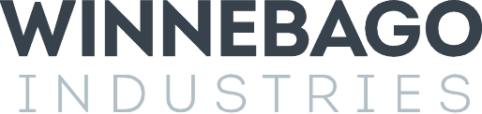

WINNEBAGO INDUSTRIES, INC.
(Name of Registrant as Specified in its Charter)
(Name of Person(s) Filing Proxy Statement, if Other than the Registrant)
Payment of Filing Fee (Check all boxes that apply):
☒ | ​ | ​ | No fee required.
☐ | ​ | ​ | Fee previously paid with preliminary materials
☐ | ​ | ​ | Fee computed on table per Exchange Act Rules 14a-6(i)(1) and 0-11.

Explanatory Note

This Amendment No. 1 to Schedule 14A (this “Amendment”) is being filed solely to amend and replace the form proxy card included in the Definitive Proxy Statement filed by Winnebago Industries, Inc. (the “Company”) with the Securities and Exchange Commission on November 3, 2023 (the “Proxy Statement”) in order to conform the voting options for Proposal 1 to those listed in the body of the Proxy Statement. No changes have been made to the body of the Proxy Statement and an updated proxy card has been included with the Proxy Statement being made available to the Company’s shareholders. This Amendment applies only to the version of the form proxy card originally filed with the Proxy Statement.



