SEC Form 4

FORM 4

Check this box if no longer subject to Section 16. Form 4 or Form 5 obligations may continue. See Instruction 1(b).

UNITED STATES SECURITIES AND EXCHANGE COMMISSION
Washington, D.C. 20549
Washington, D.C. 20549 |  | OMB APPROVAL
STATEMENT OF CHANGES IN BENEFICIAL OWNERSHIP
STATEMENT OF CHANGES IN BENEFICIAL OWNERSHIP |  | OMB Number: | 3235-0287
STATEMENT OF CHANGES IN BENEFICIAL OWNERSHIP |  | Estimated average burden
Filed pursuant to Section 16(a) of the Securities Exchange Act of 1934 |  | hours per response: | 0.5
or Section 30(h) of the Investment Company Act of 1940
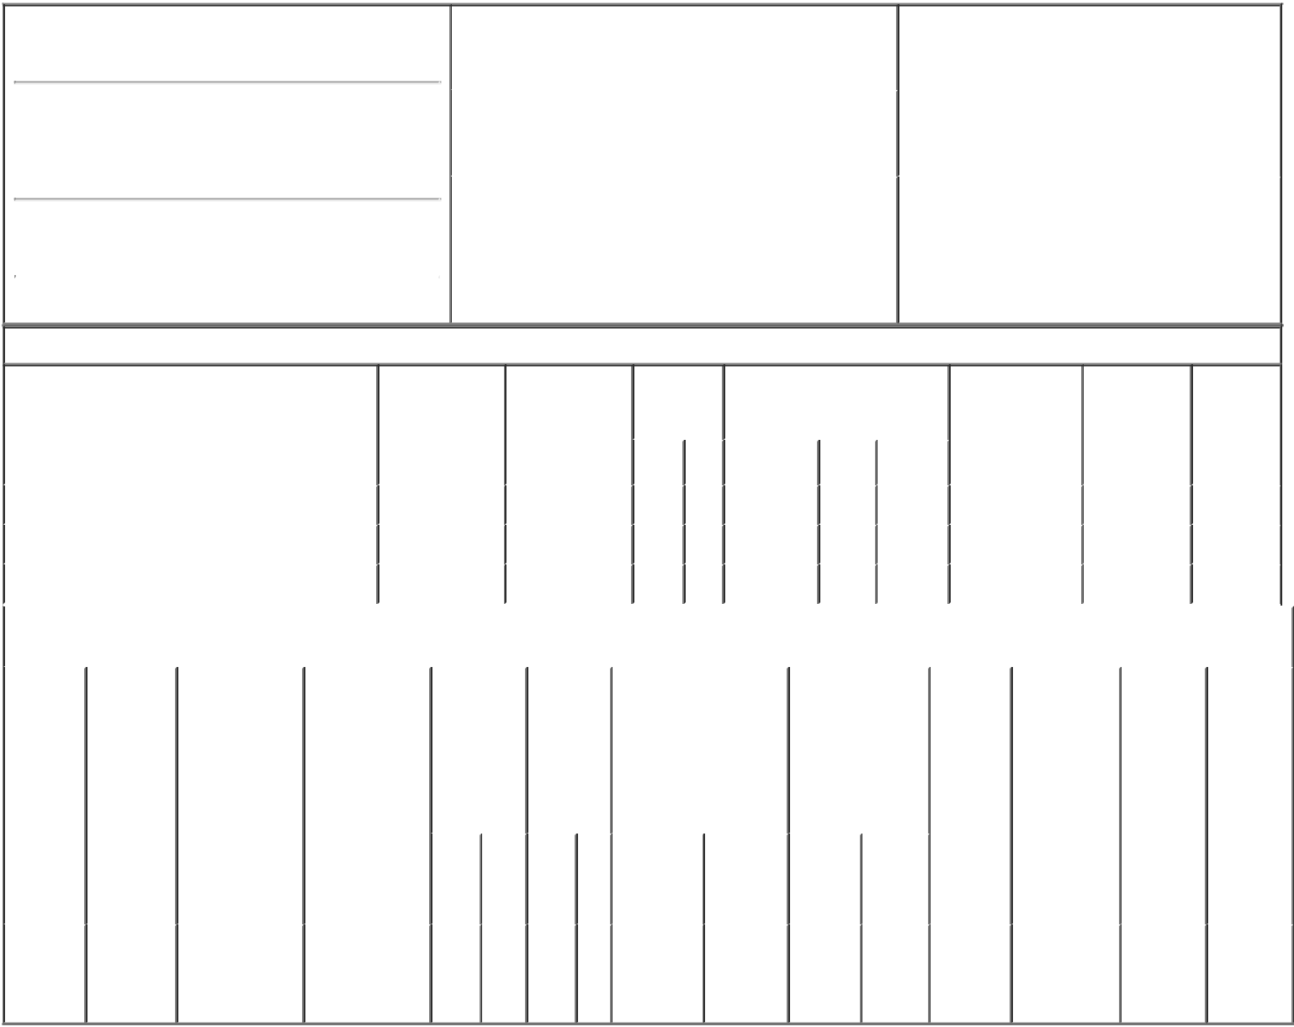

1. Name and Address of Reporting Person*
Bhattacharya Ashis Nayan

(Last) (First) (Middle)

WINNEBAGO INDUSTRIES, INC.

P.O. BOX 152

(Street)
 | FOREST CITY | IA | 50436
 | (City) | (State) | (Zip)

2. |  | Issuer Name and Ticker or Trading Symbol |  | 5. | Relationship of Reporting Person(s) to Issuer
 | WINNEBAGO INDUSTRIES INC [ WGO ] |  |  | (Check all applicable)
 |  |  |  |  |  | Director | 10% Owner
 |  |  |  |  | X | Officer (give title | Other (specify
3. |  | Date of Earliest Transaction (Month/Day/Year) |  |  | X | below) | below)
 |  |  |  |  |  | VP-Strategic Dev. & Planning
10/15/2018
4. |  | If Amendment, Date of Original Filed (Month/Day/Year) |  | 6. | Individual or Joint/Group Filing (Check Applicable
Line)
X Form filed by One Reporting Person

Form filed by More than One Reporting
Person

Table I - Non-Derivative Securities Acquired, Disposed of, or Beneficially Owned

 | 1. Title of Security (Instr. 3) |  |  | 2. Transaction |  | 2A. Deemed |  |  | 3. |  |  | 4. Securities Acquired (A) or |  |  |  |  |  | 5. Amount of |  | 6. Ownership |  | 7. Nature
 |  |  |  | Date |  | Execution Date, |  |  |  | Transaction |  | Disposed Of (D) (Instr. 3, 4 and |  |  |  |  |  | Securities |  | Form: Direct |  | of Indirect
 |  |  |  | (Month/Day/Year) |  | if any |  |  |  | Code (Instr. |  | 5) |  |  |  |  |  | Beneficially |  | (D) or Indirect |  | Beneficial
 |  |  |  |  |  | (Month/Day/Year) 8) |  |  |  |  |  |  |  |  |  |  |  | Owned Following |  | (I) (Instr. 4) |  | Ownership
 |  |  |  |  |  |  |  |  |  |  |  |  |  |  |  |  |  | Reported |  |  |  | (Instr. 4)
 |  |  |  |  |  |  |  |  |  | Code V |  | Amount |  | (A) or | Price |  |  | Transaction(s)
 |  |  |  |  |  |  |  |  |  | Code V |  | Amount |  | (D) |  |  |  | (Instr. 3 and 4)
 | Common Stock, $.50 par value |  |  | 10/15/2018 |  |  |  |  |  | A |  | 4,264⁽¹⁾ |  | A | $0 |  | 12,303 |  |  |  | D
 | Common Stock, $.50 par value |  |  | 10/15/2018 |  |  |  |  |  | A |  | 5,659 |  | A | $0 |  | 17,962 |  |  |  | D
 | Common Stock, $.50 par value |  |  | 10/15/2018 |  |  |  |  |  | F |  | 1,732 |  | D | $31.7 |  | 16,230 |  |  |  | D
 |  |  | Table II - Derivative Securities Acquired, Disposed of, or Beneficially Owned
 |  |  |  | (e.g., puts, calls, warrants, options, convertible securities)
 | 1. Title of | 2. | 3. Transaction | 3A. Deemed | 4. |  | 5. Number |  | 6. Date Exercisable and |  |  |  | 7. Title and |  |  |  | 8. Price of |  | 9. Number of |  | 10. | 11. Nature
 | Derivative | Conversion | Date | Execution Date, | Transaction |  | of |  | Expiration Date |  |  |  | Amount of |  |  |  | Derivative |  | derivative |  | Ownership | of Indirect
 | Security | or Exercise | (Month/Day/Year) | if any | Code (Instr. |  | Derivative |  | (Month/Day/Year) |  |  |  | Securities |  |  |  | Security |  | Securities |  | Form: | Beneficial
 | (Instr. 3) | Price of |  | (Month/Day/Year) | 8) |  | Securities |  |  |  |  |  | Underlying |  |  |  | (Instr. 5) |  | Beneficially |  | Direct (D) | Ownership
 |  | Derivative |  |  |  |  | Acquired |  |  |  |  |  | Derivative Security |  |  |  |  |  | Owned |  | or Indirect | (Instr. 4)
 |  | Security |  |  |  |  | (A) or |  |  |  |  |  | (Instr. 3 and 4) |  |  |  |  |  | Following |  | (I) (Instr. 4)
 |  |  |  |  |  |  | Disposed |  |  |  |  |  |  |  |  |  |  |  | Reported
 |  |  |  |  |  |  | of (D) |  |  |  |  |  |  |  |  |  |  |  | Transaction(s)
 |  |  |  |  |  |  | (Instr. 3, 4 |  |  |  |  |  |  |  |  |  |  |  | (Instr. 4)
 |  |  |  |  |  |  | and 5)
 |  |  |  |  |  |  |  |  |  |  |  |  |  |  | Amount
 |  |  |  |  |  |  |  |  |  |  |  |  |  |  | or
 |  |  |  |  |  |  |  |  |  |  |  |  |  |  | Number
 |  |  |  |  |  |  |  |  | Date |  | Expiration |  |  |  | of
 |  |  |  |  | Code V |  | (A) | (D) | Exercisable |  | Date |  | Title |  | Shares
 | Employee
 | Stock |  |  |  |  |  |  |  | (2) |  |  |  | Common |  | 8,580
 | Option | $31.7 | 10/15/2018 |  | A |  | 8,580 |  |  |  | 10/15/2028 |  |  |  | 8,580 |  | $0 |  | 8,580 |  | D
 | (right to |  |  |  |  |  |  |  |  |  |  |  |  | Stock
buy)

Explanation of Responses:

- Granted 10/15/18 under the Winnebago Industries, Inc. 2014 Omnibus Equity, Performance Awards, and Incentive Plan. Restricted stock units vest in annual increments of one-third beginning on 10/15/2019.

- Stock options vest in annual increments of one-third beginning on 10/15/2019.

/s/ Stacy Bogart, Vice
President, General Counsel &
Secretary, Winnebago 10/17/2018
Industries, Inc. under Power of
Attorney

** Signature of Reporting Person Date

Reminder: Report on a separate line for each class of securities beneficially owned directly or indirectly.

* If the form is filed by more than one reporting person, see Instruction 4 (b)(v).

- Intentional misstatements or omissions of facts constitute Federal Criminal Violations See 18 U.S.C. 1001 and 15 U.S.C. 78ff(a). Note: File three copies of this Form, one of which must be manually signed. If space is insufficient, see Instruction 6 for procedure.
Persons who respond to the collection of information contained in this form are not required to respond unless the form displays a currently valid OMB Number.

LIMITED POWER OF ATTORNEY

BE IT KNOWN, that Ashis N. Bhattacharya has made and appointed, and by these presents does hereby make and appoint, Cory J. Nelson and/or

Stacy L. Bogart, in their capacity as the legal counsel for Winnebago Industries, Inc., for the following specific and limited purposes only:

To sign any and all documents required by the Securities and Exchange Commission to ensure compliance with the rules and regulations thereof by me in connection with any transactions I may complete involving the stock of Winnebago Industries, Inc.

giving and granting said attorney(s) full power and authority to do and perform all and every act and thing whatsoever necessary to be done in and about the specific and limited premises set out herein as fully, to all intents and purposes, as might or could be done if personally present, with full power of substitution and revocation, hereby ratifying and confirming all that said attorney(s) shall lawfully do or cause to be done by virtue hereof.

IN WITNESS WHEREOF, I have hereunto set my hand this 15th day of October, 2018.
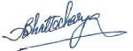

Ashis N. Bhattacharya

STATE OF Minnesota COUNTY OF Hennepin

)

)ss:

)

The foregoing instrument was acknowledged by me this 15th day of October, 2018, by Ashis N. Bhattacharya who is personally known by me and who did not take an oath.
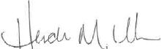

Notary Public in and for said State

My Commission Expires: Jan 31, 2022


