UNITED STATES

SECURITIES AND EXCHANGE COMMISSION

Washington, D.C. 20549

SCHEDULE 14A

Proxy Statement Pursuant to Section 14(a) of the Securities Exchange Act of 1934

(Amendment No. 1)

Filed by the Registrant x

Filed by party other than the Registrant o

Check the appropriate box:

- Preliminary Proxy Statement

- Confidential, For Use of the Commission Only (as permitted by Rule 14a-6(e)(2))

- Definitive Proxy Statement

- Definitive Additional Materials

- Soliciting Material Pursuant to section 240.14a-12


WINNEBAGO INDUSTRIES, INC.

(Name of Registrant as Specified in Its Charter)

(Name of Person(s) Filing Proxy Statement, if Other than the Registrant)

Payment of Filing Fee (Check the appropriate box):

- No fee required.

- Fee computed on table below per Exchange Act Rules 14a-6(i)(1) and 0-11.

  - Title of each class of securities to which transaction applies:

  - Aggregate number of securities to which transaction applies:

  - Per unit price or other underlying value of transaction computed pursuant to Exchange Act Rule 0-11 (set forth the amount on which the filing fee is calculated and state how it was determined):
  - Proposed maximum aggregate value of transaction:

  - Total fee paid:

- Fee paid previously with preliminary materials.

- Check box if any part of the fee is offset as provided by Exchange Act Rule 0-11(a)(2) and identify the filing for which the

offsetting fee was paid previously. Identify the previous filing by registration statement number, or the Form or Schedule and the date of its filing.

- Amount previously paid:

- Form, Schedule or Registration Statement No.:

- Filing party:

- Date filed:


Dear Shareholder:

Winnebago Industries, Inc. (the “Company”), has filed today supplemental materials (the “Supplement”) to the Definitive Proxy Statement relating to the Company’s 2017 Annual Meeting of Shareholders filed with the Securities and Exchange Commission on October 24, 2017. Attached to the Supplement is an additional proxy card soliciting your vote with respect to the matters described therein, including an additional Item 5 not included on the original proxy card.

Any proxies that have already been submitted will continue to be effective. If you have not already submitted your proxy, please complete and return the proxy card as soon as possible – even if you expect to attend the Annual Meeting of Shareholders. If you have already submitted your proxy, we request that you vote again so that your vote on Item 5 may be counted.

You may revoke your proxy at any time before it has been voted by delivering to the Company a written notice of revocation or a duly executed proxy card with a later date, or by attending the Annual Meeting of Shareholders on December 12, 2017, at 4:00 p.m. CST, and voting in person.

Sincerely,

October 31, 2017 /s/ Scott C. Folkers

Scott C. Folkers

Secretary

AMENDMENT NO. 1 TO PROXY STATEMENT FOR

2017 ANNUAL MEETING OF SHAREHOLDERS

TO BE HELD ON DECEMBER 12, 2017

EXPLANATORY NOTE

This Amendment No. 1 to Schedule 14A (“Amendment No. 1”) is being filed to amend the definitive proxy statement of Winnebago Industries, Inc. (the “Company”) for its 2017 Annual Meeting of Shareholders (“Proxy Statement”), which was filed with the Securities and Exchange Commission on October 24, 2017 (the “Original Proxy Statement”), in order to add an additional proposal to the Original Proxy Statement.

In accordance with the requirements of Section 14A of the Securities Exchange Act of 1934, as amended (which was added by the Dodd-Frank Wall Street Reform and Consumer Protection Act), and the related rules of the SEC, the Company is providing shareholders a non-binding advisory vote to approve the frequency of shareholder advisory votes on the compensation of our named executive officers (“NEOs”). At the 2011 Annual Meeting of Shareholders, our shareholders indicated their preference for us to hold advisory votes on executive compensation on an annual basis, and the Board of Directors subsequently determined that we would hold an annual advisory vote on executive compensation. Accordingly, the current frequency of our advisory votes on executive compensation is once every year.

This Amendment No. 1 affects the Notice of Annual Meeting of Shareholders; amends the Original Proxy Statement to add the voting requirements for the new Item 5; amends the Original Proxy Statement to add the new Item 5; and adds Item 5 to the Proxy Card. All other items of the Proxy Statement are unchanged.

CHANGES TO PROXY STATEMENT

The following sections of the Proxy Statement shall change in accordance with this Amendment No. 1:

- A new Item 5 shall be added to the Notice of Annual Meeting of Shareholders and current Item 5 shall be renumbered Item 6. The new Item 5 is a non-binding advisory vote on the “Say-on-Pay-Frequency” proposal regarding the frequency of shareholder advisory votes on the compensation of our NEOs. The Notice is amended to read in its entirety as follows:


Notice of Annual Meeting

of Shareholders

to be held December 12, 2017

To the Shareholders of Winnebago Industries, Inc.

The Annual Meeting of Shareholders of Winnebago Industries, Inc. will be held on Tuesday, December 12, 2017, at 4:00 p.m., Central Standard Time, in

Winnebago Industries' South Office Complex Theater, 605 West Crystal Lake Road, Forest City, Iowa, for the following purposes:

- to elect two Class II directors to serve the remainder of three year terms and to elect two Class III directors to hold office for a three-year term;

- to provide advisory approval of executive compensation;

- to approve the employee stock purchase plan;

- to ratify the appointment of Deloitte & Touche LLP as our independent registered public accountant for the fiscal year ending August 25, 2018;

- to provide advisory approval of the frequency of an executive compensation advisory vote; and

- to transact such other business as may properly come before the meeting or any adjournment or adjournments thereof.

The Board of Directors of the Company has fixed the close of business on October 17, 2017, as the record date for the determination of shareholders entitled to notice of and to vote at this meeting and at any and all adjournments thereof.

By Order of the Board of Directors

/s/ Scott C. Folkers

Scott C. Folkers

Secretary

Forest City, Iowa

October 31, 2017

Your Vote Is Important

Whether or not you expect to attend the meeting in person, please vote via the Internet or telephone or request a paper proxy card to complete, sign and return by mail so that your shares may be voted. A prompt response is helpful and your cooperation is appreciated.

PROXY STATEMENT

This Proxy Statement is furnished in connection with the solicitation by our Board of Directors of proxies to be used at the Annual Meeting of Shareholders to be held in our South Office Complex Theater, 605 West Crystal Lake Road, Forest City, Iowa on December 12, 2017, at 4:00 p.m., Central Standard Time, and at any and all adjournments thereof (the “Annual Meeting” or the “Meeting”).

In accordance with rules and regulations adopted by the SEC, instead of mailing a printed copy of our proxy materials to each shareholder of record, we are now furnishing proxy materials to our shareholders on the Internet. If you received a Notice of Internet Availability of Proxy Materials by mail, you will not receive a printed copy of the proxy materials, unless you specifically request a printed copy. Instead, the Notice of Internet Availability of Proxy Materials will instruct you as to how you may access and review all of the important information contained in the proxy materials. The Notice of Internet Availability of Proxy Materials also instructs you as to how you may submit your proxy on the Internet. If you received a Notice of Internet Availability of Proxy Materials by mail and would like to receive a printed copy of our proxy materials, you should follow the instructions for requesting such materials included in the Notice of Internet Availability of Proxy Materials.

It is anticipated that the Notice of Internet Availability of Proxy Materials will be mailed to shareholders on or about October 24, 2017.

Only holders of Common Stock of record at the close of business on October 17, 2017 (the "Record Date") will be entitled to Notice of Internet Availability of Proxy Materials and to vote at the Annual Meeting. On the Record Date, we had outstanding 31,806,892 shares of Common Stock, par value $0.50 per share (“Common Stock”) that were eligible to vote. Each share of Common Stock entitles the holder to one vote upon each matter to be voted upon at the meeting. A majority of the outstanding shares of Common Stock represented in person or by proxy will constitute a quorum for the Annual Meeting.

If you have returned your properly signed proxy or attend the Meeting in person, your Common Stock will be counted for the purpose of determining whether there is a quorum.

If you hold shares in your own name, by submitting a proxy you may either vote for or withhold authority to vote for each nominee for the Board of Directors, you may vote in favor, against or abstain from the ratification of the appointment of independent registered public accountant, you may vote in favor, against or abstain from the approval on an advisory basis of the executive compensation disclosed in this Proxy Statement, you may vote in favor, against or abstain from the approval on the proposal to approve the employee stock purchase plan and you may vote on an advisory basis of the frequency of the executive compensation vote. If you sign and submit your proxy card without voting instructions, your shares will be voted in favor of each director and each other item considered for shareholder approval. If you hold shares through a broker, follow the voting instructions provided by your broker. If you want to vote in person, a legal proxy must be obtained from your broker and brought to the Meeting. The

New York Stock Exchange (“NYSE”) permits brokers to vote their customers' shares on routine matters when the brokers have not received voting instructions from their customers. The ratification of the appointment of independent registered public accountant is an example of a routine matter on which brokers may vote in this way. Brokers may not vote their customers' shares on non-routine matters such as shareholder proposals unless they have received voting instructions from their customers. Under NYSE rules, brokers are also not permitted to exercise discretionary voting authority with respect to shares for which voting instructions have not been received, as such voting authority pertains to the election of directors (whether contested or uncontested) and to matters relating to executive compensation. As a result of the NYSE rules, unless they have received voting instructions from their customers, brokers may not vote their customers' shares on any other matters other than ratification of our independent registered public accountant.


Directors must be elected by a majority of the votes cast at the Meeting. Withheld votes and abstentions with respect to this Item will have the same effect as a vote against the matter. The ratification of the appointment of the independent registered public accountant and approval of the employee stock purchase plan requires the affirmative vote of a majority of those shares of Common Stock present in person or represented by proxy. Withheld votes and abstentions with respect to this Item will have the same effect as a vote against the matter.

In addition, while the Board of Directors intends to carefully consider the shareholder votes resulting from the proposals under Item (2) and Item (5): Proposal For an Advisory Vote on Executive Compensation (the "Say on Pay" Vote) and Proposal for Advisory Approval of the Frequency of an Executive Compensation Vote (the "Say on Pay" Frequency Vote"), the final vote of shareholders will not be binding on the Company, but will be advisory in nature.

We are not aware of any matters to be presented at the Annual Meeting other than the election of the four nominees described in this Proxy Statement, the advisory approval of executive compensation, the approval of the Employee Stock Purchase Plan, the ratification of the appointment of independent registered public accountant and the advisory approval of the frequency of executive compensation advisory vote. If any matters not described in this Proxy Statement are properly presented at the Meeting, the proxies will use their personal judgment to determine how to vote your shares. If the Meeting is adjourned, the proxies can vote your Common Stock on the new Meeting date as well, unless you have revoked your proxy instructions.

Before the Meeting, you can appoint a proxy to vote your shares of Common Stock by following the instructions as set forth in the Notice of Internet Availability of Proxy Materials. If, by request, you have received a printed copy of our proxy materials, you can appoint a proxy to vote your shares of Common Stock (i) by using the Internet (www.proxyvote.com), (ii) by calling the toll-free telephone number (1-800-690-6903) or (iii) you may indicate your vote by completing, signing and dating the proxy card where indicated and returning the card to Vote Processing, c/o Broadridge, 51 Mercedes Way, Edgewood, NY 11717 by 11:59 p.m. Eastern Standard Time on December 11, 2017.

1

If a proxy card is executed and returned, it may nevertheless be revoked at any time in accordance with the following instructions. A person may revoke a proxy electronically by entering a new vote via the Internet or by telephone or a proxy may be revoked by (i) giving written notice to the Secretary of the Company (the “Secretary”), (ii) subsequently granting a later-dated proxy,

- attending the Meeting and voting in person or (iv) executing a proxy designating another person to represent you at the Meeting and voting by your representative at the Meeting. Unless revoked, the shares represented by validly executed proxies will be voted at the Meeting in accordance with the instructions indicated thereon. To revoke a proxy by telephone or the Internet, you must do so by 12:00 p.m. Central Standard Time on December 11, 2017 (following the directions on the instructions as set forth in the Notice of Internet Availability of Proxy Materials or in the printed proxy materials received by request). Attendance at the Annual Meeting will not cause your previously granted proxy to be revoked unless you specifically so request.

If no instructions are indicated on a proxy that is signed and received by us, it will be voted: (i) for the election of the four nominees for director named below (Item 1), (ii) for the advisory approval of executive compensation (Item 2), (iii) for the approval of the employee stock purchase plan (Item 3), (iv) for the ratification of the appointment of Deloitte & Touche LLP as our independent registered public accountant for Fiscal 2018 (Item 4), (v) for the advisory approval of the frequency of an executive compensation vote annually (Item 5), (vi) in the discretion of the named proxies upon such other matters as may properly come before the Meeting.

ITEM 5

PROPOSAL FOR AN ADVISORY VOTE ON THE FREQUENCY OF "SAY ON PAY" VOTES

The Dodd-Frank Wall Street Reform and Consumer Protection Act also requires that shareholders must be given the opportunity, at least once every six years, to cast a non-binding, advisory vote on whether a "Say on Pay" vote on the compensation of Named Executive Officers should be held every one, two, or three years.

After careful consideration, the Board of Directors recommends annual ("1 Year") advisory votes on the compensation of the Named Executive Officers. The Board believes that annual votes will provide the clearest and most useful feedback from shareholders to the Company and the Human Resources Committee in this important area, and will confirm the Company's commitment to frequent and transparent communications with investors.

Shareholders are not voting to approve or disapprove of the Board's recommendation. Instead, shareholders have four choices with respect to this Item: "1 Year", "2 Years", "3 Years", or "Abstain". For the reasons discussed above, we are asking our shareholders to vote for a frequency of "1 Year" when voting on this Item.

While the Board of Directors and especially the Human Resources Committee intend to carefully consider the results of the voting on this proposal, the vote is not binding on the Company or the Board and is advisory in nature.

YOUR BOARD OF DIRECTORS UNANIMOUSLY RECOMMENDS A VOTE IN FAVOR OF CONDUCTING A NON-BINDING, ADVISORY VOTE ON EXECUTIVE COMPENSATION EACH YEAR (“1 YEAR”). PROXIES SOLICITED BY THE BOARD OF DIRECTORS WILL BE VOTED IN FAVOR OF CONDUCTING AN ADVISORY VOTE ON EXECUTIVE COMPENSATION EACH YEAR (“1 YEAR”) UNLESS A SHAREHOLDER INDICATES OTHERWISE IN VOTING THE PROXY.

OTHER MATTERS

The Board of Directors does not know of any matter, other than the election of directors, the advisory approval of executive compensation, the ratification of employee stock purchase plan, the appointment of independent registered public accountants and the advisory approval of the frequency of an executive compensation vote, which may be presented at the Meeting. However, if any other matters should properly come before the Meeting, it is the intention of the persons named in the proxy to vote thereon in accordance with their best judgment.

2

 | VOTE BY INTERNET - www.proxyvote.com
 | Use the Internet to transmit your voting instructions and for electronic delivery of information
WINNEBAGO INDUSTRIES, iNC. | up until 11:59 p.m. Eastern Time the day before the meeting date. Have your proxy card in
ATTN: KAREN POST | hand when you access the web site and follow the instructions to obtain your records and to
ATTN: CORY NELSON | create an electronic voting instruction form.
P.O. BOX 152 ELECTRONIC DELIVERY OF FUTURE PROXY MATERIALS

605 WEST CRYSTAL LAKE ROAD If you would like to reduce the costs incurred by our company in mailing proxy materials,

FOREST CITY, IA 50436 you can consent to receiving all future proxy statements, proxy cards and annual reports

electronically via e-mail or the Internet. To sign up for electronic delivery, please follow the instructions above to vote using the Internet and, when prompted, indicated that you agree to receive or access proxy materials electronically in future years.

VOTE BY PHONE - 1-800-690-6903

Use any touch-tone phone to transmit your voting instructions up until 11:59 p.m. Eastern Time the day before the meeting date. Have your proxy card in hand when you call and then follow the instructions.

VOTE BY MAIL

Mark, sign and date your proxy card and return it in the postage-paid envelope we have provided or return it to Vote Processing, c/o Broadridge, 51 Mercedes Way, Edgewood, NY 11717.

TO VOTE, MARK BLOCKS BELOW IN BLUE OR BLACK INK AS FOLLOWS:

E33735-P98584 KEEP THIS PORTION FOR YOUR RECORDS.

DETACH AND RETURN THIS PORTION ONLY

THIS PROXY CARD IS VALID ONLY WHEN SIGNED AND DATED.


WINNEBAGO INDUSTRIES, INC. | For | Withhold | For All | To withhold authority to vote any individual nominee(s),
 | All | All | Except | mark "For All Except" and write the number(s) of the
The Board of Directors recommends you vote FOR the |  |  |  | nominee(s) on the line below.
following:

1. Election of Directors _{o} _{o} _{o}

Nominees:

- Richard D. Moss

- John M. Murabito

- Michael J. Happe

- William C. Fisher

The Board of Directors recommends you vote FOR items 2, 3 and 4.

- Advisory approval of executive compensation, (the "say on pay" vote).

- Approval of the employee stock purchase plan.

- Ratification of the appointment of Deloitte & Touche LLP as Winnebago Industries, Inc. Independent Registered Public Accountant for our fiscal year 2018.

The Board of Directors recommends you vote for "1 Year" on Item 5.

- Advisory approval on frequency of "say on pay" votes.

NOTE: To transact such other business as may properly come before the meeting or any adjournment or adjournments thereof.

For address changes and/or comments, please check this box and write them on the | o
back where indicated. | o

For Against Abstain

o o o

o o o

o o o

1 Year 2 Years 3 Years Abstain

o o o o

Please sign exactly as your name(s) appears hereon. When signing as attorney, executor,
administrator, or other fiduciary, please give full title as such. Joint owner should each sign personally.
All holders must sign. If a corporation or partnership, please sign in full corporate or partnership name
by authorized officer.

Signature [PLEASE SIGN WITHIN BOX] Date Signature [Joint Owners] Date

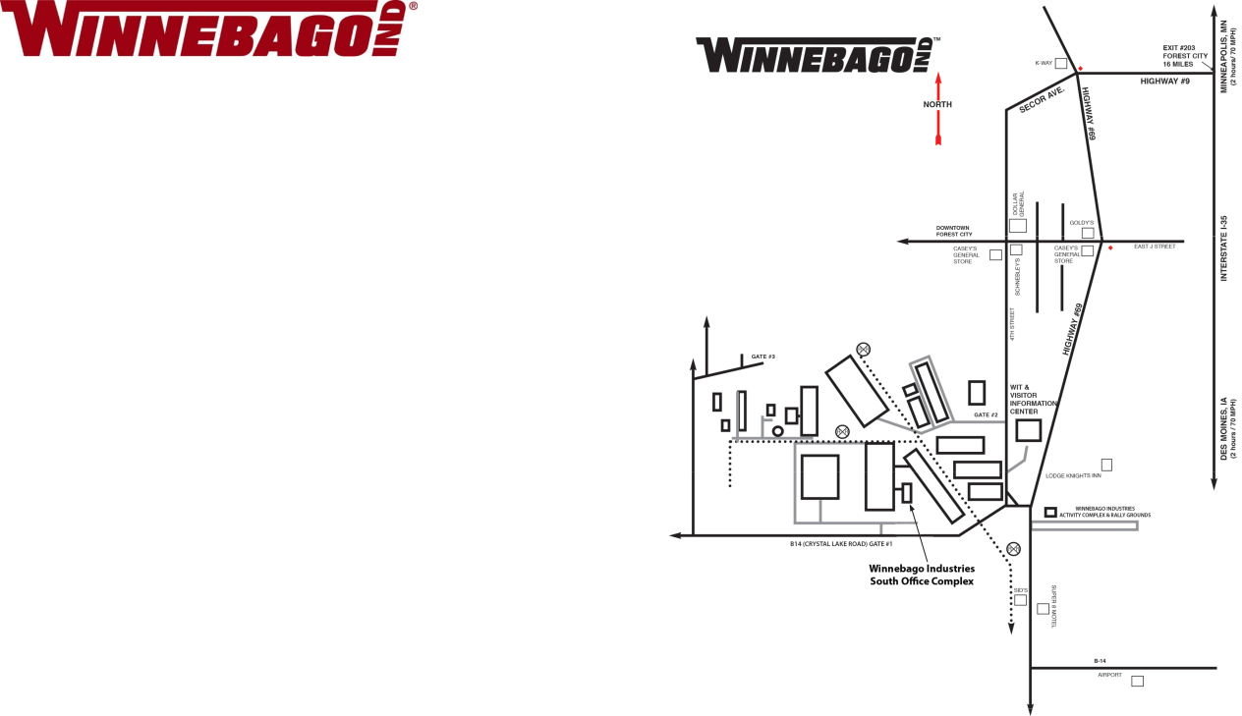

ANNUAL MEETING OF SHAREHOLDERS

Tuesday, December 12, 2017

4:00 p.m. Central Standard Time

Winnebago Industries' South Office Complex Theater, 605 W. Crystal Lake Road, Forest City, Iowa

Important Notice Regarding the Availability of Proxy Materials for the

Annual Meeting:

The Notice and Proxy Statement and Annual Report/Form 10-K are available at www.proxyvote.com

E33736-P98584
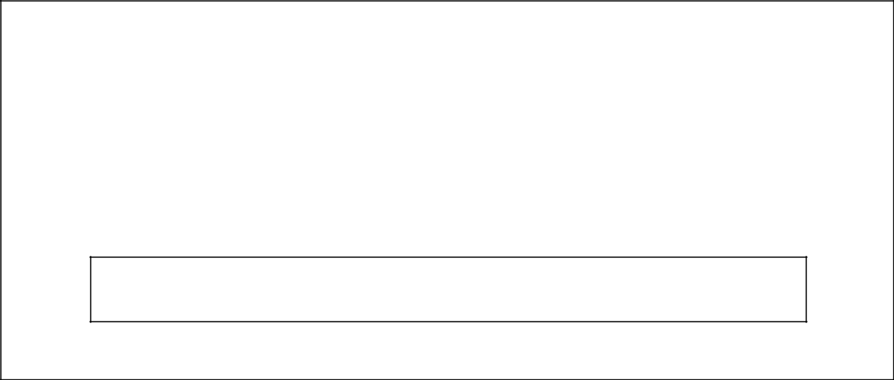

WINNEBAGO INDUSTRIES, INC.

Annual Meeting of Shareholders
December 12, 2017 4:00 PM

This proxy is solicited by the Board of Directors

The undersigned hereby appoints Scott C. Folkers and Michael J. Happe, or either of them, the undersigned's attorneys and proxies, with full power of substitution, to vote all shares of Common Stock of Winnebago Industries, Inc. which the undersigned is entitled to vote, as fully as the undersigned could do if personally present, at the Annual Meeting of Shareholders of said corporation to be held at Winnebago Industries' South Office Complex Theater, 605 W. Crystal Lake Road, Forest City, Iowa on the 12th day of December, 2017. at 4:00 p.m., Central Standard Time, and at any and all adjournments thereof.

This proxy, when properly executed, will be voted in the manner directed herein. If no such direction is made, this proxy will be voted in accordance with the Board of Directors' recommendations.

Address Changes/Comments: __________________________________________________________

____________________________________________________________________________________

(If you noted any Address Changes/Comments above, please mark corresponding box on the reverse side.)

Continued and to be signed on the reverse side

