UNITED STATES

SECURITIES AND EXCHANGE COMMISSION

Washington, D.C. 20549

FORM 10-K

(Mark One)

x ANNUAL REPORT PURSUANT TO SECTION 13 OR 15(D) OF THE SECURITIES EXCHANGE ACT OF 1934 for the fiscal year ended August 31, 2019; or

o TRANSITION REPORT PURSUANT TO SECTION 13 OR 15(D) OF THE SECURITIES EXCHANGE ACT OF 1934 for the transition period from ___________________ to

_______________________

Commission File Number 001‑06403


WINNEBAGO INDUSTRIES, INC.

(Exact name of registrant as specified in its charter)

Iowa |  | 42-0802678
(State or other jurisdiction of |  | (I.R.S. Employer Identification No.)
incorporation or organization)
P.O. Box 152, Forest City, Iowa |  | 50436
(Address of principal executive offices) |  | (Zip Code)

Registrant's telephone number, including area code: (641) 585‑3535

Securities registered pursuant to Section 12(b) of the Act:

Title of each class | Trading Symbol(s) | Name of each exchange on which registered
Common Stock, $0.50 par value per share | WGO | New York Stock Exchange

Securities registered pursuant to Section 12(g) of the Act: None

Indicate by check mark if the registrant is a well-known seasoned issuer, as defined in Rule 405 of the Securities Act. Yes x No o

Indicate by check mark if the registrant is not required to file reports pursuant to Section 13 or Section 15(d) of the Act. Yes o No x

Indicate by check mark whether the registrant (1) has filed all reports required to be filed by Section 13 or 15(d) of the Securities Exchange Act of 1934 during the preceding 12 months (or for such shorter period that the registrant was required to file such reports), and (2) has been subject to such filing requirements for the past 90 days. Yes x No o

Indicate by check mark whether the registrant has submitted electronically every Interactive Data File required to be submitted pursuant to Rule 405 of Regulation S-T (§232.405 of this chapter) during the preceding 12 months (or for such shorter period that the registrant was required to submit such files). Yes x No o

Indicate by check mark whether the registrant is a large accelerated filer, an accelerated filer, a non-accelerated filer, smaller reporting company, or an emerging growth company. See the definitions of "large accelerated filer," "accelerated filer," "smaller reporting company", and "emerging growth company" in Rule 12b-2 of the Exchange Act.

Large Accelerated Filer x Accelerated Filer o Non-accelerated filer o Smaller Reporting Company o Emerging Growth Company o

If an emerging growth company, indicate by check mark if the registrant has elected not to use the extended transition period for complying with any new or revised financial accounting standards provided pursuant to Section 13(a) of the Exchange Act. o

Indicate by check mark whether the registrant is a shell company (as defined in Rule 12b-2 of the Act). Yes o No x

Aggregate market value of the common stock held by non-affiliates of the registrant: $648,711,299 (19,209,362 shares at the closing price on the New York Stock Exchange of $33.77 on February 22, 2019).

Common stock outstanding on October 7, 2019: 31,630,845 shares.

DOCUMENTS INCORPORATED BY REFERENCE

Portions of the registrant's Proxy Statement relating to the registrant's 2019 Annual Meeting of Shareholders, scheduled to be held December 17, 2019, are incorporated by reference into Part III of this Annual Report on Form 10-K where indicated.

Winnebago Industries, Inc.

Fiscal 2019 Form 10-K

Table of Contents

PART I |  |  |  |  |  |  |  |  |  |  |  |  |  |  |  |  |  |  |  |  |  |  |  |  |  | 4
Item 1. |  |  |  |  | Business |  |  |  |  |  |  |  |  |  |  |  |  |  |  |  |  |  |  |  |  |  |  | 4
Item 1A. |  |  |  |  | Risk Factors |  |  |  |  |  |  |  |  |  |  |  |  |  |  |  |  |  |  |  |  | 7
Item 1B. |  |  |  |  | Unresolved Staff Comments |  |  |  |  |  |  |  |  |  |  |  |  |  |  |  |  |  |  |  |  | 16
Item 2. |  |  |  |  | Properties |  |  |  |  |  |  |  |  |  |  |  |  |  |  |  |  |  |  |  |  | 16
Item 3. |  |  |  |  | Legal Proceedings |  |  |  |  |  |  |  |  |  |  |  |  |  |  |  |  |  |  |  |  | 16
Item 4. |  |  |  |  | Mine Safety Disclosures |  |  |  |  |  |  |  |  |  |  |  |  |  |  |  |  |  |  |  |  | 16
 |  |  |  |  | Information about our Executive Officers |  |  |  |  |  |  |  |  |  |  |  |  |  |  |  |  |  |  |  |  | 17
PART II
 |  |  |  |  |  |  |  |  |  |  |  |  |  |  |  |  |  |  |  |  |  |  |  |  |  | 19
Item 5. |  |  |  |  | Market for the Registrant's Common Equity, Related Stockholder Matters, and Issuer Purchases of Equity Securities |  |  |  |  |  |  |  |  |  |  |  |  |  |  |  |  |  |  |  |  | 19
Item 6. |  |  |  |  | Selected Financial Data |  |  |  |  |  |  |  |  |  |  |  |  |  |  |  |  |  |  |  |  | 22
Item 7. |  |  |  |  | Management's Discussion and Analysis of Financial Condition and Results of Operations |  |  |  |  |  |  |  |  |  |  |  |  |  |  |  |  |  |  |  |  | 22
Item 7A. |  |  |  |  | Quantitative and Qualitative Disclosures About Market Risk |  |  |  |  |  |  |  |  |  |  |  |  |  |  |  |  |  |  |  |  | 35
Item 8. |  |  |  |  | Financial Statements and Supplementary Data |  |  |  |  |  |  |  |  |  |  |  |  |  |  |  |  |  |  |  |  | 37
Item 9. |  |  |  |  | Changes in and Disagreements with Accountants on Accounting and Financial Disclosure |  |  |  |  |  |  |  |  |  |  |  |  |  |  |  |  |  |  |  |  | 66
Item 9A. |  |  |  |  | Controls and Procedures |  |  |  |  |  |  |  |  |  |  |  |  |  |  |  |  |  |  |  |  | 66
Item 9B. |  |  |  |  | Other Information |  |  |  |  |  |  |  |  |  |  |  |  |  |  |  |  |  |  |  |  | 66
PART III |  |  |  |  |  |  |  |  |  |  |  |  |  |  |  |  |  |  |  |  |  |  |  |  |  | 67
Item 10. |  |  |  |  | Directors, Executive Officers, and Corporate Governance |  |  |  |  |  |  |  |  |  |  |  |  |  |  |  |  |  |  |  |  | 67
Item 11. |  |  |  |  | Executive Compensation |  |  |  |  |  |  |  |  |  |  |  |  |  |  |  |  |  |  |  |  | 67
Item 12. |  |  |  |  | Security Ownership of Certain Beneficial Owners and Management and Related Stockholder Matters |  |  |  |  |  |  |  |  |  |  |  |  |  |  |  |  |  |  |  |  | 67
Item 13. |  |  |  |  | Certain Relationships and Related Transactions and Director Independence |  |  |  |  |  |  |  |  |  |  |  |  |  |  |  |  |  |  |  |  | 67
Item 14. |  |  |  |  | Principal Accounting Fees and Services |  |  |  |  |  |  |  |  |  |  |  |  |  |  |  |  |  |  |  |  | 67
PART IV |  |  |  |  |  |  |  |  |  |  |  |  |  |  |  |  |  |  |  |  |  |  |  |  |  | 68
Item 15. |  |  |  |  | Exhibits, Financial Statement Schedules |  |  |  |  |  |  |  |  |  |  |  |  |  |  |  |  |  |  |  |  | 68
Item 16. |  |  |  |  | Form 10-K Summary |  |  |  |  |  |  |  |  |  |  |  |  |  |  |  |  |  |  |  |  | 71
 |  |  |  |  | SIGNATURES |  |  |  |  |  |  |  |  |  |  |  |  |  |  |  |  |  |  |  |  | 72
 |  |  |  |  | 2

Table of Contents

WINNEBAGO INDUSTRIES, INC.

FORM 10‑K

Report for the Fiscal Year Ended August 31, 2019

Forward-Looking Information

Certain of the matters discussed in this Annual Report on Form 10-K are "forward-looking statements" within the meaning of Section 27A of the Securities Act of 1933, as amended, and Section 21E of the Securities Exchange Act of 1934, as amended, which involve risks and uncertainties. A number of factors could cause actual results to differ materially from these statements, including, but not limited to, competition and new product introductions by competitors, our ability to attract and retain qualified personnel, increases in market compensation rates, business or production disruptions, sales order cancellations, risk related to the terms of our credit agreement and compliance with debt covenants and leverage ratios, stock price volatility and share dilution, disruptions or unanticipated costs from facility expansions, availability of labor, a slowdown in the economy, low consumer confidence, the effect of global tensions, increases in interest rates, availability of credit, availability of financing for RV and marine dealers, impairment of good will, risk related to cyclicality and seasonality of our business, slower than anticipated sales of new or existing products, integration of operations relating to merger and acquisition activities generally, our plans to acquire Newmar Corporation (“Newmar”), risk that our acquisition of Newmar (the “Newmar Acquisition”) will not be completed, the possibility that the Newmar acquisition may not perform as expected or may not result in earnings growth, difficulties and expenses related to integrating Newmar into our business, possible unknown liabilities of Newmar, significant costs related to the Newmar acquisition, increased focus of management attention and resources on the Newmar Acquisition, inadequate liquidity or capital resources, inventory and distribution channel management, our ability to innovate, our reliance on large dealer organizations, significant increase in repurchase obligations, availability and price of fuel, availability of chassis and other key component parts, increased material and component costs, exposure to warranty claims, ability to protect our intellectual property, exposure to product liability claims, dependence on information systems and web applications, any unexpected expenses related to the implementation of our Enterprise Resource Planning system, risk related to data security, governmental regulation, including for climate change, risk related to anti-takeover provisions applicable to us, and other factors which may be disclosed throughout this Annual Report on Form 10-K. Although we believe that the expectations reflected in the "forward-looking statements" are reasonable, we cannot guarantee future results, levels of activity, performance, or achievements. Undue reliance should not be placed on these "forward-looking statements," which speak only as of the date of this report. We undertake no obligation to publicly update or revise any "forward-looking statements," whether as a result of new information, future events, or otherwise, except as required by law or the rules of the New York Stock Exchange. We advise you, however, to consult any further disclosures made on related subjects in future quarterly reports on Form 10-Q and current reports on Form 8-K that are filed or furnished with the U.S. Securities and Exchange Commission ("SEC").

3

Table of Contents

PART I

Item 1. Business.

General

The "Company," "Winnebago Industries," "we," "our," and "us" are used interchangeably to refer to Winnebago Industries, Inc. and its wholly-owned subsidiaries, as appropriate in the context.

Winnebago Industries, Inc. is a leading U.S. manufacturer with a diversified portfolio of recreation vehicles ("RV"s) and marine products used primarily in leisure travel and outdoor recreation activities. We produce our Towable units in IN; our Motorhome units in manufacturing facilities in IA; and our marine products in FL. We distribute our RV and marine products primarily through independent dealers throughout the U.S. and Canada, who then retail the products to the end consumer. We also distribute our marine products internationally through independent dealers, who then retail the products to the end consumer.

We were incorporated under the laws of the state of Iowa on February 12, 1958, and adopted our present name on February 28, 1961.

Available Information

Our website, located at www.wgo.net, provides additional information about us. On our website, you can obtain, free of charge, this and prior year Annual Reports on Form 10-K, Quarterly Reports on Form 10-Q, Current Reports on Form 8-K, and all of our other filings with the SEC. Our recent press releases are also available on our website. Our website also contains important information regarding our corporate governance practices. Information contained on our website is not incorporated into this Annual Report on Form 10-K.

Principal Products

We have five operating segments: 1) Grand Design towables, 2) Winnebago towables, 3) Winnebago motorhomes, 4) Chris-Craft marine, and 5) Winnebago specialty vehicles. We evaluate performance based on each operating segment's Adjusted EBITDA, as defined within Item 7, Management's Discussion and Analysis of Financial Condition and Results of Operations, of this Annual Report on Form 10-K, which excludes certain corporate administration expenses and non-operating income and expense.

Our two reportable segments include: 1) Towable (comprised of products which are not motorized and are generally towed by another vehicle as well as other related manufactured products and services), which is an aggregation of the Winnebago towables and Grand Design towables operating segments, and 2) Motorhome (comprised of products that include a motorized chassis as well as other related manufactured products and services).

The Corporate / All Other category includes the Chris-Craft marine and Winnebago specialty vehicles operating segments as well as expenses related to certain corporate administration expenses for the oversight of the enterprise. These expenses include items such as corporate leadership and administration costs.

Towable

A towable is a non-motorized vehicle that is designed to be towed by automobiles, pickup trucks, SUVs, or vans and is used as temporary living quarters for recreational travel. The Recreation Vehicle Industry Association ("RVIA") classifies towables in four types: conventional travel trailers, fifth wheels, folding camper trailers, and truck campers. We manufacture and sell conventional travel trailers and fifth wheels under the Winnebago and Grand Design brand names, which are defined as follows:

Type | Description | Winnebago product offerings | Grand Design product offerings
Travel trailer | Towed by means of a hitch attached to the frame of the | Minnie Plus, Minnie, Micro Minnie, Minnie Drop, and | Transcend, Imagine, and Reflection
 | vehicle | Spyder
Fifth wheel | Constructed with a raised forward section that is connected Minnie Plus and Micro Minnie |  | Momentum, Reflection, and Solitude
 | to the vehicle with a special fifth wheel hitch

Our travel trailer and fifth wheel towables are sold by dealers in the retail market with manufacturer's suggested retail prices ranging from approximately $20,000 to $110,000, depending on size and model, plus optional equipment and delivery charges.

4

Table of Contents
Unit sales of our towables for the last three fiscal years were as follows:
 |  |  | 2019 |  |  |  |  | 2018 |  |  |  |  | 2017
Travel trailer |  | 22,458 | 61.0% |  |  |  | 22,360 | 61.1% |  |  |  | 13,650 | 60.7%
Fifth wheel |  | 14,371 |  |  | 39.0% |  | 14,229 |  |  | 38.9% |  | 8,824 |  |  | 39.3%
Total towables |  | 36,829 | 100.0% |  |  |  | 36,589 | 100.0% |  |  |  | 22,474 | 100.0%

Motorhome

A motorhome is a self-propelled mobile dwelling used primarily as temporary living quarters during vacation and camping trips, or to support active and mobile lifestyles. The RVIA classifies motorhomes into three types, all of which we manufacture and sell under the Winnebago brand name, which are defined as follows:

Type | Description | Winnebago products offerings
Class A | Built on a heavy truck chassis in both diesel and gas models with the ability to tow a small vehicle Gas: Adventurer, Intent, Vista, and Sunstar
 |  | Diesel: Horizon and Forza
Class B | Built by adding taller roof and amenities to existing van, which allows for easy maneuvering | Boldt, Revel, Travato, and Era
Class C | Built on a medium truck chassis in both diesel and gas models with similar features and | View, Navion, Vita, Porto, Minnie Winnie, Spirit, Outlook, and Fuse
 | amenities to Class A models

Our Class A, B, and C motorhomes are sold by dealers in the retail market with manufacturer's suggested retail prices ranging from approximately $80,000 to $500,000, depending on size and model, plus optional equipment and delivery charges. Our motorhomes range in length from 21 to 44 feet.

Unit sales of our motorhomes for the last three fiscal years were as follows:

 | 2019 |  |  |  |  |  | 2018 |  |  |  |  | 2017
Class A | 1,582 |  |  | 20.8% |  | 2,997 | 31.4% |  |  |  | 3,182 | 34.4%
Class B | 2,784 |  |  | 36.7% |  | 2,012 | 21.1% |  |  |  | 1,541 | 16.6%
Class C | 3,225 |  |  | 42.5% |  | 4,539 |  |  | 47.5% |  | 4,537 |  |  | 49.0%
Total motorhomes | 7,591 |  |  | 100.0% |  | 9,548 | 100.0% |  |  |  | 9,260 | 100.0%

Motorhome parts and service activities represent revenues generated by service work we perform for retail customers at our Forest City, IA facilities as well as revenues from the sale of unit parts. Our competitive strategy is to provide proprietary manufactured parts through our dealer network, which we believe increases customer satisfaction and the value of our motorhomes.

Chris-Craft

On June 4, 2018, we acquired 100% of the ownership interests of Chris-Craft USA, Inc. ("Chris-Craft"), a privately-owned company based in Sarasota, Florida. As a result of this acquisition, we manufacture and sell premium quality boats in the recreational powerboat industry through an established global network of independent authorized dealers.

Winnebago Specialty Vehicles

We also manufacture other specialty commercial vehicles primarily custom designed for the buyer's specific needs and requirements, such as law enforcement command centers, mobile medical clinics, and mobile office space. These specialty commercial vehicles are manufactured in Forest City, Iowa and sold through our dealer network. In addition, we also provide commercial vehicles as bare shells to third-party upfitters for conversion at their facilities.

Production

We generally produce towables and motorhomes to stock for dealers. We have some ability to increase our capacity by scheduling overtime and/or hiring additional production employees or to decrease our capacity through the use of shortened work weeks and/or reducing head count. We have long been known as an industry leader in innovation as each year we introduce new or redesigned products. These changes generally include new floor plans and sizes as well as design and decor modifications. Most of our raw materials such as steel, aluminum, fiberglass, and wood products are obtainable from numerous sources.

Our towables are produced at two assembly campuses located in Middlebury, IN. The majority of components are comprised of frames, appliances, and furniture, and are purchased from suppliers. In Fiscal 2019, we had one supplier that accounted for more than 10% of our Towable raw material purchases.

5

Table of Contents

Our motorhomes are produced in the state of IA at four different campuses. Our motorhome business utilizes vertically integrated supply streams, with the principal exceptions being chassis, engines, generators, and appliances that we purchase from reputable manufacturers. Certain parts, especially motorhome chassis, are available from a small group of suppliers. In Fiscal 2019, we had three suppliers that each individually accounted for more than 10% of our Motorhome raw material purchases.

Backlog

We strive to balance timely order fulfillment to our dealers with the lead times suppliers require to efficiently source materials and manage costs. Production facility constraints at peak periods also lead to fluctuations in backlog orders which we manage closely. The approximate revenue of our Towable backlog was $234.3 million and $244.9 million as of August 31, 2019 and August 25, 2018, respectively. The approximate revenue of our Motorhome backlog was $165.4 million and $157.6 million as of August 31, 2019 and August 25, 2018, respectively. A more detailed description of our Motorhome and Towable order backlog is included in Item 7, Management's Discussion and Analysis of Financial Condition and Results of Operations, of this Annual Report on Form 10-K.

Distribution and Financing

We market our products on a wholesale basis to a diversified independent dealer network located throughout the U.S. and, to a limited extent, in Canada, Africa, Asia, Europe, Australia, and South America. Foreign sales were 10% or less of Net revenues during each of the past three fiscal years.

As of August 31, 2019, our RV and marine dealer network in the U.S. and Canada included approximately 600 physical dealer locations, many of which carry more than one of our brands. None of our dealer organizations accounted for more than 10% of our Net revenues for Fiscal 2019, 2018, and 2017.

We have sales and service agreements with dealers which are subject to annual review. Many of the dealers are also engaged in other areas of business, including the sale of automobiles, trailers, or boats, and most dealers carry one or more competitive lines of RVs. We continue to place high emphasis on the capability of our dealers to provide complete service for our products. Dealers are obligated to provide full service for owners of our products or, in lieu thereof, to secure such service from other authorized providers.

We advertise and promote our products through national trade magazines, the distribution of product brochures, the Go RVing national advertising campaign sponsored by RVIA, our websites, social media, direct-mail advertising campaigns, various national promotional opportunities, and on a local basis through trade shows, television, radio, and newspapers, primarily in connection with area dealers.

Sales to dealers are made on cash terms. Most dealers are financed on a "floorplan" basis under which a bank or finance company lends the dealer all, or substantially all, of the purchase price, collateralized by a security interest in the merchandise purchased. As is customary in our industries, we typically enter into a repurchase agreement with a lending institution financing a dealer's purchase of our product upon the lending institution's request and after completion of a credit check of the dealer involved. Our repurchase agreements provide that, for up to 18 months after an RV unit is financed and up to 24 months after a marine unit is financed, in the event of default by the dealer on the agreement to pay the lending institution and repossession of the unit(s) by the lending institution, we will repurchase the financed merchandise from the lender at the amount then due, which is often less than dealer invoice. Our maximum exposure for repurchases varies significantly from time to time, depending upon the level of dealer inventory, general economic conditions, demand for our products, dealer location, and access to and the cost of financing. See Note

11, Contingent Liabilities and Commitments, of the Notes to Consolidated Financial Statements, included in Item 8, Financial Statements and Supplementary Data, of this Annual Report on Form 10-K.

Competition

The RV and marine markets are highly competitive with many other manufacturers selling products which compete directly with our products. Some of our competitors are much larger than us, most notably in the towable RV market, which may provide these competitors additional purchasing power. The competition in our industry is based upon design, price, quality, features, and service of the products. We believe our principal competitive advantages are our brand strength, product quality, and our service after the sale. We also believe that our products have historically commanded a price premium as a result of these competitive advantages.

Seasonality

The primary use of RVs and marine products for leisure travel and outdoor recreation has historically led to a peak retail selling season concentrated in the spring and summer months and lower sales during winter months. Our sales are generally influenced by this pattern in retail sales, but sales can also be affected by the level of dealer inventory. As a result, our RV sales are historically lowest during our second fiscal quarter, which ends in February.

6

Table of Contents

Governmental Regulations

We are subject to a variety of federal, state, local, and, to a limited extent, international laws and regulations, including the federal Motor Vehicle Act ("MVA"), under which the National Highway Traffic Safety Administration ("NHTSA") may require manufacturers to recall RVs that contain safety-related defects, and numerous state consumer protection laws and regulations relating to the operation of motor vehicles, including so-called "Lemon Laws." The Boat Safety Act of 1971 has similar safety-related recall requirements for marine units. In addition, marine units sold in the U.S. and Europe must meet the certification standards of the U.S. Coast Guard and the European Community, respectively.

We are also subject to regulations established by the Occupational Safety and Health Administration ("OSHA"). Our facilities are periodically inspected by federal and state agencies, such as OSHA. We are a member of RVIA, a voluntary association of RV manufacturers which promulgates RV safety standards. We place an RVIA seal on each of our RVs to certify that the RVIA standards have been met. We believe that our products and facilities comply in all material respects with the applicable vehicle safety, consumer protection, RVIA, and OSHA regulations and standards.

Our operations are subject to a variety of federal and state environmental laws and regulations relating to the use, generation, storage, treatment, emission, labeling, and disposal of hazardous materials and wastes, and noise pollution. We believe that we are currently in compliance with applicable environmental laws and regulations in all material aspects.

Trademarks

We have several domestic and foreign trademark registrations and pending applications associated with our products which include: Winnebago, 3-finger Salute (design), 24 W 7 (logo), +Lounger, Adventurer, Affinity, Airlie, Aspect, Benchmark, Brave, Boldt, Bound by the W, Bryon, Cambria, CC (logo), Chalet, Chris Craft, Chris-Craft (logo), Commander, Corsair, Cottesloe, Country Coach, Destination, Dynomax, Ellipse, eMLU, Era, Forza, Fuse, Glide & Dine, GoWinnebago, Grand Design, Grand Design Recreational Vehicles, Grand Design RV, Horizon, Imagine, InLounge, Inspire, Instinct, Intable, Intent, Intrigue, Itasca, Itasca (logo), Journey, Lancer, Latitude, Maxum Chassis, Meridian, Micro Minnie, Minnie, Minnie Drop, Minnie Winnie, MLU, Momentum, Navion, Outlook, Paseo, Porto Powerline Energy Management System (logo), Pure3 Energy Management System, Reflection, Rest Easy, Revel, Roamer, Scorpion, Sightseer, Solei, Solitude, Spirit, Spyder, Suncruiser, Sunova, Sunstar, Supershell, The Most Recognized Name in Motorhomes, Thermo-Panel, Transcend, Transcend Xplor, Travato, Trend, Tribute, True Air, True Trax, Via, View, Vista, Vita, Viva!, Voyage, W, Flying W (logo), Winnebago (logo), Winnebago Ind (logo), Winnebago Minnie, Winnebago Touring Coach, Winnebago Towables (logo), WinnebagoLife, WinnebagoLife (logo), Winnie Drop, WIT Club, and Design of motor home front end (trade dress).

We believe that our trademarks and trade names are significant assets to our business, and we have in the past and will in the future vigorously protect them against infringement by third parties. We are not dependent upon any patents or technology licenses of others for the conduct of our business.

Human Resources

At the end of Fiscal 2019, 2018, and 2017, we employed approximately 4,500, 4,700, and 4,060 persons, respectively. None of our employees are covered under a collective bargaining agreement. We believe our relations with our employees are good.

Item 1A. Risk Factors.

Described below are certain risks that we believe apply to our business and the industry in which we operate. The following risk factors should be considered carefully in addition to the other information contained in this Annual Report on Form 10-K. The risks and uncertainties highlighted represent the most significant risk factors that we believe may adversely affect our business, financial condition, results of operations, cash flows, liquidity or access to sources of financing, and, consequently, the market value of our common stock. The risks and uncertainties discussed in this report are not exclusive and other risk factors that we may consider immaterial or do not anticipate may emerge as significant risks and uncertainties.

The industry in which we operate is highly competitive. Failure to compete effectively against competitors could negatively impact our business and operating results.

The markets for RVs and marine products are very competitive. Competitive factors in the industry include price, design, value, quality, service, brand awareness, and reputation. There can be no assurance that existing or new competitors will not develop products that are superior to our products or that achieve better consumer acceptance, thereby adversely affecting our market share, sales volume, and profit margins. Some of our competitors are much larger than we are, and this size advantage provides these competitors with more financial resources and access to capital, additional purchasing power, and greater leverage with the dealer networks. In addition, competition could increase if new companies enter the market, existing competitors consolidate their operations, or if existing competitors expand their product lines or intensify efforts within existing product lines. Our current products, products under development, and our ability to develop new and improved products may be insufficient to enable us to compete effectively with our competitors. These competitive pressures may have a material adverse effect on our results of operations.

7

Table of Contents

If we fail to identify, attract, and retain appropriately qualified employees, including employees in key positions, our operations and profitability may be harmed. Changes in market compensation rates may adversely affect our profitability.

Our ability to meet our strategic objectives and otherwise grow our business will depend to a significant extent on the continued contributions of our leadership team. Our future success will also depend in large part on our ability to identify, attract, and retain other highly qualified managerial, technical, sales and marketing, operations, and customer service personnel. Competition for these individuals in our manufacturing markets is intense and supply is limited. Since we operate in a competitive labor market, there is a risk that market increases in compensation could have an adverse effect on our business. We may not succeed in identifying, attracting, or retaining qualified personnel on a cost-effective basis. The loss or interruption of services of any of our key personnel, inability to identify, attract, or retain qualified personnel in the future, delays in hiring qualified personnel, or any employee work slowdowns, strikes, or similar actions could make it difficult for us to conduct and manage our business and meet key objectives, which could harm our business, financial condition, and operating results.

Our operations are primarily centered in northern IA and northern IN. Any disruption at these sites could adversely affect our business and operating results.

We currently manufacture most of our products in northern IA and northern IN. These facilities may be affected by natural or man-made disasters and other external events. In the event that one of our manufacturing facilities was affected by a disaster or other event, we could be forced to shift production to one of our other manufacturing facilities or to cease operations. Although we maintain insurance for damage to our property and disruption of our business from casualties, such insurance may not be sufficient to cover all of our potential losses. Any disruption in our manufacturing capacity could have an adverse impact on our ability to produce sufficient inventory of our products or may require us to incur additional expenses in order to produce sufficient inventory, and therefore, may adversely affect our net sales and operating results. Any disruption or delay at our manufacturing facilities could impair our ability to meet the demands of our customers, and our customers may cancel orders or purchase products from our competitors, which could adversely affect our business and operating results.

The terms of our Credit Agreement could adversely affect our operating flexibility and pose risks of default under our Credit Agreement.

We incurred substantial indebtedness to finance the acquisition of Grand Design. We entered into new asset-based revolving credit ("ABL") and term loan ("Term Loan") agreements (collectively, the "Credit Agreement") with JPMorgan Chase Bank, N.A. ("JPMorgan Chase"), as administrative agent for certain lenders and the lenders from time to time party thereto. Under the terms of the Credit Agreement, we had a $165.0 million ABL credit facility, including a $10.0 million letter of credit facility, and a $300.0 million term loan as of August 31, 2019. On October 22, 2019, our ABL credit facility was amended and restated to increase the commitments thereunder to $192.5 million, which includes a $19.25 million letter of credit facility, and to extend the maturity to October 22, 2024 (subject to certain factors which may accelerate the maturity date). In addition to JPMorgan Chase, BMO Harris Bank N.A. and Goldman Sachs Bank USA are also committing lenders under the ABL credit facility.

The Credit Agreement is secured by substantially all of our assets, including cash, inventory, accounts receivable, and certain machinery and equipment. The Credit Agreement contains certain requirements, including affirmative and negative financial covenants. If we are unable to comply with these requirements and covenants, we may be restricted in our ability to pay dividends or engage in certain other business transactions, the lender may obtain control of our cash accounts, and we may experience an event of default. If a default occurs, the lenders under the Credit Agreement may elect to declare all of their respective outstanding debt, together with accrued interest and other amounts payable thereunder, to be immediately due and payable. Under such circumstances, we may not have sufficient funds or other resources to satisfy all of our obligations. In addition, the limitations imposed on our ability to incur additional debt and to take other corporate actions might significantly impair our ability to obtain other financing.

Borrowing availability under the ABL credit facility is limited to the lesser of the facility total and the calculated borrowing base, which is based on stipulated loan percentages applied to our eligible trade accounts receivable and eligible inventories. Should the borrowing base decline, our ability to borrow to fund future operations and business transactions could be limited.

In addition, the Credit Agreement contains certain restrictions on our ability to undertake certain types of transactions. Therefore, we may need to seek permission from our lenders in order to engage in certain corporate actions and any additional indebtedness that we may incur, including any indebtedness needed to fund the acquisition of Newmar Corporation ("Newmar"), will need to comply with the terms of the Credit Agreement and will have its own restrictions on our ability to undertake certain types of transactions.

In addition, our indebtedness could:

- Make us more vulnerable to general adverse economic, regulatory, and industry conditions;

- Limit our flexibility in planning for, or reacting to, changes and opportunities in the markets in which we compete;

- Place us at a competitive disadvantage compared to our competitors that have less debt or could require us to dedicate a substantial portion of our cash flow to service our debt; and

- Restrict us from making strategic acquisitions or exploiting other business opportunities.

8

Table of Contents

Various factors, including share dilution, changes to credit terms, and our ability to meet financial performance expectations, could result in a decline in our stock price.

Our stock price may fluctuate based on many factors. Our acquisition of Grand Design, for example, provided important strategic positioning and earnings growth potential, but to partially finance the transaction we issued $124.1 million worth of common stock to the owners of Grand Design and registered these shares for resale after the transaction closed. Under the terms of our agreement to acquire Newmar, we will issue 2.0 million shares of our common stock to the owners of Newmar at closing of the transaction. Any future stock issuance by us or liquidation of stock holding by the former owners of Grand Design or the owners or Newmar may cause dilution of earnings per share or put selling pressure on our share price. Changing credit agreements and leverage ratios may also impact stock price. In general, analysts' expectations and our ability to meet those expectations quarterly may cause stock price fluctuations. If we fail to meet expectations related to future growth, profitability, debt repayment, dividends, share issuance or repurchase, or other market expectations, our stock price may decline significantly.

Our current facility expansions may not provide the results that were planned, which could negatively impact our production and operating results at these locations.

We are expanding our production capabilities within our Towable segment and our Chris-Craft operating segment. The expansions and renovations entail risks that could cause disruption in the operations of our business and unanticipated cost increases. Should we experience production variances, quality, or safety issues as we ramp up these operations, our business and operating results could be adversely affected.

We could be impacted by the potential adverse effects of union activities.

Although none of our employees are currently represented by a labor union, unionization could result in higher employee costs and increased risk of work stoppages. We are, directly or indirectly, dependent upon companies with unionized work forces, such as parts suppliers and trucking and freight companies, and work stoppages or strikes organized by such unions could have a material adverse impact on our business, financial condition, or operating results. If a work stoppage occurs, it could delay the manufacture and sale of our products and have a material adverse effect on our business, prospects, operating results, or financial condition.

Our business may be sensitive to economic conditions, including those that impact consumer spending.

Companies within the RV and marine industries are subject to volatility in operating results due primarily to general economic conditions because the purchase of a RV or marine product is often viewed as a consumer discretionary purchase. Demand for discretionary goods in general can fluctuate with recessionary conditions, slow or negative economic growth rates, negative consumer confidence, reduced consumer spending levels resulting from tax increases or other factors, prolonged high unemployment rates, higher commodity and component costs, fuel prices, inflationary or deflationary pressures, reduced credit availability or unfavorable credit terms for dealers and end-user customers, higher short-term interest rates, and general economic and political conditions and expectations. Specific factors affecting the RV and marine industries include:

- Overall consumer confidence and the level of discretionary consumer spending;

- Employment trends;

- The adverse impact of global tensions on consumer spending and travel-related activities; and

- The adverse impact on margins due to increases in raw material costs, which we are unable to pass on to customers without negatively affecting sales.

An impairment in the carrying value of goodwill and trade names could negatively impact our consolidated results of operations.

Goodwill and indefinite-lived intangible assets, such as our trade names, are recorded at fair value at the time of acquisition and are not amortized but are reviewed for impairment at least annually or more frequently if impairment indicators arise. Our determination of whether goodwill impairment has occurred is based on a comparison of each of our reporting units’ fair value with its carrying value. Significant and unanticipated changes in circumstances, such as significant and long-term adverse changes in business climate, unanticipated competition, and/or changes in technology or markets, could require a provision for impairment in a future period that could negatively impact our results of operations.

Credit market deterioration and volatility may restrict the ability of our dealers and retail customers to finance the purchase of our products.

Our business is affected by the availability and terms of the financing to dealers. Generally, RV and marine dealers finance their purchases of inventory with financing provided by lending institutions. One financial flooring institution held 36.8% of our total financed dealer inventory dollars that were outstanding at August 31, 2019. In the event that this lending institution limits or discontinues dealer financing, we could experience a material adverse effect on our results of operations.

9

Table of Contents

Our business is also affected by the availability and terms of financing to retail purchasers. Retail buyers purchasing one of our products may elect to finance their purchase through the dealership or a financial institution of their choice. Substantial increases in interest rates or decreases in the general availability of credit for our dealers or for the retail purchaser may have an adverse impact upon our business and results of operations.

Our business is both cyclical and seasonal and is subject to fluctuations in sales and net income.

The RV and marine industries have been characterized by cycles of growth and contraction in consumer demand, reflecting prevailing economic and demographic conditions, which affect disposable income for leisure-time activities. Consequently, the results for any prior period may not be indicative of results for any future period.

Seasonal factors, over which we have no control, also have an effect on the demand for our products. Demand in the RV and marine industries generally declines over the winter season, while sales are generally highest during the spring and summer months. Also, unusually severe weather conditions in some markets may impact demand.

Failure to effectively manage strategic acquisitions and alliances, joint ventures, or partnerships could have a negative impact on our business.

One of our growth strategies is to drive growth through targeted acquisitions and alliances, stronger customer relations, and new joint ventures and partnerships that contribute profitable growth while supplementing our existing brands and product portfolio. In September 2019, we entered into a definitive agreement to acquire Newmar (the "Newmar Acquisition"), a leading manufacturer of Class A and Super C motorized RVs, which is expected to close in early Fiscal 2020. Our ability to grow through acquisitions depends, in part, on the availability of suitable candidates at acceptable prices, terms, and conditions, our ability to compete effectively for acquisition candidates, and the availability of capital and personnel to complete such acquisitions and run the acquired business effectively. Any acquisition, alliance, joint venture, or partnership could impair our business, financial condition, reputation, and operating results. The benefits of an acquisition, including the pending Newmar Acquisition, or new alliance, joint venture, or partnership may take more time than expected to develop or integrate into our operations, and we cannot guarantee that previous or future acquisitions, alliances, joint ventures, or partnerships will, in fact, produce any benefits. Such acquisitions, alliances, joint ventures, and partnerships may involve a number of risks, including:

- Diversion of management’s attention;

- Disruption to our existing operations and plans;

- Inability to effectively manage our expanded operations;

- Difficulties or delays in integrating and assimilating information and financial systems, operations, and products of an acquired business or other business venture or in realizing projected efficiencies, growth prospects, cost savings, and synergies;
- Inability to successfully integrate or develop a distribution channel for acquired product lines;

- Potential loss of key employees, customers, distributors, or dealers of the acquired businesses or adverse effects on existing business relationships with suppliers, customers, distributors, and dealers;
- Adverse impact on overall profitability, if our expanded operations do not achieve the financial results projected in our valuation model;

- Inaccurate assessment of additional post-acquisition or business venture investments, undisclosed, contingent or other liabilities or problems, unanticipated costs associated with an acquisition or other business venture, and an inability to recover or manage such liabilities and costs; and
- Incorrect estimates made in the accounting for acquisitions, occurrence of non-recurring charges, and write-off of significant amounts of goodwill or other assets that could adversely affect our operating results.

For further information on the risks of the Newmar Acquisition, see “Risk Factors-Risks Related to the Newmar Acquisition.”

If we are unable to properly forecast future demand of our products, our production levels may not meet demands, which could negatively impact our operating results.

Our ability to manage our inventory levels to meet our customer's demand for our products is important for our business. For example, certain dealers are focused on the rental market which spikes over the summer vacation period while other dealers are focused on direct sales to the consumer at various price points. Our production levels and inventory management are based on demand estimates six to twelve months forward taking into account supply lead times, production capacity, timing of shipments, and dealer inventory levels. If we overestimate or underestimate demand for any of our products during a given season, we may not maintain appropriate inventory levels, which could negatively impact our net sales or working capital, hinder our ability to meet customer demand, or cause us to incur excess and obsolete inventory charges.

Unanticipated changes to our distribution channel customers' inventory levels could negatively impact our operating results.

We sell many of our products through distribution channels and are subject to risks relating to their inventory management decisions and operational and sourcing practices. Our distribution channel customers carry inventories of our products as part of

10

Table of Contents

their ongoing operations and adjust those inventories based on their assessments of future needs. Such adjustments may impact our inventory management and working capital goals as well as operating results. If the inventory levels of our distribution channel customers are higher than they desire, they may postpone product purchases from us, which could cause our sales to be lower than the end-user demand for our products and negatively impact our inventory management and working capital goals as well as our operating results.

If we are unable to continue to enhance existing products and develop and market new or enhanced products that respond to customer needs and preferences, we may experience a decrease in demand for our products and our business could suffer.

One of our growth strategies is to develop innovative, customer-valued products to generate revenue growth. We may not be able to compete as effectively with our competitors, and ultimately satisfy the needs and preferences of our customers, unless we can continue to enhance existing products and develop new innovative products for the markets in which we compete. Product development requires significant financial, technological, and other resources. Product improvements and new product introductions also require significant research, planning, design, development, engineering, and testing at the technological, product, and manufacturing process levels, and we may not be able to timely develop and introduce product improvements or new products. Our competitors' new products may beat our products to market, be higher quality or more reliable, be more effective with more features and/or less expensive than our products, obtain better market acceptance, or render our products obsolete. Any new products that we develop may not receive market acceptance or otherwise generate any meaningful net sales or profits for us relative to our expectations based on, among other things, existing and anticipated investments in manufacturing capacity and commitments to fund advertising, marketing, promotional programs, and research and development.

The loss of a large dealer organization could have a significant impact on our business.

While none of our dealer organizations accounted for more than 10% of our Net revenues for Fiscal 2019, 2018, and 2017, the loss of a major dealer or multiple dealers could have a significant adverse effect on our business. In addition, deterioration in the liquidity or creditworthiness of a major dealer or multiple dealers could negatively impact our sales and could trigger repurchase obligations under our repurchase agreements.

If we are obligated to repurchase a substantially larger number of our products in the future than estimated due to dealer default, these purchases could result in adverse effects on our results of operations, financial condition, and cash flows.

In accordance with customary practice in our industries, upon request we enter into formal repurchase agreements with lending institutions financing a dealer's purchase of our products. In these repurchase agreements we agree, in the event of a default by an independent dealer in its obligation to a lender and repossession of the unit(s) by the lending institution, to repurchase units at declining prices over the term of the agreements, which can last up to 24 months. The difference between the gross repurchase price and the price at which the repurchased product can then be resold, which is typically at a discount to the gross repurchase price, represents a potential expense to us. In certain instances, we also repurchase inventory from our dealers due to state law or regulatory requirements that govern voluntary or involuntary terminations. If we are obligated to repurchase a substantially larger number of units in the future than we estimate, this would increase our costs and could have a material adverse effect on our results of operations, financial condition, and cash flows.

For some of the components used in production, we depend on a small group of suppliers and the loss of any of these suppliers could affect our ability to obtain components timely or at competitive prices, which would decrease our results of operations, financial condition, and cash flows.

Most of our RV and marine components are readily available from numerous sources. However, a few of our components are produced by a small group of suppliers. In the case of Motorhome chassis, Mercedes-Benz (USA and Canada), Ford Motor Company, and Chrysler of Forest City Inc. are our major suppliers. Our relationship with our chassis suppliers is similar to our other supplier relationships in that no specific contractual commitments are engaged in by either party. This means that we do not have minimum purchase requirements, and our chassis suppliers do not have minimum supply requirements. Our chassis suppliers also supply to our competitors. Historically, chassis suppliers resort to an industry-wide allocation system during periods when supply is restricted. These allocations have been based on the volume of chassis previously purchased, which could mean our larger competitors could receive more chassis in a time of scarcity. Sales of motorhomes rely on chassis supply and are affected by shortages from time to time. Decisions by our suppliers to decrease production, production delays or work stoppages by the employees of such suppliers, or price increases could have a material adverse effect on our ability to produce motorhomes and ultimately, on our results of operations, financial condition, and cash flows. In Fiscal 2019, none of our manufacturers individually accounted for more than 10% of our consolidated raw material purchases.

Increases in raw material, commodity, and transportation costs and shortages of certain raw materials could negatively impact our business.

We purchase raw materials such as steel, aluminum, and other commodities, and components, such as chassis, refrigerators, and televisions, for use in our products. In addition, we are a purchaser of components and parts containing various commodities, including steel, aluminum, copper, lead, rubber, and others that are integrated into our end products. Our profitability is affected by

11

Table of Contents

significant fluctuations in the prices of the raw materials and the components and parts we use in our products. Additionally, the current political landscape has introduced significant uncertainty with respect to future trade regulations and existing international trade agreements. The U.S. has initiated tariffs on certain foreign goods, including raw materials, commodities, and products manufactured outside the U.S. that are used in our manufacturing processes, which has increased our cost of goods sold. In response, certain foreign governments have imposed tariffs on certain U.S. goods, and are considering imposing additional tariffs on other U.S. goods, including goods that we sell internationally. The tariffs imposed to date and the possibility of additional retaliatory trade actions stemming from these tariffs could continue to increase our cost of goods sold, both directly and as a result of price increases implemented by domestic suppliers, which we may not be able to pass on to our customers. The impact from these tariffs could also result in decreased demand for our products. All of these could materially and adversely affect our results of operations and financial condition.

In addition, increases in other costs of doing business may also adversely affect our profit margins and businesses. For example, an increase in fuel costs may result in an increase in our transportation costs, which also could adversely affect our operating results and businesses. Historically, we have mitigated cost increases, in part, by collaborating with suppliers, reviewing alternative sourcing options, substituting materials, engaging in internal cost reduction efforts, and increasing prices on some of our products, all as appropriate. However, we may not be able to fully offset such increased costs in the future. Further, if our price increases are not accepted by our customers and the market, our net sales, profit margins, earnings, and market share could be adversely affected.

Significant product repair and/or replacement costs due to product warranty claims and product recalls could have a material adverse impact on our results of operations, financial condition, and cash flows.

We receive warranty claims from our dealers in the ordinary course of our business. Although we maintain reserves for such claims, which to date have been adequate, there can be no assurance that warranty expense levels will remain at current levels or that such reserves will continue to be adequate. A significant increase in warranty claims exceeding our current warranty expense levels could have a material adverse effect on our results of operations, financial condition, and cash flows.

In addition to the costs associated with the contractual warranty coverage provided on our products, we also occasionally incur costs as a result of additional service actions not covered by our warranties, including product recalls and customer satisfaction actions. Although we estimate and reserve for the cost of these service actions, there can be no assurance that expense levels will remain at current levels or such reserves will continue to be adequate.

Our continued success is dependent on positive perceptions of our brands which, if impaired, could adversely affect our results of operations or financial condition.

We believe that one of the strengths of our business is our brands, which are widely known around the world. We vigorously defend our brands and our other intellectual property rights against third parties on a global basis. We have, from time to time, had to bring claims against third parties to protect or prevent unauthorized use of our brand. If we are unable to protect and defend our brands or other intellectual property, it could have a material adverse effect on our results of operations or financial condition.

If the frequency and size of product liability and other claims against us increase, our reputation and business may be harmed.

We are subject, in the ordinary course of business, to litigation including a variety of warranty, "Lemon Law," and product liability claims typical in the RV and marine industries. Although we have an insurance policy with a $50.0 million limit covering product liability, we are self-insured for the first $1.0 million of product liability claims on a per occurrence basis, with a $2.0 million aggregate per policy year. We cannot be certain that our insurance coverage will be sufficient to cover all future claims against us, which may have a material adverse effect on our results of operations and financial condition. Any increase in the frequency and size of these claims, as compared to our experience in prior years, may cause the premium that we are required to pay for insurance to rise significantly. Product liability claims may also cause us to pay punitive damages, not all of which are covered by our insurance. In addition, if product liability claims rise to a level of frequency or size that are significantly higher than similar claims made against our competitors, our reputation and business may be harmed.

We may be subject to information technology system failures, network disruptions, and breaches in data security that could adversely affect our business. In addition, the benefits of our new enterprise resource planning system may not be realized, or we may incur unanticipated costs or delays, which may result in decreased sales, increased overhead costs, excess or obsolete inventory, and product shortages, causing our business, reputation, financial condition, and operating results to suffer.

We rely on our information systems and web applications to support our business operations, including but not limited to procurement, supply chain, manufacturing, distribution, warranty administration, invoicing, and collection of payments. We use information systems to report and audit our operational results. Additionally, we rely upon information systems in our sales, marketing, human resources, and communication efforts. Due to our reliance on our information systems, our business processes may be negatively impacted in the event of substantial disruption of service. Further, misuse, leakage, or falsification of information could result in a violation of privacy laws and damage our reputation which could, in turn, have a negative impact on our results.

12

Table of Contents

In addition to our general reliance on information systems, we began implementation of a new enterprise resource planning system at the end of Fiscal 2015. Though we perform planning and testing to reduce risks associated with such a complex, enterprise-wide systems change, failure to meet requirements of the business could disrupt our business and harm our reputation, which may result in decreased sales, increased overhead costs, excess or obsolete inventory, and product shortages, causing our business, reputation, financial condition, and operating results to suffer.

Failure to prevent or effectively respond to a breach of the security or privacy of our customers', clients', and suppliers' confidential information could expose us to substantial costs and reputational damage, as well as litigation and enforcement actions.

We have security systems in place with the intent of maintaining the physical security of our facilities and protecting our customers', clients', and suppliers' confidential information and information related to identifiable individuals against unauthorized access through our information systems or by other electronic transmission or through the misdirection, theft, or loss of physical media. These include, for example, the appropriate encryption of information. Despite such efforts, we are subject to breach of security systems which may result in unauthorized access to our facilities or the information we are trying to protect. Because the technologies used to obtain unauthorized access are constantly changing and becoming increasingly more sophisticated and often are not recognized until launched against a target, we may be unable to anticipate these techniques or implement sufficient preventative measures. If unauthorized parties gain physical access to one of our facilities or electronic access to our information systems or such information is misdirected, lost, or stolen during transmission or transport, any theft or misuse of such information could result in, among other things, unfavorable publicity, governmental inquiry and oversight, difficulty in marketing our services, allegations by our customers and clients that we have not performed our contractual obligations, litigation by affected parties, and possible financial obligations for damages related to the theft or misuse of such information, any of which could have a material adverse effect on our business.

We are subject to certain government regulations that could have a material adverse impact on our business.

We are subject to numerous federal, state, and local regulations and the following summarizes some, but not all, of the laws and regulations that apply to us.

Federal Motor Vehicle Safety Standards govern the design, manufacture and sale of our RV products, which standards are promulgated by the NHTSA. NHTSA requires manufacturers to recall and repair vehicles which are non-compliant with a Federal Motor Vehicle Safety Standard or contain safety defects. In addition, the U.S. Coast Guard maintains certification standards for the manufacture of our marine products, and the safety of recreational boats in the U.S. is subject to federal regulation under the Boat Safety Act of 1971, which requires boat manufacturers to recall products for replacement of parts or components that have demonstrated defects affecting safety. Any major recalls of our products, voluntary or involuntary, could have a material adverse effect on our results of operations, financial condition, and cash flows. While we believe we are in compliance with the foregoing laws and regulations as they currently exist, amendments to any of these regulations or the implementation of new regulations could significantly increase the cost of testing, manufacturing, purchasing, operating, or selling our products and could have a material adverse effect on our results of operations, financial condition, and cash flows. In addition, our failure to comply with present or future regulations could result in federal fines being imposed on us, potential civil and criminal liability, suspension of sales or production, or cessation of operations.

We are also subject to federal and numerous state consumer protection and unfair trade practice laws and regulations relating to the sale, transportation, and marketing of motor vehicles, including so-called "Lemon Laws." Federal and state laws and regulations also impose upon vehicle operators various restrictions on the weight, length, and width of motor vehicles, including motorhomes that may be operated in certain jurisdictions or on certain roadways. Certain jurisdictions also prohibit the sale of vehicles exceeding length restrictions.

Failure to comply with the New York Stock Exchange and SEC laws or regulations could also have an adverse impact on our business. Additionally, amendments to these regulations and the implementation of new regulations could increase the cost of our operations and therefore could have an adverse impact on our business.

Finally, federal and state authorities also have various environmental control standards relating to air, water, noise pollution, and hazardous waste generation and disposal that affect us and our operations. Failure by us to comply with present or future laws and regulations could result in fines being imposed on us, potential civil and criminal liability, suspension of production or operations, alterations to the manufacturing process, or costly cleanup or capital expenditures, any or all of which could have a material adverse effect on our results of operations.

Changing climate-related regulations may require us to incur additional costs in order to be in compliance.

There is growing concern from members of the scientific community and the general public that an increase in global average temperatures due to emissions of greenhouse gases ("GHG") and other human activities have or will cause significant changes in weather patterns and increase the frequency and severity of natural disasters. We are currently subject to rules limiting emissions and other climate related rules and regulations in certain jurisdictions where we operate. In addition, we may become subject to

13

Table of Contents

additional legislation and regulation regarding climate change, and compliance with any new rules could be difficult and costly. Concerned parties, such as legislators, regulators, and non-governmental organizations, are considering ways to reduce GHG emissions. Foreign, federal, state, and local regulatory and legislative bodies have proposed various legislative and regulatory measures relating to climate change, regulating GHG emissions, and energy policies. If such legislation is enacted, we could incur increased energy, environmental, and other costs and capital expenditures to comply with the limitations. Climate change regulation combined with public sentiment could result in reduced demand for our products, higher fuel prices, or carbon taxes, all of which could materially adversely affect our business. Due to uncertainty in the regulatory and legislative processes, as well as the scope of such requirements and initiatives, we cannot currently determine the effect such legislation and regulation may have on our products and operations.

Certain provisions that we are subject to may reduce the ability of a third-party to acquire us, even if beneficial to shareholders.

Provisions of our articles of incorporation, by-laws, the Iowa Business Corporation Act, and provisions in our credit agreements and certain of our compensation programs that we may enter into from time to time could make it more difficult for a third party to acquire us, even if doing so would be perceived to be beneficial by our shareholders. The combination of these provisions effectively inhibits a non-negotiated merger or other business combination, which, in turn, could adversely affect the market price of our common stock.

Risks Related to the Newmar Acquisition

The Newmar Acquisition may not be consummated, and if consummated, may not perform as expected.

Completion of the Newmar Acquisition is subject to a number of risks and uncertainties, and we can provide no assurance that the various closing conditions to the acquisition agreement will be satisfied. To fund the Newmar Acquisition, we have obtained a commitment to fund a Bridge Facility, which is subject to certain conditions; however, we intend to raise the necessary funds to provide permanent financing through a combination of the issuance of equity and debt securities and new debt financing, which is subject to market conditions and other risks and uncertainties. In addition, if we are not able to raise gross proceeds in the amounts contemplated or at all, we may draw funds under the Bridge Facility. The timing, amounts, and terms of any such issuance will depend on market conditions and other factors, and our financing plans may change. There can be no assurance that we will be able to raise the necessary funds on terms we consider favorable, or at all. The inability to complete the Newmar Acquisition, or to obtain permanent financing on terms that are favorable, or at all, could have a material adverse effect on our results of operations, financial condition and prospects.

The Newmar Acquisition is also subject to other risks and uncertainties, including: (1) the risk that the Newmar Acquisition may not be completed, or completed within the expected timeframe; (2) costs relating to the Newmar Acquisition (including in respect
of the financing transactions described above) may be greater than expected; and (3) the possibility that the closing conditions in the acquisition agreement will not be satisfied in a timely manner or at all. If the Newmar Acquisition does not close, we may be required to pay a termination fee of $5.0 million. We cannot assure you that the Newmar business will perform as expected, that integration or other one-time costs will not be greater than expected, that we will not incur unforeseen obligations or liabilities, or that the rate of return from such businesses will justify our decision to invest capital to acquire them.

We may experience difficulties in integrating the operations of Newmar into our business and in realizing the expected benefits of the Newmar Acquisition.

The success of the proposed acquisition of Newmar, if completed, will depend in part on our ability to realize the anticipated business opportunities from combining the operations of Newmar with our business in an efficient and effective manner. The integration process could take longer than anticipated and could result in the loss of key employees, the disruption of each company’s ongoing businesses, tax costs or inefficiencies, or inconsistencies in standards, controls, information technology systems, procedures, and policies, any of which could adversely affect our ability to maintain relationships with customers, employees or other third parties, or our ability to achieve the anticipated benefits of the Newmar Acquisition, and could harm our financial performance. If we are unable to successfully or timely integrate the operations of Newmar with our business, we may incur unanticipated liabilities and be unable to realize the revenue growth, synergies, and other anticipated benefits resulting from the Newmar Acquisition, and our business, results of operations, and financial condition could be materially and adversely affected.

The Newmar Acquisition also involves risks associated with acquisitions and integrating acquired assets into existing operations which could have a material adverse effect on our business, financial condition, results of operations, and cash flows, including, among others:

- failure to implement our business plan for the combined business;

- unanticipated issues in integrating equipment, logistics, information, communications, and other systems;

- possible inconsistencies in standards, controls, contracts, procedures, and policies;

- impacts of change in control provisions in contracts and agreements;

- failure to retain key customers and suppliers;

- unanticipated changes in applicable laws and regulations;

14

Table of Contents

- failure to recruit and retain key employees to operate the combined business;

- increased competition within the industries in which Newmar operates;

- difficulties in managing the expanded operations of a significantly larger and more complex combined company;

- inherent operating risks in the business;

- unanticipated issues, expenses, and liabilities;

- additional reporting requirements pursuant to applicable rules and regulations;

- additional requirements relating to internal control over financial reporting;

- diversion of our senior management’s attention from the management of daily operations to the integration of the assets acquired in the acquisition of Newmar;

- significant unknown and contingent liabilities we incur for which we have limited or no contractual remedies or insurance coverage;

- the assets to be acquired failing to perform as well as we anticipate; and

- unexpected costs, delays, and challenges arising from integrating the assets acquired in the Newmar Acquisition

- into our existing operations.

Even if we successfully integrate the assets acquired in the Newmar Acquisition into our operations, it may not be possible to realize the full benefits we anticipate or we may not realize these benefits within the expected time frame. If we fail to realize the benefits we anticipate from the Newmar Acquisition, our business, results of operations, and financial condition may be adversely affected.

Newmar may have liabilities that are not known, probable, or estimable at this time.

As a result of the Newmar Acquisition, Newmar will become our subsidiary and it will remain subject to all of its liabilities. There could be unasserted claims or assessments that we failed or were unable to discover or identify in the course of performing due diligence investigations of Newmar. In addition, there may be liabilities that are neither probable nor estimable at this time that may become probable or estimable in the future. Any such liabilities, individually or in the aggregate, could have a material adverse effect on our financial results.

Additionally, Newmar is subject to various rules, regulations, laws, and other legal requirements, enforced by governments or other public authorities. Misconduct, fraud, non-compliance with applicable laws and regulations, or other improper activities by any of Newmar’s directors, officers, employees, or agents could have a significant impact on Newmar’s business and reputation and could subject Newmar to fines and penalties and criminal, civil, and administrative legal sanctions, resulting in reduced revenues and profits.

We will incur significant transaction costs and merger-related integration costs in connection with the Newmar Acquisition.

We will incur significant costs in connection with the Newmar Acquisition. The substantial majority of these costs will be non-recurring expenses related to the acquisition. In addition, we may incur additional costs in the integration of Newmar's business and may not achieve cost synergies and other benefits sufficient to offset the incremental costs of the Newmar Acquisition.

The Newmar Acquisition may significantly increase our goodwill and other intangible assets.

We have a significant amount, and following the Newmar Acquisition we expect to have an additional amount, of goodwill and other intangible assets on our consolidated financial statements that are subject to impairment based upon future adverse changes in our business or prospects. The impairment of any goodwill and other intangible assets may have a negative impact on our consolidated results of operations.

The Newmar Acquisition may not achieve its intended results, including anticipated investment opportunities and earnings growth.

Although we expect the Newmar Acquisition to result in various benefits, we cannot assure you regarding when or the extent to which we will be able to realize these or other benefits. Achieving the anticipated benefits, is subject to a number of uncertainties, including whether the businesses acquired can be operated in the manner we intend and whether our costs to finance the Newmar Acquisition will be consistent with our expectations. Events outside of our control, including but not limited to regulatory changes or developments, could also adversely affect our ability to realize the anticipated benefits from the Newmar Acquisition. Thus, the integration of Newmar may be unpredictable, subject to delays, or changed circumstances, and we cannot assure you that Newmar will perform in accordance with our expectations or that our expectations with respect to the Newmar Acquisition will be achieved. While we expect the Newmar Acquisition to be accretive in the first year following the Newmar Acquisition, excluding transaction-related amortization and one-time costs, we cannot assure you that the Newmar Acquisition will be accretive to the extent we anticipate or at all. In addition, we cannot assure you that the Acquisition will result in higher operating or EBITDA margins, less cyclicality in our business, greater cash flow predictability, or that the Newmar Acquisition will lead to the return on invested capital currently anticipated. We cannot assure you that we will be able to drive further operating improvements to Newmar’s business, improve or expand Newmar’s operating or EBITDA margins, or be able to grow Newmar’s business, revenues, or profitability.

15

Table of Contents

Integrating Newmar’s business into our business may divert management’s attention away from operations, and we may also encounter significant difficulties in integrating the two businesses.

The Newmar Acquisition involve, among other things, the integration into our business platform of Newmar. The success of the Newmar Acquisition and its anticipated financial and operational benefits, including increased revenues, synergies,
and cost savings, will depend in part on our ability to successfully combine and integrate Newmar’s business into ours, and there can be no assurance regarding when or the extent to which we will be able to realize these increased revenues, synergies, cost savings, or other benefits. These benefits may not be achieved within the anticipated time frame, or at all.

Successful integration of Newmar’s operations, products and personnel may place a significant burden on management and other internal resources. The diversion of management’s attention, and any difficulties encountered in the transition and integration process, could harm our business, financial condition, and results of operations.

Item 1B. Unresolved Staff Comments.

None.

Item 2. Properties.

Our principal manufacturing, maintenance, and service operations are conducted in multi-building complexes owned or leased by us. The following sets forth our material facilities as of August 31, 2019:

 |  |  |  |  | # of |  |  | Owned or |  | Square
Location | Facility Type/Use |  | Reportable Segment |  | Buildings |  |  | Leased |  | Footage
Charles City, IA | Manufacturing |  | Motorhome |  |  | 2 |  | Owned |  | 161,000
 | Manufacturing, warehouse, maintenance, service,
Forest City, IA | and office |  | Motorhome |  |  | 35 |  | Owned |  | 2,005,000
Forest City, IA | Warehouse |  | Motorhome |  |  | 1 |  | Leased |  | 1,000
Lake Mills, IA | Manufacturing |  | Motorhome |  |  | 1 |  | Owned |  | 99,000
Waverly, IA | Manufacturing |  | Motorhome |  |  | 1 |  | Owned |  | 33,000
Junction City, OR | Manufacturing, service, and office |  | Motorhome |  |  | 10 |  | Owned |  | 305,000
Middlebury, IN | Manufacturing and office |  | Towable |  |  | 6 |  | Owned |  | 449,000
Middlebury, IN | Manufacturing, service, and office |  | Towable |  |  | 9 |  | Leased |  | 995,000
Bristol, IN | Manufacturing and maintenance |  | Towable |  |  | 1 |  | Leased |  | 50,000
Sarasota, FL | Manufacturing, warehouse, and office |  | Corporate / All Other |  |  | 3 |  | Owned |  | 136,000
Eden Prairie, MN | Office |  | Corporate / All Other |  |  | 1 |  | Leased |  | 30,000
 |  |  |  |  |  | 70 |  |  |  | 4,264,000

Refer to Note 11, Contingent Liabilities and Commitments, of the Notes to Consolidated Financial Statements, included in Item 8, Financial Statements and Supplementary Data, of this Annual Report on Form 10-K for additional information on our leases.

Most of our buildings are of steel or steel and concrete construction and are protected from fire with high‑pressure sprinkler systems, dust collector systems, automatic fire doors, and alarm systems.

We believe that our facilities and equipment are well maintained and suitable for the purposes for which they are intended.

Under terms of our Credit Agreement, we have encumbered substantially all of our real property for the benefit of the lenders under those facilities. For additional information, see Note 9, Long-Term Debt, of the Notes to Consolidated Financial Statements, included in Item 8, Financial Statements and Supplementary Data, of this Annual Report on Form 10-K.

Item 3. Legal Proceedings.

For a description of our legal proceedings, see Note 11, Contingent Liabilities and Commitments, of the Notes to Consolidated Financial Statements, included in Item 8, Financial Statements and Supplementary Data, of this Annual Report on Form 10-K.

Item 4. Mine Safety Disclosure.

Not Applicable.

16

Table of Contents
Information about our Executive Officers
Name |  | Office (Year First Elected an Officer) | Age
Michael J. Happe |  | President and Chief Executive Officer (2016) | 48
Ashis N. Bhattacharya |  | Vice President, Business Development, Specialty Vehicles, and Advanced Technology (2016) | 56
Stacy L. Bogart |  | Vice President, General Counsel and Secretary (2018) | 55
Donald J. Clark |  | President of Grand Design RV; Vice President of Winnebago Industries (2016) | 59
S. Scott Degnan |  | Vice President and General Manager, Towables Business (2012) | 54
Brian D. Hazelton |  | Vice President and General Manager, Motorhome Business (2016) | 53
Bryan L. Hughes |  | Vice President, Chief Financial Officer (2017) | 50
Jeff D. Kubacki |  | Vice President, Information Technology, Chief Information Officer (2016) | 61
Christopher D. West |  | Vice President, Operations (2016) | 47
Bret A. Woodson |  | Vice President, Administration (2015) | 49

Officers are elected annually by the Board of Directors and hold office until their successors are chosen and qualify or until their death or resignation. There are no family relationships between or among any of the Executive Officers or Directors of the Company.

Mr. Happe joined Winnebago Industries in January 2016 as President and Chief Executive Officer. Prior to joining Winnebago, he had been employed by The Toro Company, a provider of outdoor maintenance and beautification products, from 1997 to 2016. He served as Executive Officer and Group Vice President of Toro's Residential and Contractor businesses from March 2012 to December 2015. From August 2010 to March 2012, he served as Vice President, Residential and Landscape Contractor Businesses. Prior to that, he held a series of senior leadership positions throughout his career across a variety of Toro's domestic and international divisions.

Mr. Bhattacharya joined Winnebago Industries in May 2016 as Vice President, Strategic Planning and Development. He became Vice President, Business Development, Specialty Vehicles, and Advanced Technology in 2019. Prior to joining Winnebago, Mr. Bhattacharya served at Honeywell International, Inc., a software industrial company, as Vice President, Strategy, Alliances & Internet of Things for the Sensing and Productivity Solutions division from 2010 to 2016. Prior to that, he was employed with Moog, Motorola, and Bain & Company in a variety of roles.

Ms. Stacy Bogart joined Winnebago Industries in January 2018 as Vice President, General Counsel and Secretary. Prior to joining Winnebago Industries, Ms. Bogart was Senior Vice President, General Counsel and Compliance Officer, Corporate Secretary at Polaris Industries Inc., a manufacturer and marketer of powersports products, where she joined in November 2009. Previously, Ms. Bogart was General Counsel of Liberty Diversified International; Assistant General Counsel and Assistant Secretary at The Toro Company; and a Senior Attorney for Honeywell International, Inc.

Mr. Clark, President of Grand Design RV and Vice President of Winnebago Industries, became an officer of Winnebago Industries in November 2016 in accordance with terms of the Grand Design acquisition. He co-founded Grand Design RV, LLC in 2012 and built the team at Grand Design RV. Mr. Clark has over 30 years of successful RV industry experience.

Mr. Degnan joined Winnebago Industries in May 2012 as Vice President of Sales and Product Management. He became Vice President and General Manager, Towables Business in 2016. Prior to joining Winnebago, Mr. Degnan served as Vice President of Sales for Riverside, California's MVP RV from 2010 to 2012. He also previously served in management and sales positions with Coachmen RV from 2008 to 2010, with National RV from 2007 to 2008, and Fleetwood Enterprises from 1987 to 2007.

Mr. Hazelton joined Winnebago Industries in August 2016 as Vice President and General Manager, Motorhome Business. He previously was CEO of Schwing America, Inc., a manufacturer of concrete pumps and truck mixers, from 2009 to 2016. Prior to his employment with Schwing, he worked for Terex Corporation and Detroit Diesel Corporation in various executive roles.

Mr. Hughes joined Winnebago Industries in April 2017 and was appointed Vice President, Chief Financial Officer of the Company in May 2017. Mr. Hughes joined Winnebago Industries from Ecolab, Inc., a water technologies and services company, where he served as Senior Vice President and Corporate Controller from 2014 to 2017, as Vice President of Finance from 2008 to 2014 and in various management positions from 1996 to 2008. Prior to his employment with Ecolab, Inc., he worked for Ernst & Young, a public accounting firm.

Mr. Kubacki joined Winnebago Industries in November 2016 as Vice President, Information Technology, Chief Information Officer. He previously was Vice President and Chief Information Officer at Westinghouse Electric Company, a global provider of nuclear power plant products and services, in 2016. Prior to his employment with Westinghouse, he worked as Chief Information Officer at Alliant Techsystems, a defense, aerospace, sporting goods, and retail markets company, from 2010 to 2015, and at Kroll, a global risk consulting firm, from 2007 to 2010. He also held various IT roles with Ecolab, Inc.

17

Table of Contents

Mr. West joined Winnebago Industries in September 2016 as Vice President, Operations. He previously was Vice President of Global Supply Chain for Joy Global, a worldwide equipment manufacturer, from 2014 to 2016, and Operations Director from 2012 to 2014. Mr. West served as Director of Manufacturing for AGCO Corporation, an agricultural equipment manufacturer, from 2008 to 2012 and as Director of Operations and in other management positions for the Nordam Group, a manufacturer of aircraft interiors, from 1999 to 2009.

Mr. Woodson joined Winnebago Industries in January 2015 as Vice President, Administration. Prior to joining Winnebago, Mr. Woodson was Vice President of Human Resources at Corbion N.V., a food and biochemicals company, from 2007 to 2014 and Director, Human Resources at Sara Lee Corporation from 1999 to 2007. Mr. Woodson has over 24 years of business and human resources experience.

18

Table of Contents

PART II

Item 5. Market for the Registrant's Common Equity, Related Stockholder Matters, and Issuer Purchases of Equity Securities.

Market Information

Our common stock is listed on the New York Stock Exchange with the ticker symbol of WGO.

Holders

Shareholders of record as of October 7, 2019: 2,445

Dividends Paid Per Share

On August 14, 2019, our Board of Directors declared a quarterly cash dividend of $0.11 per share, totaling $3.5 million, paid on September 25, 2019 to common stockholders of record at the close of business on September 11, 2019. The Board currently intends to continue to pay quarterly cash dividends payments in the future; however, declaration of future dividends, if any, will be based on several factors including our financial performance, outlook, and liquidity.

Our Credit Agreement, as further described in Note 9, Long-Term Debt, of the Notes to Consolidated Financial Statements, included in Item 8, Financial Statements and Supplementary Data, of this Annual Report on Form 10-K, contains restrictions that may limit our ability to pay dividends, if we fail to maintain certain financial covenants.

Issuer Purchases of Equity Securities

Our Credit Agreement contains restrictions that may limit our ability to make distributions or payments with respect to purchases of our common stock without consent of the lenders, except for limited purchases of our common stock from employees, in the event of a significant reduction in our EBITDA or in the event of a significant borrowing on our ABL credit facility. See additional information on our ABL in Note 9, Long-Term Debt, of the Notes to Consolidated Financial Statements, included in Item 8, Financial Statements and Supplementary Data, of this Annual Report on Form 10-K.

On October 18, 2017, our Board of Directors authorized a share repurchase program in the amount of $70.0 million. There is no time restriction on the authorization. During Fiscal 2019, we repurchased 0.2 million shares of our common stock at a cost of $6.1 million. An additional 0.1 million shares of our common stock at a cost of $2.1 million were repurchased to satisfy tax obligations on employee equity awards as they vested. We continually evaluate if share repurchases reflect a prudent use of our capital and, subject to compliance with our Credit Agreement, we may purchase shares in the future. At August 31, 2019, we have $58.9 million remaining on our board repurchase authorization.

Purchases of our common stock during each fiscal month of the fourth quarter of Fiscal 2019 were:

 |  |  |  |  |  | Approximate Dollar Value of Shares That May
 | Total Number of Shares | Average Price Paid |  | Number of Shares Purchased as Part of |  |  | Yet Be Purchased Under the Plans or
 | Purchased⁽¹⁾ |  | per Share | Publicly Announced Plans or Programs⁽¹⁾ |  |  | Programs⁽²⁾⁽³⁾
05/26/19 - 06/29/19 | 13,285 | $ | 32.71 | 12,273 |  | $ | 58,870,000
06/30/19 - 07/27/19 | — | $ | — | — |  | $ | 58,870,000
07/28/19 - 08/31/19 | 409 | $ | 32.25 | — |  | $ | 58,870,000
Total | 13,694 | $ | 32.69 | 12,273 |  | $ | 58,870,000

- Shares not purchased as part of a publicly announced program were repurchased from employees who vested in Company shares and elected to pay their payroll tax via the value of shares delivered as opposed to cash.

- Pursuant to a $70.0 million share repurchase program authorized by our Board of Directors on October 18, 2017. There is no time restriction on the authorization.

- Adjustment in dollar amount remaining available for repurchase from prior quarter reflects correction in counting share repurchases against authorization.

19

Table of Contents

Equity Compensation Plan Information

The following table provides information as of August 31, 2019 with respect to shares of our common stock that may be issued under our existing equity compensation plans:

 | (a) |  |  |  | (b) |  | (c)
 |  |  |  |  |  |  | Number of Securities
 | Number of Securities |  |  |  |  |  | Remaining Available for
 | to be Issued Upon |  |  |  | Weighted Average |  | Future Issuance Under
 | Exercise of |  |  |  | Exercise Price of |  | Equity Compensation Plans
 | Outstanding Options, |  |  |  | Outstanding Options, |  | (Excluding Securities
Plan Category | Warrants and Rights |  |  |  | Warrants and Rights⁽¹⁾ |  | Reflected in (a))
Equity compensation plans |  | (2)
approved by shareholders - 2004 Plan | 6,500 | (2) |  | $ | — |  | —
Equity compensation plans |  | (3)
approved by shareholders - 2014 Plan | 667,764 | (3) |  | $ | 34.43 |  | —
Equity compensation plans |  | (4) |  |  |  |  |  | (5)
approved by shareholders - 2019 Plan | — | (4) |  | $ | — |  | 4,101,850 | (5)
Equity compensation plans approved by shareholders - ESPP | 1,820 | (6) |  | $ | — |  | 149,342 | (7)
Equity compensation plans not
approved by shareholders⁽⁸⁾ | 35,198 | (9) |  | $ | — |  | — | (10)
Total | 711,282 |  |  | $ | 34.43 |  | 4,251,192

- This number represents the weighted average exercise price of outstanding stock options only. Restricted share awards do not have an exercise price so weighted average is not applicable.

- This number represents unvested share awards granted under the 2004 Plan. No new grants may be made under the 2004 Plan.

- This number represents stock options and unvested stock awards granted under the 2014 Omnibus Equity, Performance Award, and Incentive Compensation Plan, as amended ("2014 Plan"). The 2014 Plan replaced the 2004 Plan effective January 1, 2014.
- This number represents stock options and unvested stock awards granted under the Winnebago Industries, Inc. 2019 Omnibus Incentive Plan ("2019 Plan"), which replaced the 2014 Plan effective on December 11, 2018.

- This number represents shares available for grant of awards under the 2019 Plan as of August 31, 2019.

- This number represents unvested stock awards granted under the Winnebago Industries, Inc. Employee Stock Purchase Plan ("ESPP").

- This number represents shares available for issuance under the ESPP as of August 31, 2019.

- Our sole equity compensation plan not previously submitted to our shareholders for approval is the Directors' Deferred Compensation Plan, as amended ("Directors' Plan"). The Board of Directors may terminate the Directors' Plan at any time. If not terminated earlier, the Directors' Plan will automatically terminate on June 30, 2023. For a description of the key provisions of the Directors' Plan, see the information in our Proxy Statement for the Annual Meeting of Shareholders scheduled to be held December 17, 2019 under the caption "Director Compensation," which information is incorporated by reference herein.
- Represents shares of common stock issued to a trust which underlie stock units, payable on a one-for-one basis, credited to stock unit accounts as of August 31, 2019 under the Directors' Plan.

- The table does not reflect a specific number of stock units which may be distributed pursuant to the Directors' Plan. The Directors' Plan does not limit the number of stock units issuable thereunder. The number of stock units to be distributed pursuant to the Directors' Plan will be based on the amount of the director's compensation deferred and the per share price of our common stock at the time of deferral.

20

Table of Contents

Performance Graph

The following graph compares our five-year cumulative total shareholder return (including reinvestment of dividends) with the cumulative total return on the Standard & Poor's 500 Index and a peer group. The peer group companies consisting of Thor Industries, Inc., Polaris Industries, Inc., and Brunswick Corporation were selected by us as they also manufacture recreation products. It is assumed in the graph that $100 was invested in our common stock, in the Standard & Poor's 500 Index and in the stocks of the peer group companies on August 30, 2014 and that all dividends received within a quarter were reinvested in that quarter. In accordance with the guidelines of the SEC, the shareholder return for each entity in the peer group index has been weighted on the basis of market capitalization as of each annual measurement date set forth in the graph.
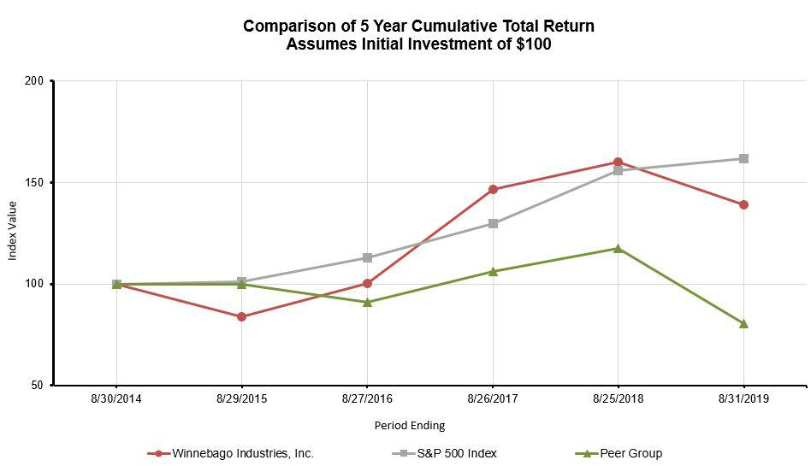

 | Base Period
 | August 30, |  | August 29, |  | August 27, |  | August 26, |  | August 25, |  | August 31,
Company/Index | 2014 |  | 2015 |  | 2016 |  | 2017 |  | 2018 |  | 2019
Winnebago Industries, Inc. | 100.00 |  | 83.98 |  | 100.25 |  | 146.84 |  | 159.98 |  | 139.15
S&P 500 Index | 100.00 |  | 101.32 |  | 112.94 |  | 129.87 |  | 155.77 |  | 161.89
Peer Group | 100.00 |  | 99.79 |  | 90.86 |  | 106.13 |  | 117.57 |  | 80.43
Source: Zacks Investment Research, Inc.
 |  |  | 21

Table of Contents
Item 6. Selected Financial Data.
(in thousands, except per share data)
Fiscal Year |  |  | 2019 |  |  | 2018 |  |  | 2017⁽¹⁾ |  |  | 2016 |  |  | 2015
Consolidated Statements of Income Data:
Net revenues |  | $ | 1,985,674 |  | $ | 2,016,829 |  | $ | 1,547,119 |  | $ | 975,226 |  | $ | 976,505
Net income |  |  | 111,798 |  |  | 102,357 |  |  | 71,330 |  |  | 45,496 |  |  | 41,210
Income per common share:
Basic |  |  | 3.55 |  |  | 3.24 |  |  | 2.33 |  |  | 1.69 |  |  | 1.53
Diluted |  |  | 3.52 |  |  | 3.22 |  |  | 2.32 |  |  | 1.68 |  |  | 1.52
Dividends paid per common share |  |  | 0.43 |  |  | 0.40 |  |  | 0.40 |  |  | 0.40 |  |  | 0.36
Year End Data:
Total assets |  |  | 1,104,231 |  |  | 1,051,805 |  |  | 902,512 |  |  | 390,718 |  |  | 362,174
Total non-current liabilities |  |  | 274,275 |  |  | 313,175 |  |  | 293,680 |  |  | 29,410 |  |  | 59,601

Note: Fiscal 2019 included 53 weeks. All other years presented included 52 weeks.

(1) Includes Grand Design operations from the date of its acquisition on November 8, 2016.

Item 7. Management's Discussion and Analysis of Financial Condition and Results of Operations.

Management's Discussion and Analysis of Financial Condition and Results of Operations (MD&A) is intended to provide a reader of our financial statements with a narrative from the perspective of our management on our financial condition, results of operations, liquidity, and certain other factors that may affect our future results. Our MD&A is presented in six sections:

- Overview

- Results of Operations

- Analysis of Financial Condition, Liquidity, and Capital Resources

- Contractual Obligations and Commercial Commitments

- Critical Accounting Estimates

- New Accounting Pronouncements

Our MD&A should be read in conjunction with the Consolidated Financial Statements and related Notes included in Item 8, Financial Statements and Supplementary Data, of this Annual Report on Form 10-K.

Overview

Winnebago Industries, Inc. is one of the leading U.S. manufacturers with a diversified portfolio of recreation vehicles ("RV"s) and marine products used primarily in leisure travel and outdoor recreation activities. We produce our Towable units in IN; our Motorhome units in manufacturing facilities in IA; and our marine products in FL. We distribute our RV and marine products primarily through independent dealers throughout the U.S. and Canada, who then retail the products to the end consumer. We also distribute our marine products internationally through independent dealers, who then retail the products to the end consumer.

Non-GAAP Reconciliation

This MD&A includes financial information prepared in accordance with accounting principles generally accepted in the U.S. ("GAAP"), as well as certain adjusted or non-GAAP financial measures such as EBITDA and Adjusted EBITDA. EBITDA is defined as net income before interest expense, provision for income taxes, and depreciation and amortization expense. Adjusted EBITDA is defined as net income before interest expense, provision for income taxes, depreciation and amortization expense, and other adjustments made in order to present comparable results from period to period. These non-GAAP financial measures, which are not calculated or presented in accordance with GAAP, have been provided as information supplemental and in addition to the financial measures presented in accordance with GAAP. Such non-GAAP financial measures should not be considered superior to, as a substitute for, or as an alternative to, and should be considered in conjunction with, the GAAP financial measures presented herein. The non-GAAP financial measures presented may differ from similar measures used by other companies.

Refer to the Results of Operations-Fiscal 2019 Compared to Fiscal 2018 and the Results of Operations-Fiscal 2018 Compared to Fiscal 2017 for a detailed reconciliation of items that impacted EBITDA and Adjusted EBITDA. We have included this non-GAAP performance measure as a comparable measure to illustrate the effect of non-recurring transactions occurring during the year and improve comparability of our results from period to period. We believe Adjusted EBITDA provides meaningful supplemental information about our operating performance because this measure excludes amounts that we do not consider part of our core

22

Table of Contents

operating results when assessing our performance. Examples of items excluded from Adjusted EBITDA include acquisition-related costs, restructuring expenses, and non-operating income.

Management uses these non-GAAP financial measures (a) to evaluate our historical and prospective financial performance and trends as well as our performance relative to competitors and peers;

- to measure operational profitability on a consistent basis; (c) in presentations to the members of our board of directors to enable our board of directors to have the same measurement basis of operating performance as is used by management in its assessments of performance and in forecasting and budgeting for our company; (d) to evaluate potential acquisitions; and (e) to ensure compliance with covenants and restricted activities under the terms of our Credit Agreement, as further described in Note 9, Long-Term Debt, of the Notes to Consolidated Financial Statements, included in Item 8, Financial Statements and Supplementary Data, of this Annual Report on Form 10-K. We believe these non-GAAP financial measures are frequently used by securities analysts, investors, and other interested parties to evaluate companies in our industry.

Business Combinations

On June 4, 2018, we acquired 100% of the ownership interests of Chris-Craft, a privately-owned company based in Sarasota, FL. Chris-Craft manufactures and sells premium quality boats in the recreational powerboat industry through an established global network of independent authorized dealers.

On November 8, 2016, we closed on the acquisition of all the issued and outstanding capital stock of towable RV manufacturer Grand Design RV, LLC ("Grand Design") for an aggregate purchase price of $520.5 million. This acquisition was funded from our cash on hand, $353.0 million from asset-based revolving and term loan credit facilities, as well as stock consideration as is more fully described in Note 2, Business Combinations, of the Notes to Consolidated Financial Statements, included in Item 8, Financial Statements and Supplementary Data, of this Annual Report on Form 10-K. We purchased Grand Design to significantly expand our existing towable RV product offerings and dealer base and acquire additional talent in the RV industry.

Subsequent to Year-end

On September 15, 2019, we entered into a definitive agreement to acquire Newmar Corporation for total consideration of approximately $344 million, based on the closing price of our stock on September 13, 2019. The consideration will consist of approximately $270.0 million in cash and a fixed amount of 2.0 million shares of our stock. Newmar is a leading manufacturer of Class A and Super C motorized recreational vehicles that sells through an established network of independent authorized dealers throughout North America.

The Purchase Agreement also provides that we may terminate the Purchase Agreement if our stock price falls below $20.00 per share, in which case we will be subject to a termination fee of $5.0 million. The acquisition is not subject to approval by our shareholders.

In connection with the execution of the Purchase Agreement, we executed a commitment letter with Goldman Sachs Bank USA, Bank of Montreal, and BMO Capital Markets Corp. (the “Commitment Letter”). As set forth in the Commitment Letter, (a) we intend to obtain up to $290.0 million in gross cash proceeds from the issuance of senior secured notes (the “Senior Notes”) and (b) if we do not, or are unable to, issue the full amount of the Senior Notes at or prior to the time of the closing of the acquisition, we plan to obtain a senior secured bridge facility in an amount up to $290.0 million minus any gross cash proceeds received by us from the issuance of any Senior Notes or other securities.

Reportable Segments

We have five operating segments: 1) Grand Design towables, 2) Winnebago towables, 3) Winnebago motorhomes, 4) Chris-Craft marine, and 5) Winnebago specialty vehicles. We evaluate performance based on each operating segment's Adjusted EBITDA, as defined above, which excludes certain corporate administration expenses and non-operating income and expense.

Our two reportable segments include: 1) Towable (comprised of products which are not motorized and are generally towed by another vehicle as well as other related manufactured products and services), which is an aggregation of the Winnebago towables and Grand Design towables operating segments, and 2) Motorhome (comprised of products that include a motorized chassis as well as other related manufactured products and services).

The Corporate / All Other category includes the Winnebago specialty vehicles and Chris-Craft marine operating segments as well as expenses related to certain corporate administration expenses for the oversight of the enterprise. These expenses include items such as corporate leadership and administration costs.

Industry Trends

Key reported statistics for the North American RV industry are as follows:

- Wholesale unit shipments: RV product delivered to the dealers, which is reported monthly by the Recreation Vehicle Industry Association ("RVIA") 23

Table of Contents

- Retail unit registrations: consumer purchases of RVs from dealers, which is reported by Stat Surveys

We track RV Industry conditions using these key statistics to monitor trends and evaluate and understand our performance relative to the overall industry. The following is an analysis of changes in these key statistics for the rolling 12 months through August as of 2019 and 2018:

 |  |  |  |  |  |  | US and Canada Industry
 |  |  | Wholesale Unit Shipments per RVIA |  |  |  |  |  |  | Retail Unit Registrations per Stat Surveys
 |  |  | Rolling 12 Months through August |  |  |  |  |  |  |  | Rolling 12 Months through August
 | 2019 |  | 2018 |  | Unit Change |  | % Change |  | 2019 |  | 2018 |  | Unit Change |  | % Change
Towable⁽¹⁾ | 355,598 |  | 443,791 |  | (88,193) |  | (19.9)% |  | 395,181 | 421,013 |  |  | (25,832) |  | (6.1)%
Motorhome⁽²⁾ | 48,605 |  | 62,095 |  | (13,490) |  | (21.7)% |  | 52,416 |  | 59,204 |  | (6,788) |  | (11.5)%
Combined | 404,203 |  | 505,886 |  | (101,683) |  | (20.1)% |  | 447,597 | 480,217 |  |  | (32,620) |  | (6.8)%

- Towable: Fifth wheel and travel trailer products.

- Motorhome: Class A, B and C products.

The rolling twelve months shipments for 2019 and 2018 reflect a contraction in shipments as dealers rationalize inventory. The rolling twelve months retail information for 2019 and 2018 illustrates that the RV industry is growing at a slower rate than previous quarters, however ahead of wholesale shipments. We believe retail demand is the key driver to continued growth in the industry.

The most recent RVIA wholesale shipment forecasts for calendar year 2020, as noted in the table below, indicate that industry shipments are most likely expected to decline in 2020. The RV sales outlook for 2019 considers the continuation of dealer inventory realignment that has been occurring over the last 9-12 months and gradually increasing interest rates, partially offset by anticipated growth in wages and employment levels.

 |  |  | Calendar Year
 | 2020 |  | 2019
Wholesale Unit Shipment Forecast per RVIA⁽¹⁾ | Forecast |  | Actual |  | Unit Change |  | % Change
Aggressive | 400,900 |  | 401,200 |  | (300) |  | (0.1)%
Most likely | 387,400 |  | 401,200 |  | (13,800) |  | (3.4)%
Conservative | 368,000 |  | 401,200 |  | (33,200) |  | (8.3)%

(1) Prepared by Dr. Richard Curtin of the University of Michigan Consumer Survey Research Center for RVIA and reported in the Roadsigns RV Fall 2019 Industry Forecast Issue.

Market Share

Our retail unit market share, as reported by Stat Surveys based on state records, is illustrated below. Note that this data is subject to adjustment and is continuously updated.

 | Rolling 12 Months through August |  |  |  |  |  |  |  |  | Calendar Year
US and Canada | 2019 | 2018 |  |  | 2018 |  |  |  |  | 2017 |  | 2016⁽¹⁾
Travel trailer and fifth wheels |  | 8.8% |  |  | 7.4% |  |  | 7.8% |  | 6.1% |  | 1.7%
Motorhome A, B, C |  | 15.3% |  |  | 15.6% |  |  | 15.6% |  | 16.3% |  | 18.0%
Total market share |  | 9.5% |  |  | 8.5% |  |  | 8.7% |  | 7.4% |  | 3.7%

(1) Includes retail unit market share for Grand Design since acquisition on November 8, 2016.

Facility Expansion

Due to the rapid growth in our Towable segment, we have implemented facility expansion projects in our Grand Design towables and Winnebago towables operating segments. The Grand Design towables expansion project consisted of three new production facilities--two were completed in Fiscal 2018 and the remaining is expected to be completed mid-Fiscal 2020. The facility expansion in the Winnebago towables division was completed in the third quarter of Fiscal 2019.

Enterprise Resource Planning System

In the second quarter of Fiscal 2015, our Board of Directors approved the strategic initiative of implementing an enterprise resource planning ("ERP") system to replace our legacy business applications. The new ERP platform will provide better support for our

24

Table of Contents

changing business needs and plans for future growth. Our initial cost estimates have grown for additional needs of the business, such as the opportunity to integrate the ERP system with additional manufacturing systems. The project includes software, external implementation assistance, and increased internal staffing directly related to this initiative. We anticipate that approximately 40% of the cost will be expensed in the period incurred and 60% will be capitalized and depreciated over its useful life.

The following table illustrates the cumulative project costs:

 |  |  |  |  |  |  |  |  |  |  |  |  |  |  |  |  | Cumulative
(in thousands) |  | 2019 |  |  | 2018 |  |  | 2017 |  |  | 2016 |  |  | 2015 |  |  | Investment
Capitalized | $ | 3,875 |  | $ | 5,941 |  | $ | 1,881 |  | $ | 7,798 |  | $ | 3,291 |  | $ | 22,786 |  |  | 57.5%
Expensed |  | 3,709 |  |  | 2,107 |  |  | 2,601 |  |  | 5,930 |  |  | 2,528 |  |  | 16,875 |  |  | 42.5%
Total | $ | 7,584 |  | $ | 8,048 |  | $ | 4,482 |  | $ | 13,728 |  | $ | 5,819 |  | $ | 39,661 |  |  | 100.0%

Restructuring

On February 4, 2019, we announced our intent to move our Motorhome diesel production from Junction City, OR to Forest City, IA to enable more effective product development and improve our cost structure. These restructuring activities resulted in pretax charges of $1.9 million in Fiscal 2019. These expenses are included in our Motorhome segment and include employee-related costs and accelerated depreciation for assets that will no longer be used. Employee-related costs were primarily paid in Fiscal 2019. We expect additional expenses of approximately $1.0 million in Fiscal 2020, primarily related to facility closure costs. We expect these expenses to be fully offset by the corresponding savings generated by the project.

We currently estimate that upon completion of this restructuring plan in Fiscal 2020, these actions will reduce annual costs by approximately $4.0 million, which is primarily due to lower employee-related costs, lower depreciation expense, and other manufacturing and logistics efficiencies. We achieved a portion of these savings in Fiscal 2019. We expect a portion of these savings will be achieved in Fiscal 2020, and the full annual benefit of these actions is expected in Fiscal 2021.

Results of Operations - Fiscal 2019 Compared to Fiscal 2018

Consolidated Performance Summary

The following is an analysis of changes in key items included in the statements of operations for the fiscal year ended August 31, 2019 compared to the fiscal year ended August 25, 2018:

(in thousands, except percent and per share
data) |  | 2019 |  | % of Revenues⁽¹⁾ |  |  | 2018 |  | % of Revenues⁽¹⁾ |  |  | $ Change |  | % Change
Net revenues | $ | 1,985,674 |  | 100.0 % |  | $ | 2,016,829 |  | 100.0 % |  | $ | (31,155) |  | (1.5)%
Cost of goods sold |  | 1,678,477 |  | 84.5 % |  |  | 1,716,993 |  | 85.1 % |  |  | (38,516) |  | (2.2)%
Gross profit |  | 307,197 |  | 15.5 % |  |  | 299,836 |  | 14.9 % |  |  | 7,361 |  | 2.5 %
Selling, general, and administrative expenses
("SG&A") |  | 142,295 |  | 7.2 % |  |  | 130,116 |  | 6.5 % |  |  | 12,179 |  | 9.4 %
Amortization of intangible assets |  | 9,635 |  | 0.5 % |  |  | 9,328 |  | 0.5 % |  |  | 307 |  | 3.3 %
Total operating expenses |  | 151,930 |  | 7.7 % |  |  | 139,444 |  | 6.9 % |  |  | 12,486 |  | 9.0 %
Operating income |  | 155,267 |  | 7.8 % |  |  | 160,392 |  | 8.0 % |  |  | (5,125) |  | (3.2)%
Interest expense |  | 17,939 |  | 0.9 % |  |  | 18,246 |  | 0.9 % |  |  | (307) |  | (1.7)%
Non-operating income |  | (1,581) |  | (0.1)% |  |  | (494) |  | — % |  |  | 1,087 |  | 220.0 %
Income before income taxes |  | 138,909 |  | 7.0 % |  |  | 142,640 |  | 7.1 % |  |  | (3,731) |  | (2.6)%
Provision for income taxes |  | 27,111 |  | 1.4 % |  |  | 40,283 |  | 2.0 % |  |  | (13,172) |  | (32.7)%
Net income | $ | 111,798 |  | 5.6 % |  | $ | 102,357 |  | 5.1 % |  | $ | 9,441 |  | 9.2 %
Diluted income per share | $ | 3.52 |  |  |  | $ | 3.22 |  |  |  | $ | 0.30 |  | 9.3 %
Diluted average shares outstanding |  | 31,721 |  |  |  |  | 31,814 |  |  |  |  | (93) |  | (0.3)%

(1) Percentages may not add due to rounding differences.

Net revenues decreased in Fiscal 2019 compared to Fiscal 2018 primarily due to a decrease in our Motorhome segment sales, which is partially offset by an increase in our Towable segment sales and the acquisition of Chris-Craft in the fourth quarter of Fiscal 2018.

25

Table of Contents

Gross profit as a percentage of revenue increased in Fiscal 2019 compared to Fiscal 2018 due to a favorable mix and pricing that were partially offset by higher allowances and higher cost inputs.

Operating expenses increased in Fiscal 2019 compared to Fiscal 2018 due to the addition of the Chris-Craft business and investments in our business, partially offset by a reduction in variable compensation.

Interest expense decreased in Fiscal 2019 compared to Fiscal 2018 due to the unamortized debt issuance costs expensed in Fiscal 2018 related to our voluntary prepayment on our Credit Agreement and our Credit Agreement amendment during the second quarter of Fiscal 2018, which resulted in a decrease to the interest rate spread by 1.0% on the Term Loan and 0.25% on the ABL.

Non-operating income increased in Fiscal 2019 compared to Fiscal 2018 due to net proceeds received from company-owned life insurance policies.

The effective tax rate decreased to 19.5% in Fiscal 2019 compared to 28.2% in Fiscal 2018 primarily due to the enactment of the Tax Cuts and Jobs Act (the "Tax Act") on December 22, 2017 and $3.6 million in net favorable discrete items, primarily attributable to R&D-related tax credits, realized in the current fiscal year. The reduction related to the enactment of the Tax Act is primarily attributable to the reduction in the Federal statutory tax rate to 21% being applied to the entirety of Fiscal 2019 earnings whereas Fiscal 2018 utilized a blended rate of 25.9%.

Net income and diluted income per share increased in Fiscal 2019 compared to Fiscal 2018 primarily due to a lower effective tax rate and increased Towable segment sales, partially offset by a decrease in our Motorhome segment profitability.

Non-GAAP Reconciliation
The following table reconciles net income to consolidated EBITDA and Adjusted EBITDA for Fiscal 2019 and 2018:
(in thousands) |  | 2019 |  |  | 2018
Net income | $ | 111,798 |  | $ | 102,357
Interest expense |  | 17,939 |  |  | 18,246
Provision for income taxes |  | 27,111 |  |  | 40,283
Depreciation |  | 13,682 |  |  | 9,849
Amortization of intangible assets |  | 9,635 |  |  | 9,328
EBITDA |  | 180,165 |  |  | 180,063
Restructuring⁽¹⁾ |  | 1,068 |  |  | —
Acquisition-related costs |  | — |  |  | 2,177
Non-operating income |  | (1,581) |  |  | (494)
Adjusted EBITDA | $ | 179,652 |  | $ | 181,746

- Balance excludes depreciation expense classified as restructuring as the balance is already included in the EBITDA calculation.

26

Table of Contents

Reportable Segment Performance Summary

Towable

The following is an analysis of key changes in our Towable segment for Fiscal 2019 and 2018:

(in thousands, except ASP) |  | 2019 |  | % of Revenues |  |  | 2018 |  | % of Revenues |  |  | $ Change |  | % Change
Net revenues | $ | 1,197,327 |  |  |  | $ | 1,127,723 | $ |  |  |  | 69,604 |  | 6.2 %
Adjusted EBITDA |  | 163,677 | 13.7% |  |  |  | 157,010 | 13.9% |  |  |  | 6,667 |  | 4.2 %
Average Selling Price ("ASP")⁽¹⁾ |  | 32,811 |  |  |  |  | 30,941 |  |  |  |  | 1,870 |  | 6.0 %
Unit deliveries |  | 2019 |  | Product Mix⁽²⁾ |  |  | 2018 |  | Product Mix⁽²⁾ |  |  | Unit Change |  | % Change
Travel trailer |  | 22,458 | 61.0% |  |  |  | 22,360 | 61.1% |  |  |  | 98 |  | 0.4 %
Fifth wheel |  | 14,371 |  | 39.0% |  |  | 14,229 |  | 38.9% |  |  | 142 |  | 1.0 %
Total Towable |  | 36,829 |  | 100.0% |  |  | 36,589 |  | 100.0% |  |  | 240 |  | 0.7 %
($ in thousands) |  | August 31, 2019 |  |  |  |  | August 25, 2018 |  |  |  |  | Change |  | % Change
Backlog⁽³⁾
Units |  | 7,225 |  |  |  |  | 7,651 |  |  |  |  | (426) |  | (5.6)%
Dollars | $ | 234,339 |  |  |  | $ | 244,854 | $ |  |  |  | (10,515) |  | (4.3)%
Dealer Inventory
Units |  | 15,658 |  |  |  |  | 14,877 |  |  |  |  | 781 |  | 5.2 %

- ASP excludes off-invoice dealer incentives.

- Percentages may not add due to rounding differences.

- We include in our backlog all accepted orders from dealers to generally be shipped within the next six months. Orders in backlog can be cancelled or postponed at the option of the dealer at any time without penalty and, therefore, backlog may not necessarily be an accurate measure of future sales.

Net revenues increased in Fiscal 2019 compared to Fiscal 2018 due to increased pricing and organic volume growth.

ASP increased in Fiscal 2019 compared to Fiscal 2018 due to price increases as well as favorable product mix.

Adjusted EBITDA increased in Fiscal 2019 compared to Fiscal 2018 primarily due to sales growth, offset partially by higher incentives to dealers and higher input costs.

Unit deliveries increased in Fiscal 2019 to Fiscal 2018 primarily due to volume growth in excess of recent industry trends. Our Towable segment market share increased from 7.4% to 8.8% when comparing retail registrations during the twelve-month trailing periods ended August 2018 and August 2019. Shipments grew faster than the industry as a result of greater penetration of our new products and further expansion of our products on dealer lots.

We have seen a decrease in the backlog volumes as of August 31, 2019 compared to August 25, 2018 due to our utilization of additional capacity added during 2018 and a change in our dealer ordering patterns as a result of a more challenging retail environment, partially offset by strong demand for our new products.

27

Table of Contents

Motorhome

The following is an analysis of key changes in our Motorhome segment for Fiscal 2019 and 2018:

(in thousands, except ASP) |  | 2019 |  | % of Revenues |  |  | 2018 |  | % of Revenues |  |  | $ Change |  | % Change
Net revenues | $ | 706,927 |  |  |  | $ | 860,675 | $ |  |  |  | (153,748) |  | (17.9)%
Adjusted EBITDA |  | 27,455 | 3.9% |  |  |  | 35,508 | 4.1% |  |  |  | (8,053) |  | (22.7)%
_{ASP}(1) |  | 93,549 |  |  |  |  | 89,879 |  |  |  |  | 3,670 |  | 4.1 %
Unit deliveries |  | 2019 |  | Product Mix⁽²⁾ |  |  | 2018 |  | Product Mix⁽²⁾ |  |  | Unit Change |  | % Change
Class A |  | 1,582 | 20.8% |  |  |  | 2,997 | 31.4% |  |  |  | (1,415) |  | (47.2)%
Class B |  | 2,784 | 36.7% |  |  |  | 2,012 | 21.1% |  |  |  | 772 |  | 38.4 %
Class C |  | 3,225 |  | 42.5% |  |  | 4,539 |  | 47.5% |  |  | (1,314) |  | (28.9)%
Total Motorhome |  | 7,591 |  | 100.0% |  |  | 9,548 |  | 100.0% |  |  | (1,957) |  | (20.5)%
($ in thousands) |  | August 31, 2019 |  |  |  |  | August 25, 2018 |  |  |  |  | Change |  | % Change
Backlog⁽³⁾
Units |  | 1,808 |  |  |  |  | 1,693 |  |  |  |  | 115 |  | 6.8 %
Dollars | $ | 165,373 |  |  |  | $ | 157,554 | $ |  |  |  | 7,819 |  | 5.0 %
Dealer Inventory
Units |  | 3,891 |  |  |  |  | 4,620 |  |  |  |  | (729) |  | (15.8)%

- ASP excludes off-invoice dealer incentives.

- Percentages may not add due to rounding differences.

- We include in our backlog all accepted orders from dealers to generally be shipped within the next six months. Orders in backlog can be cancelled or postponed at the option of the dealer at any time without penalty and, therefore, backlog may not necessarily be an accurate measure of future sales.

Net revenues decreased in Fiscal 2019 compared to Fiscal 2018 due to a decrease in the number of units sold, partially offset by increased pricing.

ASP increased in Fiscal 2019 compared to Fiscal 2018 due to price increases implemented during the second half of Fiscal 2018.

Adjusted EBITDA decreased in Fiscal 2019 compared to Fiscal 2018 due to lower volume and higher input costs, partially offset by increased pricing and favorable mix of business.

Unit deliveries decreased in Fiscal 2019 compared to Fiscal 2018 driven by decreases in our Class A and Class C products, partially offset by an increase in our Class B products.

We have seen an increase in the volume and dollar value of backlog as of August 31, 2019 compared to August 25, 2018 due to the introduction of new product models.

28

Table of Contents

Results of Operations - Fiscal 2018 Compared to Fiscal 2017

Consolidated Performance Summary

The following is an analysis of changes in key items included in the statements of operations for the fiscal year ended August 25, 2018 compared to the fiscal year ended August 26, 2017:

(in thousands, except percent and per share
data) |  | 2018 |  | % of Revenues⁽¹⁾ |  |  | 2017 |  | % of Revenues⁽¹⁾ |  |  | $ Change |  | % Change
Net revenues | $ | 2,016,829 |  | 100.0 % |  | $ | 1,547,119 |  | 100.0 % |  | $ | 469,710 |  | 30.4 %
Cost of goods sold |  | 1,716,993 |  | 85.1 % |  |  | 1,324,542 |  | 85.6 % |  |  | 392,451 |  | 29.6 %
Gross profit |  | 299,836 |  | 14.9 % |  |  | 222,577 |  | 14.4 % |  |  | 77,259 |  | 34.7 %
SG&A |  | 130,116 |  | 6.5 % |  |  | 97,607 |  | 6.3 % |  |  | 32,509 |  | 33.3 %
Postretirement health care benefit income |  | — |  | — % |  |  | (24,796) |  | (1.6)% |  |  | 24,796 |  | (100.0)%
Amortization of intangible assets |  | 9,328 |  | 0.5 % |  |  | 24,660 |  | 1.6 % |  |  | (15,332) |  | (62.2)%
Total operating expenses |  | 139,444 |  | 6.9 % |  |  | 97,471 |  | 6.3 % |  |  | 41,973 |  | 43.1 %
Operating income |  | 160,392 |  | 8.0 % |  |  | 125,106 |  | 8.1 % |  |  | 35,286 |  | 28.2 %
Interest expense |  | 18,246 |  | 0.9 % |  |  | 16,837 |  | 1.1 % |  |  | 1,409 |  | 8.4 %
Non-operating income |  | (494) |  | — % |  |  | (330) |  | — % |  |  | 164 |  | 49.7 %
Income before income taxes |  | 142,640 |  | 7.1 % |  |  | 108,599 |  | 7.0 % |  |  | 34,041 |  | 31.3 %
Provision for income taxes |  | 40,283 |  | 2.0 % |  |  | 37,269 |  | 2.4 % |  |  | 3,014 |  | 8.1 %
Net income | $ | 102,357 |  | 5.1 % |  | $ | 71,330 |  | 4.6 % |  | $ | 31,027 |  | 43.5 %
Diluted income per share | $ | 3.22 |  |  |  | $ | 2.32 |  |  |  | $ | 0.90 |  | 38.8 %
Diluted average shares outstanding |  | 31,814 |  |  |  |  | 30,766 |  |  |  |  | 1,048 |  | 3.4 %

(1) Percentages may not add due to rounding differences.

Consolidated net revenues increased in Fiscal 2018 compared to Fiscal 2017 primarily due to organic volume growth in our Towable segment and acquisition-related growth.

Gross profit as a percentage of revenue increased in Fiscal 2018 compared to Fiscal 2017 driven by a favorable mix due to the accelerated growth in the Towable segment.

Selling expenses increased in Fiscal 2018 compared to Fiscal 2017 primarily due to volume growth in our Towable segment.

Total general and administrative expenses increased in Fiscal 2018 compared to Fiscal 2017 due primarily to the $24.8 million benefit recorded in Fiscal 2017 associated with the termination of the postretirement health care plan, investments in our business, and incentives related to the growth in our business. The increase was partially offset by the reduction of amortization of definite-lived intangible assets, driven by the Grand Design acquisition in Fiscal 2017.

Interest expense increased in Fiscal 2018 compared to Fiscal 2017, which was related to our Credit Agreements associated with the acquisition of Grand Design. See Analysis of Financial Condition, Liquidity, and Resources and Note 9, Long-Term Debt, of the Notes to Consolidated Financial Statements, included in Item 8, Financial Statements and Supplementary Data, of this Annual Report on Form 10-K for further information.

The overall effective income tax rate for Fiscal 2018 was 28.2% compared to the effective income tax rate of 34.3% for Fiscal 2017. The decrease in the tax rate from Fiscal 2017 to Fiscal 2018 was primarily due to the decrease in the Federal statutory rate as part of the enactment of the Tax Act on December 22, 2017. The decrease was partially offset by the required remeasurement of our net deferred tax assets due to the change in the Federal statutory tax rate.

Net income and diluted income per share increased in Fiscal 2018 compared to Fiscal 2017 primarily due to the sales increase in the Towable segment, the increased gross profit rate, and the lower effective income tax rate. These increases were partially offset by an increase in the SG&A rate driven primarily by the termination of the postretirement health care plan, which lowered expense in Fiscal 2017.

29

Table of Contents
Non-GAAP Reconciliation
The following table reconciles net income to consolidated EBITDA and Adjusted EBITDA for Fiscal 2018 and 2017:
(in thousands) |  |  | 2018 |  |  | 2017
Net income |  | $ | 102,357 |  | $ | 71,330
Interest expense |  |  | 18,246 |  |  | 16,837
Provision for income taxes |  |  | 40,283 |  |  | 37,269
Depreciation |  |  | 9,849 |  |  | 7,315
Amortization of intangible assets |  |  | 9,328 |  |  | 24,660
EBITDA |  |  | 180,063 |  |  | 157,411
Postretirement health care benefit income |  |  | — |  |  | (24,796)
Acquisition-related costs |  |  | 2,177 |  |  | 6,592
Non-operating income |  |  | (494) |  |  | (330)
Adjusted EBITDA |  | $ | 181,746 |  | $ | 138,877

Reportable Segment Performance Summary

Towable

The following is an analysis of key changes in our Towable segment for Fiscal 2018 and 2017:

(in thousands, except ASP) |  | 2018 |  | % of Revenues |  |  | 2017 |  | % of Revenues |  |  | $ Change |  | % Change
Net revenues | $ | 1,127,723 |  |  |  | $ | 685,197 | $ |  |  |  | 442,526 |  | 64.6 %
Adjusted EBITDA |  | 157,010 | 13.9% |  |  |  | 89,734 | 13.1% |  |  |  | 67,276 |  | 75.0 %
_{ASP}(1) |  | 30,941 |  |  |  |  | 30,571 |  |  |  |  | 370 |  | 1.2 %
Unit deliveries |  | 2018 |  | Product Mix⁽²⁾ |  |  | 2017 |  | Product Mix⁽²⁾ |  |  | Unit Change |  | % Change
Travel trailer |  | 22,360 | 61.1% |  |  |  | 13,650 | 60.7% |  |  |  | 8,710 |  | 63.8 %
Fifth wheel |  | 14,229 |  | 38.9% |  |  | 8,824 |  | 39.3% |  |  | 5,405 |  | 61.3 %
Total Towable |  | 36,589 |  | 100.0% |  |  | 22,474 |  | 100.0% |  |  | 14,115 |  | 62.8 %
($ in thousands) |  | August 25, 2018 |  |  |  |  | August 26, 2017 |  |  |  |  | Change |  | % Change
Backlog⁽³⁾
Units |  | 7,651 |  |  |  |  | 8,001 |  |  |  |  | (350) |  | (4.4)%
Dollars | $ | 244,854 |  |  |  | $ | 229,706 | $ |  |  |  | 15,148 |  | 6.6 %
Dealer Inventory
Units |  | 14,877 |  |  |  |  | 9,545 |  |  |  |  | 5,332 |  | 55.9 %

- ASP excludes off-invoice dealer incentives.

- Percentages may not add due to rounding differences.

- We include in our backlog all accepted orders from dealers to generally be shipped within the next six months. Orders in backlog can be cancelled or postponed at the option of the dealer at any time without penalty and, therefore, backlog may not necessarily be an accurate measure of future sales.

Towable net revenues increased in Fiscal 2018 as compared to Fiscal 2017 primarily due to organic volume growth as well as the annualization of net revenues related to the Fiscal 2017 acquisition of Grand Design.

Towable unit deliveries grew in Fiscal 2018 as compared to Fiscal 2017 primarily due to Towable growth in excess of recent industry trends and due to the acquisition of Grand Design. With the addition of Grand Design in the first quarter of Fiscal 2017, our Towable market share increased to 7.4% from 5.2% when comparing shipments during the twelve-month trailing periods ended August 2018 and August 2017.

Towable Adjusted EBITDA increased in Fiscal 2018 as compared to Fiscal 2017 due to the favorable impact of organic growth as well as the annualization of net revenues related to the Fiscal 2017 acquisition of Grand Design. We achieved strong results in our

30

Table of Contents

Towable segment, where shipments grew much faster than the industry as a result of greater penetration of our new products and further expansion of our distribution base, as well as higher gross profit from cost savings initiatives and pricing, which more than offset escalating cost inputs.

Motorhome

The following is an analysis of key changes in our Motorhome segment for Fiscal 2018 and 2017:

(in thousands, except ASP) |  | 2018 |  | % of Revenues |  |  | 2017 |  | % of Revenues |  |  | $ Change |  | % Change
Net revenues | $ | 860,675 |  |  |  | $ | 853,360 | $ |  |  |  | 7,315 |  | 0.9 %
Adjusted EBITDA |  | 35,508 | 4.1% |  |  |  | 56,518 | 6.6% |  |  |  | (21,010) |  | (37.2)%
ASP⁽¹⁾ |  | 89,879 |  |  |  |  | 91,759 |  |  |  |  | (1,880) |  | (2.0)%
Unit deliveries |  | 2018 |  | Product Mix⁽²⁾ |  |  | 2017 |  | Product Mix⁽²⁾ |  |  | Unit Change |  | % Change
Class A |  | 2,997 | 31.4% |  |  |  | 3,182 | 34.4% |  |  |  | (185) |  | (5.8)%
Class B |  | 2,012 | 21.1% |  |  |  | 1,541 | 16.6% |  |  |  | 471 |  | 30.6 %
Class C |  | 4,539 |  | 47.5% |  |  | 4,537 |  | 49.0% |  |  | 2 |  | — %
Total Motorhome |  | 9,548 |  | 100.0% |  |  | 9,260 |  | 100.0% |  |  | 288 |  | 3.1 %
($ in thousands) |  | August 25, 2018 |  |  |  |  | August 26, 2017 |  |  |  |  | Change |  | % Change
Backlog⁽³⁾
Units |  | 1,693 |  |  |  |  | 1,293 |  |  |  |  | 400 |  | 30.9 %
Dollars | $ | 157,554 |  |  |  | $ | 122,142 | $ |  |  |  | 35,412 |  | 29.0 %
Dealer Inventory
Units |  | 4,620 |  |  |  |  | 4,282 |  |  |  |  | 338 |  | 7.9 %

- ASP excludes off-invoice dealer incentives.

- Percentages may not add due to rounding differences.

- We include in our backlog all accepted orders from dealers to generally be shipped within the next six months. Orders in backlog can be cancelled or postponed at the option of the dealer at any time without penalty and, therefore, backlog may not necessarily be an accurate measure of future sales.

Motorhome net revenues increased in Fiscal 2018 as compared to Fiscal 2017 primarily due to an increase in the number of units sold, partially offset by product mix.

Motorhome unit deliveries grew slower than recent industry growth in Fiscal 2018 compared to Fiscal 2017. Our overall Motorhome market share moved to 15.7% from 16.4% when comparing shipments during the twelve-month trailing periods ended August 2018 and August 2017 due to a mix change from our Class A-diesel products to our Class B products.

Motorhome Adjusted EBITDA decreased in Fiscal 2018 as compared to Fiscal 2017 due to increased material costs and investments in our business, including higher costs and lower productivity associated with a new facility that produces our Class A diesel product line.

31

Table of Contents

Analysis of Financial Condition, Liquidity, and Capital Resources

Cash Flows

The following table summarizes our cash flows from total operations for Fiscal 2019, 2018, and 2017:

(in thousands) |  | 2019 |  |  | 2018 |  |  | 2017
Total cash provided by (used in):
Operating activities | $ | 133,750 |  | $ | 83,346 |  | $ | 97,127
Investing activities |  | (38,936) |  |  | (111,761) |  |  | (405,385)
Financing activities |  | (59,725) |  |  | (5,188) |  |  | 258,620
Net increase (decrease) in cash and cash equivalents | $ | 35,089 |  | $ | (33,603) |  | $ | (49,638)

Operating Activities

Cash provided by operating activities increased in Fiscal 2019 compared to Fiscal 2018 primarily due to steady profitability and working capital as a percent of sales.

Cash provided by operating activities decreased in Fiscal 2018 compared to Fiscal 2017 due to an increase in inventory to support organic growth, partially offset by growth in net income.

Investing Activities

Cash used in investing activities decreased in Fiscal 2019 compared to Fiscal 2018 primarily due to a decrease in cash used for the Chris-Craft acquisition in Fiscal 2018 partially offset by increased capital expenditures related to the capacity expansions within our Towable segment.

Cash used in investing activities for Fiscal 2018 consisted primarily of the acquisition of Chris-Craft and capital expenditures related to the capacity expansions taking place in our Towable segment. In Fiscal 2017, cash used in investing activities consisted of the acquisition of Grand Design for which we paid cash of $392.5 million, net of cash acquired, in addition to issuing Winnebago stock with a value of $124.1 million at closing.

Financing Activities

Cash used in financing activities increased in Fiscal 2019 compared to Fiscal 2018 primarily due to increased net payments on our Credit Agreement and increased share repurchases.

Cash used in financing activities for Fiscal 2018 consisted of payments on the Credit Agreement, dividend payments, and share repurchases; these were partially offset by cash proceeds on the Credit Agreement. Cash provided by financing activities for Fiscal 2017 consisted of cash proceeds from the Credit Agreement, partially offset by payments on the Credit Agreement, payment of debt issuance costs, and dividend payments.

Debt and Capital

As described in Note 9, Long-Term Debt, of the Notes to Consolidated Financial Statements, included in Item 8, Financial Statements and Supplementary Data, of this Annual Report on Form 10-K, our Credit Agreement consisted of a term loan B loan agreement ("Term Loan") and an asset-based revolving credit agreement ("ABL") (collectively, the "Credit Agreement") with JPMorgan Chase. The commitment under the ABL was increased to $192.5 million revolving credit agreement as of October 22, 2019.

Other Financial Measures

Working capital at August 31, 2019 and August 25, 2018 was $212.9 million and $167.8 million, respectively. We currently expect cash on hand, funds generated from operations, and the borrowing available under our Credit Agreement to be sufficient to cover both short-term and long-term operating requirements.

Capital Expenditures

We anticipate capital expenditures in Fiscal 2020 of approximately $35.0 million to $45.0 million. We will continue to invest in our ERP system as well as expand our Towable and marine facilities and make improvements to our Motorhome facilities.

32

Table of Contents

Share Repurchases and Dividends

We repurchase our common stock and pay dividends pursuant to programs approved by our Board of Directors. Our long-term capital allocation strategy is to first fund operations and investments in growth, maintain a debt leverage ratio within our targeted zone, maintain reasonable liquidity, and then return excess cash over time to shareholders through dividends and share repurchases.

On October 18, 2017, our Board of Directors authorized a share repurchase program in the amount of $70.0 million. There is no time restriction on the authorization. During Fiscal 2019, we repurchased 0.2 million shares of our common stock at a cost of $6.1 million. An additional 0.1 million shares of our common stock at a cost of $2.1 million were repurchased to satisfy tax obligations on employee equity awards as they vested. We continually evaluate if share repurchases reflect a prudent use of our capital and, subject to compliance with our Credit Agreement, we may purchase shares in the future. At August 31, 2019, we have $58.9 million remaining on our board repurchase authorization.

On August 14, 2019, our Board of Directors declared a quarterly cash dividend of $0.11 per share, totaling $3.5 million, paid on September 25, 2019 to common stockholders of record at the close of business on September 11, 2019.

Contractual Obligations and Commercial Commitments

Our principal contractual obligations and commercial commitments as of August 31, 2019 were as follows:

(in thousands) |  | Total
ABL⁽¹⁾ | $ | —
Term loan⁽²⁾ |  | 260,000
Interest at variable rate⁽³⁾ |  | 29,956
Net swap payments⁽⁴⁾ |  | 28,596
Deferred compensation obligations |  | 15,798
Operating leases⁽⁵⁾ |  | 25,057
Contracted services |  | 4,571
Unrecognized tax benefits⁽⁶⁾ |  | 3,591
Total contractual cash obligations | $ | 367,569

(In thousands) |  | Total
Contingent repurchase obligations | $ | 874,912

Payments Due by Period

 | Less than 1 Year |  |  | 1-3 Years |  |  | 3-5 Years |  | More than 5 Years
$ | — |  | $ | — |  | $ | — |  | $ | —
 | 10,250 |  |  | 30,000 |  |  | 219,750 |  |  | —
 | 8,447 |  |  | 14,596 |  |  | 6,913 |  |  | —
 | 6,580 |  |  | 13,675 |  |  | 8,341 |  |  | —
 | 2,925 |  |  | 5,606 |  |  | 4,288 |  |  | 2,979
 | 4,100 |  |  | 7,553 |  |  | 7,928 |  |  | 5,476
 | 1,771 |  |  | 2,088 |  |  | 665 |  |  | 47
 | — |  |  | — |  |  | — |  |  | —
$ | 34,073 |  | $ | 73,518 |  | $ | 247,885 |  | $ | 8,502

Expiration by Period

 | Less than 1 Year |  |  | 1-3 Years |  |  | 3-5 Years |  | More than 5 Years
$ | 770,005 |  | $ | 104,907 |  | $ | — |  | $ | —

Note: For additional information refer to Note 4, Derivatives, Investments, and Fair Value Measurements; Note 9, Long-Term Debt; Note 10, Employee and Retiree Benefits; and Note 11, Contingent Liabilities and Commitments, of the Notes to Consolidated Financial Statements, included in Item 8, Financial Statements and Supplementary Data, of this Annual Report on Form 10-K.

- Borrowings and repayments are expected to fluctuate over the term; therefore, we are not able to reasonably estimate in which future periods this amount will ultimately be settled.

- Our Term Loan matures on November 8, 2023. The contractual principal payments are included in the table. Additional principal payments are potentially due annually on a formula based on excess cash flow and the leverage ratio at that time as defined in the Credit Agreement. No amounts for this contingency are included in the above table.
- The Term Loan is at a variable rate and the interest in the table assumes the variable rate of 5.95% at August 31, 2019 is constant through the maturity dates of the debt and the principal payments on the term debt are made as scheduled. The variable rate is subject to change. Additionally, included in interest payments due by period is a 0.25% commitment fee on the ABL for unused borrowings, which are assumed to be at $165.0 million.

- We have an interest rate swap agreement with a notional amount of $120.0 million as of August 31, 2019 that decreases to $60.0 million on December 9, 2019 and expires on December 8, 2020. We pay a fixed rate at 1.82%, and receive a floating rate that was 2.45% at August 31, 2019. In the table, we have assumed the floating rate will be constant through the expiration of the interest rate swap when calculating the net swap payments. The variable rate is subject to change.
- Certain renewal options have been included in our future lease commitments as disclosed in Note 11, Contingent Liabilities and Commitments, of the Notes to Consolidated Financial Statements, included in Item

8, Financial Statements and Supplementary Data, of this Annual Report on Form 10-K. However, because these renewals have not been signed and are not contractually obligated, balances within the table exclude the payments related to these options.
- Unrecognized tax benefits relate to uncertain tax positions. As we are not able to reasonably estimate the timing of the payments or the amount by which the liability will increase or decrease over time, the related balances have not been reflected in the "Payments Due by Period" section of the table.

33

Table of Contents

Critical Accounting Estimates

Our consolidated financial statements are prepared in accordance with GAAP. In connection with the preparation of our financial statements, we are required to make assumptions and estimates about future events and apply judgments that affect the reported amounts of assets, liabilities, revenue, expenses, and the related disclosures. We base our assumptions, estimates, and judgments on historical experience, current trends, and other factors believed to be relevant at the time our consolidated financial statements are prepared. Because future events and their effects cannot be determined with certainty, actual results could differ from our assumptions and estimates, and such differences could be material.

Our significant accounting policies are discussed in Note 1, Summary of Significant Accounting Policies, of the Notes to Consolidated Financial Statements, included in Item 8, Financial Statements and Supplementary Data , of this Annual Report on Form 10-K. We believe that the following accounting estimates are the most critical to aid in fully understanding and evaluating our reported financial results. These estimates require our most difficult, subjective, or complex judgments because they relate to matters that are inherently uncertain. We have reviewed these critical accounting estimates and related disclosures with the Audit Committee of our Board of Directors.

We have not made any material changes during the past three fiscal years, nor do we believe there is a reasonable likelihood of a material future change to the accounting methodologies for the areas described below.

Goodwill and Indefinite-lived Intangible Assets

We test goodwill and indefinite-lived intangible assets (trade names) for impairment at least annually in the fourth quarter and more frequently if events or circumstances occur that would indicate a reduction in fair value. Our test of impairment begins by either performing a qualitative evaluation or a quantitative test:

- Qualitative evaluation - Performed to determine whether it is more likely than not that the carrying value of goodwill or the trade name exceeds the fair value of the asset. During our qualitative assessment, we make significant estimates, assumptions, and judgments, including, but not limited to, the macroeconomic conditions, industry and market conditions, cost factors, overall financial performance of the Company and the reporting units, changes in our share price, and relevant company-specific events. If we determine that it is more likely than not that the carrying value of goodwill exceeds the fair value of goodwill, we perform the quantitative test to determine the amount of the impairment.

- Quantitative test - Used to calculate the fair value of goodwill or the trade name. If the carrying value of goodwill or the trade name exceeds the fair value of the asset, the impairment is calculated as the difference between the carrying value and fair value. Our goodwill fair value model uses a blend of the income (discounted future cash flow) and market (guideline public company) approaches, which includes the use of significant unobservable inputs (Level 3 inputs). Our trade name fair value model uses the income (relief-from-royalty) approach, which includes the use of significant unobservable inputs (Level 3 inputs). During these valuations, we make significant estimates, assumptions, and judgments, including, current and projected future levels of income based on management’s plans, business trends, market and economic conditions, and market-participant considerations.

Actual results may differ from assumed and estimated amounts. As of August 31, 2019, our goodwill balance includes $244.7 million related to our Towable segment and $30.2 million related to our Chris-Craft operating segment, and our indefinite-lived intangible asset balance is $177.3 million. The qualitative test was not performed in the current year. No impairments were recorded in Fiscal 2019, 2018, and 2017.

Repurchase Commitments

It is customary practice for manufacturers in our industries to enter into repurchase agreements with financing institutions that provide financing to their dealers. Our repurchase agreements generally provide that, in the event of a default by a dealer in its obligation to these lenders, we will repurchase units sold to the dealer that have not been resold to retail customers. The terms of these agreements, which can last up to 24 months, provide that our liability will be the lesser of remaining principal owed by the dealer or dealer invoice less periodic reductions based on the time since the date of the original invoice. Our liability cannot exceed 100% of the dealer invoice. In certain instances, we also repurchase inventory from our dealers due to state law or regulatory requirements that govern voluntary or involuntary relationship terminations.

Based on these repurchase agreements, we establish an associated loss reserve. Our loss reserve for repurchase commitments contains uncertainties because the calculation requires management to make assumptions and apply judgment regarding a number of factors. We base our reserve primarily on our historical loss experience rate per dollar of dealer inventory. The historical experience has been affected by a number of factors which are evaluated, such as macro-market conditions, current retail demand for our product, location of the dealer, and the financing source. The percentage of dealer inventory we estimate we will repurchase and the associated estimated loss is based on historical loss experience and current trends and economic conditions.

Repurchase risk is affected by the credit worthiness of our dealer network and if we are obligated to repurchase a substantially larger number of units in the future, this would increase our costs and could have a material adverse effect on our results of

34

Table of Contents

operations, financial condition, and cash flows. A hypothetical change of a 10% increase or decrease in our repurchases commitments as of August 31, 2019 would have not have a material effect on our net income.

Warranty

We provide certain service and warranty on our products. Estimated costs related to product warranty are accrued at the time of sale and are based upon past warranty claims and unit sales history.

Estimates are adjusted as needed to reflect actual costs incurred as information becomes available.

In addition to the costs associated with the contractual warranty coverage provided on our products, we also occasionally incur costs as a result of additional service actions not covered by our warranties, including product recalls and customer satisfaction actions. Although we estimate and reserve for the cost of these service actions, there can be no assurance that expense levels will remain at current levels or such reserves will continue to be adequate.

A significant increase in dealership labor rates, the cost of parts, or the frequency of claims could have a material adverse impact on our operating results for the period or periods in which such claims or additional costs materialize. A hypothetical change of a 10% increase or decrease in our warranty liability as of August 31, 2019 would have affected net income by approximately $3.7 million.

Income Taxes

We account for income taxes in accordance with Accounting Standards Codification ("ASC") 740, Income Taxes. In preparing our financial statements, we are required to estimate our income taxes in each of the jurisdictions in which we operate. Significant judgment is required in determining our provision for income taxes, our deferred tax assets and liabilities, and any valuation allowance recorded against our deferred tax assets.

We will continue to assess the likelihood that our deferred tax assets are properly measured and will be realizable at each reporting period. Any adjustment to the deferred tax assets could materially impact our financial position and results of operations. As of August 31, 2019, we have determined that our deferred tax assets are properly measured and realizable and, therefore, no valuation allowance has been recorded.

New Accounting Pronouncements

For a summary of new applicable accounting pronouncements, see Note 1, Summary of Significant Accounting Policies, of the Notes to Consolidated Financial Statements, included in Item 8, Financial Statements and Supplementary Data, of this Annual Report on Form 10-K.

Item 7A. Quantitative and Qualitative Disclosures About Market Risk.

The assets we maintain to fund deferred compensation have market risk, but we maintain a corresponding liability for these assets. The market risk is therefore borne by the participants in the deferred compensation program.

Interest rate risk

We are exposed to market risks related to fluctuations in interest rates on the outstanding variable rate debt. As of August 31, 2019, we had $260.0 million outstanding under our Term Loan, subject to variable interest rates. This risk is partially mitigated through the use of an interest rate swap contract as detailed below.

We entered into an interest swap contract on January 23, 2017, to effectively convert $200.0 million of the Term Loan balance to a fixed rate. The notional amount of the swap reduced to $170.0 million on December 8, 2017, to $120.0 million on December 8, 2018 and will reduce to $60.0 million on December 9, 2019. The swap contract expires on December 8, 2020. For our Term Loan in Fiscal 2019, a 1.0% increase in interest rates would have increased our interest expense by an estimated $1.4 million, and a 1.0% decrease in interest rates would have decreased our interest expense by an estimated $1.4 million. For additional information, see Note 9, Long-Term Debt, of the Notes to Consolidated Financial Statements, included in Item 8, Financial Statements and Supplementary Data, of this Annual Report on Form 10-K.

For variable rate debt, interest rate changes generally do not affect the fair value of the debt instrument, but do impact future earnings and cash flows, assuming other factors are held constant.

Derivative instruments are accounted for at fair value and have been designated for hedge accounting. The fair value of the interest rate swap is based on observable market data (Level 2) and was $0.1 million on August 31, 2019. The interest rate swap requires us to pay interest at a fixed rate of 1.82% through the December 8, 2020 expiration of the swap. A 1.0% increase in the interest rate would have changed the fair value of the swap as of August 31, 2019 by an estimated $0.8 million and a 1.0% decrease would have changed the fair value by an estimated $0.8 million. For additional information, see Note 4, Derivatives, Investments, and Fair Value Measurements, of the Notes to Consolidated Financial Statements, included in Item 8, Financial

35

Table of Contents

Statements and Supplementary Data, of this Annual Report on Form 10-K. While these are our best estimates of the impact of the specified interest rate scenario, actual results could differ from those projected. The sensitivity analysis presented assumes interest rate changes are instantaneous, parallel shifts in the yield curve. In reality, interest rate changes of this magnitude are rarely instantaneous or parallel.

36

Table of Contents

Item 8. Financial Statements and Supplementary Data.

MANAGEMENT'S REPORT ON INTERNAL CONTROL OVER FINANCIAL REPORTING

We, the management of Winnebago Industries, Inc. (the "Company") are responsible for establishing and maintaining effective internal control over financial reporting and for the assessment of the effectiveness of internal control over financial reporting. The Company's internal control over financial reporting is a process designed, as defined in Rule 13a-15(f) under the Securities Exchange Act of 1934, as amended, to provide reasonable assurance regarding the reliability of financial reporting and the preparation of financial statements for external purposes in accordance with generally accepted accounting principles.

The Company's internal control over financial reporting is supported by written policies and procedures that:

- pertain to the maintenance of records that, in reasonable detail, accurately and fairly reflect the transactions and dispositions of the Company's assets;

- provide reasonable assurance that transactions are recorded as necessary to permit preparation of financial statements in accordance with generally accepted accounting principles and that receipts and expenditures of the Company are being made only in accordance with authorizations of the Company's management and directors; and

- provide reasonable assurance regarding prevention or timely detection of unauthorized acquisition, use or disposition of the Company's assets that could have a material effect on the financial statements.

In addition, the Audit Committee of the Board of Directors, consisting solely of independent directors, meets periodically with management of the Company, the internal auditors, and the independent registered public accounting firm to review internal accounting controls, audit results, and accounting principles and practices and annually selects the independent registered public accounting firm.

Because of its inherent limitations, internal control over financial reporting may not prevent or detect misstatements. Projections of any evaluation of effectiveness to future periods are subject to the risk that controls may become inadequate because of changes in conditions or that the degree of compliance with the policies or procedures may deteriorate.

In connection with the preparation of the Company's annual financial statements, management of the Company has undertaken an assessment of the effectiveness of the Company's internal control over financial reporting based on criteria established in Internal Control - Integrated Framework (2013) issued by the Committee of Sponsoring Organizations of the Treadway Commission ("COSO"). Management's assessment included an evaluation of the design of the Company's internal control over financial reporting and testing of the operational effectiveness of the Company's internal control over financial reporting.

Based on its assessment, management has concluded that the Company's internal control over financial reporting was effective as of August 31, 2019.

Deloitte & Touche LLP, the independent registered public accounting firm that audited the Company's financial statements included in this Annual Report on Form 10-K, has issued a report included herein, which expressed an unqualified opinion on the Company's internal control over financial reporting.

/s/ Michael J. Happe |  | /s/ Bryan L. Hughes
Michael J. Happe |  | Bryan L. Hughes
President, Chief Executive Officer |  | Vice President, Chief Financial Officer
October 23, 2019 |  | October 23, 2019
 | 37

Table of Contents

REPORT OF INDEPENDENT REGISTERED PUBLIC ACCOUNTING FIRM

To the Stockholders and the Board of Directors of Winnebago Industries, Inc.

Opinion on the Financial Statements

We have audited the accompanying consolidated balance sheets of Winnebago Industries, Inc. and subsidiaries (the "Company") as of August 31, 2019 and August 25, 2018, the related consolidated statements of income and comprehensive income, changes in stockholders' equity, and cash flows, for each of the three years in the period ended August 31, 2019, and the related notes (collectively referred to as the "financial statements"). In our opinion, the financial statements present fairly, in all material respects, the financial position of the Company as of August 31, 2019 and August 25, 2018, and the results of its operations and its cash flows for each of the three years in the period ended August 31, 2019, in conformity with accounting principles generally accepted in the United States of America.

We have also audited, in accordance with the standards of the Public Company Accounting Oversight Board (United States) (PCAOB), the Company's internal control over financial reporting as of August 31, 2019, based on criteria established in Internal Control - Integrated Framework (2013) issued by the Committee of Sponsoring Organizations of the Treadway Commission and our report dated October 23, 2019, expressed an unqualified opinion on the Company's internal control over financial reporting.

Basis for Opinion

These financial statements are the responsibility of the Company's management. Our responsibility is to express an opinion on the Company's financial statements based on our audits. We are a public accounting firm registered with the PCAOB and are required to be independent with respect to the Company in accordance with the U.S. federal securities laws and the applicable rules and regulations of the Securities and Exchange Commission and the PCAOB.

We conducted our audits in accordance with the standards of the PCAOB. Those standards require that we plan and perform the audit to obtain reasonable assurance about whether the financial statements are free of material misstatement, whether due to error or fraud. Our audits included performing procedures to assess the risks of material misstatement of the financial statements, whether due to error or fraud, and performing procedures that respond to those risks. Such procedures included examining, on a test basis, evidence regarding the amounts and disclosures in the financial statements. Our audits also included evaluating the accounting principles used and significant estimates made by management, as well as evaluating the overall presentation of the financial statements. We believe that our audits provide a reasonable basis for our opinion.

Critical Audit Matter

The critical audit matter communicated below is a matter arising from the current-period audit of the financial statements that was communicated or required to be communicated to the audit committee and that (1) relates to accounts or disclosures that are material to the financial statements and (2) involved our especially challenging, subjective, or complex judgments. The communication of critical audit matters does not alter in any way our opinion on the financial statements, taken as a whole, and we are not, by communicating the critical audit matter below, providing a separate opinion on the critical audit matter or on the accounts or disclosures to which it relates.

Product Warranties - Grand Design - Refer to Note 8 to the financial statements

Critical Audit Matter Description

The Company provides certain service and warranty on its products. Estimated costs related to product warranty are accrued at the time of sale based upon historical warranty claims and unit sales history. Estimates are adjusted as needed to reflect actual costs incurred as information becomes available. Grand Design RV, LLC (“Grand Design”) was founded in 2013 and acquired by the Company in November 2016 and makes up the majority of the Company’s $44.4 million product warranty accrual as of August 31, 2019.

We identified the product warranty accrual for Grand Design as a critical audit matter because of the significant judgments made by management to estimate costs related to product warranties at the time of sale. This required a high degree of auditor judgment and an increased extent of effort, when performing audit procedures to evaluate the reasonableness of management’s estimates of future warranty claims based on historical claims paid, specifically due to Grand Design’s significant growth since inception and a relatively short history of warranty claims paid from which to develop product warranty estimates.

How the Critical Audit Matter Was Addressed in the Audit

Our procedures related to the auditing of the product warranty accrual for Grand Design included the following, among others:

- We evaluated the operating effectiveness of controls over management’s estimation of the product warranty accrual, including those over historical product warranty claim data and projected future product warranty claims.
- We evaluated the accuracy and relevance of the historical product warranty claims as an input to management’s product warranty accrual calculation.

38

Table of Contents

- We evaluated the completeness of the accrual estimate through inquiries of operational and executive management regarding knowledge of known product warranty claims or product issues and evaluated whether they were appropriately considered in the determination of the product warranty accrual.
- We evaluated management’s ability to accurately estimate the warranty accrual by comparing the product warranty accrual in prior years to the actual product warranty claims paid in the subsequent years.
- We assessed management’s methodology and tested the valuation of the product warranty accrual by developing an expectation for the accrual based on the historical amounts recorded as a percentage of sales and compared our expectation to the amount recorded by management.

/s/ Deloitte & Touche LLP

Minneapolis, Minnesota

October 23, 2019

We have served as the Company's auditor since 1986.

39

Table of Contents

REPORT OF INDEPENDENT REGISTERED PUBLIC ACCOUNTING FIRM

To the Stockholders and the Board of Directors of Winnebago Industries, Inc.

Opinion on Internal Control over Financial Reporting

We have audited the internal control over financial reporting of Winnebago Industries, Inc. and subsidiaries (the “Company”) as of August 31, 2019, based on criteria established in Internal Control - Integrated Framework (2013) issued by the Committee of Sponsoring Organizations of the Treadway Commission (COSO). In our opinion, the Company maintained, in all material respects, effective internal control over financial reporting as of August 31, 2019, based on criteria established in Internal Control - Integrated Framework (2013) issued by COSO.

We have also audited, in accordance with the standards of the Public Company Accounting Oversight Board (United States) (PCAOB), the consolidated financial statements as of and for the year ended August 31, 2019, of the Company and our report dated October 23, 2019, expressed an unqualified opinion on those financial statements.

Basis for Opinion

The Company’s management is responsible for maintaining effective internal control over financial reporting and for its assessment of the effectiveness of internal control over financial reporting, included in the accompanying Management’s Report on Internal Control over Financial Reporting. Our responsibility is to express an opinion on the Company’s internal control over financial reporting based on our audit. We are a public accounting firm registered with the PCAOB and are required to be independent with respect to the Company in accordance with the U.S. federal securities laws and the applicable rules and regulations of the Securities and Exchange Commission and the PCAOB.

We conducted our audit in accordance with the standards of the PCAOB. Those standards require that we plan and perform the audit to obtain reasonable assurance about whether effective internal control over financial reporting was maintained in all material respects. Our audit included obtaining an understanding of internal control over financial reporting, assessing the risk that a material weakness exists, testing and evaluating the design and operating effectiveness of internal control based on the assessed risk, and performing such other procedures as we considered necessary in the circumstances. We believe that our audit provides a reasonable basis for our opinion.

Definition and Limitations of Internal Control over Financial Reporting

A company’s internal control over financial reporting is a process designed to provide reasonable assurance regarding the reliability of financial reporting and the preparation of financial statements for external purposes in accordance with generally accepted accounting principles. A company’s internal control over financial reporting includes those policies and procedures that (1) pertain to the maintenance of records that, in reasonable detail, accurately and fairly reflect the transactions and dispositions of the assets of the company; (2) provide reasonable assurance that transactions are recorded as necessary to permit preparation of financial statements in accordance with generally accepted accounting principles, and that receipts and expenditures of the company are being made only in accordance with authorizations of management and directors of the company; and (3) provide reasonable assurance regarding prevention or timely detection of unauthorized acquisition, use, or disposition of the company’s assets that could have a material effect on the financial statements.

Because of its inherent limitations, internal control over financial reporting may not prevent or detect misstatements. Also, projections of any evaluation of effectiveness to future periods are subject to the risk that controls may become inadequate because of changes in conditions, or that the degree of compliance with the policies or procedures may deteriorate.

/s/ Deloitte & Touche LLP

Minneapolis, Minnesota

October 23, 2019

40

Table of Contents
Winnebago Industries, Inc.
Consolidated Statements of Income and Comprehensive Income
$ in thousands, except per share data
Fiscal Years Ended |  |  | August 31, 2019 |  |  | August 25, 2018 |  |  | August 26, 2017
Net revenues |  | $ | 1,985,674 |  | $ | 2,016,829 |  | $ | 1,547,119
Cost of goods sold |  |  | 1,678,477 |  |  | 1,716,993 |  |  | 1,324,542
Gross profit |  |  | 307,197 |  |  | 299,836 |  |  | 222,577
Selling, general, and administrative expenses |  |  | 142,295 |  |  | 130,116 |  |  | 97,607
Postretirement health care benefit income |  |  | — |  |  | — |  |  | (24,796)
Amortization of intangible assets |  |  | 9,635 |  |  | 9,328 |  |  | 24,660
Total operating expenses |  |  | 151,930 |  |  | 139,444 |  |  | 97,471
Operating income |  |  | 155,267 |  |  | 160,392 |  |  | 125,106
Interest expense |  |  | 17,939 |  |  | 18,246 |  |  | 16,837
Non-operating income |  |  | (1,581) |  |  | (494) |  |  | (330)
Income before income taxes |  |  | 138,909 |  |  | 142,640 |  |  | 108,599
Provision for income taxes |  |  | 27,111 |  |  | 40,283 |  |  | 37,269
Net income |  | $ | 111,798 |  | $ | 102,357 |  | $ | 71,330
Income per common share:
Basic |  | $ | 3.55 |  | $ | 3.24 |  | $ | 2.33
Diluted |  | $ | 3.52 |  | $ | 3.22 |  | $ | 2.32
Weighted average common shares outstanding:
Basic |  |  | 31,536 |  |  | 31,596 |  |  | 30,648
Diluted |  |  | 31,721 |  |  | 31,814 |  |  | 30,766
Net income |  | $ | 111,798 |  | $ | 102,357 |  | $ | 71,330
Other comprehensive income (loss):
Amortization of prior service credit (net of tax of $0, $0, and $15,409) |  |  | — |  |  | — |  |  | (25,035)
Amortization of net actuarial loss (net of tax of $10, $11, and $5,976) |  |  | 32 |  |  | 27 |  |  | 9,705
Increase in actuarial loss (net of tax of $0, $0, and $35) |  |  | — |  |  | — |  |  | (57)
Plan amendment (net of tax of $0, $0, and $2,402) |  |  | — |  |  | — |  |  | 3,903
Change in fair value of interest rate swap (net of tax of $454, $840, and $314) |  |  | (1,415) |  |  | 1,947 |  |  | (514)
Total other comprehensive income (loss) |  |  | (1,383) |  |  | 1,974 |  |  | (11,998)
Comprehensive income |  | $ | 110,415 |  | $ | 104,331 |  | $ | 59,332

See Notes to Consolidated Financial Statements.

41

Table of Contents
Winnebago Industries, Inc.
Consolidated Balance Sheets
$ and shares in thousands, except per share data
 |  |  | August 31, 2019 |  |  | August 25, 2018
Assets
Current assets:
Cash and cash equivalents |  | $ | 37,431 |  | $ | 2,342
Receivables, less allowance for doubtful accounts ($160 and $197, respectively) |  |  | 158,049 |  |  | 164,585
Inventories |  |  | 201,126 |  |  | 195,128
Prepaid expenses and other assets |  |  | 14,051 |  |  | 9,883
Total current assets |  |  | 410,657 |  |  | 371,938
Property, plant, and equipment, net |  |  | 127,572 |  |  | 101,193
Other assets:
Goodwill |  |  | 274,931 |  |  | 274,370
Other intangible assets, net |  |  | 256,082 |  |  | 265,717
Investment in life insurance |  |  | 26,846 |  |  | 28,297
Other assets |  |  | 8,143 |  |  | 10,290
Total assets |  | $ | 1,104,231 |  | $ | 1,051,805
Liabilities and Stockholders' Equity
Current liabilities:
Accounts payable |  | $ | 81,635 |  | $ | 81,039
Income taxes payable |  |  | — |  |  | 15,655
Accrued expenses:
Accrued compensation |  |  | 20,328 |  |  | 29,350
Product warranties |  |  | 44,436 |  |  | 40,498
Self-insurance |  |  | 13,820 |  |  | 12,262
Promotional |  |  | 10,896 |  |  | 11,017
Accrued interest |  |  | 4,059 |  |  | 3,095
Other |  |  | 13,678 |  |  | 11,269
Current maturities of long-term debt |  |  | 8,892 |  |  | —
Total current liabilities |  |  | 197,744 |  |  | 204,185
Non-current liabilities:
Long-term debt, less current maturities |  |  | 245,402 |  |  | 291,441
Deferred income taxes |  |  | 12,032 |  |  | 4,457
Unrecognized tax benefits |  |  | 3,591 |  |  | 1,745
Deferred compensation benefits, net of current portion |  |  | 12,878 |  |  | 15,282
Other |  |  | 372 |  |  | 250
Total non-current liabilities |  |  | 274,275 |  |  | 313,175
Contingent liabilities and commitments (Note 11)
Stockholders' equity:
Preferred stock, par value $0.01: Authorized-10,000 shares; Issued-none |  |  | — |  |  | —
Common stock, par value $0.50: Authorized-60,000 shares; Issued-51,776 shares |  |  | 25,888 |  |  | 25,888
Additional paid-in capital |  |  | 91,185 |  |  | 86,223
Retained earnings |  |  | 866,886 |  |  | 768,816
Accumulated other comprehensive income (loss) |  |  | (491) |  |  | 892
Treasury stock, at cost: 20,262 and 20,243 shares, respectively |  |  | (351,256) |  |  | (347,374)
Total stockholders' equity |  |  | 632,212 |  |  | 534,445
Total liabilities and stockholders' equity |  | $ | 1,104,231 |  | $ | 1,051,805

See Notes to Consolidated Financial Statements.

42

Table of Contents
Winnebago Industries, Inc.
Consolidated Statements of Cash Flows
$ in thousands
Fiscal Years Ended |  |  | August 31, 2019 |  |  | August 25, 2018 |  |  | August 26, 2017
Operating activities:
Net income |  | $ | 111,798 |  | $ | 102,357 |  | $ | 71,330
Adjustments to reconcile net income to net cash provided by operating activities:
Depreciation |  |  | 13,682 |  |  | 9,849 |  |  | 7,315
Amortization of intangibles |  |  | 9,635 |  |  | 9,328 |  |  | 24,660
Amortization of debt issuance costs |  |  | 1,612 |  |  | 2,206 |  |  | 1,596
Last in, first-out expense |  |  | 2,258 |  |  | 3,344 |  |  | 1,722
Stock-based compensation |  |  | 7,058 |  |  | 7,434 |  |  | 2,977
Deferred income taxes |  |  | 7,984 |  |  | 5,784 |  |  | 8,360
Deferred compensation expense and postretirement benefit income |  |  | 1,056 |  |  | 1,201 |  |  | (23,379)
Other, net |  |  | 257 |  |  | (995) |  |  | (1,257)
Change in assets and liabilities:
Receivables |  |  | 6,418 |  |  | (37,739) |  |  | (25,136)
Inventories |  |  | (8,256) |  |  | (46,429) |  |  | (6,165)
Prepaid expenses and other assets |  |  | (4,499) |  |  | 2,353 |  |  | (2,461)
Accounts payable |  |  | 907 |  |  | (1,278) |  |  | 23,778
Income taxes and unrecognized tax benefits |  |  | (13,810) |  |  | 7,939 |  |  | 7,045
Accrued expenses and other liabilities |  |  | (2,350) |  |  | 17,992 |  |  | 6,742
Net cash provided by operating activities |  |  | 133,750 |  |  | 83,346 |  |  | 97,127
Investing activities:
Purchases of property and equipment |  |  | (40,858) |  |  | (28,668) |  |  | (13,993)
Acquisition of business, net of cash acquired |  |  | (702) |  |  | (81,200) |  |  | (392,473)
Proceeds from the sale of property |  |  | 148 |  |  | 338 |  |  | 223
Other, net |  |  | 2,476 |  |  | (2,231) |  |  | 858
Net cash used in investing activities |  |  | (38,936) |  |  | (111,761) |  |  | (405,385)
Financing activities:
Borrowings on credit agreement |  |  | 891,892 |  |  | 221,133 |  |  | 366,400
Repayments of credit agreement |  |  | (930,424) |  |  | (206,601) |  |  | (82,400)
Payments of cash dividends |  |  | (13,670) |  |  | (12,738) |  |  | (12,738)
Payments for repurchases of common stock |  |  | (8,171) |  |  | (6,481) |  |  | (1,530)
Payments of debt issuance costs |  |  | — |  |  | (589) |  |  | (11,020)
Other, net |  |  | 648 |  |  | 88 |  |  | (92)
Net cash (used in) provided by financing activities |  |  | (59,725) |  |  | (5,188) |  |  | 258,620
Net increase (decrease) in cash and cash equivalents |  |  | 35,089 |  |  | (33,603) |  |  | (49,638)
Cash and cash equivalents at beginning of year |  |  | 2,342 |  |  | 35,945 |  |  | 85,583
Cash and cash equivalents at end of year |  | $ | 37,431 |  | $ | 2,342 |  | $ | 35,945
Supplement cash flow disclosure:
Income taxes paid, net |  | $ | 37,061 |  | $ | 26,436 |  | $ | 21,421
Interest paid |  | $ | 14,921 |  | $ | 16,565 |  | $ | 11,893
Non-cash transactions:
Issuance of Winnebago common stock for acquisition of business |  | $ | — |  | $ | — |  | $ | 124,066
Capital expenditures in accounts payable |  | $ | 387 |  | $ | 698 |  | $ | 1,021

See Notes to Consolidated Financial Statements.

43

Table of Contents

Winnebago Industries, Inc.

Consolidated Statements of Changes in Stockholders' Equity $ and shares in thousands, except per share data

Common Shares

Number Amount

 |  | Accumulated Other | Treasury Stock
Additional Paid-In | Retained | Comprehensive Income |  |  | Total Stockholders'
Capital | Earnings | (Loss) | Number | Amount | Equity

Balances at August 27, 2016 | 51,776 | $ | 25,888 | $ | 32,717 | $ | 620,546 | $ | 10,975 | (24,875) | $ | (421,767) | $ | 268,359
Stock-based compensation, net of forfeitures | — |  | — |  | 2,830 |  | — |  | — | 5 |  | 78 |  | 2,908
Issuance of stock | — |  | — |  | (1,821) |  | — |  | — | 155 |  | 2,629 |  | 808
Issuance of stock for acquisition | — |  | — |  | 46,205 |  | — |  | — | 4,586 |  | 77,861 |  | 124,066
Creation of APIC pool due to stock award | — |  | — |  | 470 |  | — |  | — | — |  | — |  | 470
Repurchase of common stock | — |  | — |  | — |  | — |  | — | (54) |  | (1,531) |  | (1,531)
Common stock dividends; $0.40 per share | — |  | — |  | — |  | (12,738) |  | — | — |  | — |  | (12,738)
Prior service cost and actuarial loss, net of tax | — |  | — |  | — |  | — |  | (15,387) | — |  | — |  | (15,387)
Plan amendment, net of tax | — |  | — |  | — |  | — |  | 3,903 | — |  | — |  | 3,903
Change in fair value of interest rate swap, net of tax | — |  | — |  | — |  | — |  | (514) | — |  | — |  | (514)
Net income | — |  | — |  | — |  | 71,330 |  | — | — |  | — |  | 71,330
Balances at August 26, 2017 | 51,776 |  | 25,888 |  | 80,401 |  | 679,138 |  | (1,023) | (20,183) |  | (342,730) |  | 441,674
Stock-based compensation, net of forfeitures | — |  | — |  | 7,406 |  | — |  | — | 5 |  | 78 |  | 7,484
Issuance of stock | — |  | — |  | (1,584) |  | — |  | — | 104 |  | 1,759 |  | 175
Repurchase of common stock | — |  | — |  | — |  | — |  | — | (169) |  | (6,481) |  | (6,481)
Common stock dividends; $0.40 per share | — |  | — |  | — |  | (12,738) |  | — | — |  | — |  | (12,738)
Actuarial loss, net of tax | — |  | — |  | — |  | — |  | 27 | — |  | — |  | 27
Change in fair value of interest rate swap, net of tax | — |  | — |  | — |  | — |  | 1,947 | — |  | — |  | 1,947
Reclassification of tax effects | — |  | — |  | — |  | 59 |  | (59) | — |  | — |  | —
Net income | — |  | — |  | — |  | 102,357 |  | — | — |  | — |  | 102,357
Balances at August 25, 2018 | 51,776 |  | 25,888 |  | 86,223 |  | 768,816 |  | 892 | (20,243) |  | (347,374) |  | 534,445
Stock-based compensation, net of forfeitures | — |  | — |  | 6,993 |  | — |  | — | 5 |  | 82 |  | 7,075
Issuance of stock | — |  | — |  | (2,031) |  | — |  | — | 244 |  | 4,207 |  | 2,176
Repurchase of common stock | — |  | — |  | — |  | — |  | — | (268) |  | (8,171) |  | (8,171)
Common stock dividends; $0.43 per share | — |  | — |  | — |  | (13,728) |  | — | — |  | — |  | (13,728)
Actuarial loss, net of tax | — |  | — |  | — |  | — |  | 32 | — |  | — |  | 32
Change in fair value of interest rate swap, net of tax | — |  | — |  | — |  | — |  | (1,415) | — |  | — |  | (1,415)
Net income | — |  | — |  | — |  | 111,798 |  | — | — |  | — |  | 111,798
Balances at August 31, 2019 | 51,776 | $ | 25,888 | $ | 91,185 | $ | 866,886 | $ | (491) | (20,262) | $ | (351,256) | $ | 632,212

See Notes to Consolidated Financial Statements.

44

Table of Contents

Winnebago Industries, Inc.

Notes to Consolidated Financial Statements

Note 1: Summary of Significant Accounting Policies

Unless the context otherwise requires, the use of the terms "Winnebago Industries," "we," "us," and "our" in these Notes to Consolidated Financial Statements refers to Winnebago Industries, Inc. and its wholly-owned subsidiaries.

Nature of Operations

Winnebago Industries, Inc. is one of the leading U.S. manufacturers with a diversified portfolio of recreation vehicles ("RV"s) and marine products used primarily in leisure travel and outdoor recreation activities. We distribute our RV and marine products primarily through independent dealers throughout the U.S. and Canada, who then retail the products to the end consumer. We also distribute our marine products internationally through independent dealers, who then retail the products to the end consumer. Other products manufactured by us consist primarily of original equipment manufacturing parts for other manufacturers and commercial vehicles.

Reportable Segments

We have two reportable segments: (1) Towable and (2) Motorhome. The Towable segment includes all products which are not motorized and are generally towed by another vehicle. The Motorhome segment includes products that include a motorized chassis as well as other related manufactured products. Certain corporate administration expenses and non-operating income and expense are recorded in a Corporate / All Other category. See Note 3, Business Segments.

Principles of Consolidation

The consolidated financial statements for Fiscal 2019 include the parent company and our wholly-owned subsidiaries. All intercompany balances and transactions with our subsidiaries have been eliminated.

Fiscal Period

We follow a 52-/53-week fiscal year, ending the last Saturday in August. Fiscal 2019 is a 53-week year, while Fiscal 2018 and 2017 were 52-week years. The extra (53rd) week in Fiscal 2019 was recognized in our fourth quarter.

Use of Estimates

The preparation of financial statements in conformity with accounting principles generally accepted in the U.S. ("GAAP") requires management to make estimates and assumptions that affect the reported amounts of assets and liabilities and disclosure of contingent assets and liabilities at the date of the financial statements and the reported amounts of revenues and expenses during the reporting years. Actual results could differ from those estimates.

Cash and Cash Equivalents

Cash and cash equivalents consist primarily of highly liquid investments with an original maturity of three months or less. The carrying amount approximates fair value due to the short maturity of the investments.

Derivative Instruments and Hedging Activities

We use derivative instruments to hedge our floating interest rate exposure. Derivative instruments are accounted for at fair value in accordance with Accounting Standards Codification ("ASC") Topic 815, Derivatives and Hedging. We have designated these derivatives as cash flow hedges for accounting purposes. Changes in fair value, for the effective portion of qualifying hedges, are recorded in other comprehensive income. We review the effectiveness of our hedging instruments on a quarterly basis, recognize current year hedge ineffectiveness immediately in earnings, and discontinue hedge accounting for any hedge that we no longer consider to be highly effective. Refer to Note 4, Derivatives, Investments, and Fair Value Measurements, for additional information.

Receivables

Receivables consist principally of amounts due from our dealer network for RVs and boats sold.

We establish allowances for doubtful accounts based on historical loss experience and any specific customer collection issues identified. Additional amounts are provided through charges to income as we believe necessary after evaluation of receivables and current economic conditions. Amounts which are considered to be uncollectible are written off, and recoveries of amounts previously written off are credited to the allowance upon recovery.

45

Table of Contents

Inventories

Generally, inventories are stated at the lower of cost or market, valued using the First-in, First-out basis ("FIFO"), except for our Motorhome segment which is valued using the Last-in, First-out ("LIFO") basis. Manufacturing cost includes materials, labor, and manufacturing overhead. Unallocated overhead and abnormal costs are expensed as incurred.

Property and Equipment

Depreciation of property and equipment is computed using the straight‑line method on the cost of the assets, less allowance for salvage value where appropriate, at rates based upon their estimated service lives as follows:

Asset Class | Asset Life
Buildings | 8-45 years
Machinery and equipment | 1-15 years
Software | 1-10 years
Transportation equipment | 1-7 years
Goodwill and Indefinite-Lived Intangible Assets

Goodwill

Goodwill is tested annually in the fourth quarter of each year and is tested for impairment between annual tests if an event occurs or circumstances change that would indicate the carrying amounts may be impaired. Impairment testing for goodwill is done at a reporting unit level and all goodwill is assigned to a reporting unit. Our reporting units are the same as our operating segments as defined in Note 3, Business Segments.

Companies have the option to first assess qualitative factors to determine whether the fair value of a reporting unit is “more likely than not” less than its carrying amount. If it is more likely than not that an impairment has occurred, companies then perform the quantitative goodwill impairment test. If we perform the quantitative test, we compare the carrying value of the reporting unit to an estimate of the reporting unit’s fair value to identify impairment. The estimate of the reporting unit’s fair value is determined by weighting a discounted cash flow model and a market-related model using current industry information that involve significant unobservable inputs (Level 3 inputs). In determining the estimated future cash flow, we consider and apply certain estimates and judgments, including current and projected future levels of income based on management’s plans, business trends, prospects, market and economic conditions, and market-participant considerations. If we fail the quantitative assessment of goodwill impairment, we will recognize an impairment loss equal to the amount that a reporting unit's carrying value exceeds its fair value.

Trade names

We have indefinite-lived intangible assets for trade names related to Grand Design within our Towable segment and to Chris-Craft within our Corporate / All Other category. Annually in the fourth quarter, or if conditions indicate an interim review is necessary, we assess qualitative factors to determine if it is more likely than not that the fair value of an indefinite-lived intangible asset is less than its carrying amount. If we perform a quantitative test, we use the relief from royalty method to determine the fair value of the trade name. This method uses assumptions, which require significant judgment and actual results may differ from assumed and estimated amounts. If we conclude that there has been impairment, we will write down the carrying value of the asset to its fair value.

During the fourth quarter of Fiscal 2019, we completed our annual impairment tests. We elected not to rely on the qualitative assessment as of the testing date and rather performed the quantitative analysis. The result of the test was that the fair value exceeded the carrying value, and no impairment was indicated.

Definite-Lived Intangible Assets and Long-Lived Assets

Long-lived assets, which include property, plant and equipment, and definite-lived intangible assets, primarily the dealer network, are assessed for impairment whenever events or changes in circumstances indicate the carrying amount of the asset may not be recoverable from future cash flows. The impairment test involves comparing the carrying amount of the asset to the forecasted undiscounted future cash flows generated by that asset. These assumptions require significant judgment and actual results may differ from assumed and estimated amounts. In the event the carrying amount of the asset exceeds the undiscounted future cash flows generated by that asset and the carrying amount is not considered recoverable, an impairment exists. An impairment loss is measured as the excess of the asset’s carrying amount over its fair value and is recognized in the statement of income in the period that the impairment occurs. The reasonableness of the useful lives of this asset and other long-lived assets is regularly evaluated.

There was no impairment loss for the year ended August 31, 2019 for definite-lived intangible assets or long-lived assets.

46

Table of Contents

Self-Insurance

Generally, we self-insure for a portion of product liability claims, workers' compensation, and health insurance. Under these plans, liabilities are recognized for claims incurred, including those incurred but not reported. We use third party administrators and actuaries using historical claims experience and various state statutes to assist in the determination of our accrued liability balance. We have a $50.0 million insurance policy that includes a self-insured retention for product liability of $1.0 million per occurrence and $2.0 million in aggregate per policy year. Our self-insured health insurance policy includes an individual retention of $0.2 million per occurrence and an aggregate retention of 125% of expected annual claims. We maintain excess liability insurance with outside insurance carriers to minimize our risks related to catastrophic claims in excess of our self-insured positions for product liability, health insurance, and personal injury matters. Any material change in the aforementioned factors could have an adverse impact on our operating results. Balances are included within Accrued expenses: Self-insurance on our Consolidated Balance Sheets.

Income Taxes

In preparing our financial statements, we are required to estimate our income taxes in each of the jurisdictions in which we operate. This process involves estimating our current tax exposure together with assessing temporary differences resulting from differing treatment of items for tax and accounting purposes. These temporary differences result in deferred tax assets and liabilities, which are included within our balance sheet. We then assess the likelihood that our deferred tax assets will be realized based on future taxable income and, to the extent we believe that recovery is not likely, we establish a valuation allowance. To the extent we establish a valuation allowance or change this allowance in a period, we include an expense or a benefit within the tax provision in our Consolidated Statements of Income and Comprehensive Income.

Legal

Litigation expense, including estimated defense costs, is recorded when probable and reasonably estimable.

Revenue Recognition

Our primary source of revenue is generated through the sale of non-motorized towable units, motorized units, and marine units to our independent dealer network (our customers). Unit revenue is recognized at a point-in-time when the performance obligation is satisfied, which generally occurs when the unit is shipped to or picked-up from our manufacturing facilities by the customer. Our payment terms are typically before or on delivery, and do not include a significant financing component. The amount of consideration received and recorded to revenue varies with changes in marketing incentives and offers to our customers. These marketing incentives and offers to our customers are considered variable consideration. We adjust the estimate of revenue at the earlier of when the most likely amount of consideration we expect to receive changes or when the consideration becomes fixed. Refer to Note 12, Revenue Recognition, for additional information.

Advertising

Advertising costs, which consist primarily of literature and trade shows, were $8.3 million, $7.4 million, and $5.7 million in Fiscal 2019, 2018, and 2017, respectively. Advertising costs are included in Selling, general, and administrative expenses and are expensed as incurred.

Subsequent Events

We evaluated events occurring between the end of our most recent fiscal year and the date the financial statements were issued. There were no material subsequent events, except as noted in Note 9, Long-Term Debt, and Note 13, Stock-Based Compensation Plans, and the items described below.

Dividend

On August 14, 2019, our Board of Directors declared a quarterly cash dividend of $0.11 per share, totaling $3.5 million, paid on September 25, 2019 to common stockholders of record at the close of business on September 11, 2019.

Acquisition

On September 15, 2019, we entered into a definitive agreement to acquire Newmar Corporation ("Newmar") for total consideration of approximately $344.0 million, based on the closing price of our stock on September 13, 2019. The consideration will consist of approximately $270.0 million in cash and a fixed amount of 2.0 million shares of our stock. Newmar is a leading manufacturer of Class A and Super C motorized recreational vehicles that sells through an established network of independent authorized dealers throughout North America.

47

Table of Contents

The Purchase Agreement also provides that we may terminate the Purchase Agreement if our stock price falls below $20.00 per share, in which case we will be subject to a termination fee of $5.0 million. The acquisition is not subject to approval by our shareholders.

In connection with the execution of the Purchase Agreement, we executed a commitment letter with Goldman Sachs Bank USA, Bank of Montreal, and BMO Capital Markets Corp. (the “Commitment Letter”). As set forth in the Commitment Letter, (a) we intend to obtain up to $290.0 million in gross cash proceeds from the issuance of senior secured notes (the “Senior Notes”) and (b) if we do not, or are unable to, issue the full amount of the Senior Notes at or prior to the time of the closing of the acquisition, we plan to obtain a senior secured bridge facility in an amount up to $290.0 million minus any gross cash proceeds received by us from the issuance of any Senior Notes or other securities.

Recently Adopted Accounting Pronouncements

In the first quarter of Fiscal 2019, we adopted Accounting Standard Update (“ASU”) 2014-09, Revenue from Contracts with Customers (Topic 606), which establishes a comprehensive five-step model for the recognition of revenue from contracts with customers. This model is based on the core principle that revenue should be recognized to depict the transfer of promised goods or services to customers in an amount that reflects the consideration to which the entity expects to be entitled in exchange for those goods or services. We elected the modified retrospective method of adoption, which we applied to contracts not completed as of the initial date of adoption. Application of the transition requirements had no material impact on operations or beginning retained earnings. While certain control processes and procedures were updated for this adoption, the changes did not have a material impact on our internal control over financial reporting framework.

Also, in the first quarter of Fiscal 2019, we retrospectively adopted ASU 2016-15, Classification of Certain Cash Receipts and Cash Payments (Topic 230), which provides guidance for eight specific cash flow issues with the objective of reducing the existing diversity in practice. The adoption of this standard did not materially impact our statements of cash flows, and no cash flow reclassifications were required for the prior years.

Recently Issued Accounting Pronouncements

In February 2016, the Financial Accounting Standards Board ("FASB") issued ASU 2016-02, Leases (Topic 842), which requires an entity to recognize both assets and liabilities arising from financing and operating leases, along with additional qualitative and quantitative disclosures. We plan to adopt the standard as of September 1, 2019, the beginning of Fiscal 2020. We will elect the package of practical expedients permitted under the transition guidance within the new standard, which among other things, allows us to carryforward the historical lease classification. In addition, we are electing the hindsight practical expedient to determine the reasonably certain lease term for existing leases. We will make an accounting policy election to keep leases with an initial term of 12 months or less off of the balance sheet. We will recognize these lease payments in the Consolidated Statement of Income on a straight-line basis over the lease term.

We estimate adoption of the standard will result in recognition of additional net lease assets and lease liabilities of approximately $34.0 million as of September 1, 2019. We do not believe the standard will materially impact our consolidated net earnings or our cash flows. As part of our adoption, we have also modified our control procedures and processes.

In August 2017, the FASB issued ASU 2017-12, Derivatives and Hedging (Topic 815), which improves the financial reporting of hedging relationships to better portray the economic results of an entity's risk management activities in its financial statements. ASU 2017-12 is effective for annual reporting periods beginning after December 15, 2018 (our Fiscal 2020), including interim periods within those annual reporting periods. Early adoption is permitted. We expect to adopt the new guidance in the first quarter of Fiscal 2020, and we do not expect a material impact to our consolidated financial statements.

In June 2016, the FASB issued ASU 2016-13, Financial Instruments - Credit Losses (Topic 326): Measurement of Credit Losses on Financial Instruments, and has since issued additional amendments. ASU 2016-13 will replace today’s “incurred loss” approach with an “expected loss” model for instruments measured at amortized cost. The standard is effective for annual reporting periods beginning after December 15, 2019 (our Fiscal 2021), including interim periods within those annual reporting periods. We expect to adopt the new guidance in the first quarter of Fiscal 2021, and we do not expect a material impact to our consolidated financial statements.

Note 2: Business Combinations

Chris-Craft USA, Inc.

On June 4, 2018, we acquired 100% of the ownership interest of Chris-Craft USA, Inc. ("Chris-Craft"). The acquisition diversifies our outdoor lifestyle value proposition into the recreational powerboat industry. The assets, liabilities, and operating results have been included in our financial statements from the date of acquisition within the Corporate / All Other category. Pro forma results of operations for this acquisition have not been presented, as it was immaterial to the reported results. The purchase price allocation was finalized during the fourth quarter of Fiscal 2019.

48

Table of Contents

Grand Design RV, LLC

On November 8, 2016, we acquired 100% of the ownership interests of Grand Design RV, LLC ("Grand Design") in accordance with the Securities Purchase Agreement for an aggregate purchase price of $520.5 million, which was paid in cash and Winnebago common stock shares as follows:

(in thousands, except shares) |  | November 8, 2016
Cash | $ | 396,442
Winnebago shares: 4,586,555 at $27.05 per share |  | 124,066
Total | $ | 520,508

The cash portion was funded from cash on hand and borrowings under our debt agreements discussed in Note 9, Long-Term Debt. The stock was valued using our share price on the date of closing.

The acquisition has been accounted for in accordance with ASC 805, Business Combinations, using the acquisition method of accounting. Under the acquisition method of accounting, the total purchase price was allocated to the net tangible and intangible assets of Grand Design acquired, based on their fair values at the date of the acquisition. The purchase price allocation was finalized during the first quarter of Fiscal 2018.

The acquisition of 100% of the ownership interests of Grand Design occurred in two steps: (1) direct purchase of 89.34% of Grand Design member interests and (2) simultaneous acquisition of the remaining 10.66% of Grand Design member interests via the purchase of 100% of the shares of SP GE VIII-B GD RV Blocker Corp. ("Blocker Corporation"), which held the remaining 10.66% of the Grand Design member interests. We agreed to acquire Blocker Corporation as part of the Securities Purchase Agreement, and we did not receive a step-up in basis for 10.66% of the Grand Design assets. As a result, we established certain deferred tax liabilities on the opening balance sheet that relate to Blocker Corporation. In Fiscal 2018, Blocker Corporation was dissolved.

The goodwill recognized is primarily attributable to the value of the workforce, reputation of founders, customer and dealer growth opportunities, and expected synergies. Key areas of cost synergies include increased purchasing power for raw materials and supply chain consolidation. Goodwill is expected to be mostly deductible for tax purposes.

Within the Towable segment, the results of Grand Design's operations have been included in our consolidated financial statements from the close of the acquisition. The following table provides net revenues and operating income (which includes amortization expense) from the Grand Design business included in our consolidated results during Fiscal 2019, 2018, and 2017 following the November 8, 2016 closing date:

(in thousands) |  | 2019 |  |  | 2018 |  |  | 2017
Net revenues | $ | 1,069,862 |  | $ | 969,362 |  | $ | 559,664
Operating income |  | 145,900 |  |  | 129,123 |  |  | 54,188

Unaudited pro forma information has been prepared as if the acquisition had taken place on August 30, 2015. The unaudited pro forma information is not necessarily indicative of the results that we would have achieved had the transaction actually taken place on August 30, 2015, and the unaudited pro forma information does not purport to be indicative of future financial operating results. The unaudited pro forma condensed consolidated financial information does not reflect any operating efficiencies and cost savings that may be realized from the integration of the acquisition. Unaudited pro forma information is as follows:

(in thousands, except per share data) |  | 2017⁽¹⁾
Net revenues | $ | 1,642,786
Net income |  | 91,163
Income per share - basic |  | 2.89
Income per share - diluted |  | 2.88

- Net income and income per share include the increased benefit of $16.3 million, net of tax, associated with the termination of the postretirement health care plan in Fiscal 2017.

49

Table of Contents

The unaudited pro forma data above includes the following significant non-recurring adjustments made to account for certain costs which would have changed if the acquisition of Grand Design had been completed on August 30, 2015:

(in thousands) |  | 2017
Amortization of intangibles (1 year or less useful life)⁽¹⁾ | $ | (18,751)
Increase in amortization of intangibles⁽¹⁾ |  | 1,551
Expenses related to business combination (transaction costs)⁽²⁾ |  | (6,649)
Interest to reflect new debt structure⁽³⁾ |  | 3,672
Taxes related to the adjustments to the pro forma data and to the income of Grand Design |  | 11,648

- Refer to Note 7, Goodwill and Intangible Assets, for additional information on the intangible assets recorded as a result of the acquisition.

- Pro forma transaction costs include $0.1 million incurred by Grand Design prior to the acquisition.

- Refer to Note 9, Long-Term Debt, for additional information on the new debt structure as a result of the acquisition.

We incurred approximately $7.0 million of acquisition-related costs to date, of which $0.1 million and $6.6 million was expensed during Fiscal 2018 and 2017, respectively.

Share Registration

As a result of the acquisition of Grand Design, we agreed to register the 4,586,555 shares of common stock issued to the sellers pursuant to the terms of a registration rights agreement. Under the registration rights agreement, we filed a shelf registration statement on January 20, 2017 to register these shares for resale. On April 11, 2017, pursuant to an underwriting agreement dated as of April 5, 2017, by and among the Company, certain of the sellers, and Morgan Stanley & Co., LLC, the sellers sold 2,293,277 shares of common stock in an underwritten block trade.

Note 3: Business Segments

We have identified five operating segments: 1) Grand Design towables, 2) Winnebago towables, 3) Winnebago motorhomes, 4) Chris-Craft marine, and 5) Winnebago specialty vehicles. We evaluate performance based on each operating segment's Adjusted EBITDA, as defined below, which excludes certain corporate administration expenses and non-operating income and expense.

Our two reportable segments include: 1) Towable (comprised of products which are not motorized and are generally towed by another vehicle as well as other related manufactured products and services), which is an aggregation of the Winnebago towables and Grand Design towables operating segments and 2) Motorhome (comprised of products that include a motorized chassis as well as other related manufactured products and services).

The Corporate / All Other category includes the Chris-Craft marine and Winnebago specialty vehicles operating segments as well as expenses related to certain corporate administration expenses for the oversight of the enterprise. These expenses include items such as corporate leadership and administration costs.

Identifiable assets of the reportable segments exclude general corporate assets, which principally consist of cash and cash equivalents and certain deferred tax balances. The general corporate assets are included in the Corporate / All Other category.

Our chief operating decision maker ("CODM") is our Chief Executive Officer. Our CODM relies on internal management reporting that analyzes consolidated results to the net earnings level and operating segment's Adjusted EBITDA. Our CODM has ultimate responsibility for enterprise decisions. Our CODM determines, in particular, resource allocation for, and monitors the performance of, the consolidated enterprise, the Towable segment, and the Motorhome segment. The Towable segment management and Motorhome segment management have responsibility for operating decisions, allocating resources, and assessing performance within their respective segments. The accounting policies of both reportable segments are the same and are described in Note 1, Summary of Significant Accounting Policies.

We evaluate the performance of our reportable segments based on Adjusted EBITDA. EBITDA is defined as net income before interest expense, provision for income taxes, and depreciation and amortization expense. Adjusted EBITDA is defined as net income before interest expense, provision for income taxes, depreciation and amortization expense, and other adjustments made in order to present comparable results from year to year. Examples of items excluded from Adjusted EBITDA include the postretirement health care benefit income from terminating the plan, acquisition-related costs, restructuring expenses, and non-operating income.

50

Table of Contents
The following table shows information by reportable segment:
(in thousands) |  |  |  |  | 2019 |  |  |  |  |  | 2018 |  |  |  |  | 2017
Net Revenues
Towable |  | $ |  |  | 1,197,327 |  |  | $ |  |  | 1,127,723 |  |  | $ |  | 685,197
Motorhome |  |  |  |  | 706,927 |  |  |  |  |  | 860,675 |  |  |  |  | 853,360
Corporate / All Other |  |  |  |  | 81,420 |  |  |  |  |  | 28,431 |  |  |  |  | 8,562
Consolidated |  | $ |  |  | 1,985,674 |  |  | $ |  |  | 2,016,829 |  |  | $ |  | 1,547,119
Adjusted EBITDA
Towable |  | $ |  |  | 163,677 |  |  | $ |  |  | 157,010 |  |  | $ |  | 89,734
Motorhome |  |  |  |  | 27,455 |  |  |  |  |  | 35,508 |  |  |  |  | 56,518
Corporate / All Other |  |  |  |  | (11,480) |  |  |  |  |  | (10,772) |  |  |  |  | (7,375)
Consolidated |  | $ |  |  | 179,652 |  |  | $ |  |  | 181,746 |  |  | $ |  | 138,877
Capital expenditures
Towable |  | $ |  |  | 27,679 |  |  | $ |  |  | 18,460 |  |  | $ |  | 4,406
Motorhome |  |  |  |  | 9,969 |  |  |  |  |  | 9,302 |  |  |  |  | 9,563
Corporate / All Other |  |  |  |  | 3,210 |  |  |  |  |  | 906 |  |  |  |  | 24
Consolidated |  | $ |  |  | 40,858 |  |  | $ |  |  | 28,668 |  |  | $ |  | 13,993
(in thousands) |  |  |  |  |  |  |  |  |  |  | August 31, 2019 |  |  |  |  | August 25, 2018
Total Assets
Towable |  |  |  |  |  |  |  | $ |  |  | 628,994 |  |  | $ |  | 626,588
Motorhome |  |  |  |  |  |  |  |  |  |  | 332,157 |  |  |  |  | 322,048
Corporate / All Other |  |  |  |  |  |  |  |  |  |  | 143,080 |  |  |  |  | 103,169
Consolidated |  |  |  |  |  |  |  | $ |  |  | 1,104,231 |  |  | $ |  | 1,051,805
The following table reconciles net income to consolidated Adjusted EBITDA:
(in thousands) |  |  |  |  | 2019 |  |  |  |  |  | 2018 |  |  |  |  | 2017
Net income |  | $ |  |  | 111,798 |  |  | $ |  |  | 102,357 |  |  | $ |  | 71,330
Interest expense |  |  |  |  | 17,939 |  |  |  |  |  | 18,246 |  |  |  |  | 16,837
Provision for income taxes |  |  |  |  | 27,111 |  |  |  |  |  | 40,283 |  |  |  |  | 37,269
Depreciation |  |  |  |  | 13,682 |  |  |  |  |  | 9,849 |  |  |  |  | 7,315
Amortization of intangible assets |  |  |  |  | 9,635 |  |  |  |  |  | 9,328 |  |  |  |  | 24,660
EBITDA |  |  |  |  | 180,165 |  |  |  |  |  | 180,063 |  |  |  |  | 157,411
Postretirement health care benefit income |  |  |  |  | — |  |  |  |  |  | — |  |  |  |  | (24,796)
Restructuring⁽¹⁾ |  |  |  |  | 1,068 |  |  |  |  |  | — |  |  |  |  | —
Acquisition-related costs |  |  |  |  | — |  |  |  |  |  | 2,177 |  |  |  |  | 6,592
Non-operating income |  |  |  |  | (1,581) |  |  |  |  |  | (494) |  |  |  |  | (330)
Adjusted EBITDA |  |  | $ |  | 179,652 |  |  | $ |  |  | 181,746 |  |  | $ |  | 138,877
(1) Balance excludes depreciation expense classified as restructuring as the balance is already included in the EBITDA calculation.
The following table reconciles net revenues by geographic area:
(in thousands) |  |  |  |  | 2019 |  |  |  |  |  | 2018 |  |  |  |  | 2017
United States |  | $ |  |  | 1,836,472 |  |  | $ |  |  | 1,860,613 |  |  | $ |  | 1,445,401
International |  |  |  |  | 149,202 |  |  |  |  |  | 156,216 |  |  |  |  | 101,718
Net Revenues |  | $ |  |  | 1,985,674 |  |  | $ |  |  | 2,016,829 |  |  | $ |  | 1,547,119
 |  | 51

Table of Contents

Note 4: Derivatives, Investments, and Fair Value Measurements

Assets and Liabilities that are Measured at Fair Value on a Recurring Basis

We account for fair value measurements in accordance with ASC 820, Fair Value Measurements and Disclosures, which defines fair value, establishes a framework for measurement, and expands disclosure about fair value measurement. The fair value hierarchy requires the use of observable market data when available. In instances in which the inputs used to measure fair value fall into different levels of the fair value hierarchy, the fair value measurement has been determined based on the lowest level input that is significant to the fair value measurement in its entirety. Our assessment of the significance of a particular item to the fair value measurement in its entirety requires judgment, including the consideration of inputs specific to the asset or liability.

Fair value is defined as the price that would be received to sell an asset or paid to transfer a liability (an exit price) in the principal or most advantageous market for the asset or liability in an orderly transaction between market participants on the measurement date. The fair value hierarchy contains three levels as follows:

Level 1 - Unadjusted quoted prices that are available in active markets for the identical assets or liabilities at the measurement date.

Level 2 - Other observable inputs available at the measurement date, other than quoted prices included in Level 1, either directly or indirectly, including:

- Quoted prices for similar assets or liabilities in active markets;

- Quoted prices for identical or similar assets in nonactive markets;

- Inputs other than quoted prices that are observable for the asset or liability; and

- Inputs that are derived principally from or corroborated by other observable market data.

Level 3 - Unobservable inputs that cannot be corroborated by observable market data and reflect the use of significant management judgment. These values are generally determined using pricing models for which the assumptions utilize management’s estimates of market participant assumptions.

The following tables set forth by level within the fair value hierarchy our financial assets and liabilities that were accounted for at fair value on a recurring basis at August 31, 2019 and August 25, 2018 according to the valuation techniques we used to determine their fair values:

 | Fair Value at |  |  |  |  |  |  | Fair Value Hierarchy
(in thousands) | August 31, 2019 |  |  | Level 1 |  |  |  | Level 2 |  |  | Level 3
Assets that fund deferred compensation:
Domestic equity funds | $ | 373 |  | $ | 288 |  | $ | 85 |  | $ | —
International equity funds |  | 101 |  |  | 45 |  |  | 56 |  |  | —
Fixed income funds |  | 155 |  |  | 54 |  |  | 101 |  |  | —
Interest rate swap contract |  | 90 |  |  | — |  |  | 90 |  |  | —
Total assets at fair value | $ | 719 |  | $ | 387 |  | $ | 332 |  | $ | —

 |  | Fair Value at |  |  |  |  |  | Fair Value Hierarchy
(in thousands) |  | August 25, 2018 |  | Level 1 |  |  |  | Level 2 |  |  | Level 3
Assets that fund deferred compensation:
Domestic equity funds | $ | 1,143 |  | $ | 1,114 |  | $ | 29 |  | $ | —
International equity funds |  | 139 |  |  | 120 |  |  | 19 |  |  | —
Fixed income funds |  | 223 |  |  | 132 |  |  | 91 |  |  | —
Interest rate swap contract |  | 1,959 |  |  | — |  |  | 1,959 |  |  | —
Total assets at fair value | $ | 3,464 |  | $ | 1,366 |  | $ | 2,098 |  | $ | —

The following methods and assumptions were used to estimate the fair value of each class of financial instrument:

Assets that fund deferred compensation

Our assets that fund deferred compensation are marketable equity securities measured at fair value using quoted market prices and primarily consist of equity-based mutual funds. These securities are classified as Level 1 as they are traded in an active market for which closing stock prices are readily available. These securities fund the Executive Share Option Plan and the Executive Deferred Compensation Plan. Refer to Note 10, Employee and Retiree Benefits.

52

Table of Contents

The proportion of the assets that will fund options which expire within a year are included in Prepaid expenses and other assets on the Consolidated Balance Sheets. The remaining assets are classified as non-current and are included in Other assets.

Interest Rate Swap Contract

On January 23, 2017, we entered into an interest swap contract, which effectively fixed our interest rate on our $300.0 million loan agreement ("Term Loan") for a notional amount that reduces each December during the swap contract. As of August 31, 2019, we had $120.0 million of our Term Loan fixed at an interest rate of 5.32%. As of August 25, 2018, we had $170.0 million of our Term Loan fixed at an interest rate of 5.32%. The swap contract expires on December 8, 2020.

The fair value of the interest rate swap is classified as Level 2 as it is determined based on observable market data. The asset is included in Other assets on the Consolidated Balance Sheets. The change in value is recorded to Accumulated other comprehensive income (loss) on the Consolidated Balance Sheets since the interest rate swap has been designated for hedge accounting.

Assets and Liabilities that are measured at Fair Value on a Nonrecurring Basis

Our non-financial assets, which includes goodwill, intangible assets, and property, plant, and equipment, are not required to be measured at fair value on a recurring basis. However, if certain triggering events occur, or if an annual impairment test is required, we must evaluate the non-financial asset for impairment. If an impairment occurs, the asset is required to be recorded at the estimated fair value. No impairments were recorded for non-financial assets in Fiscal 2019, 2018, and 2017.

Fair Value of Financial Instruments

Our financial instruments, other than those presented in the disclosures above, include cash, receivables, accounts payable, other payables, and long-term debt. The fair values of cash, receivables, accounts payable, and other payables approximated carrying values because of the short-term nature of these instruments. If these instruments were measured at fair value in the financial statements, they would be classified as Level 1 in the fair value hierarchy. See Note 9, Long-Term Debt, for information about the fair value of our long-term debt.

Note 5: Inventories
Inventories consist of the following:
(in thousands) |  | August 31, 2019 |  |  | August 25, 2018
Finished goods | $ | 53,417 |  | $ | 26,513
Work-in-process ("WIP") |  | 82,926 |  |  | 68,339
Raw materials |  | 105,804 |  |  | 139,039
Total |  | 242,147 |  |  | 233,891
Less LIFO reserve |  | 41,021 |  |  | 38,763
Inventories | $ | 201,126 |  | $ | 195,128
Inventory valuation methods consist of the following:
(in thousands) |  | August 31, 2019 |  |  | August 25, 2018
LIFO basis | $ | 184,007 |  | $ | 176,215
FIFO basis |  | 58,140 |  |  | 57,676
Total | $ | 242,147 |  | $ | 233,891

The above value of inventories, before reduction for the LIFO reserve, approximates replacement cost at the respective dates.

53

Table of Contents
Note 6: Property, Plant, and Equipment
Property, plant, and equipment is stated at cost, net of accumulated depreciation and consists of the following:
(in thousands) |  |  | August 31, 2019 |  |  | August 25, 2018
Land |  | $ | 6,799 |  | $ | 6,747
Buildings and building improvements |  |  | 119,638 |  |  | 94,622
Machinery and equipment |  |  | 107,701 |  |  | 105,663
Software |  |  | 29,169 |  |  | 23,388
Transportation |  |  | 3,865 |  |  | 8,837
Property, plant, and equipment, gross |  |  | 267,172 |  |  | 239,257
Less accumulated depreciation |  |  | 139,600 |  |  | 138,064
Property, plant, and equipment, net |  | $ | 127,572 |  | $ | 101,193

For Fiscal 2019, 2018, and 2017, depreciation charged to operations was $13.7 million, $9.8 million, and $7.3 million, respectively.

Note 7: Goodwill and Intangible Assets

The changes in carrying amount of goodwill by segment were as follows in Fiscal 2019, 2018, and 2017, noting we have no accumulated impairment losses:

(in thousands) |  | Towable |  |  | Corporate / All Other |  |  | Total
Balances at August 27, 2016 | $ | 1,228 |  | $ | — |  | $ | 1,228
Acquisition of Grand Design⁽¹⁾ |  | 241,500 |  |  | — |  |  | 241,500
Balances at August 26, 2017 |  | 242,728 |  |  | — |  |  | 242,728
Grand Design purchase price adjustment⁽¹⁾ |  | 1,956 |  |  | — |  |  | 1,956
Acquisition of Chris-Craft⁽¹⁾ |  | — |  |  | 29,686 |  |  | 29,686
Balances at August 25, 2018 |  | 244,684 |  |  | 29,686 |  |  | 274,370
Chris-Craft purchase price adjustment⁽¹⁾ |  | — |  |  | 561 |  |  | 561
Balances at August 31, 2019 | $ | 244,684 |  | $ | 30,247 |  | $ | 274,931

- Refer to Note 2, Business Combinations, for additional information on the acquisitions of Grand Design and Chris-Craft.

Intangible assets, net of accumulated amortization consists of the following:

 |  |  |  | August 31, 2019 |  |  |  |  |  |  |  | August 25, 2018
 | Weighted |  |  |  |  |  |  |  | Weighted
 | Average Life- |  |  |  |  |  | Accumulated |  | Average Life- |  |  |  |  |  | Accumulated
(in thousands) | Years |  |  | Cost |  |  | Amortization |  | Years |  |  | Cost |  |  | Amortization
Trade names | Indefinite |  | $ | 177,250 |  |  |  |  | Indefinite |  | $ | 177,250
Dealer networks | 12.2 |  |  | 95,581 | $ |  | 20,329 | 12.2 |  |  |  | 95,581 | $ |  | 12,328
Backlog | 0.5 |  |  | 19,527 |  |  | 19,527 | 0.5 |  |  |  | 19,527 |  |  | 19,135
Non-compete agreements | 4.1 |  |  | 5,347 |  |  | 3,077 | 4.1 |  |  |  | 5,347 |  |  | 2,084
Leasehold interest-favorable | 8.1 |  |  | 2,000 |  |  | 690 | 8.1 |  |  |  | 2,000 |  |  | 441
Other intangible assets, gross |  |  |  | 299,705 |  |  | 43,623 |  |  |  |  | 299,705 |  |  | 33,988
Less accumulated amortization |  |  |  | 43,623 |  |  |  |  |  |  |  | 33,988
Other intangible assets, net |  |  | $ | 256,082 |  |  |  |  |  |  | $ | 265,717

The weighted average remaining amortization period for intangible assets as of August 31, 2019 was approximately ten years.

54

Table of Contents
Remaining estimated aggregate annual amortization expense by fiscal year is as follows:
(in thousands) |  |  | Amount
Fiscal 2020 |  | $ | 9,032
Fiscal 2021 |  |  | 9,032
Fiscal 2022 |  |  | 8,390
Fiscal 2023 |  |  | 8,197
Fiscal 2024 |  |  | 8,095
Thereafter |  |  | 36,086
Total amortization expense remaining |  | $ | 78,832

Note 8: Product Warranties

We provide certain service and warranty on our products. From time to time, we also voluntarily incur costs for certain warranty-type expenses occurring after the normal warranty period to help protect the reputation of our products and the goodwill of our customers. Estimated costs related to product warranty are accrued at the time of sale and are based upon historical warranty and service claims experience. Adjustments are made to accruals as claim data and cost experience becomes available.

In addition to the costs associated with the contractual warranty coverage provided on our products, we also occasionally incur costs as a result of additional service actions not covered by our warranties, including product recalls and customer satisfaction actions. Although we estimate and reserve for the cost of these service actions, there can be no assurance that expense levels will remain at current levels or such reserves will continue to be adequate.

Changes in our product warranty liability are as follows:
(in thousands) |  | 2019 |  |  | 2018 |  |  | 2017
Balance at beginning of year | $ | 40,498 |  | $ | 30,805 |  | $ | 12,412
Business acquisitions⁽¹⁾ |  | — |  |  | 611 |  |  | 12,904
Provision |  | 45,902 |  |  | 42,377 |  |  | 31,631
Claims paid |  | (41,964) |  |  | (33,295) |  |  | (26,142)
Balance at end of year | $ | 44,436 |  | $ | 40,498 |  | $ | 30,805

- Refer to Note 2, Business Combinations, for additional information on the acquisitions of Grand Design and Chris-Craft.

Note 9: Long-Term Debt

On November 8, 2016, we entered into a $125.0 million credit agreement ("ABL") and a $300.0 million loan agreement ("Term Loan") with JPMorgan Chase Bank, N.A. ("JPMorgan Chase"), as administrative agent ("Credit Agreement") and certain lenders from time to time party thereto. The loan parties under the ABL and Term Loan are Winnebago Industries, Inc. and all material direct and indirect domestic subsidiaries, and the obligations under the Credit Agreement are secured by a security interest in substantially all of our assets and those of our subsidiaries.

Under the ABL, we have a five-year credit facility on a revolving basis, subject to availability under a borrowing base consisting of eligible accounts receivable and eligible inventory. The ABL is available for issuance of letters of credit to a specified limit of $10.0 million. We pay a commitment fee of 0.25% on the average daily amount of the facility available, but unused. We can elect to base the interest rate on various rates plus specific spreads depending on the amount of borrowings outstanding. We currently pay interest on ABL borrowings at a floating rate based upon LIBOR plus 1.25%. The amount that may be borrowed under the ABL was increased to $165.0 million as of September 21, 2018. On October 22, 2019, our ABL credit facility was amended and restated to increase the commitments thereunder to $192.5 million, which includes a $19.25 million letter of credit facility, and to extend the maturity to October 22, 2024 (subject to certain factors which may accelerate the maturity date). In addition to JPMorgan Chase, BMO Harris Bank N.A. and Goldman Sachs Bank USA are also committing lenders under the ABL credit facility.

Under the Term Loan, we can elect to base the interest rate on various rates plus specific spreads. The interest rate as of August 31, 2019 was based on LIBOR plus 2.32%. The Term Loan agreement currently requires quarterly payments in the amount of $2.8 million until December 31, 2019 at which time the quarterly payments change to $3.8 million, with all amounts then outstanding due on November 8, 2023. We have made voluntary prepayments that have extended the opportunity to defer quarterly payments, at our option, until December 31, 2019. There are mandatory prepayments for proceeds of new debt other than debt permitted under the Term Loan, sale of significant assets or subsidiaries, and excess cash flow as such terms are defined in the Term Loan. Incremental term loans of up to $125.0 million are available if certain financial ratios and other conditions are met.

55

Table of Contents

We amortize debt issuance costs on a straight-line basis over the term of the associated debt agreement. If early principal payments are made on the Term Loan, a proportional amount of the unamortized issuance costs is expensed. During Fiscal 2018 as part of our amended Credit Agreement, we incurred $1.1 million of costs related to our ABL that are being amortized over the five-year term of the agreement and $10.5 million of costs related to our Term Loan that are being amortized over the seven-year term of the agreement. Unamortized debt issuance costs of $0.6 million related to the voluntary prepayment on the Term Loan were expensed in Fiscal 2018.

The Credit Agreement contains certain financial covenants. As of August 31, 2019, we were in compliance with all financial covenants of the Credit Agreement.

The components of long-term debt are as follows:
(in thousands) |  | August 31, 2019 |  |  | August 25, 2018
ABL | $ | — |  | $ | 38,532
Term Loan |  | 260,000 |  |  | 260,000
Long-term debt, excluding debt issuance costs |  | 260,000 |  |  | 298,532
Debt issuance cost, net |  | (5,706) |  |  | (7,091)
Long-term debt |  | 254,294 |  |  | 291,441
Less current maturities |  | 8,892 |  |  | —
Long-term debt, less current maturities | $ | 245,402 |  | $ | 291,441

As of August 31, 2019, the fair value of long-term debt, excluding debt issuance costs, was $255.8 million. As of August 25, 2018, the fair value of long-term debt, excluding debt issuance costs, approximated the carrying value.

Aggregate contractual maturities of debt in future fiscal years, are as follows:
(in thousands) |  |  |  |  |  | Amount
Fiscal 2020 |  |  |  | $ |  | 10,250
Fiscal 2021 |  |  |  |  |  | 15,000
Fiscal 2022 |  |  |  |  |  | 15,000
Fiscal 2023 |  |  |  |  |  | 15,000
Fiscal 2024 |  |  |  | $ |  | 204,750
Total Term Loan |  |  |  | $ |  | 260,000
Note 10: Employee and Retiree Benefits
Deferred compensation benefits are as follows:
(in thousands) |  | August 31, 2019 |  |  |  | August 25, 2018
Non-qualified deferred compensation | $ | 13,093 |  | $ |  | 14,831
Supplemental executive retirement plan |  | 2,072 |  |  |  | 2,309
Executive share option plan |  | 12 |  |  |  | 935
Executive deferred compensation plan |  | 621 |  |  |  | 421
Officer stock-based compensation |  | — |  |  |  | 1,528
Total deferred compensation benefits |  | 15,798 |  |  |  | 20,024
Less current portion⁽¹⁾ |  | 2,920 |  |  |  | 4,742
Deferred compensation benefits, net of current portion | $ | 12,878 |  | $ |  | 15,282

(1) Included in accrued compensation in the consolidated balance sheets.

Postretirement Health Care Benefits

Historically, we provided certain health care and other benefits for retired employees hired before April 1, 2001, who had fulfilled eligibility requirements at age 55 with 15 years of continuous service. During the first quarter of Fiscal 2017, we announced the termination of the remaining postretirement health care benefits to all participants. As of January 1, 2017, postretirement health care benefits were discontinued.

56

Table of Contents
Net periodic postretirement benefit income consisted of the following components:
(in thousands) |  |  | 2017
Interest cost |  | $ | 29
Service cost |  |  | 16
Amortization of prior service benefit |  |  | (40,444)
Amortization of net actuarial loss |  |  | 15,648
Net periodic postretirement benefit income |  | $ | (24,751)

For accounting purposes, we recognized net periodic postretirement income as presented in the previous table, due to the amortization of prior service benefit associated with the establishment of caps on the employer portion of benefits in Fiscal 2005 and the plan amendments.

Deferred Compensation Benefits

Non-Qualified Deferred Compensation

We have a Non-Qualified Deferred Compensation Program which permitted key employees to annually elect to defer a portion of their compensation until their retirement. The plan has been closed to any additional deferrals since January 2001. The retirement benefit to be provided is based upon the amount of compensation deferred and the age of the individual at the time of the contracted deferral. An individual generally vests at age 55 and 5 years of participation under the plan. For deferrals prior to December 1992, vesting occurs at the later of age 55 and 5 years of service from first deferral or 20 years of service. Deferred compensation expense was $0.9 million, $1.1 million, and $1.2 million in Fiscal 2019, 2018, and 2017, respectively.

Supplemental Executive Retirement Plan ("SERP")

The primary purpose of this plan was to provide our officers and managers with supplemental retirement income for a period of 15 years after retirement. We have not offered this plan on a continuing basis to members of management since 1998. The plan was funded with individual whole life insurance policies (split dollar program) owned by the named insured officer or manager. We initially paid the life insurance premiums on the life of the individual, and the individual would receive life insurance and supplemental cash payments during the 15 years following retirement. In October 2008, the plan was amended as a result of changes in the tax and accounting regulations and rising administrative costs. Under the redesigned SERP, the underlying life insurance policies previously owned by the insured individual became company-owned life insurance ("COLI") by a release of all interests by the participant and assignment to us as a prerequisite to participate in the SERP and transition from the Split Dollar Program. This program remains closed to new employee participation.

To assist in funding the deferred compensation and SERP liabilities, we have invested in COLI policies. The cash surrender value of these policies is presented in investment in life insurance in the accompanying balance sheets and consists of the following:

(in thousands) |  | August 31, 2019 |  |  | August 25, 2018
Cash value | $ | 61,836 |  | $ | 63,574
Borrowings |  | (34,990) |  |  | (35,277)
Investment in life insurance | $ | 26,846 |  | $ | 28,297

Executive Deferred Compensation Plan

In December 2006, we adopted the Winnebago Industries, Inc. Executive Deferred Compensation Plan (the "Executive Deferred Compensation Plan"). Under the Executive Deferred Compensation Plan, corporate officers and certain key employees may annually choose to defer up to 50% of their salary and up to 100% of their cash incentive awards. The assets are presented as other assets in the accompanying balance sheets. Such assets on August 31, 2019 and August 25, 2018 were $0.6 million and $0.4 million, respectively.

Profit Sharing Plan

We have a qualified profit sharing and contributory 401(k) plan for eligible employees. The plan provides matching contributions made by us and discretionary contributions as approved by our Board of Directors. Matching contributions to the plan for Fiscal 2019, 2018, and 2017 were $2.9 million, $2.3 million, and $1.6 million, respectively. No discretionary contributions were approved for the years presented.

57

Table of Contents

Note 11: Contingent Liabilities and Commitments

Repurchase Commitments

Generally, manufacturers in our industries enter into repurchase agreements with lending institutions which have provided wholesale floorplan financing to dealers. Most dealers are financed on a "floorplan" basis under which a bank or finance company lends the dealer all, or substantially all, of the purchase price, collateralized by a security interest in the units purchased.

Our repurchase agreements generally provide that, in the event of default by the dealer on the agreement to pay the lending institution, we will repurchase the financed merchandise. The terms of these agreements, which generally can last up to 24 months, provide that our liability will be the lesser of remaining principal owed by the dealer to the lending institution, or dealer invoice less periodic reductions based on the time since the date of the original invoice. Our liability cannot exceed 100% of the dealer invoice. In certain instances, we also repurchase inventory from our dealers due to state law or regulatory requirements that govern voluntary or involuntary relationship terminations. Although laws vary from state to state, some states have laws in place that require manufacturers of RVs or boats to repurchase current inventory if a dealership exits the business. Our total contingent liability on all repurchase agreements was approximately $874.9 million and $879.0 million at August 31, 2019 and August 25, 2018, respectively.

Repurchased sales are not recorded as a revenue transaction, but the net difference between the original repurchase price and the resale price are recorded against the loss reserve, which is a deduction from gross revenue. Our loss reserve for repurchase commitments contains uncertainties because the calculation requires management to make assumptions and apply judgment regarding a number of factors. Our risk of loss related to these repurchase commitments is significantly reduced by the potential resale value of any products that are subject to repurchase and is spread over numerous dealers and lenders. The aggregate contingent liability related to our repurchase agreements represents all financed dealer inventory at the period reporting date subject to a repurchase agreement, net of the greater of periodic reductions per the agreement or dealer principal payments. Based on these repurchase agreements and our historical loss experience, we establish an associated loss reserve which is included in accrued expenses-other on the consolidated balance sheets. Our accrued losses on repurchases were $0.9 million and $0.9 million as of August 31, 2019 and August 25, 2018, respectively. Repurchase risk is affected by the credit worthiness of our dealer network and we do not believe there is a reasonable likelihood that there will be a material change in the estimates or assumptions used to establish the loss reserve for repurchase commitments.

A summary of the activity for the fiscal years stated for repurchased units is as follows:
($ in thousands) |  | 2019 |  |  | 2018 |  |  | 2017
Inventory repurchased:
Units |  | 125 |  |  | 56 |  |  | 14
Dollars | $ | 5,535 |  | $ | 1,716 |  | $ | 408
Inventory resold:
Units |  | 109 |  |  | 56 |  |  | 15
Cash collected | $ | 4,634 |  | $ | 1,585 |  | $ | 393
Loss recognized | $ | 556 |  | $ | 132 |  | $ | 44
Units in ending inventory |  | 16 |  |  | — |  |  | —

Litigation

We are involved in various legal proceedings which are ordinary and routine litigation incidental to our business, some of which are covered in whole or in part by insurance. While we believe the ultimate disposition of litigation will not have a material adverse effect on our financial position, results of operations or liquidity, there exists the possibility that such litigation may have an impact on our results for a particular reporting period in which litigation effects become probable and reasonably estimable. Though we do not believe there is a reasonable likelihood that there will be a material change related to these matters, litigation is subject to inherent uncertainties and management’s view of these matters may change in the future.

Lease Commitments

Donald Clark, one of our executive officers, has a 20% ownership interest in Three Oaks, LLC, an entity which owns the land and buildings that Grand Design leases in order to operate its business. Upon joining our company, Mr. Clark agreed that as long as he is an employee of Grand Design, he has relinquished his voting rights in Three Oaks, LLC while retaining all other economic rights in Three Oaks, LLC.

We have operating leases for certain land, buildings, and equipment. Lease expense was $6.2 million, $4.4 million, and $2.9 million for Fiscal 2019, 2018, and 2017, respectively.

58

Table of Contents
Our future lease commitments for future fiscal years included the following related party and non-related party leases:
 |  |  |  |  |  |  | Operating Leases
(In thousands) |  |  | Related Party Amount |  |  | Non-Related Party Amount |  |  |  | Total
Fiscal 2020 |  | $ | 2,864 | $ |  |  | 1,236 |  | $ | 4,100
Fiscal 2021 |  |  | 2,863 |  |  |  | 1,068 |  |  | 3,931
Fiscal 2022 |  |  | 2,863 |  |  |  | 759 |  |  | 3,622
Fiscal 2023 |  |  | 3,597 |  |  |  | 530 |  |  | 4,127
Fiscal 2024 |  |  | 3,963 |  |  |  | 361 |  |  | 4,324
Thereafter |  |  | 25,064 |  |  |  | 1,359 |  |  | 26,423
Total future lease commitments |  | $ | 41,214 | $ |  |  | 5,313 |  | $ | 46,527
Note 12: Revenue Recognition
The following table disaggregates revenue by reportable segment and product category:
(in thousands) |  |  |  |  |  |  | 2019 |  |  | 2018
Net Revenues
Towable:
Fifth Wheel |  |  |  | $ |  |  | 688,932 |  | $ | 629,906
Travel Trailer |  |  |  |  |  |  | 489,956 |  |  | 484,416
Other⁽¹⁾ |  |  |  |  |  |  | 18,439 |  |  | 13,401
Total Towable |  |  |  |  |  |  | 1,197,327 |  |  | 1,127,723
Motorhome:
Class A |  |  |  |  |  |  | 178,750 |  |  | 318,197
Class B |  |  |  |  |  |  | 255,000 |  |  | 168,495
Class C |  |  |  |  |  |  | 246,417 |  |  | 346,876
Other⁽¹⁾ |  |  |  |  |  |  | 26,760 |  |  | 27,107
Total Motorhome |  |  |  |  |  |  | 706,927 |  |  | 860,675
Corporate / All Other:
Other⁽²⁾ |  |  |  |  |  |  | 81,420 |  |  | 28,431
Total Corporate / All Other |  |  |  |  |  |  | 81,420 |  |  | 28,431
Consolidated |  |  |  | $ |  |  | 1,985,674 |  | $ | 2,016,829

- Relates to parts, accessories, and services.

- Relates to marine and specialty vehicle units, parts, accessories, and services.

We generate all of our operating revenue from contracts with customers. Our primary source of revenue is generated through the sale of manufactured motorized units, non-motorized towable units, and marine units to our independent dealer network (our customers). We also generate income through the sale of certain parts and services, acting as the principal in these arrangements. We apply the new revenue standard requirements to a portfolio of contracts (or performance obligations) with similar characteristics for transactions where it is expected that the effects on the financial statements of applying the revenue recognition guidance to the portfolio would not differ materially from applying this guidance to the individual contracts (or performance obligations) within that portfolio. Revenue is recognized when control of the promised goods or services is transferred to our customers, in an amount that reflects the transaction price consideration that we expect to receive in exchange for those goods or services. Control refers to the ability of the customer to direct the use of, and obtain substantially all of, the remaining benefits from the goods or services. Our transaction price consideration is fixed, unless otherwise disclosed below as variable consideration. We made an accounting policy election so that our revenue excludes sales and usage-based taxes collected.

Unit revenue

Unit revenue is recognized at a point-in-time when control passes, which generally occurs when the unit is shipped to or picked-up from our manufacturing facilities by the customer, which is consistent with our past practice. Our payment terms are typically before or on delivery, and do not include a significant financing component. The amount of consideration received and recorded to revenue varies with changes in marketing incentives and offers to our customers. These marketing incentives and offers to

59

Table of Contents

our customers are considered variable consideration. We adjust the estimate of revenue at the earlier of when the most likely amount of consideration we expect to receive changes or when the consideration becomes fixed.

Our contracts include some incidental items that are immaterial in the context of the contract. We have made an accounting policy election to not assess whether promised goods or services are performance obligations if they are immaterial in the context of the contract with the customer. We have made an accounting policy to account for any shipping and handling costs that occur after the transfer of control as a fulfillment cost that is accrued when control is transferred. Warranty obligations associated with the sale of a unit are assurance-type warranties that are a guarantee of the unit’s intended functionality and, therefore, do not represent a distinct performance obligation within the context of the contract. Contract costs incurred related to the sale of manufactured units are expensed at the point-in-time when the related revenue is recognized.

We do not have material contract assets or liabilities. We establish allowances for uncollectible receivables based on historical collection trends and write-off history.

Concentration of Risk

None of our dealer organizations accounted for more than 10% of our Net revenues for Fiscal 2019, 2018, and 2017.

Note 13: Stock-Based Compensation Plans

On December 11, 2018, our shareholders approved the Winnebago Industries, Inc. 2019 Omnibus Incentive Plan ("2019 Plan") as detailed in our Proxy Statement for the 2018 Annual Meeting of Shareholders. The 2019 Plan allows us to grant or issue non-qualified stock options, incentive stock options, share awards, and other equity compensation to key employees and to non-employee directors. The 2019 Plan replaces our 2014 Omnibus Equity, Performance Award, and Incentive Compensation Plan (as amended, the "2014 Plan"). The number of shares of our Common Stock that may be the subject of awards and issued under the 2019 Plan is 4.1 million, plus the shares subject to any awards outstanding under the 2014 Plan and our predecessor plan, the 2004 Incentive Compensation Plan (the “2004 Plan”), on December 11, 2018 that subsequently expire, are forfeited or canceled, or are settled for cash. Until such time, however, awards under the 2014 Plan and the 2004 Plan, respectively, that are outstanding on December 11, 2018 will continue to be subject to the terms of the 2014 Plan or 2004 Plan, as applicable. Shares remaining available for future awards under the 2014 Plan were not carried over into the 2019 Plan.

Our outstanding options have a 10-year term. Options issued to employees generally vest over a three-year period in equal annual installments on the annual anniversary dates following the grant date. Share awards generally vest based either upon continued employment ("time-based") or upon attainment of specified goals. Outstanding share awards that are not time-based vest at the end of a three-year incentive period based upon the achievement of company performance goals ("performance-based"). Generally, time-based share awards vest over a three-year period in equal annual installments on the annual anniversary dates following the grant date. Time-based share awards to directors vest one year from the grant date.

Beginning with our annual grant of restricted stock units in October 2018, we attach dividend equivalents to our restricted stock units equal to dividends payable on the same number of shares of our common stock during the applicable period. Dividend equivalents, settled in cash, accrue on restricted stock unit awards during the vesting period. No dividend equivalents are paid on any restricted stock units that are forfeited prior to the vesting date.

Our Employee Stock Purchase Plan ("ESPP") permits employees to purchase our common stock at a 15% discount from the market price at the end of semi-annual purchase periods and is compensatory. Employees are required to hold the common stock purchased for one-year. In Fiscal 2019 and 2018, 30,956 shares and 2,760 shares, respectively were purchased through the ESPP. Plan participants had accumulated $0.2 million and $0.1 million as of August 31, 2019 and August 25, 2018, respectively, to purchase our common stock pursuant to this plan.

Compensation expense associated with share-based awards is recognized on a straight-line basis over the required service period and forfeitures are recorded when it occurs. Total stock-based compensation expense for the past three fiscal years consisted of the following components:

(in thousands) |  | 2019 |  |  | 2018 |  |  | 2017
Share awards:
Time-based | $ | 4,986 |  | $ | 4,152 |  | $ | 2,606
Performance-based |  | 716 |  |  | 2,525 |  |  | 69
Stock options |  | 925 |  |  | 502 |  |  | 164
Other⁽¹⁾ |  | 431 |  |  | 255 |  |  | 138
Total stock-based compensation expense | $ | 7,058 |  | $ | 7,434 |  | $ | 2,977

- Includes stock-based compensation expense related to Board of Directors stock award expense and ESPP expense. Directors may elect to defer all or part of their annual retainer into a deferred compensation plan. The plan allows them to defer into either money units or stock units and is more fully described in the Proxy Statement.

60

Table of Contents

Share Awards - Time-Based

The fair value of time-based share awards is determined based on the closing market price of our stock on the date of grant. A summary of the status of our nonvested time-based share awards at

August 31, 2019, and changes during Fiscal 2019, were as follows:

 |  |  |  |  | Weighted Average Fair
 | Shares |  |  |  | Value
Outstanding at August 25, 2018 |  | 285,191 | $ |  | 34.08
Granted |  | 152,152 | $ |  | 31.70
Vested |  | (213,379) | $ |  | 32.88
Forfeited/canceled |  | (8,458) | $ |  | 38.58
Outstanding at August 31, 2019 |  | 215,506 | $ |  | 33.40

As of August 31, 2019, there was $3.3 million of unrecognized compensation expense related to nonvested time-based share awards that we expect to be recognized over a weighted average period of 0.8 years. The total fair value of awards vested during Fiscal 2019, 2018, and 2017 was $6.6 million, $7.1 million, and $4.9 million, respectively.

On October 9, 2019, the Board of Directors granted 81,872 restricted stock units under the 2019 Plan valued at $3.1 million to our key management group. The value of the restricted stock units, which is based on the closing price of our common stock on the date of grant, was $37.33. Estimated non-cash stock compensation expense based on this grant is expected to be approximately $1.5 million for Fiscal 2020.

Share Awards - Performance-Based

The fair value of performance-based share awards is determined based on the closing market price of our stock on the date of grant. A summary of the status of our nonvested performance-based share awards at August 31, 2019, and changes during Fiscal 2019, were as follows:

 |  |  |  |  | Weighted Average Fair
 | Shares |  |  |  | Value
Outstanding at August 25, 2018 |  | 127,226 | $ |  | 35.08
Granted |  | 80,207 | $ |  | 31.70
Vested |  | — | $ |  | —
Forfeited/canceled |  | — | $ |  | —
Outstanding at August 31, 2019 |  | 207,433 | $ |  | 33.77

As of August 31, 2019, there was $2.5 million of unrecognized compensation expense related to nonvested performance-based share awards that we expect to be recognized over a weighted average period of 1.1 years. No performance-based share awards vested during Fiscal 2019, 2018, or 2017.

Stock Options
A summary of stock option activity for Fiscal 2019 is as follows:
 |  |  |  |  |  | Weighted Average
 |  |  | Weighted Average Exercise |  |  | Remaining Contractual |  | Aggregate Intrinsic Value
 | Stock Options |  |  | Price Per Share |  | Term (in years) |  |  | (in thousands)
Outstanding at August 25, 2018 | 138,510 | $ |  | 36.68
Granted | 114,635 | $ |  | 31.70
Exercised | — | $ |  | —
Forfeited/canceled | — | $ |  | —
Outstanding at August 31, 2019 | 253,145 | $ |  | 34.43 |  | 8.3 |  | $ | 350.4
Vested and expected to vest at August 31, 2019 | 253,145 | $ |  | 34.43 |  | 8.3 |  | $ | 350.4
Exercisable at August 31, 2019 | 71,426 | $ |  | 33.13 |  | 7.4 |  | $ | 260.3
 | 61

Table of Contents

As of August 31, 2019, there was $1.3 million of unrecognized compensation expense related to option awards that is expected to be recognized over a weighted average period of 0.9 years.

The fair value of each stock option is estimated on the date of grant using the Black-Scholes option-pricing model with the following assumptions:

Valuation Assumptions⁽¹⁾ |  | 2019 |  |  | 2018 |  |  | 2017
Expected dividend yield |  | 1.3% |  |  | 0.9% |  |  | 1.4%
Risk-free interest rate⁽²⁾ |  | 3.0% |  |  | 2.0% |  |  | 1.5%
Expected life of stock options (in years)⁽³⁾ |  | 5 |  |  | 5 |  |  | 5
Expected stock price volatility⁽⁴⁾ |  | 39.1% |  |  | 38.1% |  |  | 39.3%
Weighted average fair value of options granted | $ | 11.09 |  | $ | 14.78 |  | $ | 9.58

- Forfeitures are recorded when they occur.

- Based on U.S. Treasury constant maturity interest rate whose term is consistent with the expected life of our stock options.

- Estimated based on historical experience.

- Based on historical experience over a term consistent with the expected life of the stock options.

Note 14: Restructuring

On February 4, 2019, we announced our intent to move our diesel production from Junction City, OR to Forest City, IA to enable more effective product development and improve our cost structure.

The following table details the restructuring charges incurred:

 |  | Motorhome
(in thousands) |  | 2019
Cost of goods sold | $ | 1,724
Selling, general, and administrative expenses |  | 219
Restructuring expense | $ | 1,943

These expenses include employee-related costs and accelerated depreciation for assets that will no longer be used. Employee-related costs were primarily paid in Fiscal 2019. We expect additional expenses of up to $1.0 million in Fiscal 2020, primarily related to facility closure costs. We expect these expenses to be fully offset by the corresponding savings generated by the project.

Note 15: Income Taxes
Income tax expense consisted of the following:
(in thousands) |  |  | 2019 |  |  | 2018 |  |  | 2017
Current
Federal | $ |  | 16,433 |  | $ | 28,874 |  | $ | 33,125
State |  |  | 3,138 |  |  | 5,215 |  |  | 2,937
Total |  |  | 19,571 |  |  | 34,089 |  |  | 36,062
Deferred
Federal |  |  | 6,395 |  |  | 5,123 |  |  | 926
State |  |  | 1,145 |  |  | 1,071 |  |  | 281
Total |  |  | 7,540 |  |  | 6,194 |  |  | 1,207
Provision for income taxes | $ |  | 27,111 |  | $ | 40,283 |  | $ | 37,269
 | 62

Table of Contents
The following table provides a reconciliation of the U.S. statutory income tax rate to our effective income tax rate:
2019 |  |  |  |  | 2018 |  | 2017
U.S. federal statutory rate⁽¹⁾ |  |  | 21.0 % |  | 25.9 % |  | 35.0 %
State taxes, net of federal benefit |  |  | 2.9 % |  | 3.0 % |  | 2.8 %
Impact from Tax Act |  |  | — % |  | 2.6 % |  | — %
Domestic production activities deduction |  |  | — % |  | (2.2)% |  | (2.4)%
Income tax credits |  |  | (4.5)% |  | (0.5)% |  | (0.6)%
Tax-free and dividend income |  |  | (0.5)% |  | (0.4)% |  | (0.7)%
Uncertain tax position settlements and adjustments |  |  | 0.9 % |  | 0.1 % |  | (0.6)%
Other items |  |  | (0.3)% |  | (0.3)% |  | 0.8 %
Effective tax provision rate |  |  | 19.5 % |  | 28.2 % |  | 34.3 %

(1) The U.S. federal statutory rate for Fiscal 2018 is a blended rate, which includes the impact of the Tax Act enactment.

Our effective tax rate decreased to 19.5% for Fiscal 2019 from 28.2% for Fiscal 2018 due to the enactment of the 2017 Tax Cuts and Jobs Act ("Tax Act") on December 22, 2017 and net favorable discrete items, primarily attributable to R&D-related tax credits, which totaled $3.6 million or 2.6%.

ASU 2018-05, Income Taxes (Topic 740): Amendments to SEC Paragraphs Pursuant to SEC Staff Accounting Bulletin No. 118, provided guidance for companies that allows for a measurement period of up to one year after the enactment date of the Tax Act to finalize the recording of the related tax impacts under ASC 740, Income Taxes. In accordance with this guidance, a company must reflect the income tax effect of those aspects of the Tax Act for which the accounting under ASC 740 is complete. To the extent that a company's accounting for certain income tax effects of the Tax Act is incomplete, but it is able to determine a reasonable estimate, the company must record a provisional estimate in the financial statements.

In accordance with ASC 740, we recorded non-cash provisional estimates of $3.6 million to income tax expense in Fiscal 2018 as a result of revaluing all deferred tax assets and liabilities at the newly enacted Federal corporate income tax rate. We made no measurement period adjustments related to these items during Fiscal 2019 and are complete in analyzing and recording all aspects of the enactment of the Tax Act.

The tax effects of temporary differences that give rise to deferred income taxes were as follows:
(in thousands) |  | August 31, 2019 |  |  | August 25, 2018
Warranty reserves | $ | 10,949 |  | $ | 9,842
Deferred compensation |  | 3,989 |  |  | 4,730
Self-insurance reserve |  | 2,617 |  |  | 2,601
Stock-based compensation |  | 2,558 |  |  | 1,277
Accrued vacation |  | 1,227 |  |  | 1,298
Unrecognized tax benefit |  | 444 |  |  | 584
Inventory |  | — |  |  | 615
Other⁽¹⁾ |  | 3,337 |  |  | 1,797
Total deferred tax assets |  | 25,121 |  |  | 22,744
Intangibles |  | 28,055 |  |  | 21,292
Depreciation |  | 8,192 |  |  | 5,909
Inventory |  | 906 |  |  | —
Total deferred tax liabilities |  | 37,153 |  |  | 27,201
Total deferred income tax liabilities, net | $ | 12,032 |  | $ | 4,457

- At August 31, 2019, other includes $0.6 million and $0.4 million related to federal and state net operating losses, respectively. At August 25, 2018, other includes $1.4 million and $0.1 million related to federal and state net operating losses, respectively. These net operating losses do not expire. We have evaluated all the positive and negative evidence and consider it more likely than not that these carryforwards can be realized.

63

Table of Contents
Changes in the unrecognized tax benefits are as follows:
(in thousands) |  |  | 2019 |  |  | 2018 |  |  | 2017
Balance at beginning of year |  | $ | 1,220 |  | $ | 1,195 |  | $ | 1,710
Gross increases (decreases)-tax positions in a prior year |  |  | 1,173 |  |  | 25 |  |  | (536)
Gross increases-current year tax positions |  |  | 429 |  |  | — |  |  | 21
Balance at end of year |  |  | 2,822 |  |  | 1,220 |  |  | 1,195
Accrued interest and penalties |  |  | 769 |  |  | 525 |  |  | 411
Total unrecognized tax benefits |  | $ | 3,591 |  | $ | 1,745 |  | $ | 1,606

The amount of unrecognized tax benefits is not expected to change materially within the next 12 months. If the remaining uncertain tax positions are ultimately resolved favorably, $2.8 million of unrecognized tax benefits would have a positive impact on our effective tax rate. It is our policy to recognize interest and penalties accrued relative to unrecognized tax benefits in income tax expense.

We file a U.S. Federal tax return, as well as returns in various international and state jurisdictions. Although certain years are no longer subject to examination by the Internal Revenue Service ("IRS") and various state taxing authorities, net operating loss carryforwards generated in those years may still be adjusted upon examination by the IRS or state taxing authorities. As of August 31, 2019, our federal returns from Fiscal 2016 to present are subject to review by the IRS. With limited exception, state returns from Fiscal 2015 to present continue to be subject to review by state taxing jurisdictions. Several years may lapse before an uncertain tax position is audited and finally resolved and it is difficult to predict the outcome of such audits.

Note 16: Income per Share
The following table reflects the calculation of basic and diluted income per share:
(in thousands, except per share data) |  | 2019 |  |  | 2018 |  |  | 2017
Numerator
Net income | $ | 111,798 |  | $ | 102,357 |  | $ | 71,330
Denominator
Weighted average common shares outstanding |  | 31,536 |  |  | 31,596 |  |  | 30,648
Dilutive impact of stock compensation awards |  | 185 |  |  | 218 |  |  | 118
Weighted average common shares outstanding, assuming dilution |  | 31,721 |  |  | 31,814 |  |  | 30,766
Anti-dilutive securities excluded from Weighted average common shares outstanding, assuming dilution |  | 189 |  |  | 62 |  |  | 56
Basic income per common share | $ | 3.55 |  | $ | 3.24 |  | $ | 2.33
Diluted income per common share | $ | 3.52 |  | $ | 3.22 |  | $ | 2.32

Anti-dilutive securities were not included in the computation of diluted income per share, because they are considered anti-dilutive under the treasury stock method.

64

Table of Contents

Note 17: Accumulated Other Comprehensive Income (Loss)

Changes in Accumulated Other Comprehensive Income ("AOCI") by component, net of tax, were:

 |  |  |  |  |  | 2019 |  |  |  |  |  |  |  |  |  |  |  | 2018
 |  |  | Defined Benefit |  |  |  |  |  |  |  |  |  | Defined Benefit
(in thousands) |  |  | Pension Items |  | Interest Rate Swap |  |  |  | Total |  |  |  | Pension Items |  |  |  | Interest Rate Swap |  |  |  |  |  | Total
Balance at beginning of year | $ |  | (591) |  | $ | 1,483 |  | $ | 892 |  | $ |  | (509) |  | $ |  |  | (514) |  | $ |  |  | (1,023)
OCI before reclassifications |  |  | — |  |  | (1,415) |  |  | (1,415) |  |  |  | — |  |  |  |  | 1,947 |  |  |  |  | 1,947
Amounts reclassified from AOCI |  |  | 32 |  |  | — |  |  | 32 |  |  |  | 27 |  |  |  |  | — |  |  |  |  | 27
Net current-year OCI |  |  | 32 |  |  | (1,415) |  |  | (1,383) |  |  |  | 27 |  |  |  |  | 1,947 |  |  |  |  | 1,974
Reclassification to retained earnings |  |  | — |  |  | — |  |  | — |  |  |  | (109) |  |  |  |  | 50 |  |  |  |  | (59)
Balance at end of year | $ |  | (559) |  | $ | 68 |  | $ | (491) |  | $ |  | (591) |  | $ |  |  | 1,483 |  | $ |  |  | 892
Reclassifications out of AOCI in net periodic benefit costs, net of tax, were:
 | Location on Consolidated Statements of Income and Comprehensive
(In thousands) |  |  |  |  |  | Income |  |  |  |  |  |  | 2019 |  |  |  |  | 2018 |  |  |  |  | 2017
Amortization of prior service credit | SG&A |  |  |  |  |  |  |  |  |  | $ |  | — |  | $ |  |  | — |  | $ |  |  | (25,035)
Amortization of net actuarial loss | SG&A |  |  |  |  |  |  |  |  |  |  |  | 32 |  |  |  |  | 27 |  |  |  |  | 9,705
Total reclassifications |  |  |  |  |  |  |  |  |  |  | $ |  | 32 |  | $ |  |  | 27 |  | $ |  |  | (15,330)

Note 18: Interim Financial Information (Unaudited)

The following tables show selected operating results for each 3-month quarter of Fiscal 2019 and 2018 (unaudited):

Fiscal 2019 |  |  |  |  | Quarter Ended
 |  | November 24, |  |  | February 23, |  |  | May 25,
(In thousands, except per share data) |  | 2018 |  |  | 2019 |  |  | 2019 |  |  | August 31, 2019⁽¹⁾
Net revenues | $ | 493,648 |  | $ | 432,690 |  | $ | 528,940 |  | $ | 530,396
Gross profit |  | 70,996 |  |  | 66,429 |  |  | 86,584 |  |  | 83,188
Operating income |  | 32,625 |  |  | 28,903 |  |  | 48,974 |  |  | 44,765
Net income |  | 22,161 |  |  | 21,598 |  |  | 36,171 |  |  | 31,868
Net income per share (basic) |  | 0.70 |  |  | 0.68 |  |  | 1.15 |  |  | 1.01
Net income per share (diluted) |  | 0.70 |  |  | 0.68 |  |  | 1.14 |  |  | 1.01
Fiscal 2018 |  |  |  |  | Quarter Ended
 |  | November 25, |  |  | February 24, |  |  | May 26, |  |  | August 25,
(In thousands, except per share data) |  | 2017 |  |  | 2018 |  |  | 2018 |  |  | 2018
Net revenues | $ | 450,021 |  | $ | 468,359 |  | $ | 562,261 |  | $ | 536,188
Gross profit |  | 62,831 |  |  | 67,661 |  |  | 85,514 |  |  | 83,830
Operating income |  | 31,176 |  |  | 35,251 |  |  | 48,277 |  |  | 45,688
Net income |  | 17,958 |  |  | 22,088 |  |  | 32,521 |  |  | 29,790
Net income per share (basic) |  | 0.57 |  |  | 0.70 |  |  | 1.03 |  |  | 0.94
Net income per share (diluted) |  | 0.57 |  |  | 0.69 |  |  | 1.02 |  |  | 0.94

- During the quarter ended August 31, 2019, we recorded a $10.8 million reduction of WIP inventory and increase to Cost of goods sold for the cumulative correction of an immaterial error related to prior periods. The error was not material to our Consolidated Financial Statements for any quarterly or annual period.

65

Table of Contents

Item 9. Changes in and Disagreements with Accountants on Accounting and Financial Disclosure.

None.

Item 9A. Controls and Procedures.

Evaluation of Disclosure Controls and Procedures

We maintain disclosure controls and procedures that are designed to ensure that information required to be disclosed in our reports filed or submitted under the Exchange Act is recorded, processed, summarized, and reported within the time periods specified in the SEC's rules and forms, and that such information is accumulated and communicated to our management, including our Chief Executive Officer and Chief Financial Officer, as appropriate, to allow timely decisions regarding required disclosures. Management necessarily applied its judgment in assessing the costs and benefits of such controls and procedures and believes that such controls and procedures are effective at the reasonable assurance level.

Our management, under the supervision and with the participation of our Chief Executive Officer and Chief Financial Officer, has evaluated the effectiveness of the design and operation of our disclosure controls and procedures (as defined in the Exchange Act Rule 13a-15(b)), as of the end of the period covered by this Annual Report (the "Evaluation Date"). Based on this evaluation, the Chief Executive Officer and Chief Financial Officer have concluded that our disclosure controls and procedures were effective as of the Evaluation Date.

Evaluation of Internal Control Over Financial Reporting

Management's report on internal control over financial reporting as of August 31, 2019 is included within Item 8, Financial Statements and Supplementary Data, of this Annual Report on Form 10-K and is incorporated herein by reference. The report of Deloitte & Touche LLP on the effectiveness of internal control over financial reporting is included within Item 8, Financial Statements and Supplementary Data, of this Annual Report on Form 10-K and is incorporated herein by reference.

Changes in Internal Control Over Financial Reporting

There were no changes in internal control over financial reporting during the fourth fiscal quarter ended August 31, 2019 that have materially affected, or are reasonably likely to materially affect, our internal control over financial reporting.

We are implementing an Enterprise Resource Planning ("ERP") system which is expected to improve the efficiency of certain financial and related transaction processes. The implementation of an ERP system will likely affect the processes that constitute our internal control over financial reporting and will require testing for effectiveness. As we have completed implementation of certain phases of the ERP, internal controls over financial reporting have been tested for effectiveness with respect to the scope of the phase completed. We concluded, as part of our evaluation described in the above paragraphs, that the implementation of ERP in these circumstances has not materially affected our internal control over financial reporting. The implementation is continuing in a phased approach and will continue to be evaluated for effect on our internal control over financial reporting.

Item 9B. Other Information.

None.

66

Table of Contents

PART III

Item 10. Directors, Executive Officers, and Corporate Governance.

Reference is made to the table entitled "Information about our Executive Officers" in Part I of this report and to the information included under the captions Corporate Governance, Election of Directors, and Fiscal 2020 Shareholder Proposals in our Proxy Statement for the Annual Meeting of Shareholders scheduled to be held December 17, 2019, which information is incorporated by reference herein.

We have adopted a written code of ethics, the "Code of Conduct" (the "Code"), which is applicable to each our employees, including our Chief Executive Officer, Chief Financial Officer, and Treasurer (such three officers, collectively, the "Senior Officers"). In accordance with the rules and regulations of the SEC, a copy of the Code is posted on our website at www.winnebagoind.com in the "Company" section under "Investor Relations - Corporate Governance."

We intend to disclose any changes in or waivers from the Code applicable to any Senior Officer on our website at www.winnebagoind.com or by filing a Form 8-K.

Item 11. Executive Compensation.

Reference is made to the information included under the captions Director Compensation and Executive Compensation in our Proxy Statement for the Annual Meeting of Shareholders scheduled to be held December 17, 2019, which information is incorporated by reference herein.

Item 12. Security Ownership of Certain Beneficial Owners and Management and Related Stockholder Matters.

Reference is made to the table entitled Equity Compensation Plan Information included in Item 5, Market for the Registrant's Common Equity, Related Stockholder Matters, and Issuer Purchases of Equity Securities, of this Annual Report on Form 10-K and to the share ownership information included under the caption Voting Securities and Principal Holders Thereof in our Proxy Statement for the Annual Meeting of Shareholders scheduled to be held December 17, 2019, which information is incorporated by reference herein.

Item 13. Certain Relationships and Related Transactions, and Director Independence.

Reference is made to the information included under the caption Corporate Governance in our Proxy Statement for the Annual Meeting of Shareholders scheduled to be held December 17, 2019, which information is incorporated by reference herein.

Item 14. Principal Accounting Fees and Services.

Reference is made to the information included under the caption Independent Registered Public Accountant's Fees and Services in our Proxy Statement for the Annual Meeting of Shareholders scheduled to be held December 17, 2019 which information is incorporated by reference herein.

67

Table of Contents

PART IV

Item 15. Exhibits, Financial Statement Schedules.

- Our consolidated financial statements are set forth under Item 8 of this report.

- Financial Statement Schedules: Winnebago Industries, Inc. and Subsidiaries

All schedules are omitted because of the absence of the conditions under which they are required or because the information required is shown in the consolidated financial statements or the notes thereto.

- Exhibit Index

Exhibit |  |  |  |  |  |  |  |  |  |  |  |  |  |  |  |  |  |  |  |  |  |  |  |  |  |  |  |  |  | Incorporated by Reference
No. |  | Exhibit Description |  |  |  |  |  |  |  |  |  |  |  |  |  |  |  |  |  |  |  |  |  |  |  |  |  |  |  | Form |  | Exhibit |  | Filing Date |  | Filed Herewith
2a. |  | Securities Purchase Agreement by and among, Grand Design RV, LLC, Octavius Corporation, Winnebago |  |  |  |  |  |  |  |  |  |  |  |  |  |  |  |  |  |  |  |  |  |  |  |  |  |  |  | 8-K |  | 2.1 |  | 10/05/2016
 |  | Industries, Inc., Summit Partners Growth Equity Fund VIII-B, L.P., Summit Partners Growth Equity Fund
 |  | VIII-A, L.P., Summit Partners Entrepreneur Advisors Fund I, L.P., Summit Investors I, LLC, Summit
 |  | Investors I (UK), L.P., SP GE VIII-B GD RV Holdings, L.P., RDB III, Inc., and each of the shareholders of
 |  | RDB III, Inc.
2b. |  | Stock Purchase Agreement dated as of September 15, 2019, by and among Winnebago Industries, Inc., |  |  |  |  |  |  |  |  |  |  |  |  |  |  |  |  |  |  |  |  |  |  |  |  |  |  |  | 8-K |  | 2.1 |  | 09/16/2019
 |  | Octavius Corporation, Newmar Corporation, Dutch Real Estate Corp., New-Way Transport Corp., New-
 |  | Serv, Inc., the shareholders of Newmar Corporation, Dutch Real Estate Corp., New-Way Transport Corp.
 |  | and New-Serv, Inc. and Matthew Miller, as Sellers Agent.
3a. |  | Articles of Incorporation. |  |  |  |  |  |  |  |  |  |  |  |  |  |  |  |  |  |  |  |  |  |  |  |  |  |  |  | 10-K |  | 3a |  | 10/18/2018
3b. |  | Amended By-Laws of the Registrant. |  |  |  |  |  |  |  |  |  |  |  |  |  |  |  |  |  |  |  |  |  |  |  |  |  |  |  | 8-K |  | 3.1 |  | 03/29/2016
4a. |  | Description of Securities. |  |  |  |  |  |  |  |  |  |  |  |  |  |  |  |  |  |  |  |  |  |  |  |  |  |  |  |  |  |  |  |  |  | X
10a. |  | Winnebago Industries, Inc. Deferred Compensation Plan previously filed with the Registrant's Quarterly |  |  |  |  |  |  |  |  |  |  |  |  |  |  |  |  |  |  |  |  |  |  |  |  |  |  |  | 10-K |  | 10.B |  | 11/22/1995
 |  | Report on Form 10-Q for the quarter ended March 2, 1991 and incorporated by reference herein and the
 |  | Amendment dated June 29, 1995.*
10b. |  | Winnebago Industries, Inc. Executive Share Option Plan previously filed as Exhibit 10.J with the |  |  |  |  |  |  |  |  |  |  |  |  |  |  |  |  |  |  |  |  |  |  |  |  |  |  |  | 10-Q |  | 10.I |  | 04/09/2001
 |  | Registrant's Annual Report on Form 10-K for the fiscal year ended August 29, 1998 (Commission File
 |  | Number 001-06403) and incorporated by reference herein, and the Amendment dated July 1, 1999
 |  | previously filed as Exhibit 10.J with the Registrant's Quarterly Report on Form 10-Q for the quarter ended
 |  | May 29, 1999 (Commission File Number 001-06403) and incorporated by reference herein and the
 |  | Amendment dated January 1, 2001.*
10c. |  | Winnebago Industries, Inc. Executive Deferred Compensation Plan previously filed as Exhibit 10.C with the |  |  |  |  |  |  |  |  |  |  |  |  |  |  |  |  |  |  |  |  |  |  |  |  |  |  |  | 10-K |  | 10.BB |  | 10/25/2011
 |  | Registrant's Quarterly Report on Form 10-Q for the quarter ended November 25, 2006 (Commission File
 |  | Number 001-06403) and the Amendment dated June 21, 2011.*
10d. |  | Winnebago Industries, Inc. 2004 Incentive Compensation Plan previously filed as Appendix B with the |  |  |  |  |  |  |  |  |  |  |  |  |  |  |  |  |  |  |  |  |  |  |  |  |  |  |  | 10-Q |  | 10.1 |  | 07/01/2011
 |  | Registrant's Proxy Statement for the Annual Meeting of Shareholders held on January 13, 2004
 |  | (Commission File Number 001-06403) and incorporated by reference herein and the Amendment dated
 |  | October 11, 2006 previously filed as Exhibit 10.A with the Registrant's Quarterly Report on Form 10-Q for
 |  | the quarter ended November 25, 2006 (Commission File Number 001-06403) and incorporated by
 |  | reference herein and the Amendment dated March 23, 2011.*
10e. |  | Winnebago Industries, Inc. 2014 Omnibus Equity, Performance Award, and Incentive Compensation Plan |  |  |  |  |  |  |  |  |  |  |  |  |  |  |  |  |  |  |  |  |  |  |  |  |  |  |  | 8-K |  | 10.1 |  | 12/06/2013
 |  | previously filed as Appendix B with the Registrant's Proxy Statement for the Annual Meeting of
 |  | Shareholders held on December 17, 2013 (Commission File Number 001-06403) and incorporated by
 |  | reference herein and the Supplement previously filed as Exhibit 10.1 with the Registrant's Current Report
 |  | on Form 8-K dated December 6, 2013 (Commission File Number 001-06403) and incorporated by
 |  | reference herein.*
 |  |  |  | 68

Table of Contents
Exhibit |  |  |  |  |  |  |  |  |  |  |  |  |  |  |  |  |  |  |  |  |  |  |  |  |  |  |  |  |  |  |  |  |  | Incorporated by Reference
No. |  |  | Exhibit Description |  |  |  |  |  |  |  |  |  |  |  |  |  |  |  |  |  |  |  |  |  |  |  |  |  |  |  |  |  |  | Form |  | Exhibit |  | Filing Date |  | Filed Herewith
10f. |  |  | Winnebago Industries, Inc. 2019 Omnibus Incentive Plan, previously filed as Appendix A to the Registrant's |  |  |  |  |  |  |  |  |  |  |  |  |  |  |  |  |  |  |  |  |  |  |  |  |  |  |  |  |  |  | DEF 14A |  | A |  | 10/31/2018
 |  |  | Definitive Proxy Statement on Schedule 14A filed on October 31, 2018 (Commission File Number 001-
 |  |  | 06403) and incorporated by reference herein.
10g. |  |  | Winnebago Industries, Inc. Directors' Deferred Compensation Plan previously filed as Exhibit 10.E with the |  |  |  |  |  |  |  |  |  |  |  |  |  |  |  |  |  |  |  |  |  |  |  |  |  |  |  |  |  |  | 10-Q |  | 10.1 |  | 06/28/2013
 |  |  | Registrant's Annual Report on Form 10-K for the fiscal year ended August 30, 1997 (Commission File
 |  |  | Number 001-06403), and incorporated by reference herein and the Amendment dated October 15, 2003
 |  |  | previously filed as Exhibit 10.H with the Registrant's Quarterly Report on Form 10-Q for the quarter ended
 |  |  | November 29, 2003 (Commission File Number 001-06403) and incorporated by reference herein and the
 |  |  | Amendment dated October 11, 2006 previously filed as Exhibit 10.B with the Registrant's Quarterly Report
 |  |  | on Form 10-Q for the quarter ended November 25, 2006 (Commission File Number 001-06403) and the
 |  |  | Amendment dated July 1, 2013.*
10h. |  |  | Winnebago Industries, Inc. Profit Sharing and Deferred Savings Investment Plan previously filed with the |  |  |  |  |  |  |  |  |  |  |  |  |  |  |  |  |  |  |  |  |  |  |  |  |  |  |  |  |  |  | 10-K |  | 10.C |  | 11/22/1995
 |  |  | Registrant's Annual Report on Form 10-K for the fiscal year ended August 31, 1985 (Commission File
 |  |  | Number 001-06403), and incorporated by reference herein, the Amendment dated July 1, 1995 and
 |  |  | incorporated by reference herein.*
10i. |  |  | Winnebago Industries, Inc. Officers' Long-Term Incentive Plan, fiscal three-year period 2016, 2017, and |  |  |  |  |  |  |  |  |  |  |  |  |  |  |  |  |  |  |  |  |  |  |  |  |  |  |  |  |  |  | 8-K |  | 99.2 |  | 06/18/2015
 |  | 2018.*
10j. |  |  | Winnebago Industries, Inc. Officers' Long-Term Incentive Plan, fiscal three-year period 2017, 2018, and |  |  |  |  |  |  |  |  |  |  |  |  |  |  |  |  |  |  |  |  |  |  |  |  |  |  |  |  |  |  | 8-K |  | 99.2 |  | 10/14/2016
 |  | 2019.*
10k. |  |  | Winnebago Industries, Inc. Officers' Long-Term Incentive Plan, fiscal three-year period 2018, 2019, and |  |  |  |  |  |  |  |  |  |  |  |  |  |  |  |  |  |  |  |  |  |  |  |  |  |  |  |  |  |  | 8-K |  | 99.2 |  | 10/20/2017
 |  | 2020.*
10l. |  |  | Form of Non-Qualified Stock Option Agreement under Winnebago Industries, Inc. 2014 Omnibus Equity, |  |  |  |  |  |  |  |  |  |  |  |  |  |  |  |  |  |  |  |  |  |  |  |  |  |  |  |  |  |  | 10-Q |  | 10.b |  | 12/20/2018
 |  |  | Performance, and Incentive Compensation Plan (Fiscal 2019 awards).
10m. |  |  | Form of Restricted Stock Unit Award Agreement (Executives) under Winnebago Industries, Inc. 2014 |  |  |  |  |  |  |  |  |  |  |  |  |  |  |  |  |  |  |  |  |  |  |  |  |  |  |  |  |  |  | 10-Q |  | 10.c |  | 12/20/2018
 |  |  | Omnibus Equity, Performance Award, and Incentive Compensation Plan (Fiscal 2019 awards).
10n. |  |  | Form of Performance Stock Unit Agreement under Winnebago Industries, Inc. 2014 Omnibus Equity, |  |  |  |  |  |  |  |  |  |  |  |  |  |  |  |  |  |  |  |  |  |  |  |  |  |  |  |  |  |  | 10-Q |  | 10.d |  | 12/20/2018
 |  |  | Performance Award, and Incentive Compensation Plan (Fiscal 2019 awards).
10o. |  |  | Form of Restricted Stock Unit Award Agreement (Non-Employee Director) under Winnebago Industries, |  |  |  |  |  |  |  |  |  |  |  |  |  |  |  |  |  |  |  |  |  |  |  |  |  |  |  |  |  |  | 10-Q |  | 10.e |  | 12/20/2018
 |  |  | Inc. 2014 Omnibus Equity, Performance Award, and Incentive Compensation Plan (Fiscal 2019 awards).
10p. |  |  | Executive Change of Control Agreement dated November 2018 between Winnebago Industries, Inc. and |  |  |  |  |  |  |  |  |  |  |  |  |  |  |  |  |  |  |  |  |  |  |  |  |  |  |  |  |  |  |  |  |  |  |  |  | X
 |  |  | Michael J. Happe.*
10q. |  |  | Form of Change in Control Agreement. |  |  |  |  |  |  |  |  |  |  |  |  |  |  |  |  |  |  |  |  |  |  |  |  |  |  |  |  |  |  | 10-Q |  | 10.f |  | 12/20/2018
10r. |  |  | Winnebago Industries, Inc. Supplemental Executive Retirement Plan.* |  |  |  |  |  |  |  |  |  |  |  |  |  |  |  |  |  |  |  |  |  |  |  |  |  |  |  |  |  |  | 10-K |  | 10.Z |  | 10/27/2009
10s. |  |  | Winnebago Industries, Inc. Officers' Incentive Compensation Plan for Fiscal Period 2019.* |  |  |  |  |  |  |  |  |  |  |  |  |  |  |  |  |  |  |  |  |  |  |  |  |  |  |  |  |  |  |  |  |  |  |  |  | X
10t. |  |  | Winnebago Industries, Inc. Amended and Restated Credit Agreement with General Electric Capital |  |  |  |  |  |  |  |  |  |  |  |  |  |  |  |  |  |  |  |  |  |  |  |  |  |  |  |  |  |  | 8-K |  | 10.1 |  | 05/30/2014
 |  |  | Corporation (later acquired by Wells Fargo Capital Finance) previously filed as Exhibit 10.1 with the
 |  |  | Registrant's Current Report on Form 8-K dated October 31, 2012.
10u. |  |  | Non-competition, Non-solicitation and Confidentiality Agreement by and among Octavius Corporation, |  |  |  |  |  |  |  |  |  |  |  |  |  |  |  |  |  |  |  |  |  |  |  |  |  |  |  |  |  |  | 8-K |  | 10.1 |  | 10/05/2016
 |  |  | Winnebago Industries, Inc., Grand Design RV, LLC, RDB III, Inc., Ronald Fenech, Donald Clark and William
 |  |  | Fenech.
10v. |  |  | Non-Solicitation and Confidentiality Agreement by and among Octavius Corporation, Winnebago Industries, |  |  |  |  |  |  |  |  |  |  |  |  |  |  |  |  |  |  |  |  |  |  |  |  |  |  |  |  |  |  | 8-K |  | 10.2 |  | 10/05/2016
 |  |  | Inc., Grand Design, RV, LLC, Summit Partners Growth Equity Fund VIII-B, L.P., Summit Partners Growth
Equity Fund VIII-A, L.P., Summit Partners Entrepreneur Advisors Fund I, L.P., Summit Investors I, LLC, Summit Investors I (UK), L.P., and SP GE VIII-B GD RV Holdings, L.P.

69

Table of Contents
Exhibit |  |  |  |  |  |  |  |  |  |  |  |  |  |  |  |  |  |  |  |  |  |  |  |  |  |  |  |  |  |  |  |  |  |  |  |  |  | Incorporated by Reference
No. |  |  | Exhibit Description |  |  |  |  |  |  |  |  |  |  |  |  |  |  |  |  |  |  |  |  |  |  |  |  |  |  |  |  |  |  |  |  |  |  | Form |  | Exhibit |  | Filing Date |  | Filed Herewith
10w. |  |  | Registration Rights Agreement by and among Winnebago Industries, Inc., Summit Partners Growth Equity |  |  |  |  |  |  |  |  |  |  |  |  |  |  |  |  |  |  |  |  |  |  |  |  |  |  |  |  |  |  |  |  |  |  | 8-K |  | 10.3 |  | 10/05/2016
 |  |  | Fund VIII-A, L.P., Summit Partners Growth Equity Fund VIII-B, L.P., Summit Partners Entrepreneur
 |  |  | Advisors Fund I, L.P., Summit Investors I, LLC, Summit Investors I (UK), L.P. and SP GE VIII-B GD RV
 |  |  | Holdings, L.P., Donald Clark, Ronald Fenech, and William Fenech.
10x. |  |  | Employment Agreement by and between Grand Design RV, LLC and Donald Clark dated October 2, 2016, |  |  |  |  |  |  |  |  |  |  |  |  |  |  |  |  |  |  |  |  |  |  |  |  |  |  |  |  |  |  |  |  |  |  | 8-K |  | 10.9 |  | 10/05/2016
 |  |  | including Exhibit A, Executive Change of Control Agreement between Winnebago Industries, Inc. and
 |  |  | Donald Clark.*
10y. |  |  | Loan Agreement by and among Winnebago Industries, Inc., Octavius Corporation and JPMorgan Chase |  |  |  |  |  |  |  |  |  |  |  |  |  |  |  |  |  |  |  |  |  |  |  |  |  |  |  |  |  |  |  |  |  |  | 8-K |  | 99.2 |  | 11/14/2016
 |  |  | Bank, N.A.
10z. |  |  | Amendment No. 1 to Loan Agreement dated as of December 8, 2017 among Octavius Corporation, |  |  |  |  |  |  |  |  |  |  |  |  |  |  |  |  |  |  |  |  |  |  |  |  |  |  |  |  |  |  |  |  |  |  | 8-K |  | 10.1 |  | 12/12/2017
 |  |  | JPMorgan Chase Bank, N.A. as Administrative Agent and the lender parties hereto.
10aa. |  |  | Amendment No. 2 to Loan Agreement dated as of August 22, 2019 among Octavius Corporation, |  |  |  |  |  |  |  |  |  |  |  |  |  |  |  |  |  |  |  |  |  |  |  |  |  |  |  |  |  |  |  |  |  |  |  |  |  |  |  |  | X
 |  |  | JPMorgan Chase Bank, N.A. as Administrative Agent and the lender parties hereto.
10ab. |  |  | Amended and Restated Credit Agreement dated as of October 22, 2019 among Winnebago Industries, Inc., |  |  |  |  |  |  |  |  |  |  |  |  |  |  |  |  |  |  |  |  |  |  |  |  |  |  |  |  |  |  |  |  |  |  | 8-K |  | 10.1 |  | 10/23/2019
 |  |  | Winnebago of Indiana, LLC and Grand Design RV, LLC, the other loan parties party thereto from time to
 |  |  | time, the lenders party thereto from time to time and JPMorgan Chase Bank, N.A.
10ac. |  |  | Intercreditor Agreement by and among Winnebago Industries, Inc., Winnebago of Indiana, LLC, Grand |  |  |  |  |  |  |  |  |  |  |  |  |  |  |  |  |  |  |  |  |  |  |  |  |  |  |  |  |  |  |  |  |  |  | 8-K |  | 99.4 |  | 11/14/2016
 |  |  | Design RV, LLC, Octavius Corporation and JPMorgan Chase Bank, N.A.
10ad. |  |  | Lease Agreement (Main Facility) dated November 8, 2016 by and between Three Oaks, LLC and Grand |  |  |  |  |  |  |  |  |  |  |  |  |  |  |  |  |  |  |  |  |  |  |  |  |  |  |  |  |  |  |  |  |  |  | 10-Q |  | 99.4 |  | 12/29/2016
 |  |  | Design RV, LLC.
10ae. |  |  | Lease Agreement (Expansion Facility) dated November 8, 2016 by and between Three Oaks, LLC and |  |  |  |  |  |  |  |  |  |  |  |  |  |  |  |  |  |  |  |  |  |  |  |  |  |  |  |  |  |  |  |  |  |  | 10-Q |  | 99.5 |  | 12/29/2016
 |  |  | Grand Design RV, LLC.
10af. |  |  | Amended and Restated Employment Agreement between Winnebago Industries, Inc., Grand Design RV, |  |  |  |  |  |  |  |  |  |  |  |  |  |  |  |  |  |  |  |  |  |  |  |  |  |  |  |  |  |  |  |  |  |  | 8-K |  | 10.1 |  | 06/24/2019
 |  |  | LLC, and Donald Clark effective September 1, 2019.*
10ag. |  |  | Amended and Restated Change of Control Agreement between Winnebago Industries, Inc. and Donald |  |  |  |  |  |  |  |  |  |  |  |  |  |  |  |  |  |  |  |  |  |  |  |  |  |  |  |  |  |  |  |  |  |  | 8-K |  | 10.2 |  | 06/24/2019
 |  |  | Clark effective September 1, 2019.*
10ah. |  |  | Commitment Letter dated September 15, 2019, by and among Winnebago Industries, Inc., Goldman Sachs |  |  |  |  |  |  |  |  |  |  |  |  |  |  |  |  |  |  |  |  |  |  |  |  |  |  |  |  |  |  |  |  |  |  | 8-K |  | 10.1 |  | 09/16/2019
 |  |  | Bank USA, Bank of Montreal, and BMO Capital Markets Corp.
21 |  |  | List of Subsidiaries. |  |  |  |  |  |  |  |  |  |  |  |  |  |  |  |  |  |  |  |  |  |  |  |  |  |  |  |  |  |  |  |  |  |  |  |  |  |  |  |  | X
23 |  |  | Consent of Independent Registered Public Accounting Firm. |  |  |  |  |  |  |  |  |  |  |  |  |  |  |  |  |  |  |  |  |  |  |  |  |  |  |  |  |  |  |  |  |  |  |  |  |  |  |  |  | X
31.1 |  |  | Certification by the Chief Executive Officer pursuant to Section 302 of the Sarbanes-Oxley Act of 2002. |  |  |  |  |  |  |  |  |  |  |  |  |  |  |  |  |  |  |  |  |  |  |  |  |  |  |  |  |  |  |  |  |  |  |  |  |  |  |  |  | X
31.2 |  |  | Certification by the Chief Financial Officer pursuant to Section 302 of the Sarbanes-Oxley Act of 2002. |  |  |  |  |  |  |  |  |  |  |  |  |  |  |  |  |  |  |  |  |  |  |  |  |  |  |  |  |  |  |  |  |  |  |  |  |  |  |  |  | X
32.1 |  |  | Certification by the Chief Executive Officer pursuant to Section 1350, as adopted pursuant to Section 906 of |  |  |  |  |  |  |  |  |  |  |  |  |  |  |  |  |  |  |  |  |  |  |  |  |  |  |  |  |  |  |  |  |  |  |  |  |  |  |  |  | X
 |  |  | the Sarbanes-Oxley Act of 2002.
32.2 |  |  | Certification by the Chief Financial Officer pursuant to Section 1350, as adopted pursuant to Section 906 of |  |  |  |  |  |  |  |  |  |  |  |  |  |  |  |  |  |  |  |  |  |  |  |  |  |  |  |  |  |  |  |  |  |  |  |  |  |  |  |  | X
 |  |  | the Sarbanes-Oxley Act of 2002.

101.INS XBRL Instance Document**

101.SCH XBRL Taxonomy Extension Schema Document**

101.CAL XBRL Taxonomy Extension Calculation Linkbase Document**

101.DEF XBRL Taxonomy Extension Definitions Linkbase Document**

101.LAB XBRL Taxonomy Extension Label Linkbase Document**

101.PRE XBRL Taxonomy Extension Presentation Linkbase Document**

- Management contract or compensation plan or arrangement.

- Attached as Exhibit 101 to this report are the following financial statements from our Annual Report on Form 10-K for the year ended August 31, 2019 formatted in XBRL: (i) the Consolidated Balance Sheets, (ii) the Consolidated Statements of Income

70

Table of Contents

and Comprehensive Income, (iii) the Consolidated Statements of Cash Flows, (iv) the Consolidated Statements of Changes in Stockholders' Equity, and (v) related notes to these financial statements. Such exhibits are deemed furnished and not filed pursuant to Rule 406T of Regulation S-T.

Item 16. Form 10-K Summary.

None.

71

Table of Contents

SIGNATURES

Pursuant to the requirements of Section 13 or 15(d) of the Securities Exchange Act of 1934, the Registrant has duly caused this report to be signed on its behalf by the undersigned, thereunto duly authorized.

WINNEBAGO INDUSTRIES, INC.

By /s/ Michael J. Happe

Michael J. Happe

President, Chief Executive Officer

(Principal Executive Officer)

Date: October 23, 2019

Pursuant to the requirements of the Securities Exchange Act of 1934, this report has been signed below on October 23, 2019, by the following persons on behalf of the Registrant and in the capacities indicated.

Signature Capacity

/s/ Michael J. Happe
Michael J. Happe | President, Chief Executive Officer
 | (Principal Executive Officer)
/s/ Bryan L. Hughes
Bryan L. Hughes | Vice President, Chief Financial Officer
 | (Principal Financial and Accounting Officer)
/s/ Maria F. Blase
Maria F. Blase | Director
/s/ Christopher J. Braun
Christopher J. Braun | Director
/s/ Robert M. Chiusano
Robert M. Chiusano | Director
/s/ William C. Fisher
William C. Fisher | Director
/s/ David W. Miles
David W. Miles | Director
/s/ Richard D. Moss
Richard D. Moss | Director
/s/ John M. Murabito
John M. Murabito | Director
 | 72

Exhibit 4a

WINNEBAGO INDUSTRIES, INC.

DESCRIPTION OF SECURITIES

The summary of the general terms and provisions of the capital stock of Winnebago Industries, Inc. (the “Company”) set forth below does not purport to be complete and is subject to and qualified by reference to the Company’s Amended and Restated Articles of Incorporation (as amended, the “Articles”) and By-Laws (“By-Laws,” and together with the Articles, the “Charter Documents”), each of which is incorporated herein by reference and attached as an exhibit to the Company’s most recent Annual Report on Form 10-K filed with the Securities and Exchange Commission. For additional information, please read the Company’s Charter Documents and the applicable provisions of the Iowa Business Corporation Act (the “IBCA”).

Authorized Shares

Under the Articles, the Company is authorized to issue (i) 60,000,000 shares of common stock, par value $.50 per share and (ii) 10,000,000 shares of preferred stock, par value $.01 per share. In 2000, the Company created a series of preferred stock designated as “Series A Preferred Stock” in connection with a shareholder rights plan. The number of shares constituting such series is 300,000. The shareholder rights plan expired in 2010, and no shares of such Series A Preferred Stock and no shares of any other preferred stock are currently outstanding. Without shareholder approval, the Company may issue preferred stock in the future in such series as may be designated by the Company’s board of directors (the “Board”). In creating any such series, the Board has the authority to fix the rights and preferences of each series with respect to, among other things, the dividend rate, redemption provisions, liquidation preferences, sinking fund provisions, conversion rights and voting rights. The terms of any series of preferred stock that the Company may issue in the future may provide the holders of such preferred stock with rights that are senior to the rights of the holders of the Company’s common stock.

Voting Rights

Each outstanding share of the Company’s common stock is entitled to one vote per share held of record on all matters submitted to a vote of shareholders and, except as otherwise required by law or in any certificate of designation creating a series of preferred stock, will vote together as a single class with the holders of any outstanding preferred stock and any other capital stock having general voting rights on all matters submitted to a vote of shareholders of the Company. At a meeting of shareholders at which a quorum is present, all questions other than the election of directors shall be decided by determining if the votes cast by shareholders favoring the action exceed the votes cast by shareholders opposing the action, unless the matter is one upon which a different vote is required by express provision of Iowa law, the New York Stock Exchange or the Charter Documents. Directors will be elected by a plurality of the votes of the shares present at a meeting at which a quorum is present. The Board has adopted a policy that, in any uncontested election of directors, if a nominee receives less than a majority of the votes cast for such nominee, then the nominee shall still be elected; provided, however, that the nominee must tender his or her resignation to the Board and the Board shall only not accept such resignation for, in its judgment, a compelling reason. Holders of shares of common stock do not have cumulative voting rights with respect to the election of directors or any other matter.

Dividend Rights

Holders of the Company’s common stock are entitled to receive dividends or other distributions when, as and if declared by the Board. The right of the Board to declare dividends, however, is subject to the possible prior rights of holders of preferred stock that may be issued in the future, and the availability of sufficient funds under Iowa law to pay dividends. Whenever any dividends or other distributions payable on any outstanding preferred stock are in arrears, no dividends or other distributions may be declared or paid on the common stock.

Preemptive Rights

The holders of the Company’s common stock do not have preemptive rights to purchase or subscribe for any of the Company’s capital stock or other securities.

Liquidation Rights

In the event of any liquidation, dissolution or winding up of the Company, subject to the rights of the holders of preferred stock that may be issued in the future, the holders of shares of the Company’s common stock are entitled to receive any of its remaining assets available for distribution to the Company’s shareholders ratably in proportion to the number of shares of common stock held by them.

Listing

The Company’s common stock is listed on the New York Stock Exchange under the symbol “WGO.”

Anti-takeover Measures

1

Certain provisions of the Charter Documents and Iowa law, as well as other actions that the Company has taken, could make the Company’s acquisition by a third party, a change in its incumbent management or a similar change in control more difficult, including:

- an acquisition of the Company by means of a tender or exchange offer;

- an acquisition of the Company by means of a proxy contest or otherwise; or

- the removal of a majority or all of the Company’s incumbent officers and directors.

These provisions, which are summarized below, are likely to discourage certain types of coercive takeover practices and inadequate takeover bids. These provisions are also designed to encourage persons seeking to acquire control of the Company to first negotiate with the Board. The Company believes that these provisions help to protect its potential ability to negotiate with the proponent of an unfriendly or unsolicited proposal to acquire or restructure the Company, and that this benefit outweighs the potential disadvantages of discouraging such a proposal because the Company’s ability to negotiate with the proponent could result in an improvement of the terms of the proposal. The existence of these provisions which are described below could limit the price that investors might otherwise pay in the future for the Company’s common stock. The description below is intended as a summary only and is qualified in its entirety by reference to Iowa law and the Charter Documents.

Articles of Incorporation, By-laws and Iowa Law

Authorized But Unissued Capital Stock

The Company has shares of common stock, including treasury shares, and preferred stock available for future issuance without shareholder approval, subject to any limitations imposed by the listing standards of the New York Stock Exchange. The Company may utilize these additional shares for a variety of corporate purposes, including for future public offerings to raise additional capital or facilitate corporate acquisitions or for payment as a dividend on its capital stock. The existence of unissued and unreserved common stock and preferred stock may enable the Board to issue shares to persons friendly to current management or to issue preferred stock with terms that could have the effect of making it more difficult for a third party to acquire, or could discourage a third party from seeking to acquire, a controlling interest in the Company by means of a merger, tender offer, proxy contest or otherwise. In addition, if the Company issues preferred stock, the issuance could adversely affect the likelihood that common shareholders will receive dividend payments and payments upon liquidation.

Blank Check Preferred Stock

The Board, without shareholder approval, has the authority under the Articles to issue preferred stock with rights superior to the rights of the holders of common stock. As a result, preferred stock could be issued quickly and easily, could impair the rights of holders of common stock and could be issued with terms calculated to delay or prevent a change in control or make removal of management more difficult.

Number of Directors; Removal; Filling Vacancies

The Articles provide that (i) the number of directors shall be not more than 15 and not less than three, the precise number to be determined by resolution of the Board from time to time and (ii) shareholders may remove directors only for cause. Iowa law provides that a director cannot be removed by written consent of shareholders unless written consents are obtained from the holders of all the outstanding shares entitled to vote on the removal of the director. Iowa law further provides that vacancies on the Board may be filled by the remaining directors, even if there is less than a quorum of director votes to fill such vacancy. These provisions may make it more difficult for shareholders to remove a director or fill a director vacancy.

Shareholder Action

Iowa law provides that shareholders may act outside of a meeting by written consent only if one or more written consents describing the action taken are signed by the holders of outstanding shares having not less than 90% of the votes entitled to be cast at a meeting at which all shares entitled to vote on the action were present and voted. The Company’s shareholders can only call a special shareholders’ meeting if the holders of not less than 50% of all votes entitled to be cast on any issue proposed to be considered at the proposed special meeting sign, date and deliver one or more written demands that describe the purpose or purposes for which the special meeting is to be held. These provisions may prevent shareholders from taking action outside of an annual meeting because of the ownership threshold required to call a shareholder meeting or act by written consent.

Requirements for Advance Notification of Shareholder Nominations and Proposals

The Company’s By-Laws provide that a shareholder seeking to bring business before an annual meeting of shareholders, or to nominate candidates for election as directors at an annual meeting of shareholders, must provide timely notice of this intention in writing. To be timely, a shareholder must generally deliver the notice in writing to the Corporate Secretary at the Company’s principal executive offices not less than 90 days and not more than 120 days prior to the first anniversary of the preceding year’s annual meeting, subject to certain exceptions. The By-Laws also specify requirements as to the form and content of the

2

shareholder’s notice. These provisions could delay shareholder actions that are favored by the holders of a majority of the Company’s outstanding shares until the next annual shareholders’ meeting.

Classified Board of Directors

The Company’s Board is divided into three classes, as nearly equal in number as is reasonably possible, serving staggered terms. One class of directors is elected at each annual meeting to serve a term of three years.

Under the Articles, amendments to the staggered board provisions require the affirmative vote of the holders of 75% of all issued and outstanding shares of the Company entitled to vote thereon and voting together as a single class. The effect of a classified board of directors may be to make it more difficult to acquire control of the Company.

Iowa Business Combination Statute

The Company is subject to the provisions of Section 490.1110 of the IBCA (the “Business Combination Statute”). Under the Business Combination Statute, certain “business combinations” between an Iowa corporation whose stock is publicly traded and an “interested shareholder” (as defined in the IBCA) are prohibited for a three-year period following the date that such a shareholder became an interested shareholder, unless: (i) prior to the time the shareholder became an interested shareholder, the board of directors of the corporation approved either the business combination or the transaction which resulted in the shareholder becoming an interested shareholder; (ii) at or subsequent to the time the shareholder became an interested shareholder, the business combination is approved by the board of directors and authorized at an annual or special meeting of shareholders (which approval shall not be by written consent) by the affirmative vote of at least 66-2/3% of the outstanding voting stock which is not owned by the interested shareholder; or (iii) upon consummation of the transaction that made it an interested shareholder, the interested shareholder owned at least 85% of the voting stock of the corporation outstanding at the commencement of the transaction. The term “business combination” is defined broadly to include mergers or consolidations between an Iowa corporation and an “interested shareholder,” asset sales and other transactions with an “interested shareholder” involving the assets or stock of the corporation or its majority-owned subsidiaries, and transactions which increase an interested shareholder’s percentage ownership of stock.

3

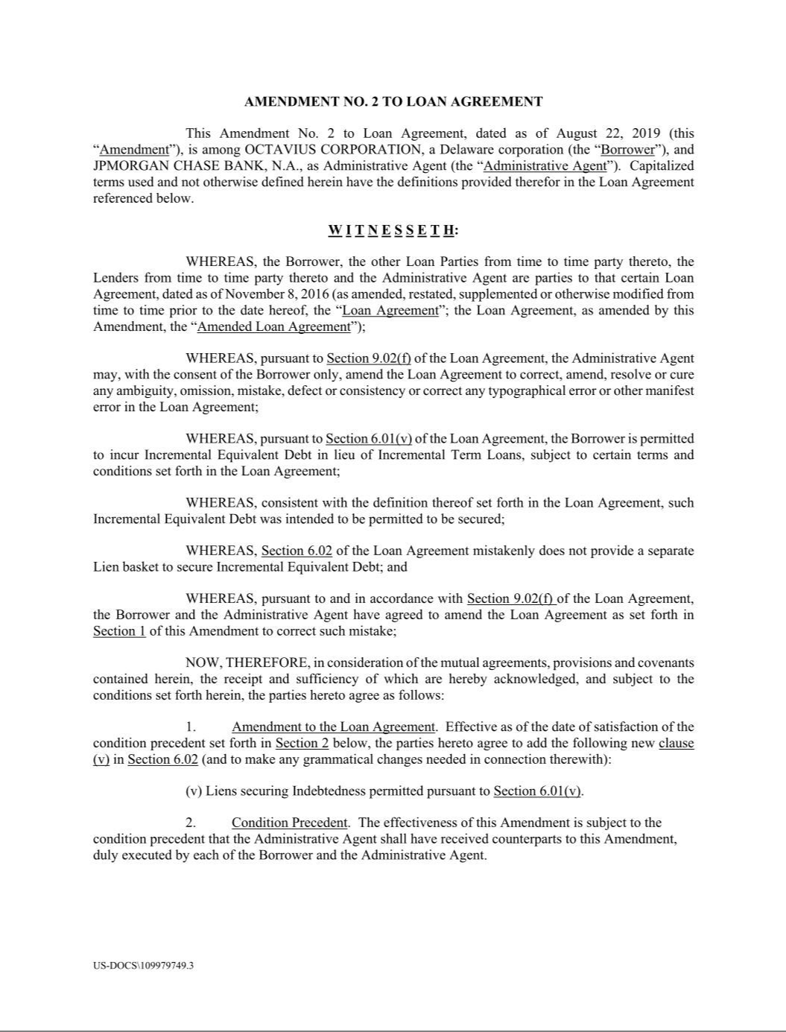

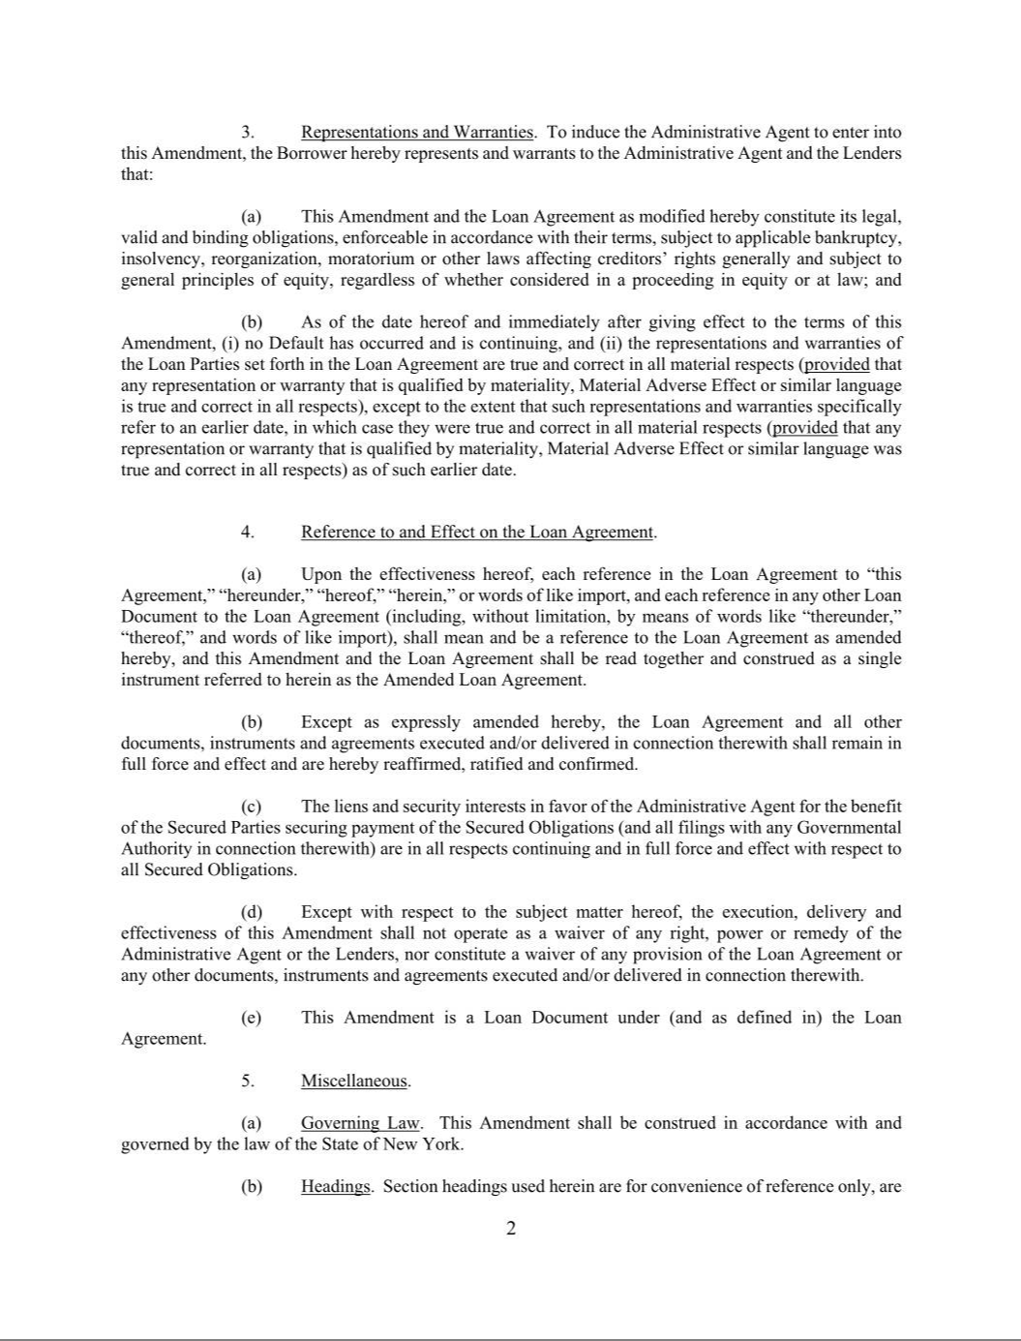

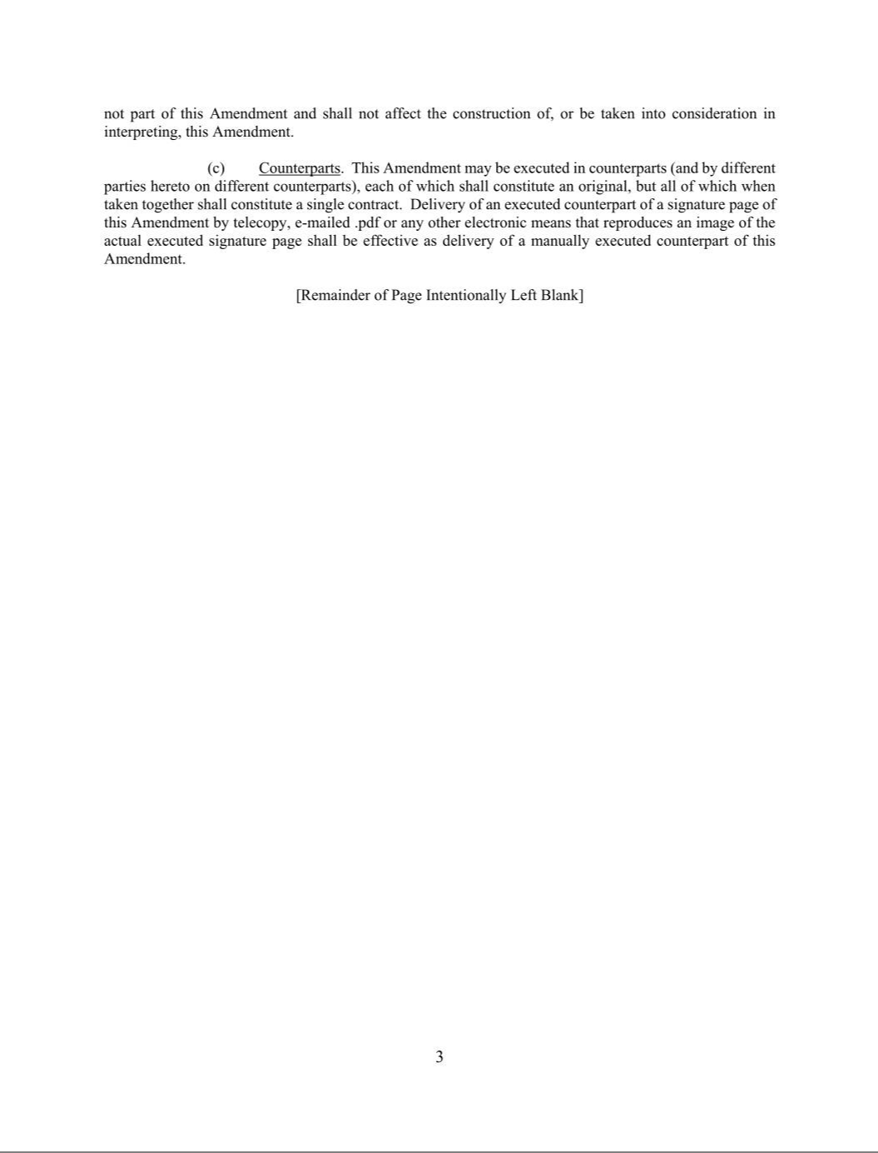

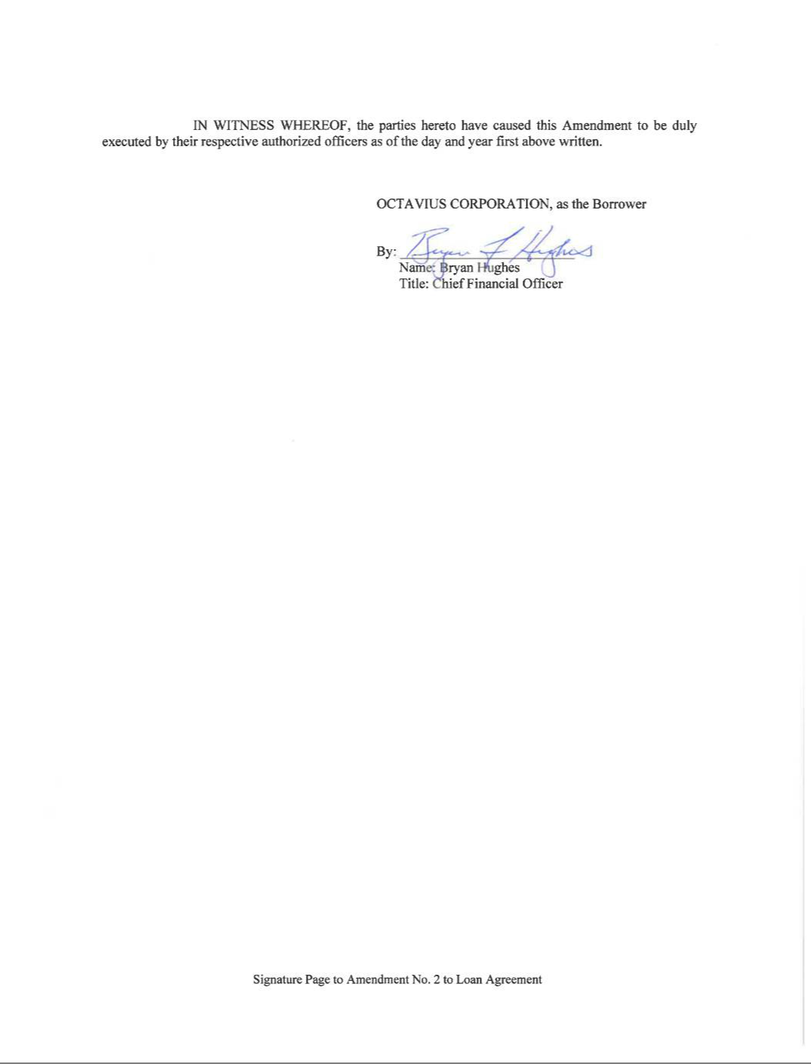

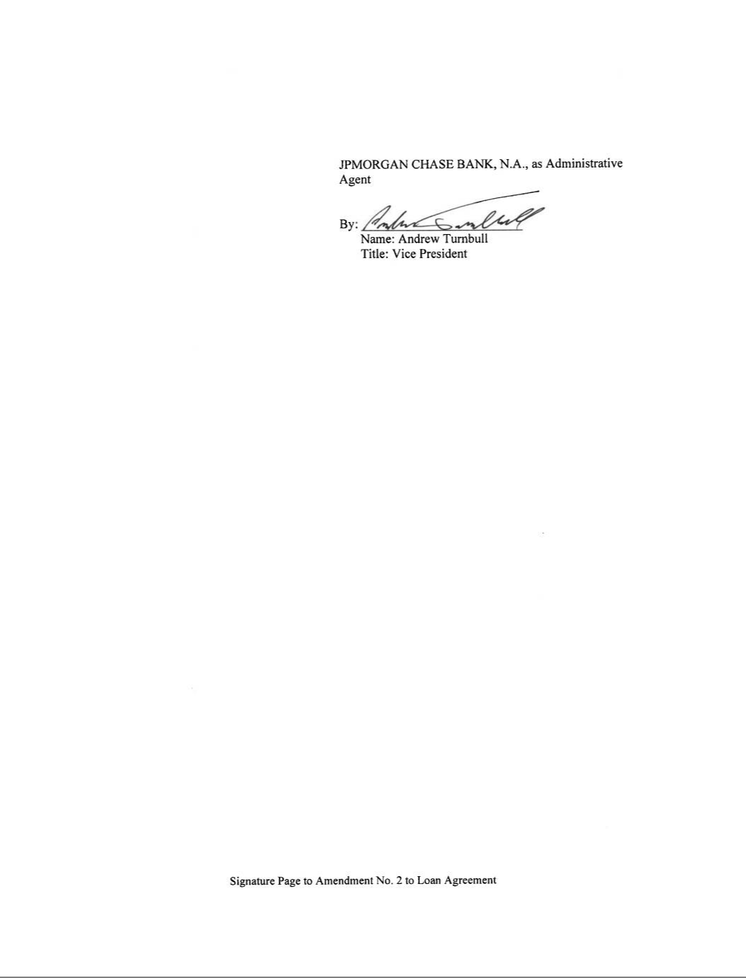

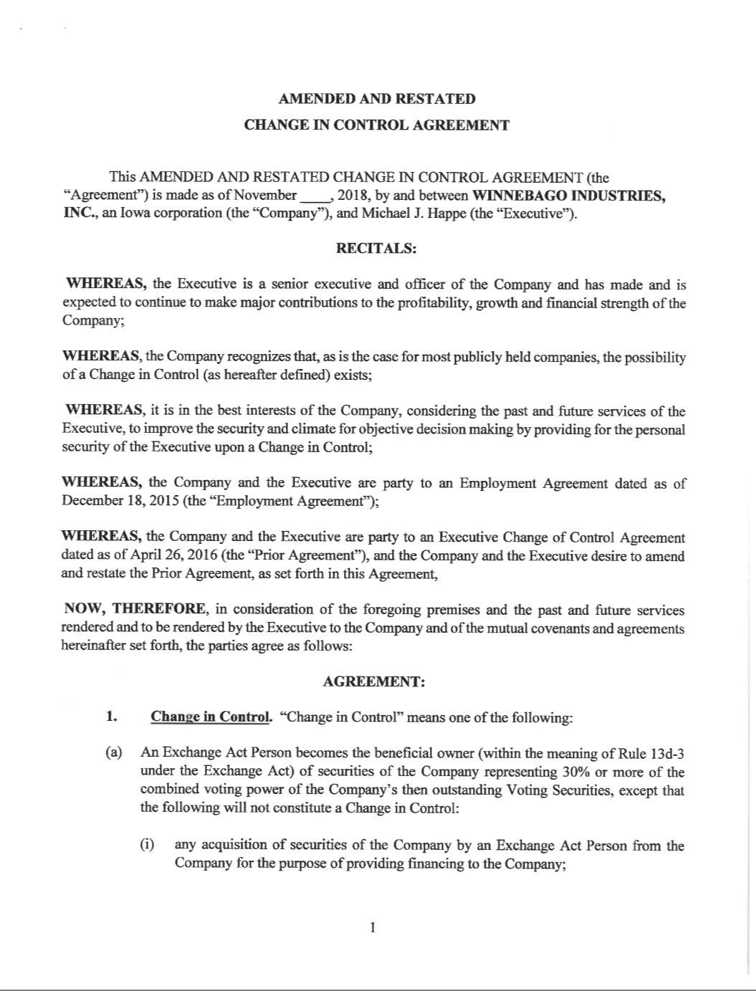

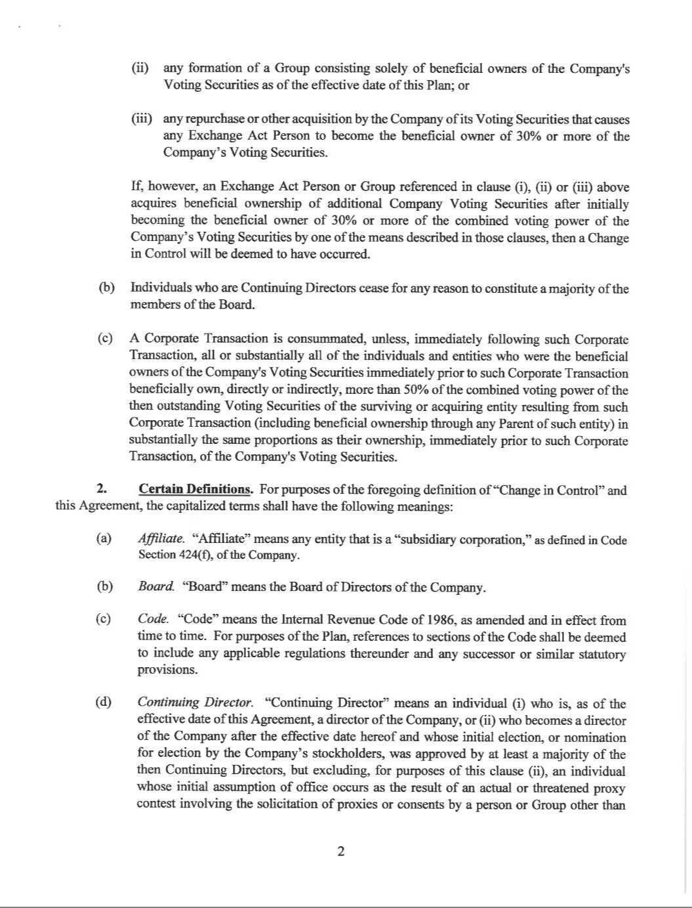

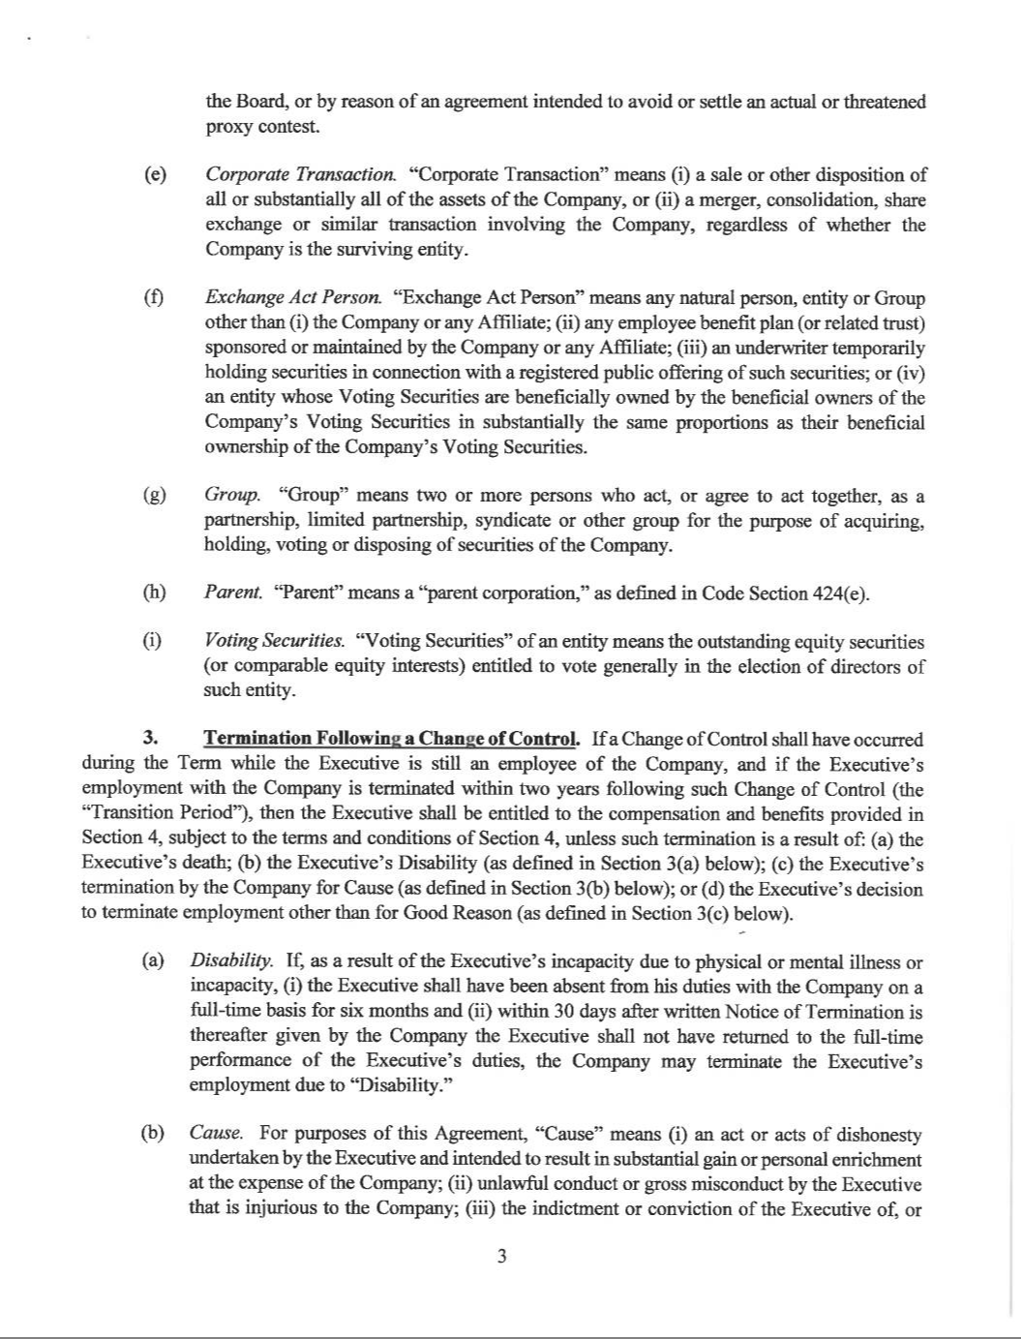

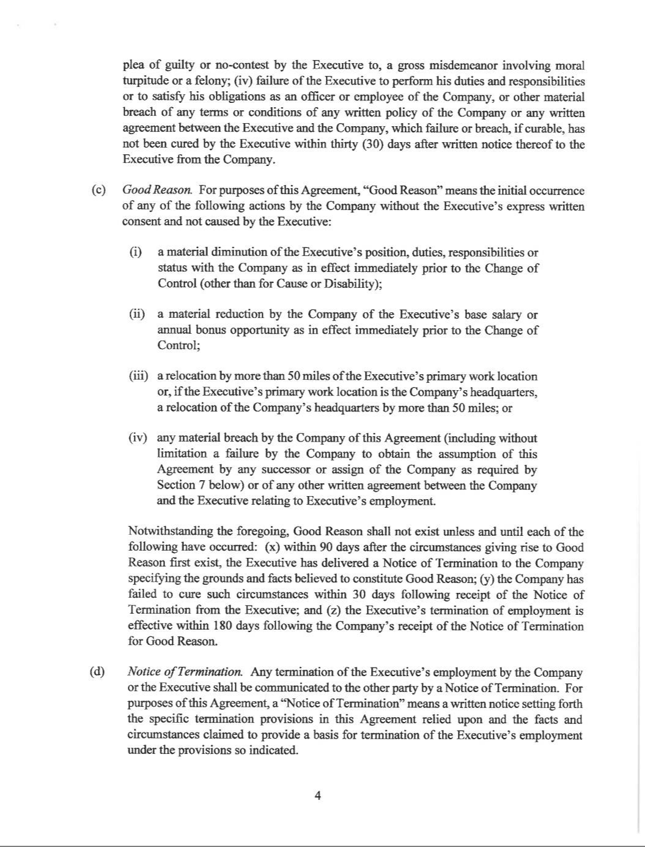

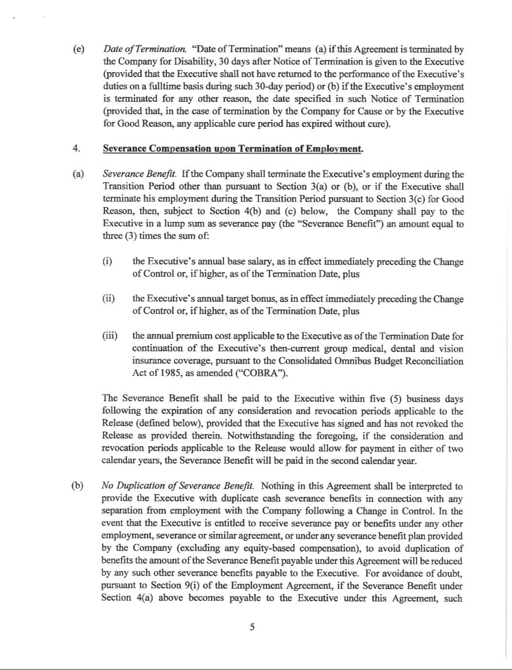

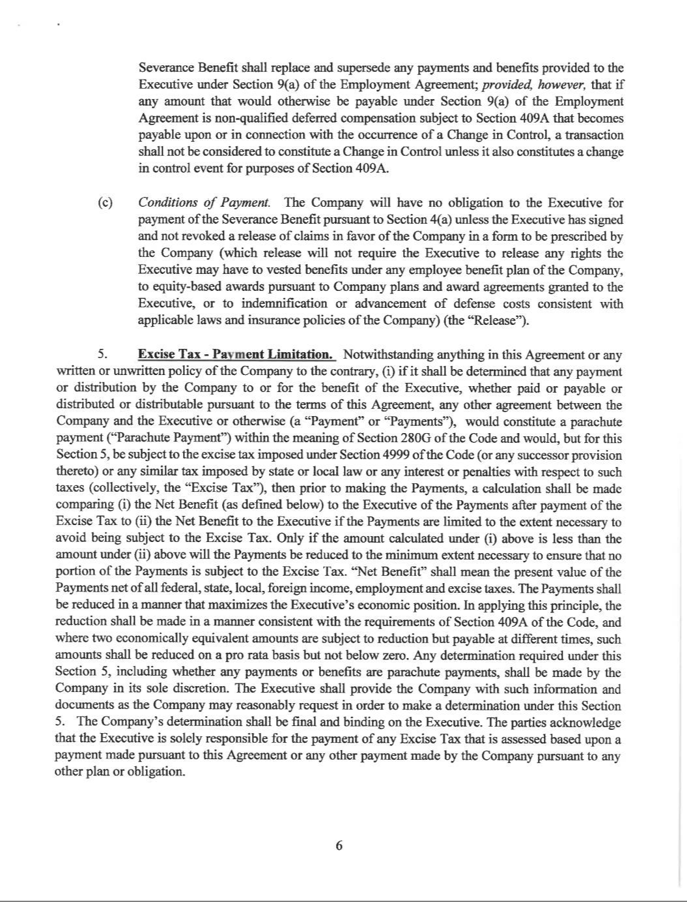

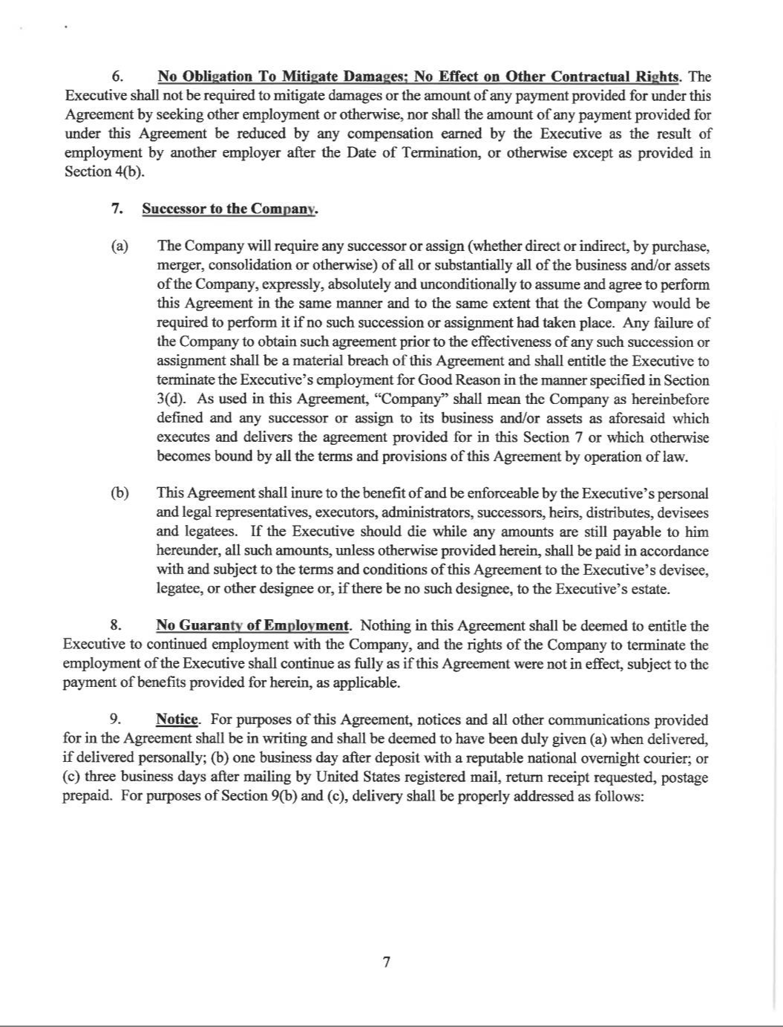

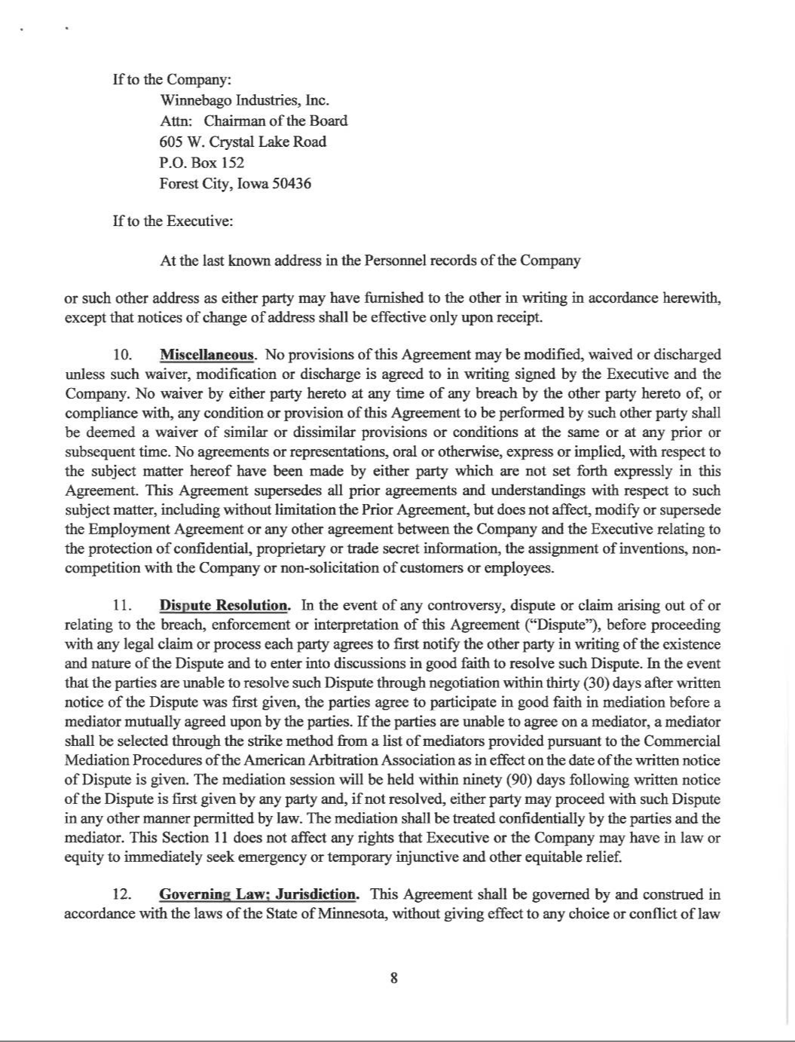

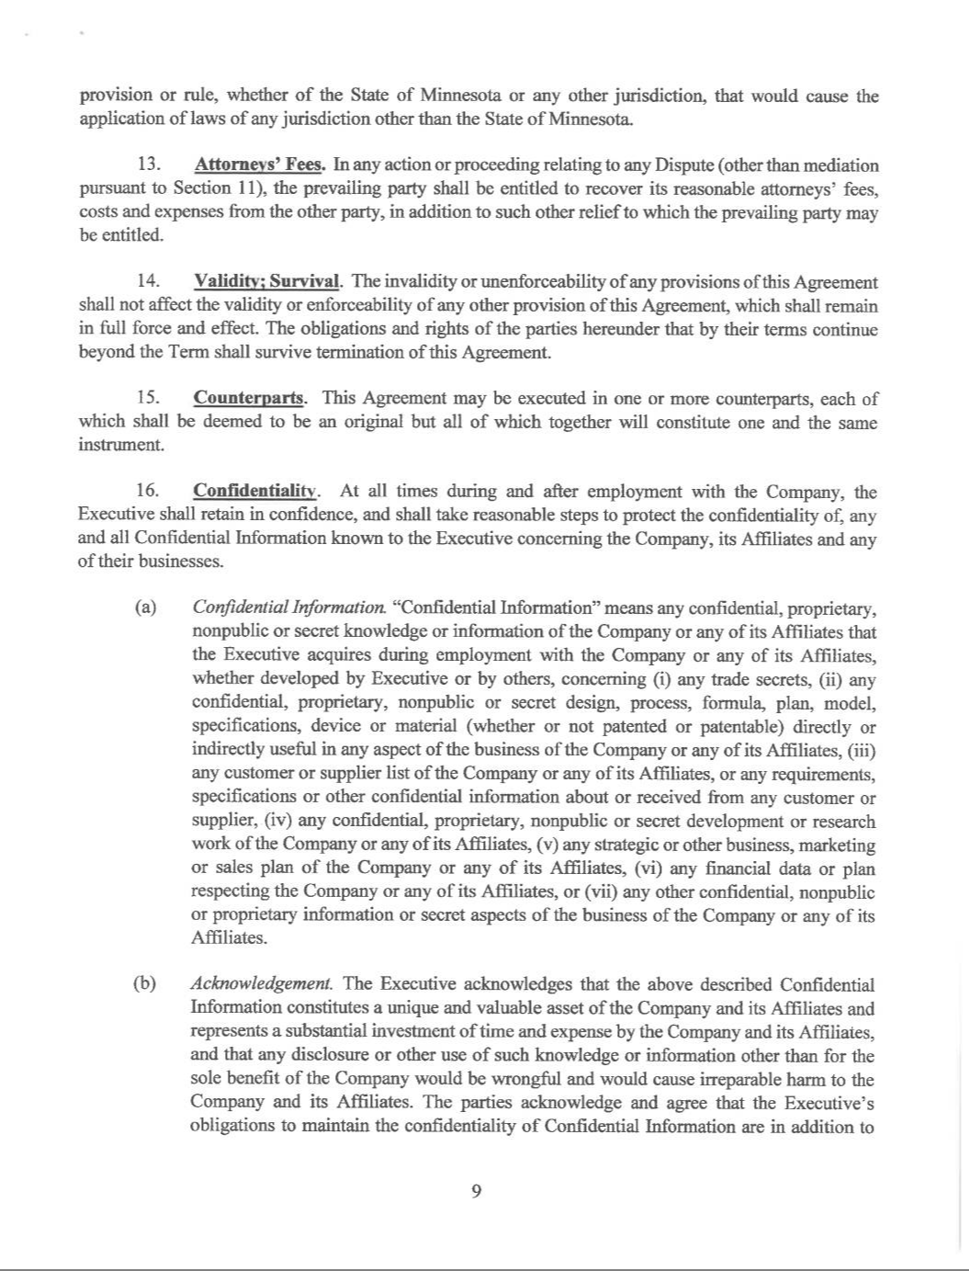

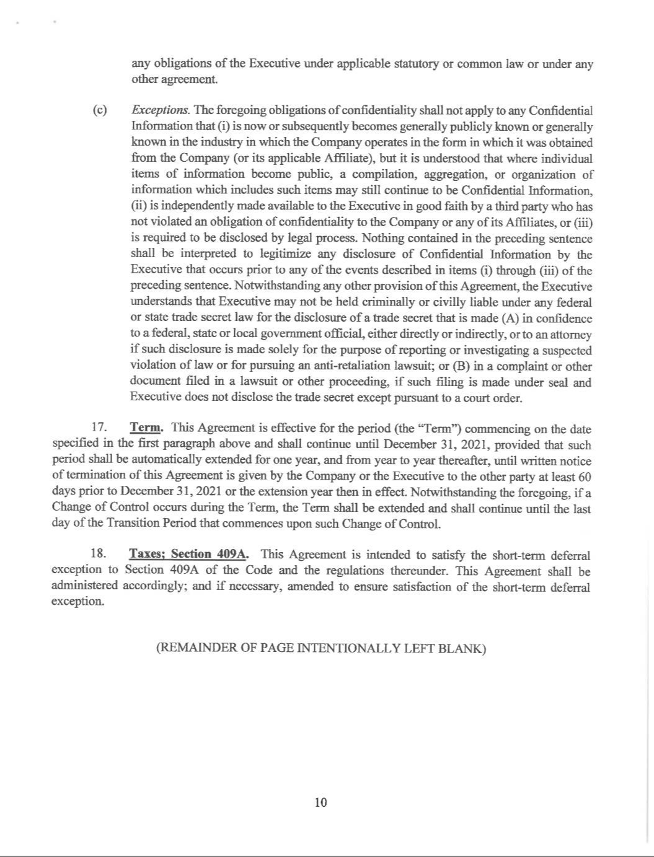

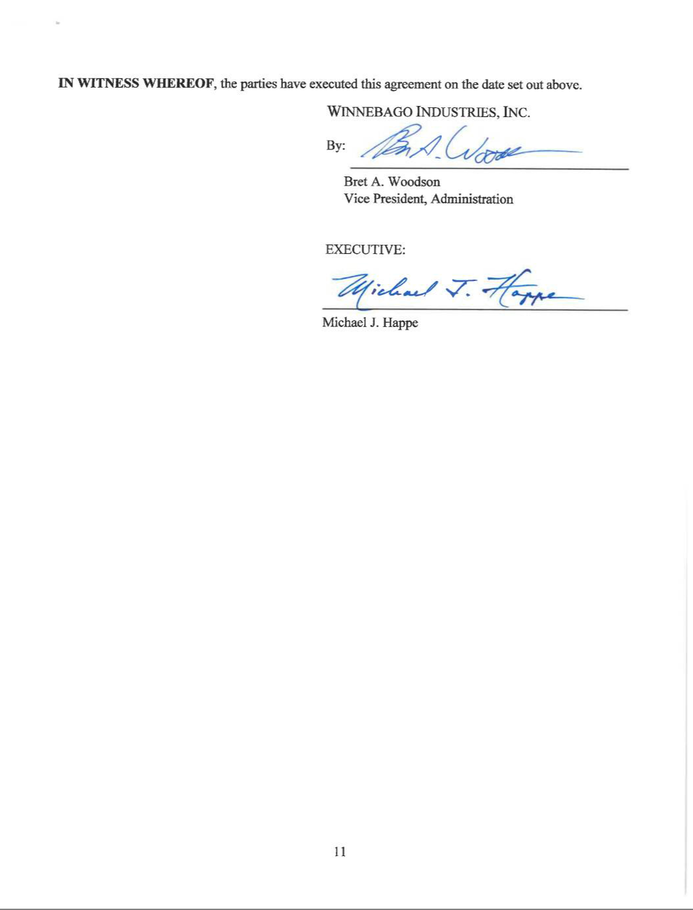

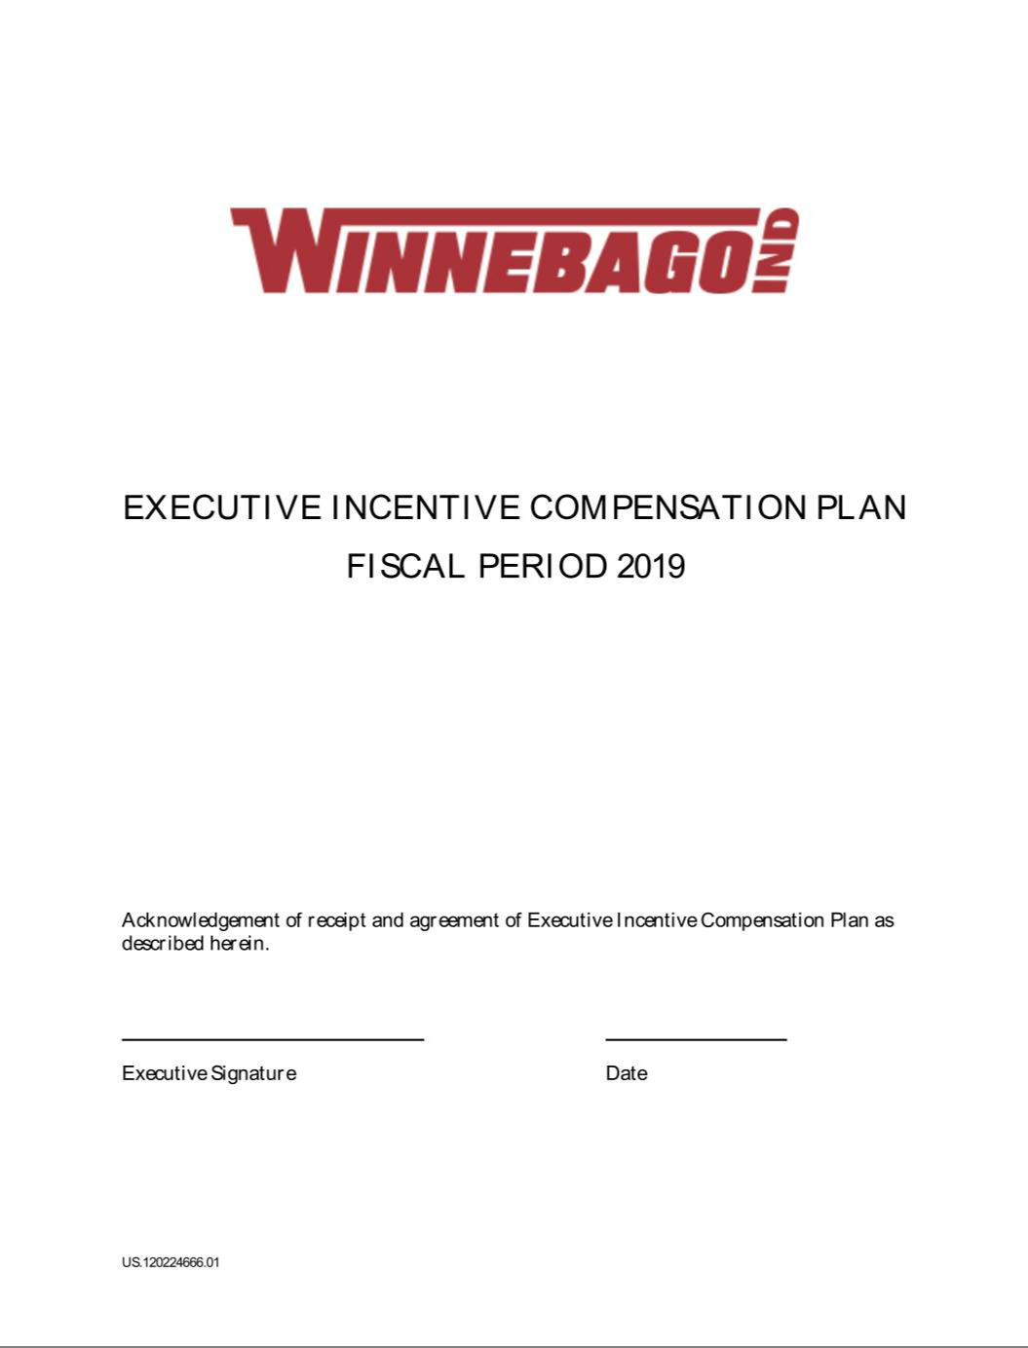

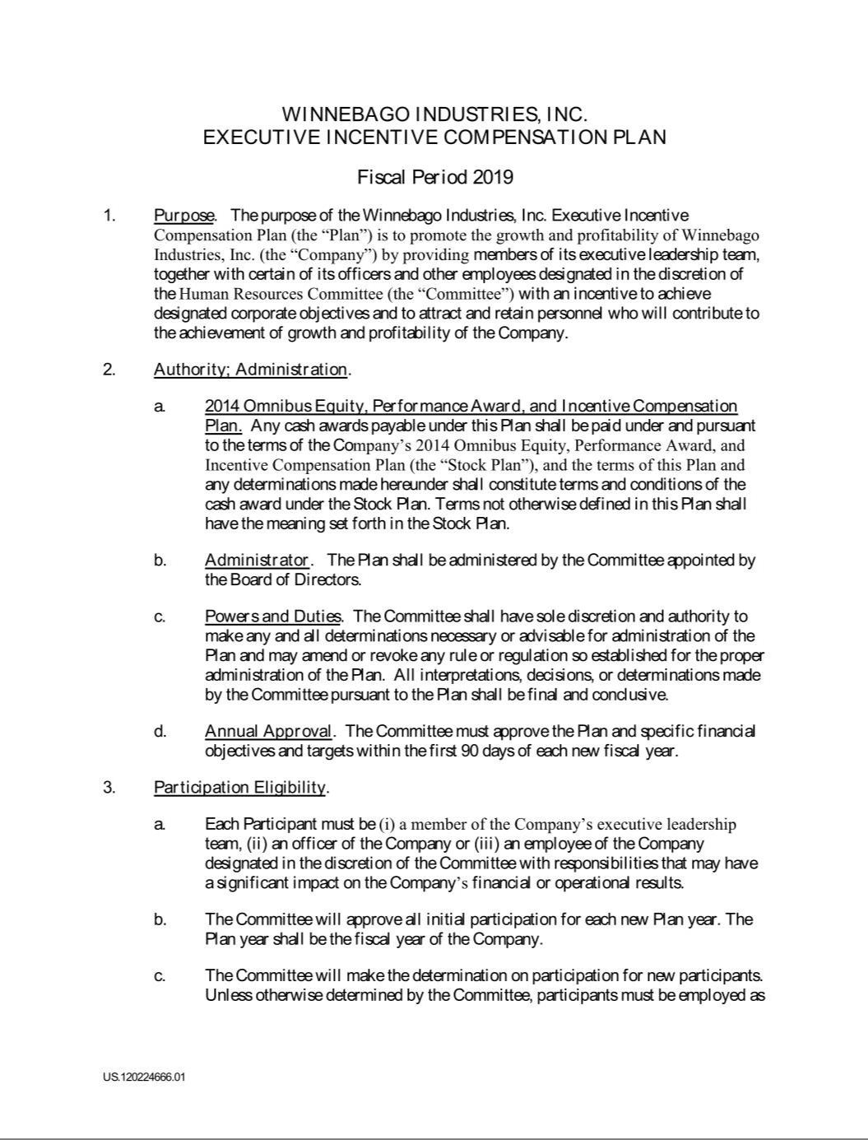

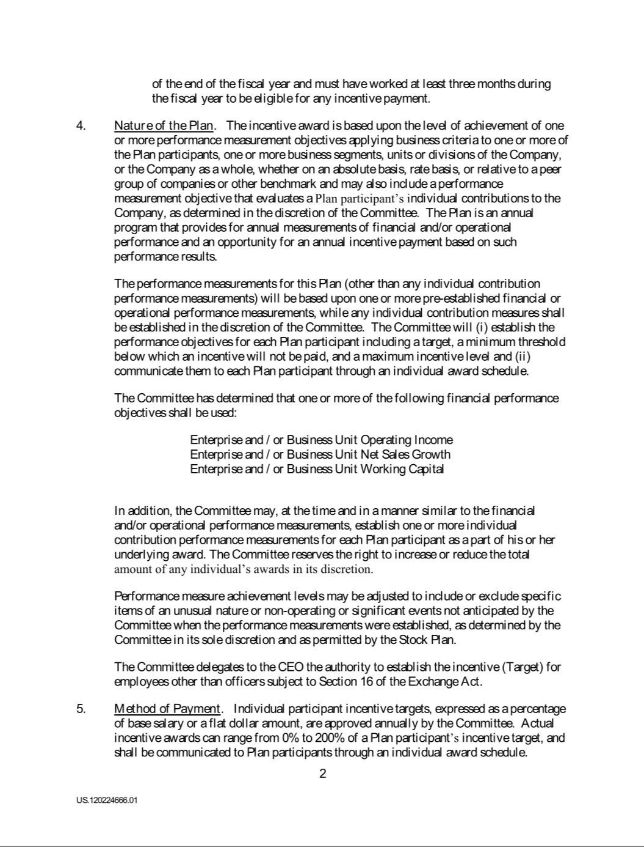

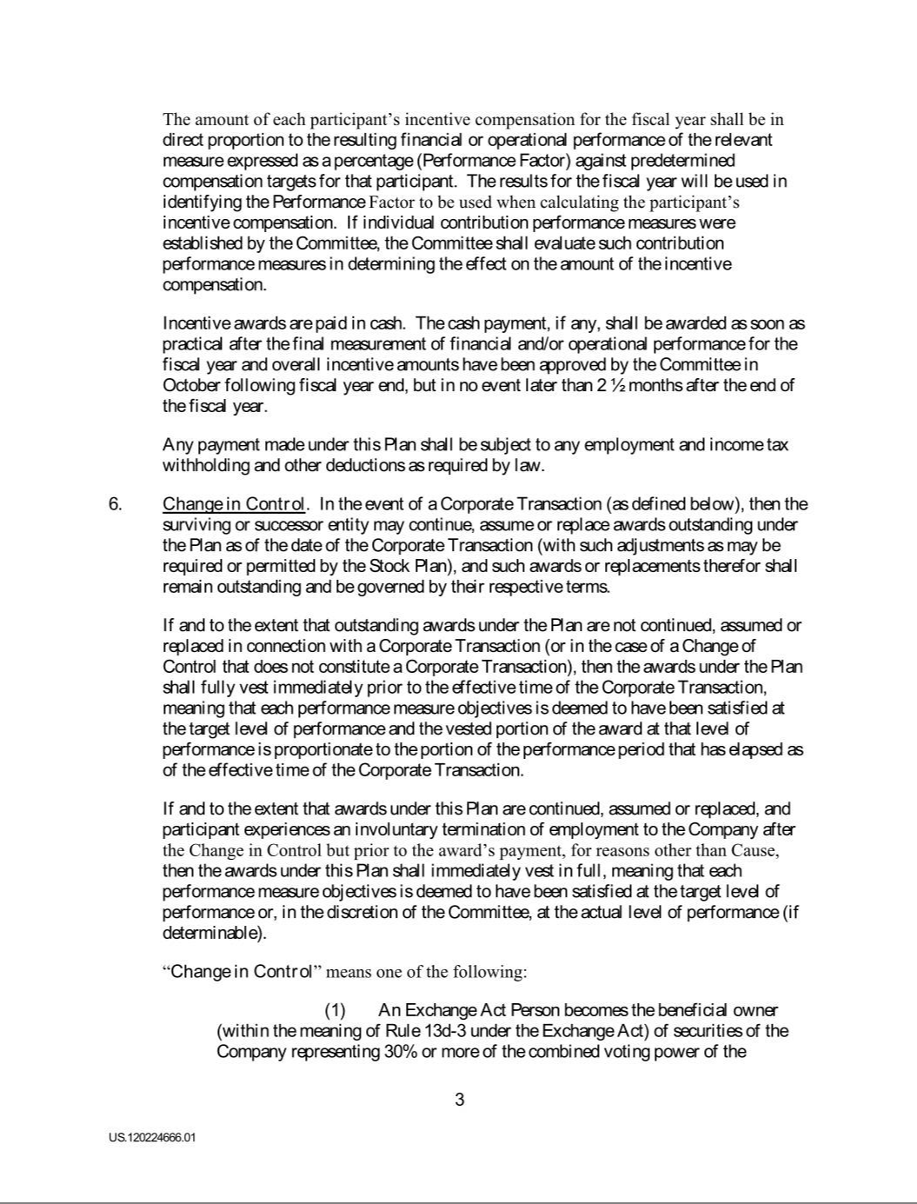

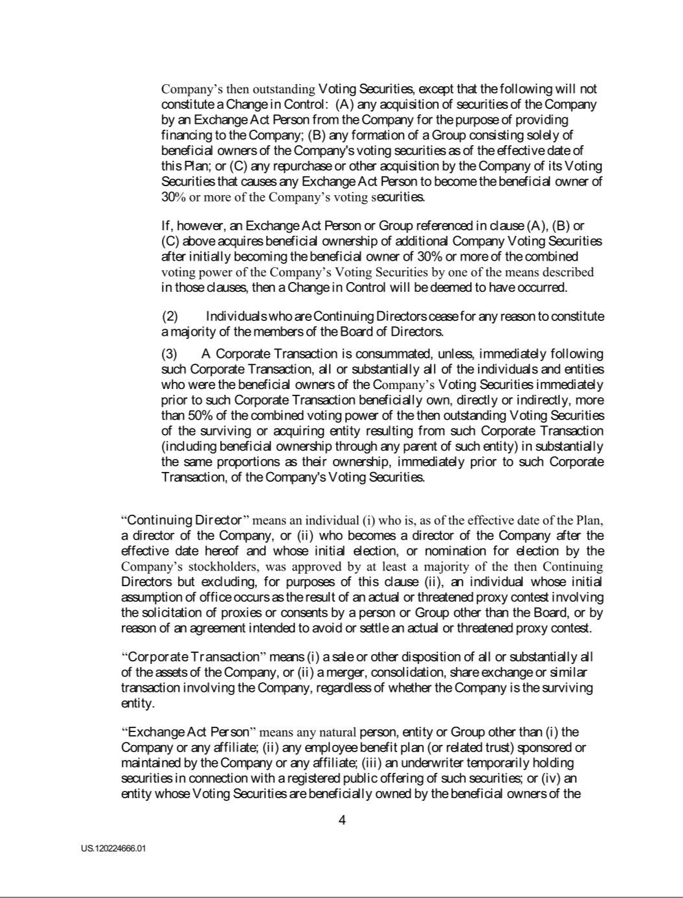

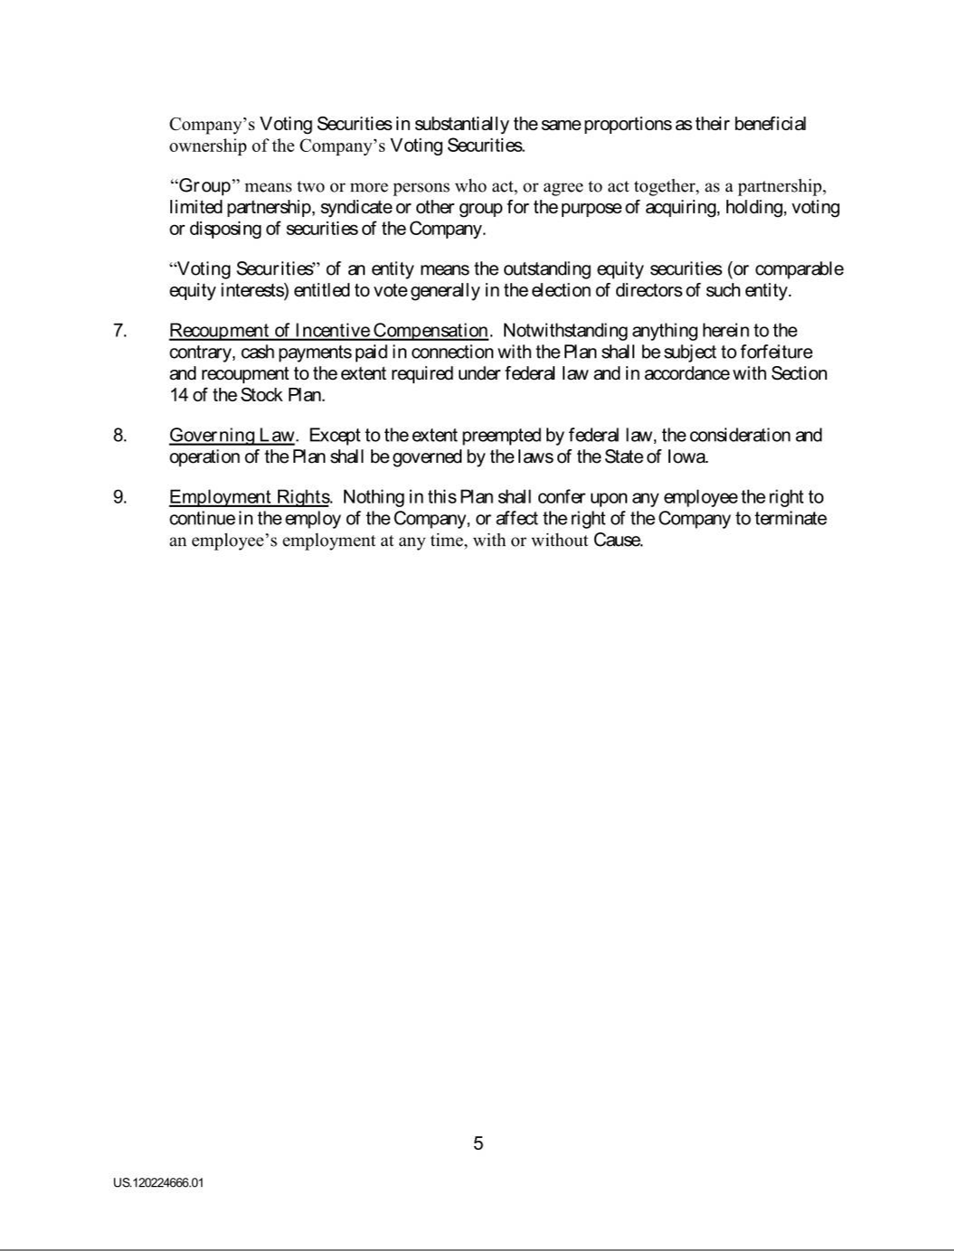

Exhibit 21

SUBSIDIARIES OF THE REGISTRANT

at August 31, 2019

 |  | Jurisdiction of |  | Percent of
Name of Corporation |  | Incorporation |  | Ownership
Winnebago Industries, Inc. |  | Iowa |  | Parent
Winnebago of Indiana, LLC |  | Iowa |  | 100%
Grand Design RV, LLC |  | Indiana |  | 100%
Winnebago Industries Holdco, LLC |  | Delaware |  | 100%
Octavius Corporation |  | Delaware |  | 100%
Chris-Craft Limited Jersey, Channel Islands Holding Company LLC |  | Jersey Channel Islands |  | 100%
Chris-Craft USA, Inc. |  | Delaware |  | 100%
CC Marine Brand Acquisition LLC |  | Delaware |  | 100%
Chris Craft Corporation |  | Delaware |  | 100%
CC Property Acquisition LLC |  | Delaware |  | 100%

Exhibit 23

CONSENT OF INDEPENDENT REGISTERED PUBLIC ACCOUNTING FIRM

We consent to the incorporation by reference in Registration Statements No. 333-31595, No. 333-47123, No. 333-113246, No. 333-194854, No. 333-222261 and No. 333-232220 on Form S-8 and No. 333-215641 on Form S-3 of our reports dated October 23, 2019, relating to the consolidated financial statements of Winnebago Industries, Inc. and subsidiaries and the effectiveness of Winnebago Industries, Inc. and subsidiaries’ internal control over financial reporting, appearing in this Annual Report on Form 10-K of Winnebago Industries, Inc. for the year ended August 31, 2019.

/s/ Deloitte & Touche LLP

Minneapolis, Minnesota

October 23, 2019

Exhibit 31.1

CERTIFICATION BY CHIEF EXECUTIVE OFFICER

PURSUANT TO 18 U.S.C. SECTION 1350,

AS ADOPTED PURSUANT TO SECTION 302

OF THE SARBANES-OXLEY ACT OF 2002

I, Michael J. Happe, Chief Executive Officer of Winnebago Industries, Inc., certify that:

- I have reviewed this Annual Report on Form 10-K of Winnebago Industries, Inc. (the "Registrant");

- Based on my knowledge, this Annual Report does not contain any untrue statement of a material fact or omit to state a material fact necessary to make the statements made, in light of the circumstances under which such statements were made, not misleading with respect to the period covered by this Annual Report;

- Based on my knowledge, the financial statements and other financial information included in this Annual Report fairly present in all material respects the financial condition, results of operations and cash flows of the Registrant as of, and for, the periods presented in this Annual Report;

- The Registrant's other certifying officer and I are responsible for establishing and maintaining disclosure controls and procedures (as defined in Exchange Act Rules 13a-15(e) and 15d-15(e)) and internal control over financial reporting (as defined in Exchange Act Rules 13a-15(f) and 15d-15(f)) for the Registrant and have:

  - Designed such disclosure controls and procedures, or caused such disclosure controls and procedures to be designed under our supervision to ensure that material information relating to the Registrant, including its consolidated subsidiaries, is made known to us by others within those entities, particularly during the period in which this Annual Report is being prepared;

  - Designed such internal control over financial reporting, or caused such internal control over financial reporting to be designed under our supervision to provide reasonable assurance regarding the reliability of financial reporting and the preparation of financial statements for external purposes in accordance with generally accepted accounting principles;

  - Evaluated the effectiveness of the Registrant's disclosure controls and procedures and presented in this Annual Report our conclusions about the effectiveness of the disclosure controls and procedures, as of the end of the period covered by this Annual Report based on such evaluation;

  - Disclosed in this Annual Report any change in the Registrant's internal control over financial reporting that occurred during the Registrant's most recent fiscal quarter (the Registrant's fourth fiscal quarter in this case) that has materially affected, or is reasonably likely to materially affect, the Registrant's internal control over financial reporting;

- The Registrant's other certifying officer and I have disclosed, based on our most recent evaluation of internal control over financial reporting, to the Registrant's auditors and the audit committee of Registrant's Board of Directors (or persons performing the equivalent functions):

  - All significant deficiencies and material weaknesses in the design or operation of internal control over financial reporting which are reasonably likely to adversely affect the Registrant's ability to record, process, summarize and report financial information; and

  - Any fraud, whether or not material, that involves management or other employees who have a significant role in the Registrant's internal control over financial reporting.

Date: October 23, 2019 By: /s/ Michael J. Happe

Michael J. Happe

President, Chief Executive Officer

Exhibit 31.2

CERTIFICATION BY CHIEF FINANCIAL OFFICER

PURSUANT TO 18 U.S.C. SECTION 1350,

AS ADOPTED PURSUANT TO SECTION 302

OF THE SARBANES-OXLEY ACT OF 2002

I, Bryan L. Hughes, Chief Financial Officer of Winnebago Industries, Inc., certify that:

- I have reviewed this Annual Report on Form 10-K of Winnebago Industries, Inc. (the "Registrant");

- Based on my knowledge, this Annual Report does not contain any untrue statement of a material fact or omit to state a material fact necessary to make the statements made, in light of the circumstances under which such statements were made, not misleading with respect to the period covered by this Annual Report;

- Based on my knowledge, the financial statements and other financial information included in this Annual Report fairly present in all material respects the financial condition, results of operations and cash flows of the Registrant as of, and for, the periods presented in this Annual Report;

- The Registrant's other certifying officer and I are responsible for establishing and maintaining disclosure controls and procedures (as defined in Exchange Act Rules 13a-15(e) and 15d-15(e)) and internal control over financial reporting (as defined in Exchange Act Rules 13a-15(f) and 15d-15(f)) for the Registrant and have:

  - Designed such disclosure controls and procedures, or caused such disclosure controls and procedures to be designed under our supervision to ensure that material information relating to the Registrant, including its consolidated subsidiaries, is made known to us by others within those entities, particularly during the period in which this Annual Report is being prepared;

  - Designed such internal control over financial reporting, or caused such internal control over financial reporting to be designed under our supervision to provide reasonable assurance regarding the reliability of financial reporting and the preparation of financial statements for external purposes in accordance with generally accepted accounting principles;

  - Evaluated the effectiveness of the Registrant's disclosure controls and procedures and presented in this Annual Report our conclusions about the effectiveness of the disclosure controls and procedures, as of the end of the period covered by this Annual Report based on such evaluation;

  - Disclosed in this Annual Report any change in the Registrant's internal control over financial reporting that occurred during the Registrant's most recent fiscal quarter (the Registrant's fourth fiscal quarter in this case) that has materially affected, or is reasonably likely to materially affect, the Registrant's internal control over financial reporting;

- The Registrant's other certifying officer and I have disclosed, based on our most recent evaluation of internal control over financial reporting, to the Registrant's auditors and the audit committee of Registrant's Board of Directors (or persons performing the equivalent functions):

  - All significant deficiencies and material weaknesses in the design or operation of internal control over financial reporting which are reasonably likely to adversely affect the Registrant's ability to record, process, summarize and report financial information; and

  - Any fraud, whether or not material, that involves management or other employees who have a significant role in the Registrant's internal control over financial reporting.

Date: October 23, 2019 By: /s/ Bryan L. Hughes

Bryan L. Hughes

Vice President, Chief Financial Officer

Exhibit 32.1

CERTIFICATION OF PRINCIPAL EXECUTIVE OFFICER

PURSUANT TO SECTION 18 U.S.C. SECTION 1350

AS ADOPTED PURSUANT TO SECTION 906

OF THE SARBANES-OXLEY ACT OF 2002

Pursuant to 18 U.S.C. Section 1350, as adopted pursuant to Section 906 of the Sarbanes-Oxley Act of 2002, I, Michael J. Happe, Chief Executive Officer of Winnebago Industries, Inc. (the "Company"), hereby certify that to my knowledge:

- The Annual Report on Form 10-K for the year ended August 31, 2019 (the "Report") of the Company fully complies with the requirements of Section 13(a) or 15(d) of the Securities Exchange Act of 1934, and

- The information contained in this Report fairly presents, in all material respects, the financial condition and results of operations of the Company.

Date: | October 23, 2019 | By: | /s/ Michael J. Happe
 |  |  | Michael J. Happe
 |  |  | President, Chief Executive Officer

Exhibit 32.2

CERTIFICATION OF PRINCIPAL FINANCIAL OFFICER

PURSUANT TO SECTION 18 U.S.C. SECTION 1350

AS ADOPTED PURSUANT TO SECTION 906

OF THE SARBANES-OXLEY ACT OF 2002

Pursuant to 18 U.S.C. Section 1350, as adopted pursuant to Section 906 of the Sarbanes-Oxley Act of 2002, I, Bryan L. Hughes, Chief Financial Officer of Winnebago Industries, Inc. (the "Company"), hereby certify that to my knowledge:

- The Annual Report on Form 10-K for the year ended August 31, 2019 (the "Report") of the Company fully complies with the requirements of Section 13(a) or 15(d) of the Securities Exchange Act of 1934, and

- The information contained in this Report fairly presents, in all material respects, the financial condition and results of operations of the Company.

Date: | October 23, 2019 | By: | /s/ Bryan L. Hughes
 |  |  | Bryan L. Hughes
 |  |  | Vice President, Chief Financial Officer

